$ mkdir server

$ cd server

$ npm init (generates package.json)

(press enter several times to skip through setup)

$ npm install --save express

$ cat package.json

Node.js is a way to run JavaScript code outside the browser.

Express.js is a library on top of Node to help deal with http requests. Everything done in express could technically be coded in Node.

This is a basic express app that displays a simple json file on port 5000. (localhost:5000)

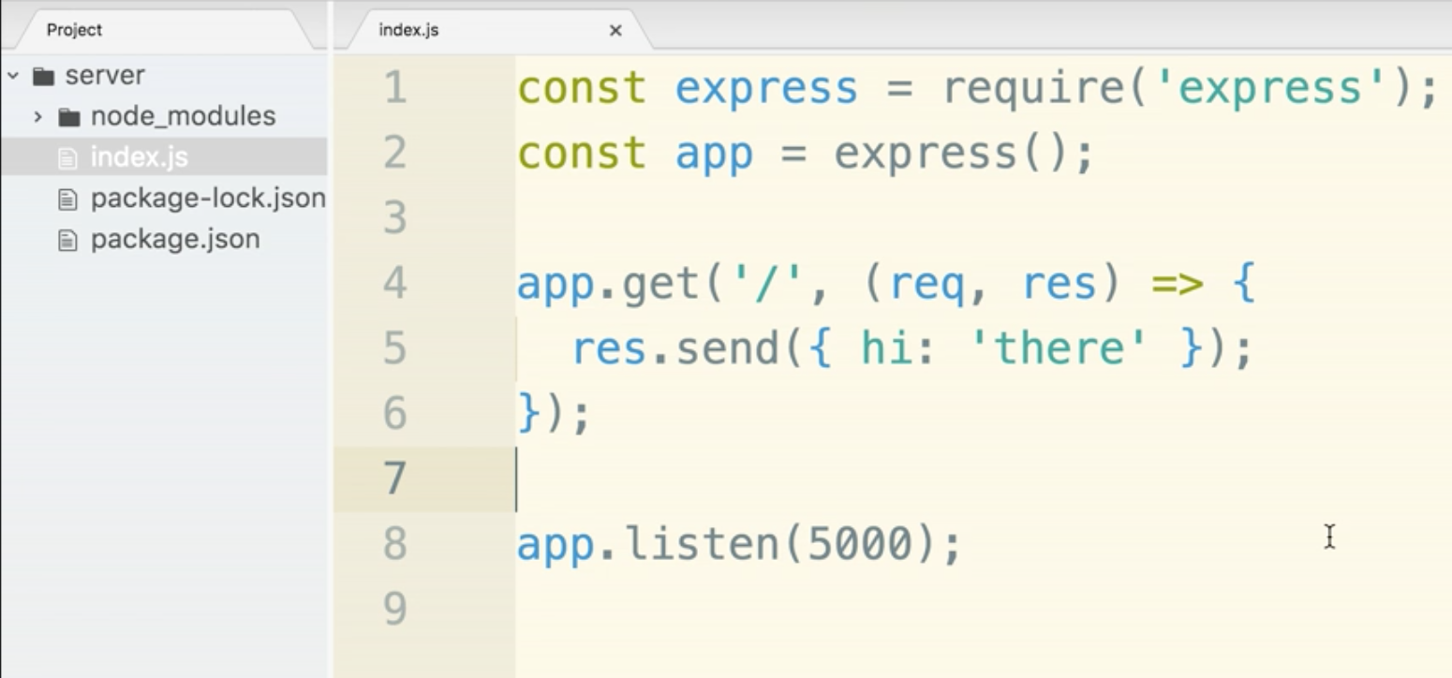

Deploying to Heroku! This is more like the PRE-deployment checklist. There will be a seperate checklist later. 4 Steps:

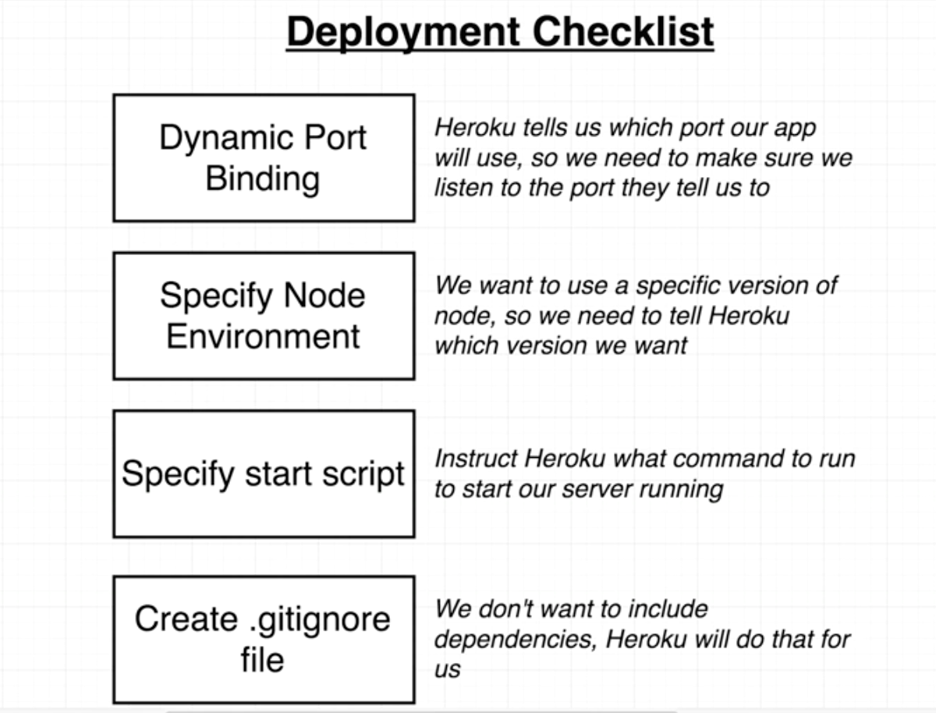

Step 1:

At runtime, Heroku has the ability to inject environment variables. Environment variables are variables that are set in the underlying runtime that node is running on top of. It is Heroku’s opportunity to pass us runtime configuration, specific information Heroku wants to tell us after the actual deployment of the application.

We are unable to look up the port ahead of time, we need to wait until the very last second. When are app is starting to be executed by Heroku.

“Look at the underlying environment and see if they have defined a port for us to use.”

Line 8 below has an OR statement that handles both production and development ports. If there is environment variable defined by heroku - use it. Otherwise, by default, use the port 5000. 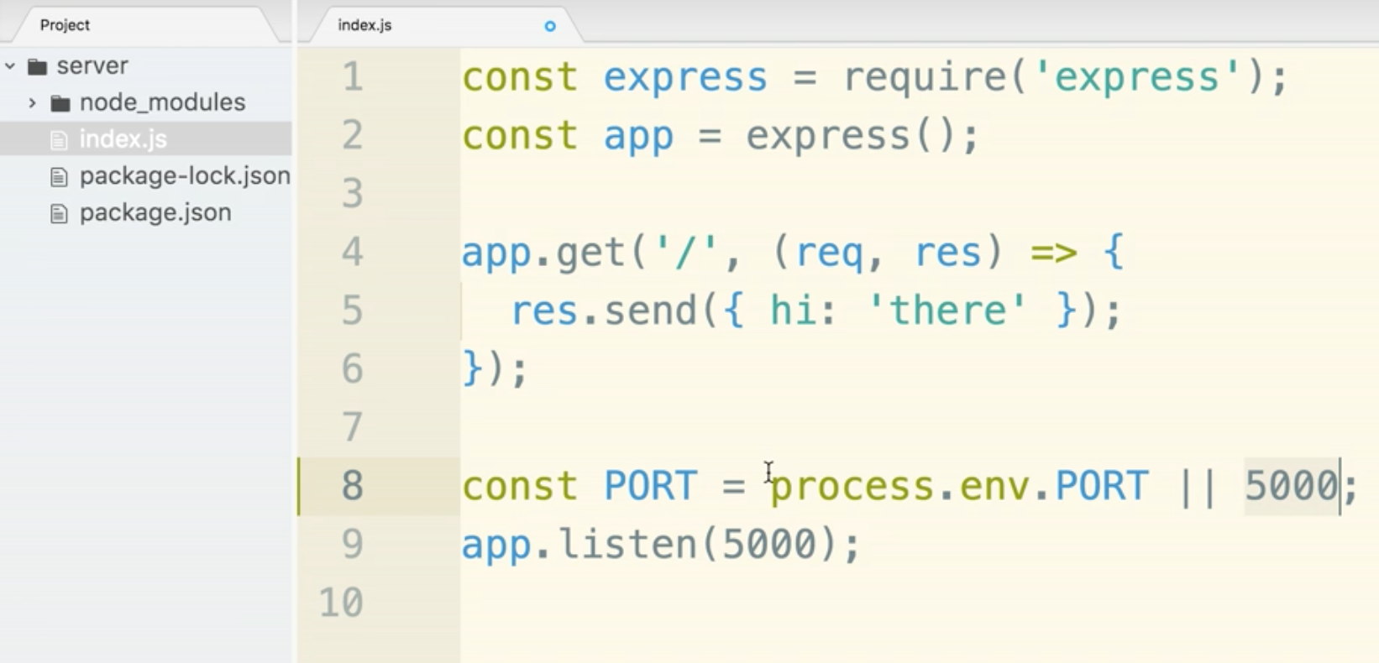

Step 2:

We need to let Heroku or our hosting service that we need to use updated versions of node and npm. They may use older versions by default. You need to add an “engines” key in the package.json file. Remember to double check quotations and commas.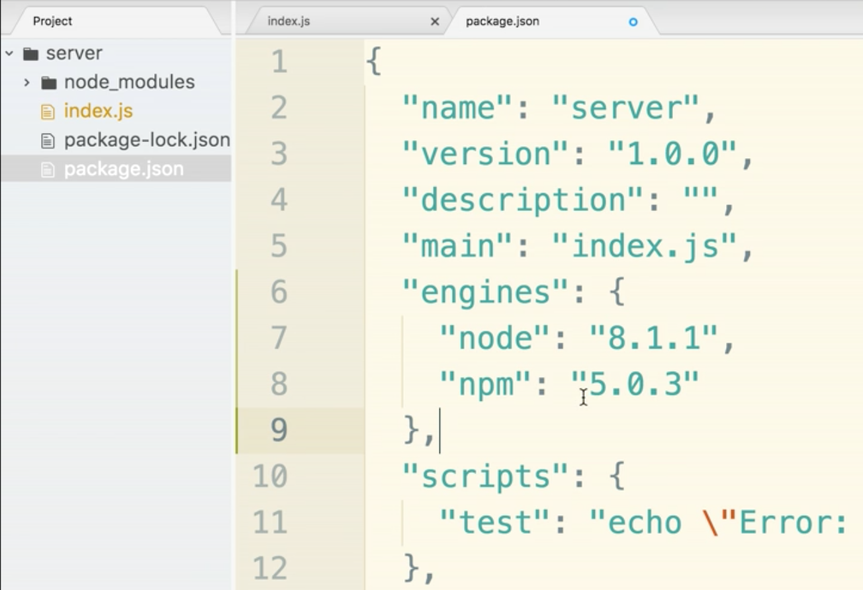

Step 3: Add a start script so Heroku knows how to fire up the application.

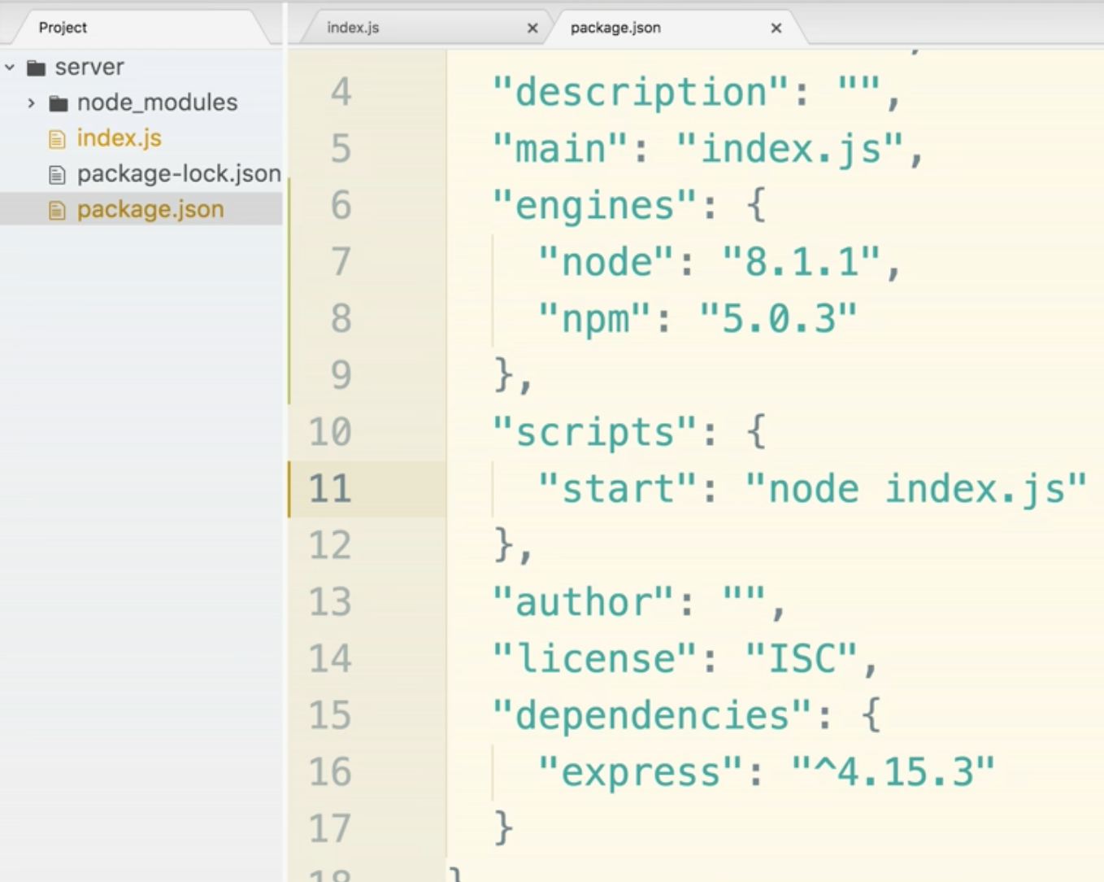

Step 4: Create a .gitignore file. Heroku uses git to deploy. It used a git-based deployment workflow.

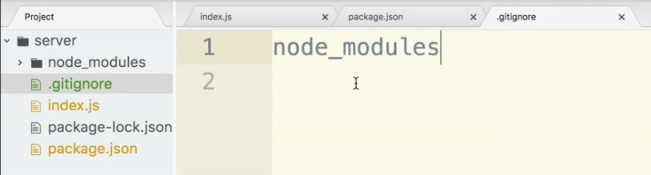

These is the actual deployment checklist. It will differ if you are doing this for the first time or subsequent times.

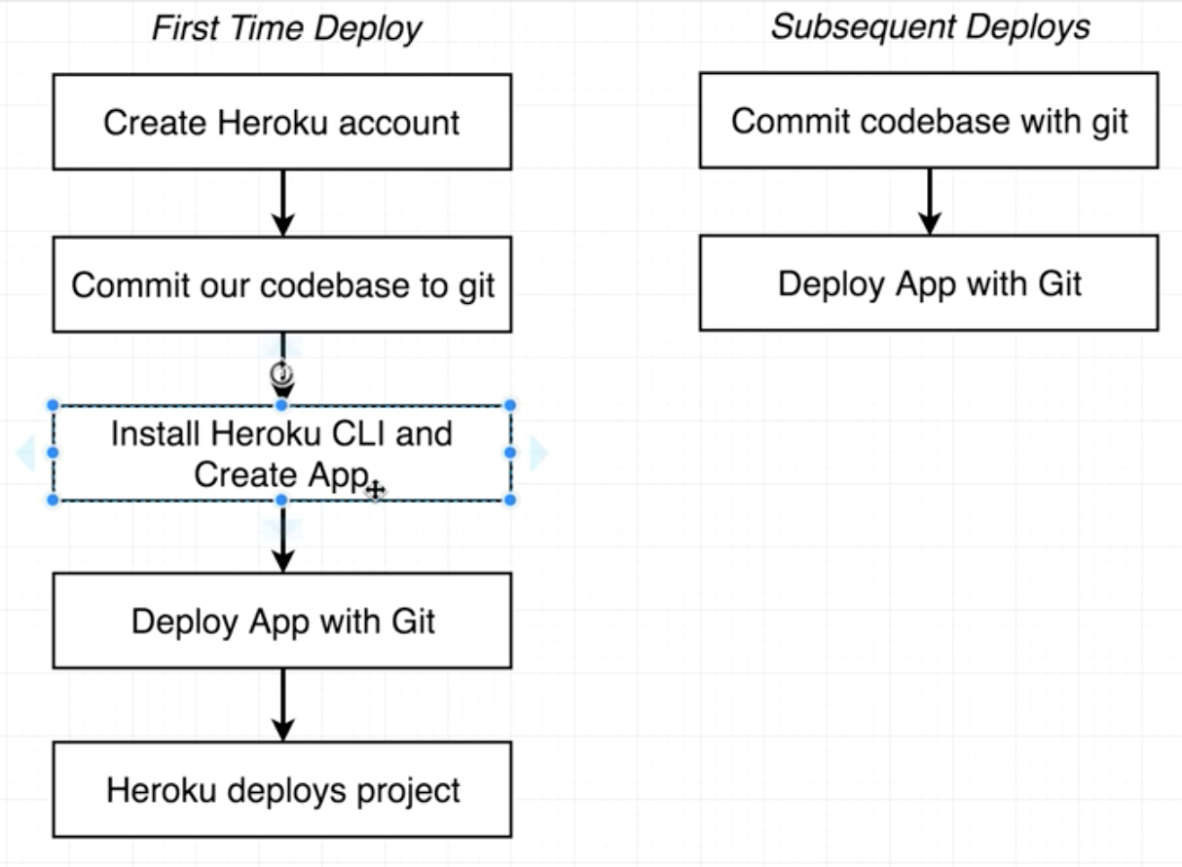

**First Time Deployment:**

Step 1:

Heroku.com and sign up.

Sign in.

Step 2: Commit our codebase to git

$ git --version (this will check if you have git installed. If you don’t have git installed just google it and you can install it.)

within the server folder:

$ git init

$ git add .

$ git commit -m “initial commit”

Step 3:

Install Heroku CLI and Create App

search for Heroku CLI

Install Heroku CLI for MacOS

Check that you have it installed properly by using this command:

$ heroku -v

Step 4: Deploy App with Git

$ heroku login

(enter credentials)

$ heroku create

(there will be a two urls generated. The first is the address we will navigate to to view the current deployment in the browser.

The second url is the deployment target. It is a git repository that we can push our codebase to. We can push the repository to this remote one. s soon as we push, heroku will take it a deploy automatically.

Copy the second url.

git remote add heroku <pasted in second url>

(you may see a “fatal: remote heroku already exists”. This is ok)

$ git push heroku master

(lots of remote messages will pop up. Debug info will occur. Lots of feedback from Heroku direcly. It will look to build our app. It will detect Node jS it will set runtime flags. It will install the versions of node. It will load dependencies, and finally it will say Verifying deploy...done. To <url>

If all is well, you can run this command to automatically open your app where it is live on the web:

$ huroku open

If it did not go well and there were errors use this command:

$ heroku logs

Then the error messages can be googled for help.

END FIRST TIME DEPLOYMENT

**Subsequent Deployments:**

Start by making sure all files are saved.

Go to the terminal and make sure you are in the server folder

$ git status

$ git add .

$ git commit -m “changed greeting”

$ git push heroku master

(At this point it should be re-deployed)

$ heroku logs (this will check for errors if things did not deploy properly)

$ heroku open (this will launch the app. This will tell you that things worked properly)

Custom domain names will come later.

**Google OAuth Section**

This is the overall app and how it will work:

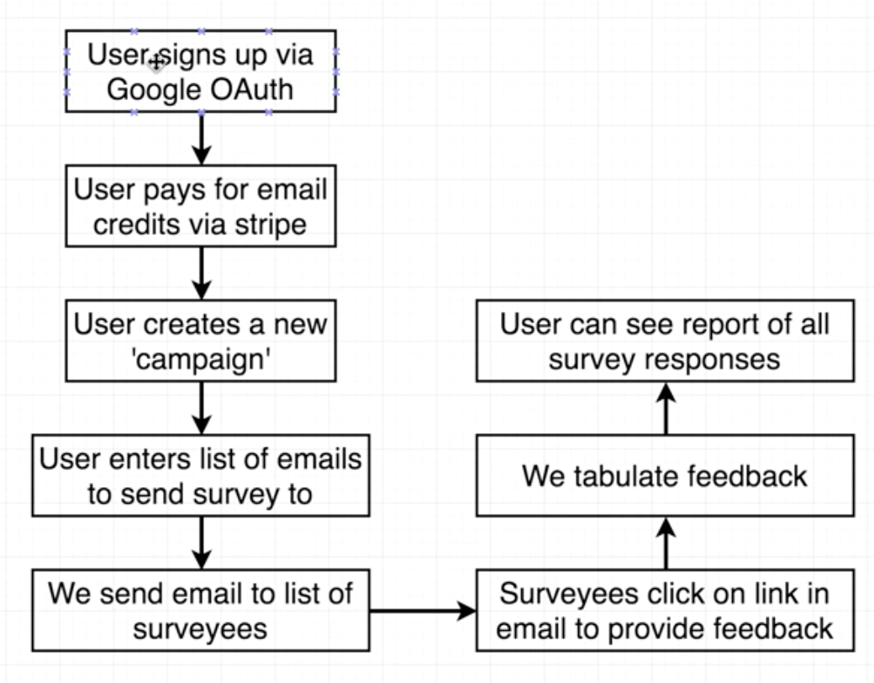

OAuth is completely servers side - so all backend at this point.

This will be the most challenging portion of the course.

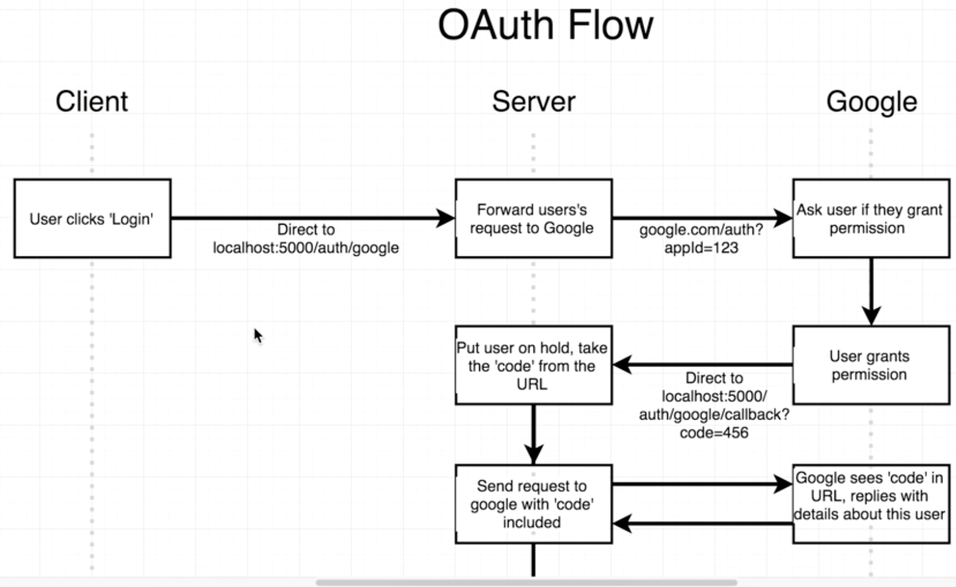

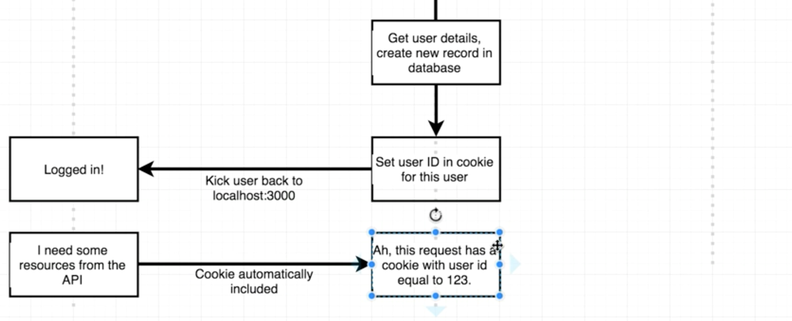

Common complaints about Passport.JS:

It automates a vast majority of the flow but you have to jump in at times at very specific points and add in code. It may feel weird, like you are adding in code at weird times and you many not understand the whole larger picture. A common complaints is that it does things magically and it’s not clear what is happening behind the scenes.

Second complaint is about how the library is structured. Passport uses at least two different libraries. The first library is passport. This is a set of general helpers handling auth in Express apps. “passport strategy” are helpers for authenticating with one very specific method (email/password, Google, Facebook, etc) If you are using multiple forms of authentication, you will be using multiple strategies and wiring them all up.

Below is what Passport JS is doing for us in yellow:

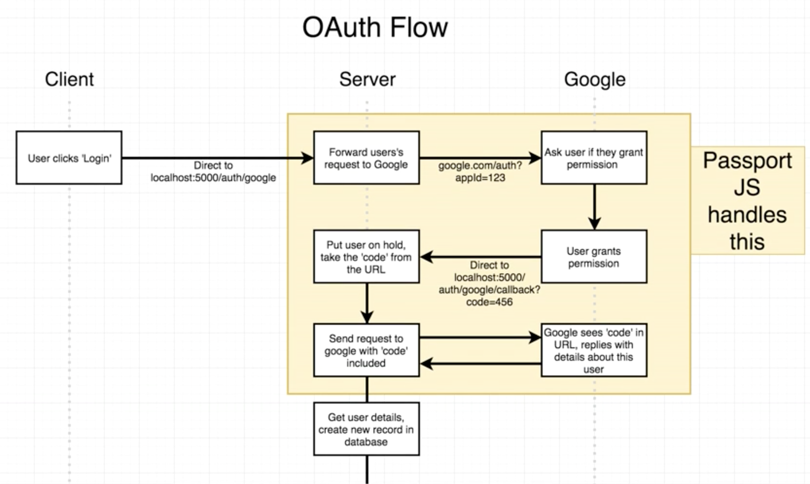

Install passport JS

$ npm install --save passport passport-google-oauth20

(oauth20 is for OAuth 2.0 for google)

If you want to look into installing other passport strategies, there are a ton. Just visit passportjs.org/docs. You can search for strategies there. You can use login oauth for tons of stuff.

import or require into index.js. index.js will be refactored into multiple files later.

require passport and require passport-google-oauth20

passport.use(new GoogleStrategy());

^new GoogleStrategy() creates a new instance of the Google Passport strategy.

passport.use() is a generic register. It is telling passport, ‘I want you to be aware that there is a new strategy available. Here it is, make use of it. Users can use this to authenticate themselves inside our application.’

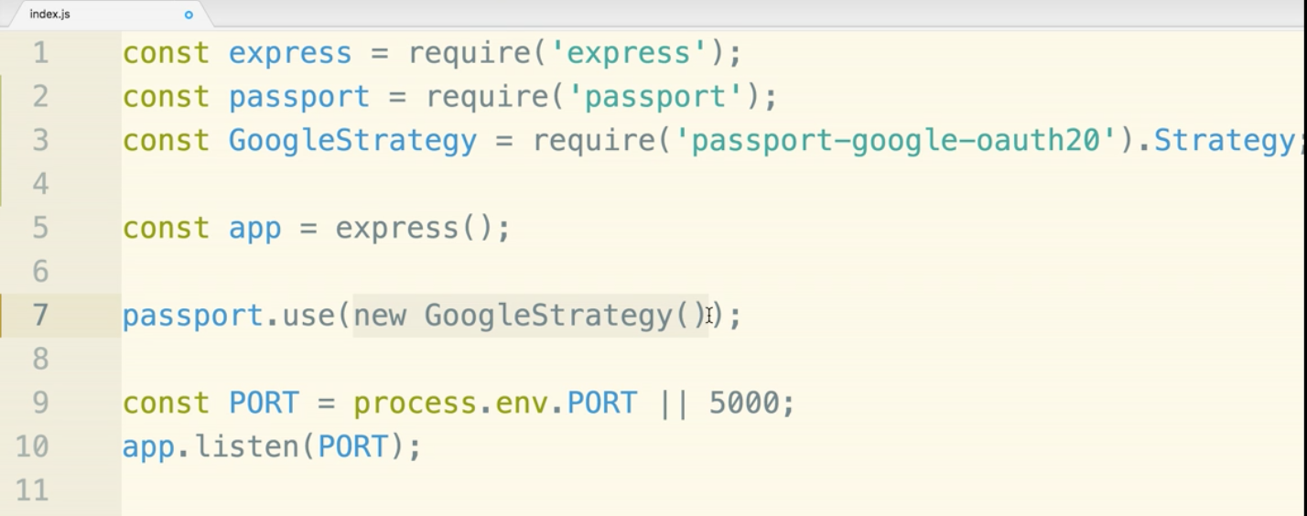

GoogleStrategy() needs a client id and a client secret. Both are provided from Google’s OAuth service.

console.developers.google.com

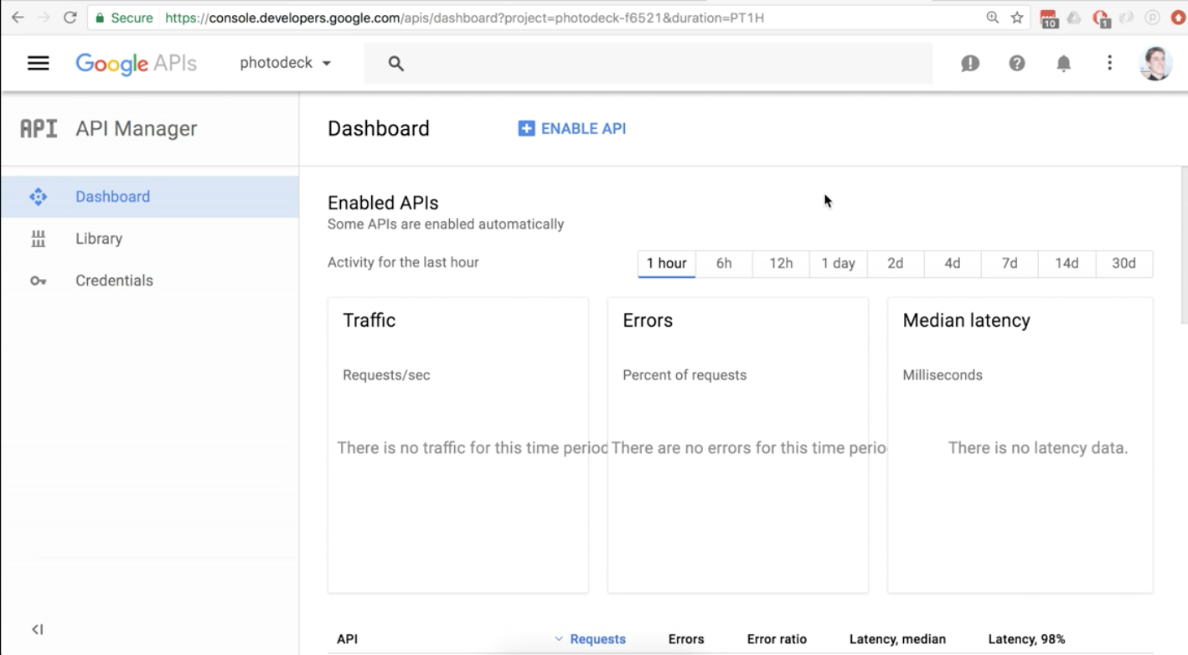

Click the drop down towards the top left. “photodeck” on this particular screen.

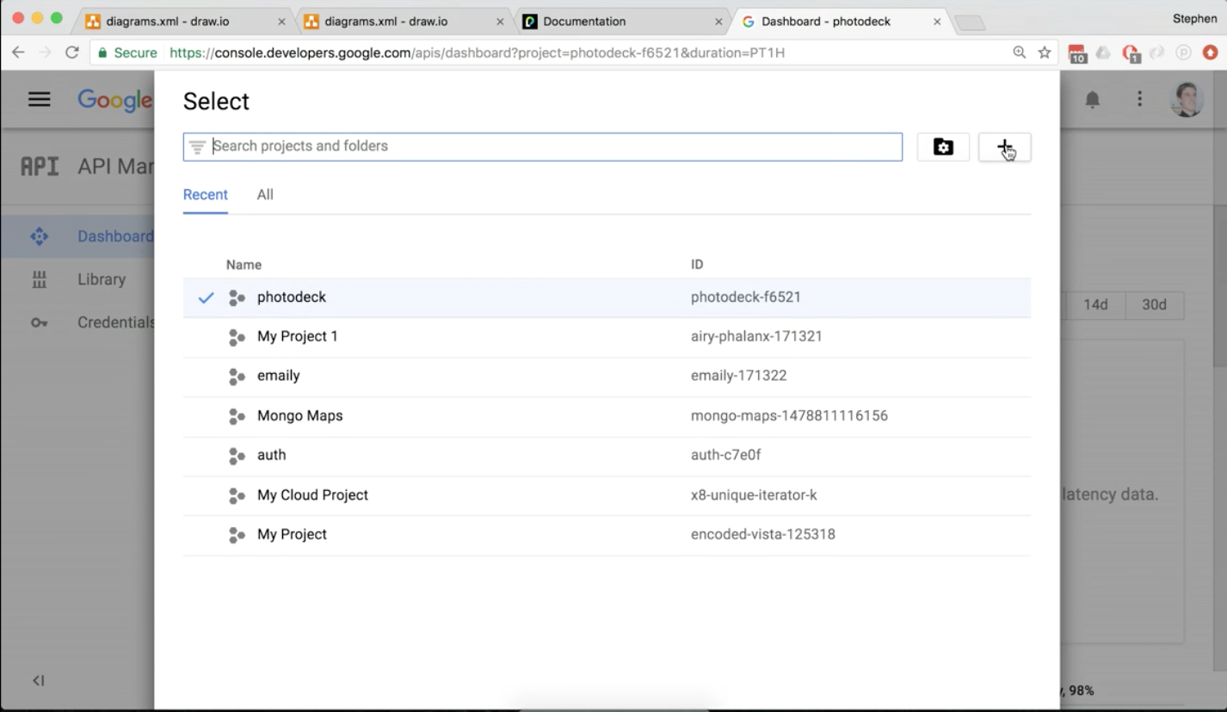

Click the plus at the top right to add a project.

Project name emaily-dev

recommended to indicate that this is for dev purposes. We will come back and create another for production.

Once you press create, it will not instantly create. It starts the process and you will likely see a loading spinner. It will take a few seconds, but once it is loaded, go back to the dropdown and select your project name ‘emaily-dev’ in this case.

Click ENABLE API

Search for google+, select Google+ API from the results,

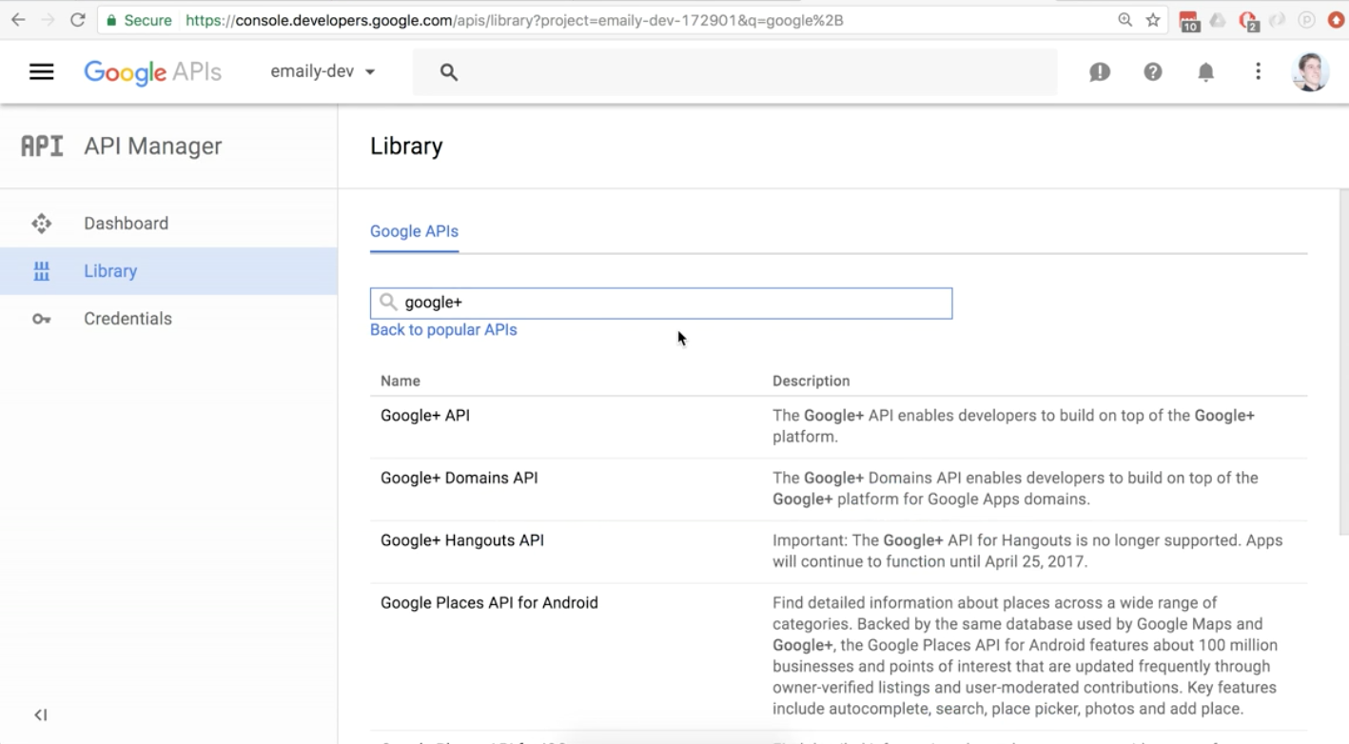

then on the page that pops up click ENABLE.

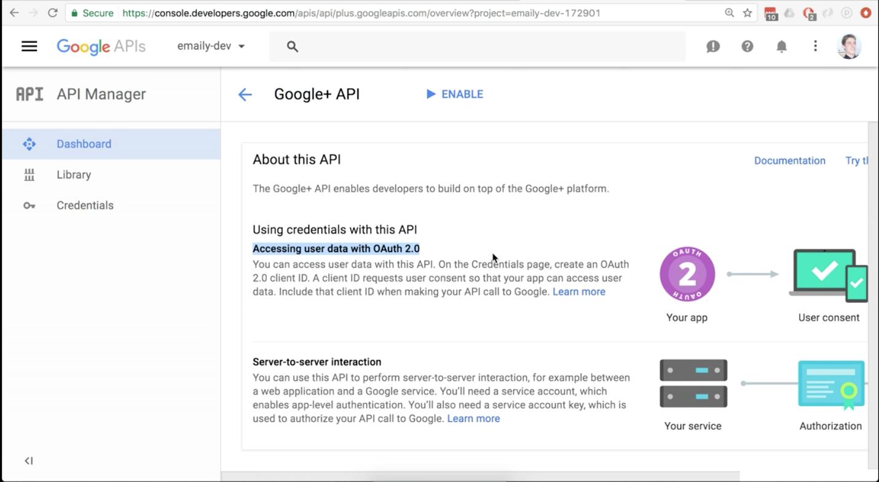

Now you need to create credentials.

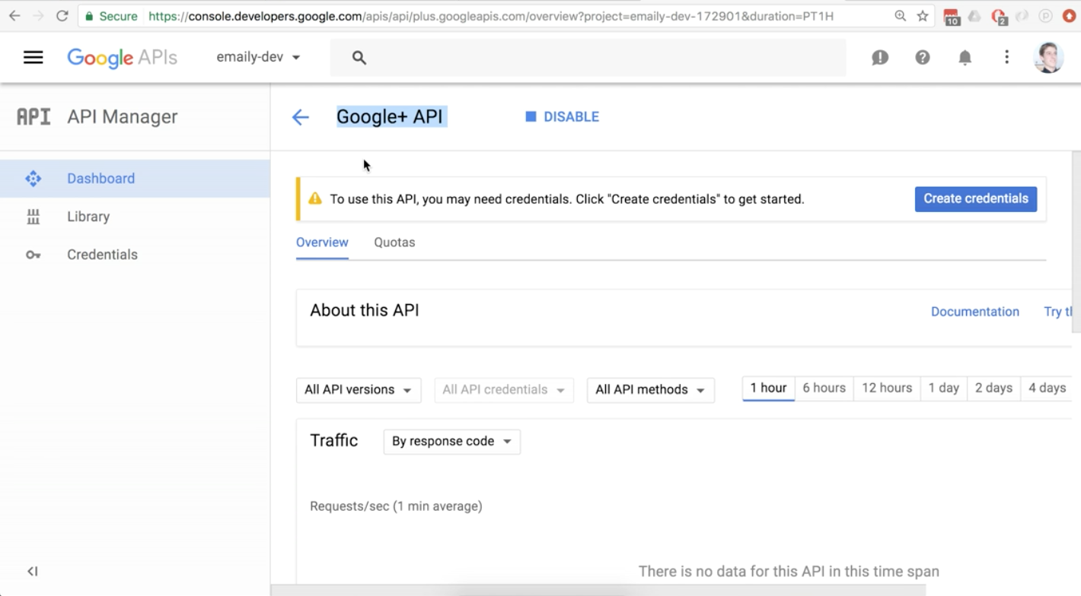

Then select the ‘OAuth client ID’ option

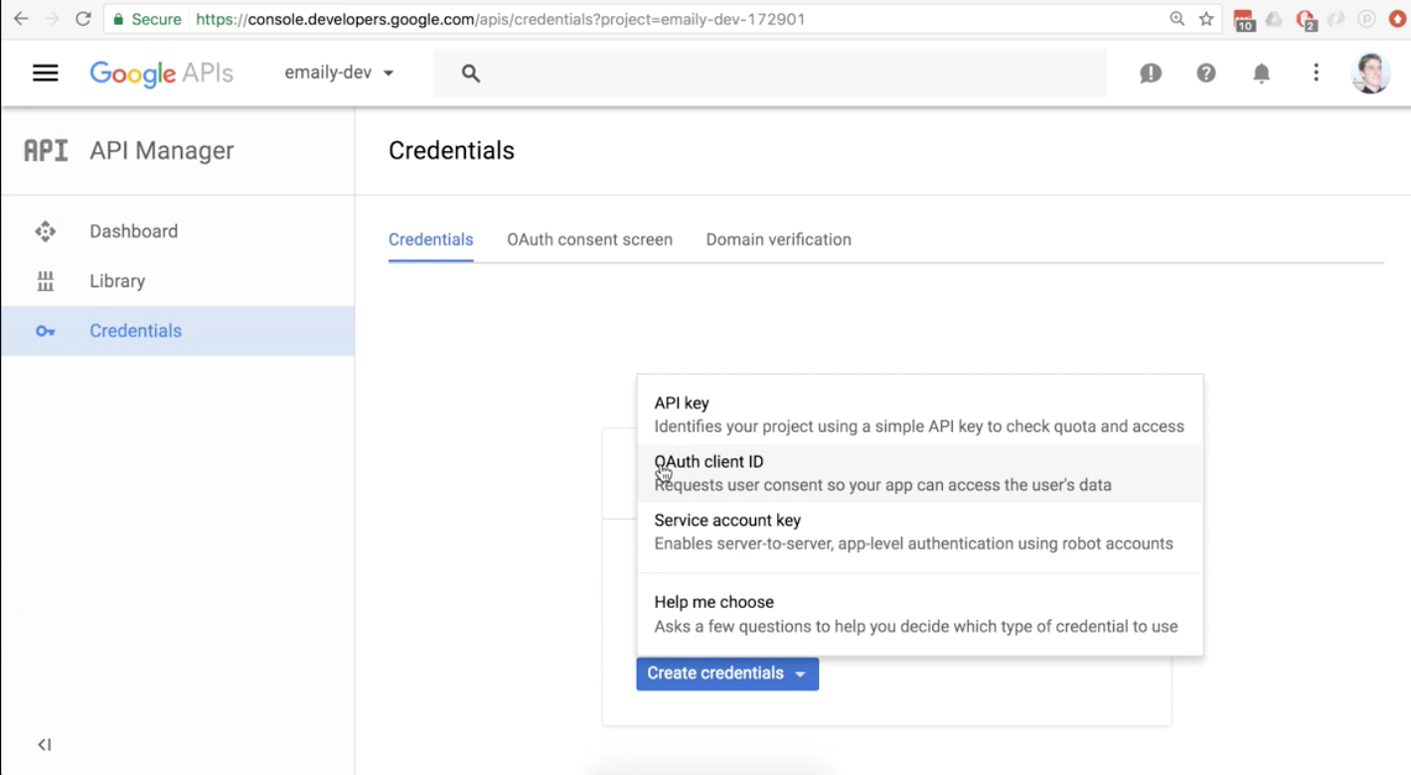

Now we need a product name for our consent screen. This is what will show when Google asks the users for permission to login.

Now click on configure consent screen:

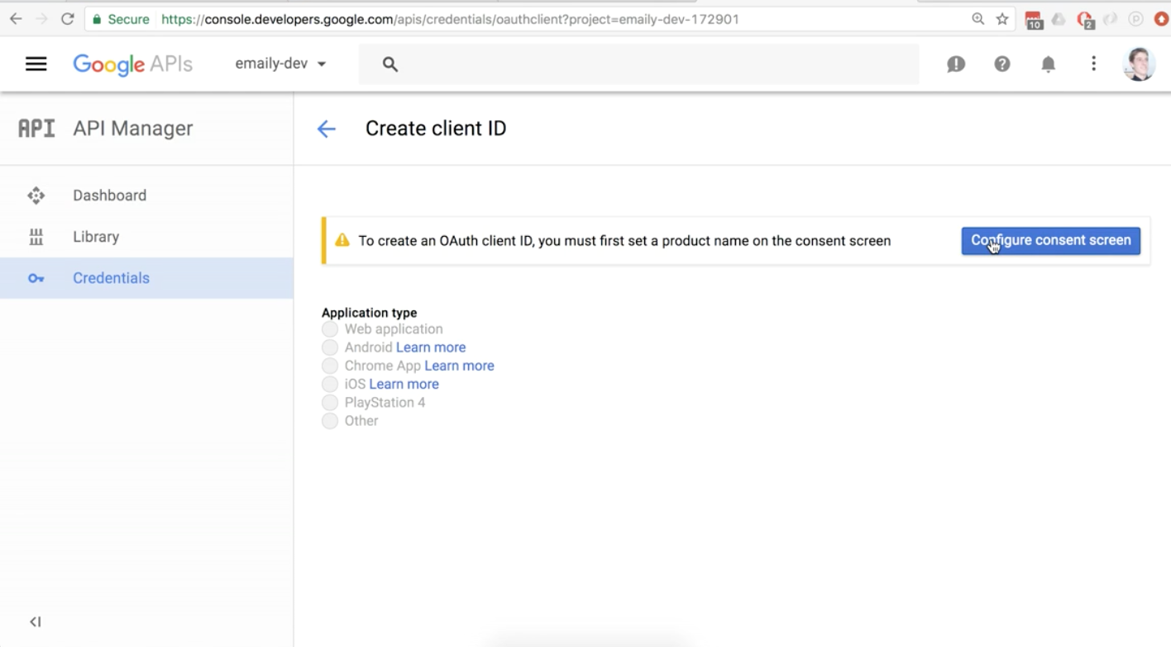

At this point your email should be in there, and all you need to add is the product name. In this case we will put in ‘emaily-dev’. Click save.

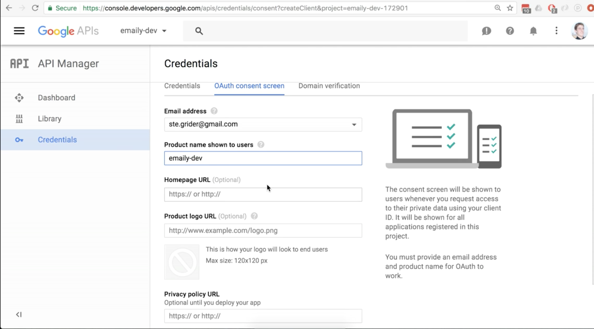

Now you will get to a screen where you will select Web Application.

The name can be left alone as Web client 1

for the Authorized JavaScript origins:

<http://localhost:5000>

for Authorized redirect URIs

[http://localhost:5000/*](http://localhost:5000/*)

This will be changed later! And talk about it.

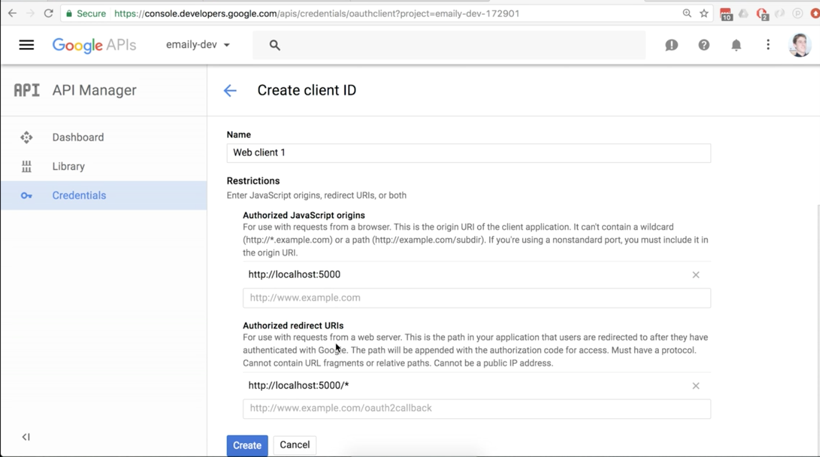

Now hit create button.

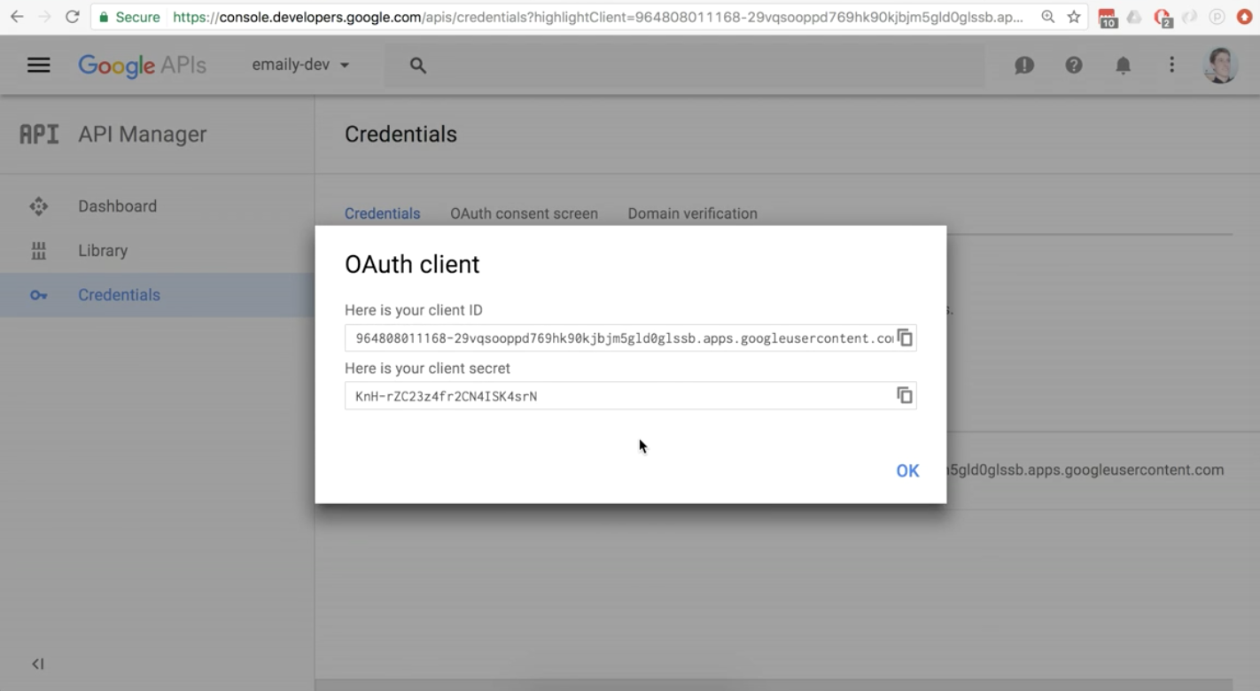

Copy the first and second codes and paste them into your document just so we have them. We will make use of them in a moment.

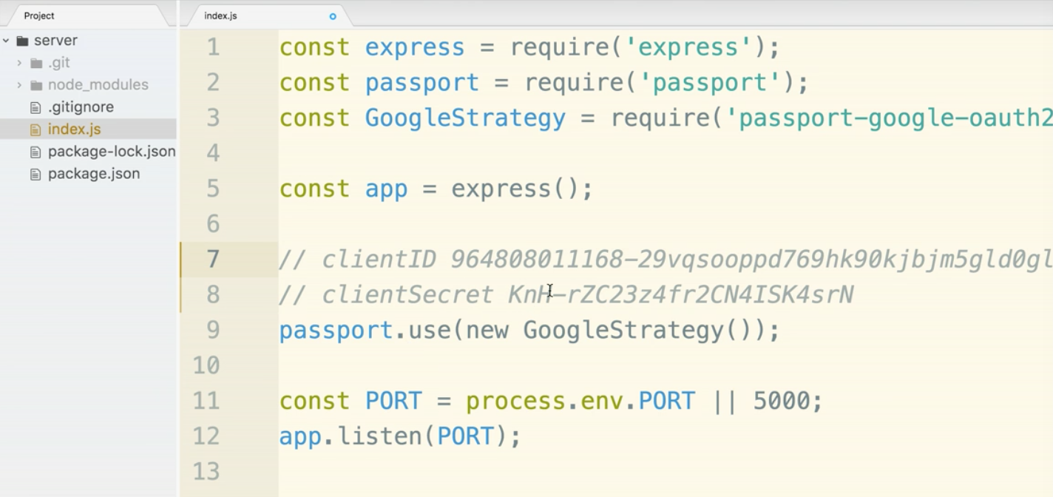

What are the keys doing for us?

The clientID is a public token. It is ok for this to be available to the outside world.

The clientSecret is more of a big deal if it gets out. It is a much more secure piece of information. We don’t want to share this id with anyone by mistake or on purpose. If someone gets this info they will have elevated privileges within the account.

We are currently using Git. We do not want to commit secure data like the clientSecret. Let's take a quick detour from what we are doing to make this stuff secure.

We will use a simple solution for this but eventually we will make a more sophisticated setup. It will eventually look like this:

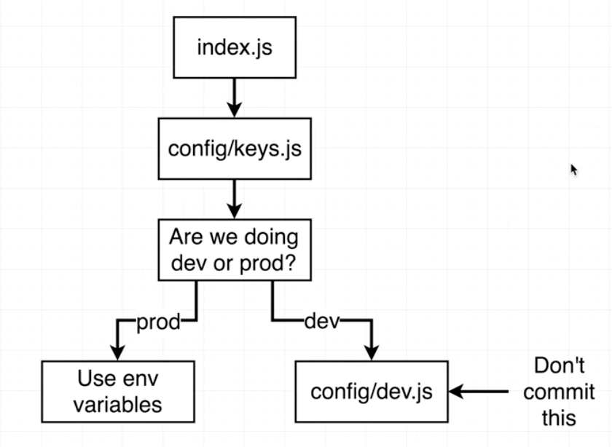

Simple solution:

Create a folder within server called config.

Make a file called keys.js and make sure it is in the ‘config’ folder.

Cut the clientID from where we pasted it before.

Paste it in keys.js. We will use module.exports and assign it an object with the googleClientID and googleClientSecret.

cut the client secret from index and paste in keys.js.

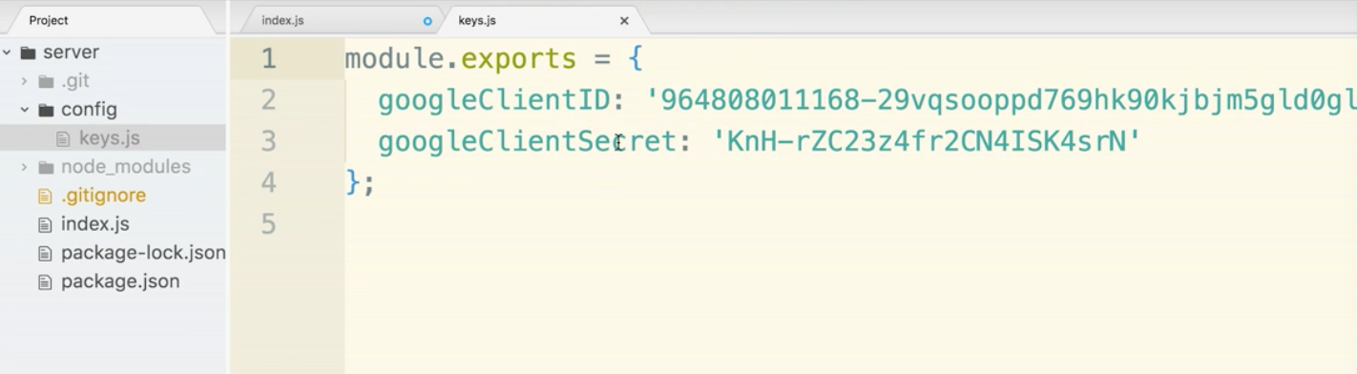

(remember comma at end of googleClientID:

open .gitignore and tell git to ignore our secret file ‘keys.js’

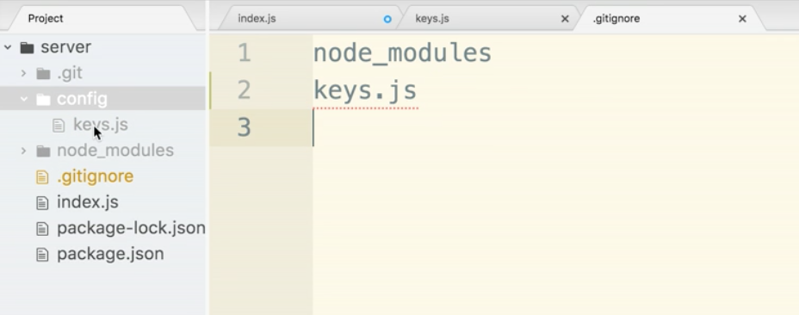

Be sure that index.js is clean, and does not still have those keys in there.

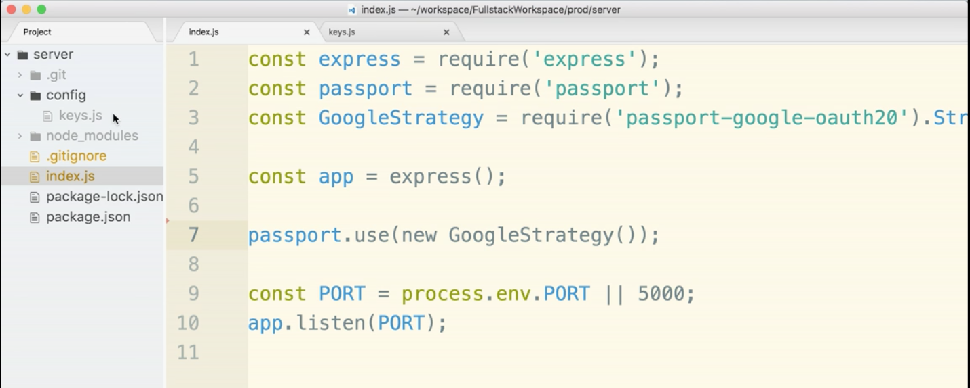

Now you will notice in keys.js that we added ‘google’ to the front of the clientID. We do that because we want to be open to having other oauth systems in. If we want facebook login in the future, for instance we may have a facebookClientID.

quick note: we used a capital D in ID so make sure you don’t have a typo now or later.



Now we need to import our ids into index.js. In order to do this we will adding the line:

const keys = require(‘./config/keys’)

Now we will put in an object within new GoogleStrategy() and include the googleClientID and googleClientSecret.

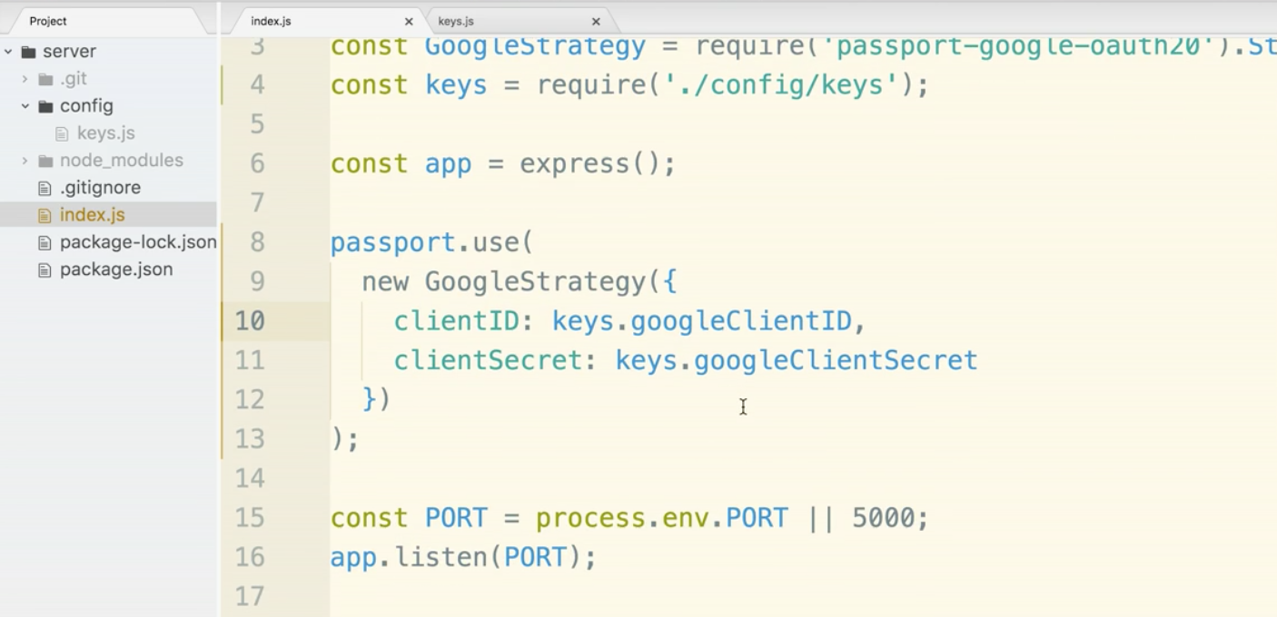

Next we will add in a callbackURL index to the object. ‘auth/google/callback’ We will add a route handler in for this.

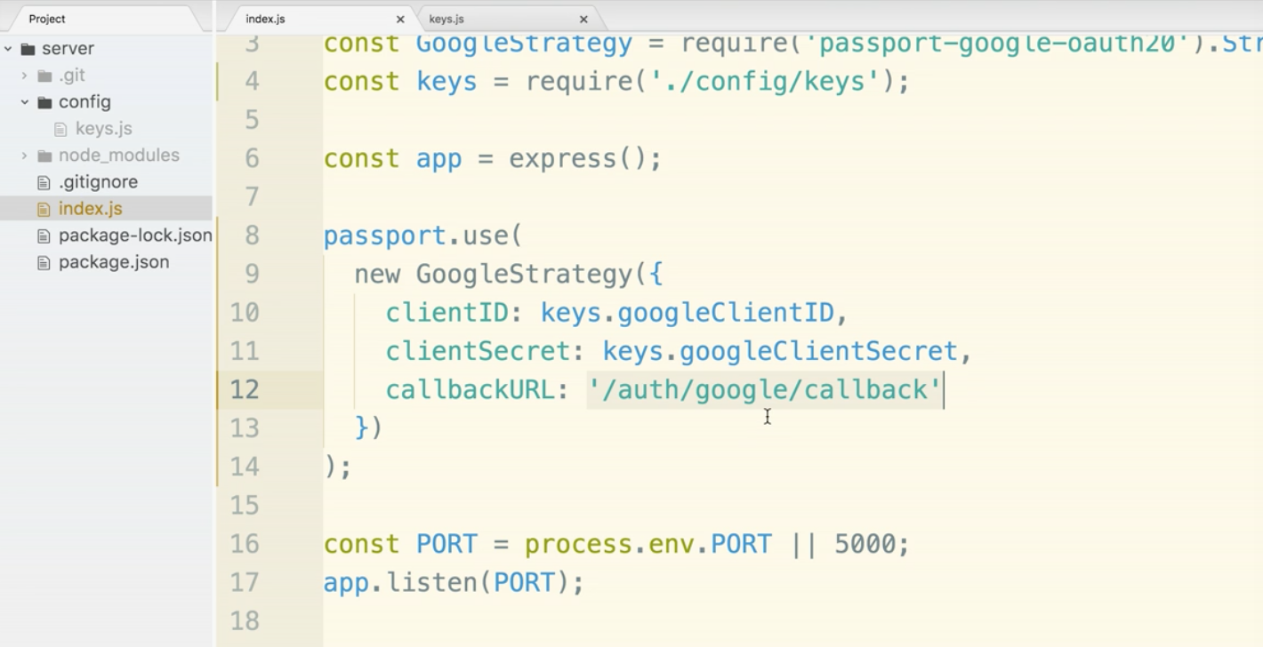We will need to add a second argument to the GoogleStrategy. The argument will be an arrow function. For the time being we will put in accessToken as the argument and a console log within the body of the function.

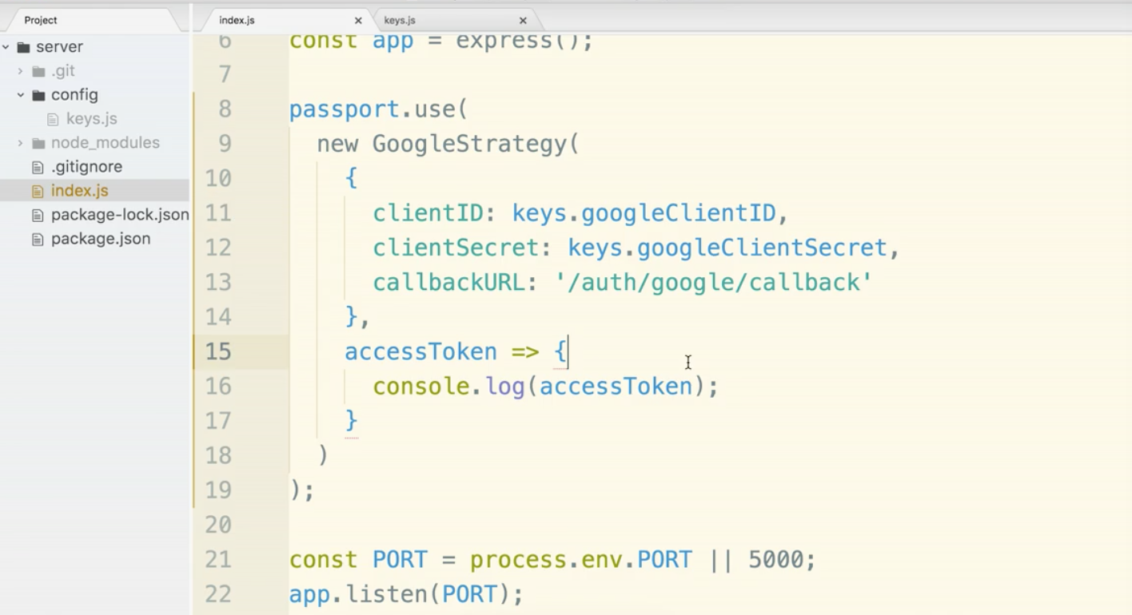

Under passport.use() statement, we will add in a route handler.

app.get(‘/auth/google’, passport.authenticate(‘google’, {

scope: [‘profile’, ‘email’]

})

);

the string ‘google’ within authenticate() has a special internal meaning in GoogleStartegy(). GoogleStategy() has an internal identifier of ‘google’. This might be a bit confusing because the string ‘google’ does not reference other parts of the code. This is how passport connects. Seems a bit magic but this is why.

The second argument in authenticate is an options object. We pass in scope. Scope will specify to google servers what access we would like to have. (After looking at the documentation, it looks like ‘profile’ and ‘email’ are really like the only two things you can pull. Documentation: <https://developers.google.com/+/web/api/rest/oauth#scopes> )

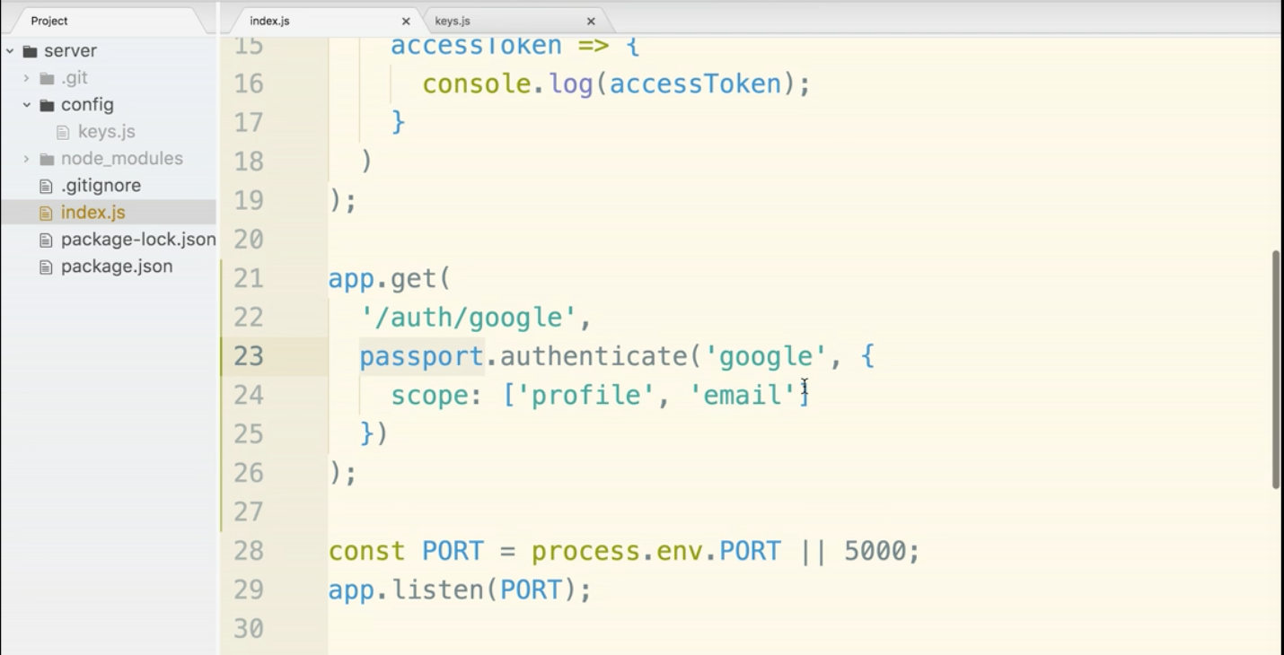

We can now check to see if this works in the browser. We will get a small error.

go to terminal and start up server

$ node index.js

Navigate to:

localhost:5000/auth/google

There will be a redirect to google, but there will probably be a 400 error. redirect_uri_mismatch error. This is a error due to security. This is to make sure that users don’t get tricked into approving access to one company and maliciously get redirected to another company.

The error on google will give you a link to visit to update the authorized URIs. Go to that link.

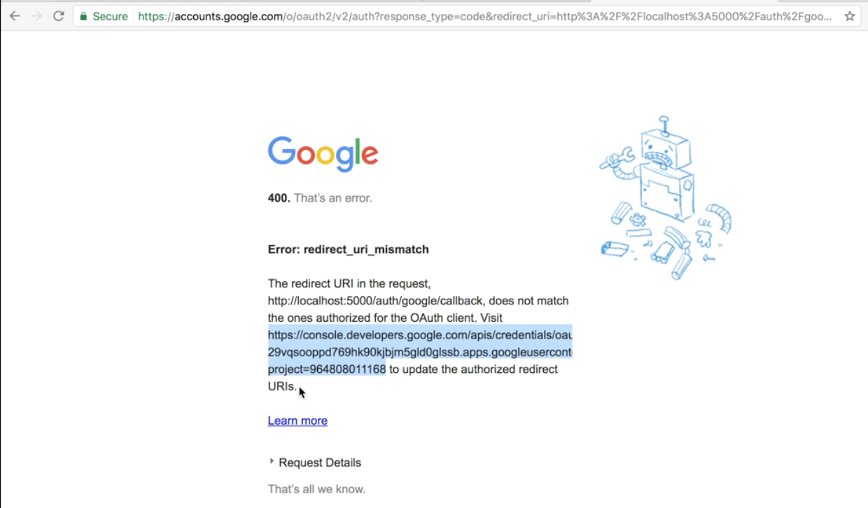

Change localhost:5000/* to <http://localhost:5000/auth/google/callback>

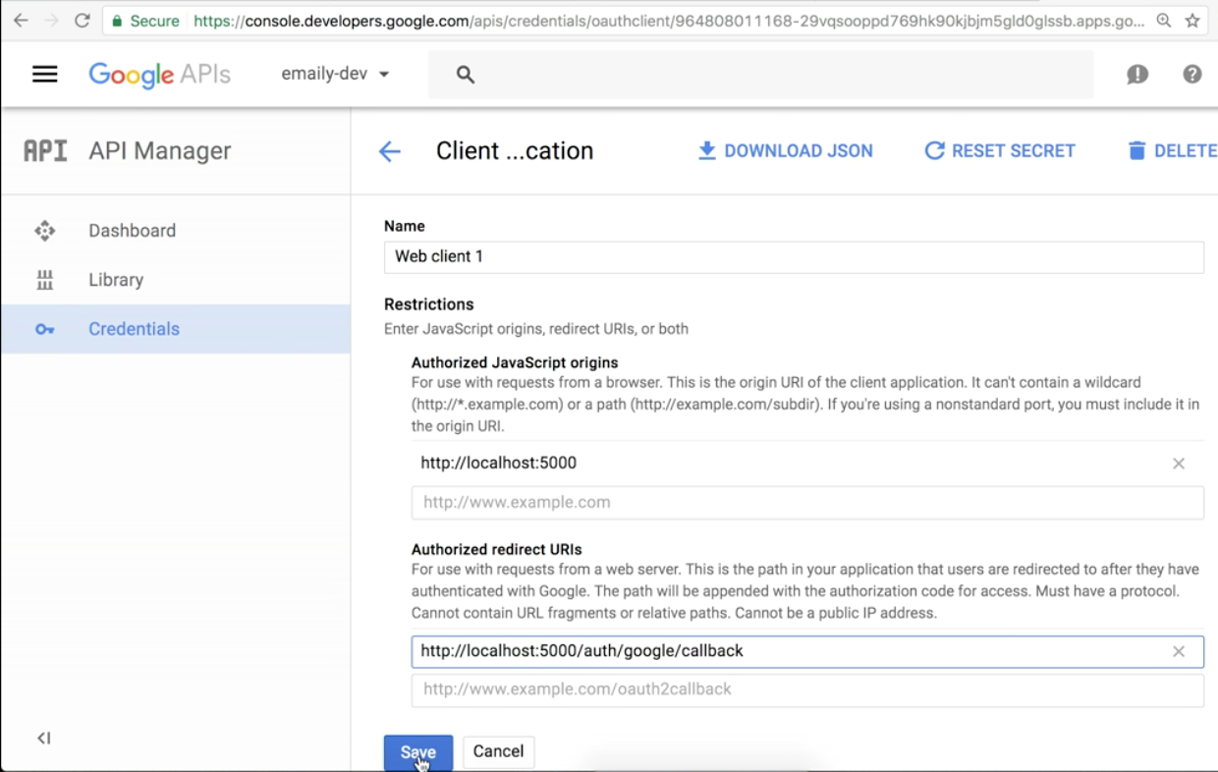

The new uri will take a few minutes to update.

Now let’s test. With the express server running, go to localhost:5000/auth/google

You should be directed to a page that will prompt you to select your google account.

After this, you will get another error. You will however be redirected back to your site after going through google. Progress! We now need a route handler for /auth/google/callback.

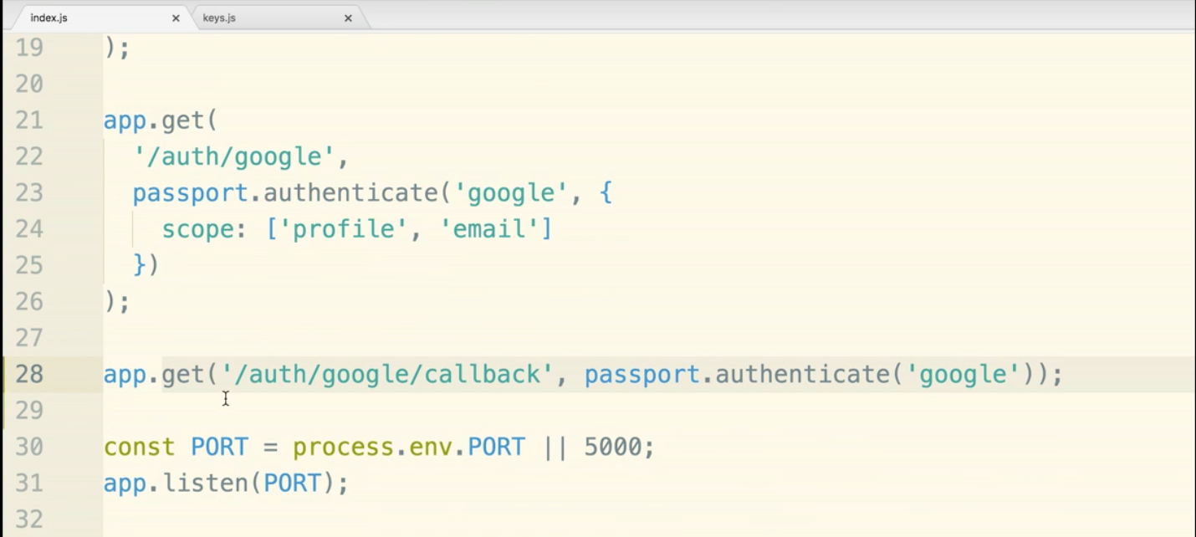

Let’s test it and see what happens.

restart server.

$ node index.js

localhost:5000/auth/google

now select your account

now we might have an infinite load screen issue now.

Take a look at the terminal though!

There is a long string. This is coming from the console log of the accessToken in index.js.

This may be a bit confusing, but hopefully we will clear it up.

If we think about the flow of the oauth process we have made it through the ‘yellow section’ and the callback function, where we are currently just logging the access token is our opportunity to use the data that came back from google.

We are on the ‘Get user details, create new record in the database step.

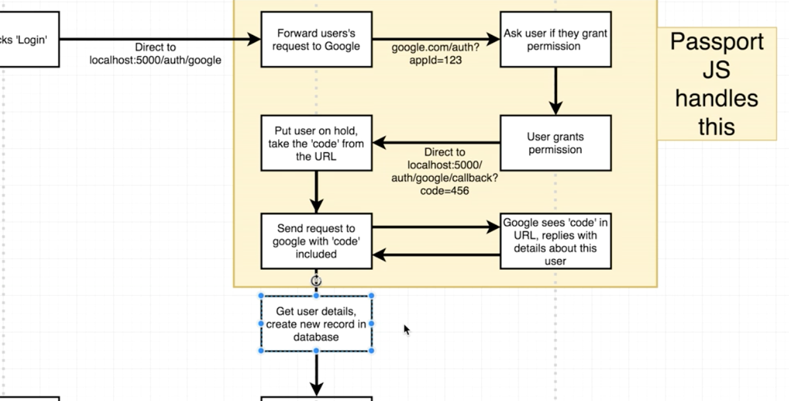

Now let’s update the callback function and add more to it. We will add more arguments to accessToken

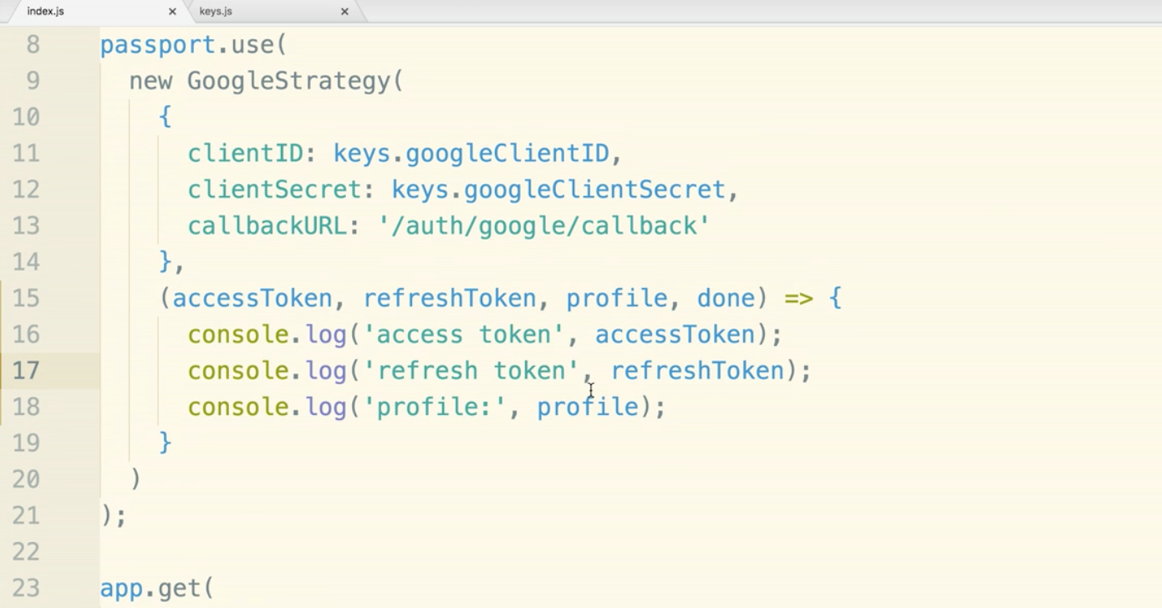

Now let’s roll through the auth process again. Kill the server with control c.

$node index.js

go to localhost:5000/auth/google

(profile might ‘hang’ loading because we have previously given this account permission.)

Now, check the terminal. There should be a large console log.

The access token is what gives us permission to do things on the user’s behalf. The access token will expire after time. We will not really be using the access token. Because of this, the refresh token is actually not useful to us as well. This would allow us to keep permission even after the access token expired. The profile is much more interesting to us in this project.

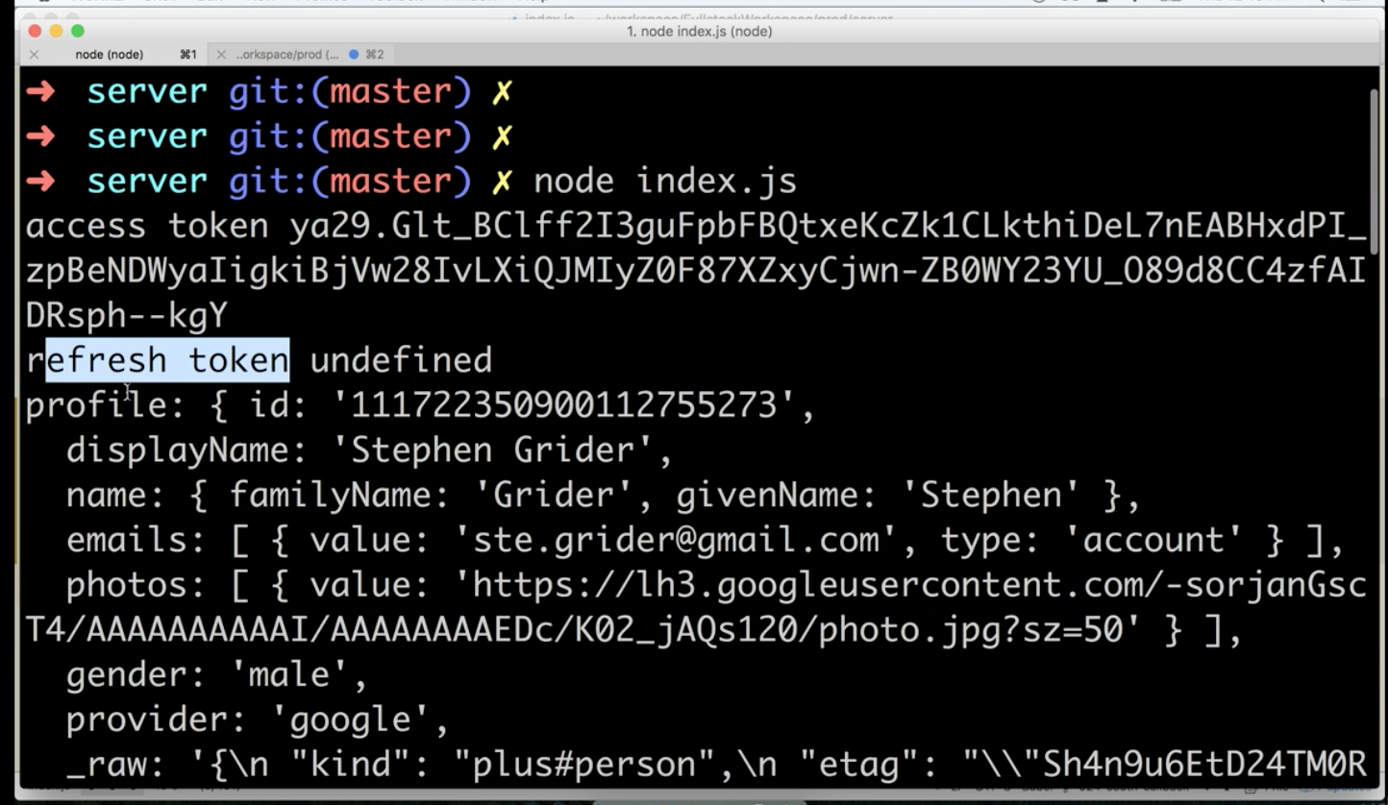

We are more or less done with the Passport.js section.

Currently we have to restart our server manually every time. We need it to have it automatically restart every time we save a change inside the project.

**Nodemon Section**

terminal:

$ npm install --save nodemon

Go to package.json and locate the scripts section.

add a script call “dev” that executes “nodemon index.js”

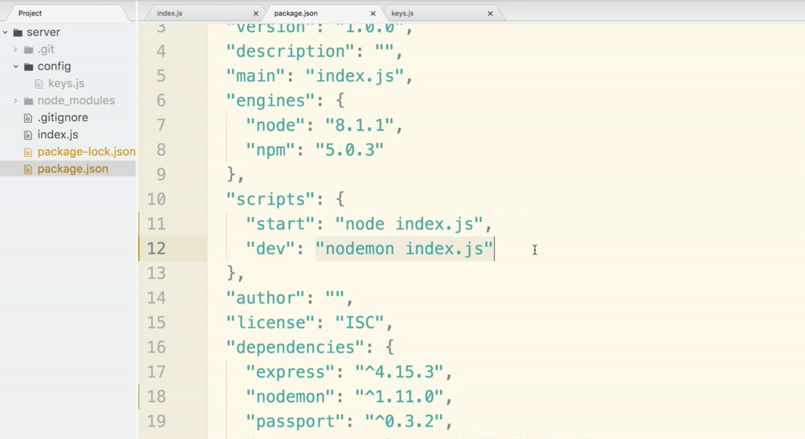

Now at the terminal

$ npm run dev

will give us auto-reload!

You can test if it is working by just making a small change. If you pop back onto the server it will have a note that it is restarting.

Time to make a big Refactor of the code within index.js!

**Refactor Backend Section**

There is no universal way of structuring express projects, so this setup will just be one way of doing it.

This what the folder system will look like:

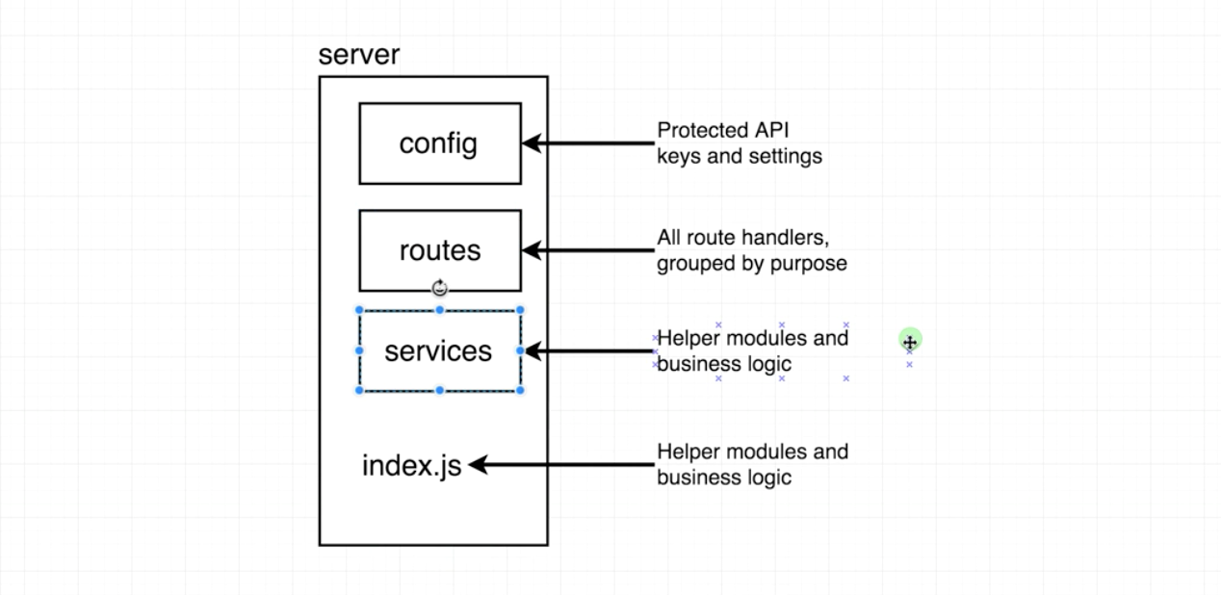

Services folder: Helper modules and business logic, probably include a passport.js file where we will put in all the passport configurations.

Create new folder called routes. Then create a file called authRoutes.js.

Now go into index.js file and find the two route handlers and cut them.

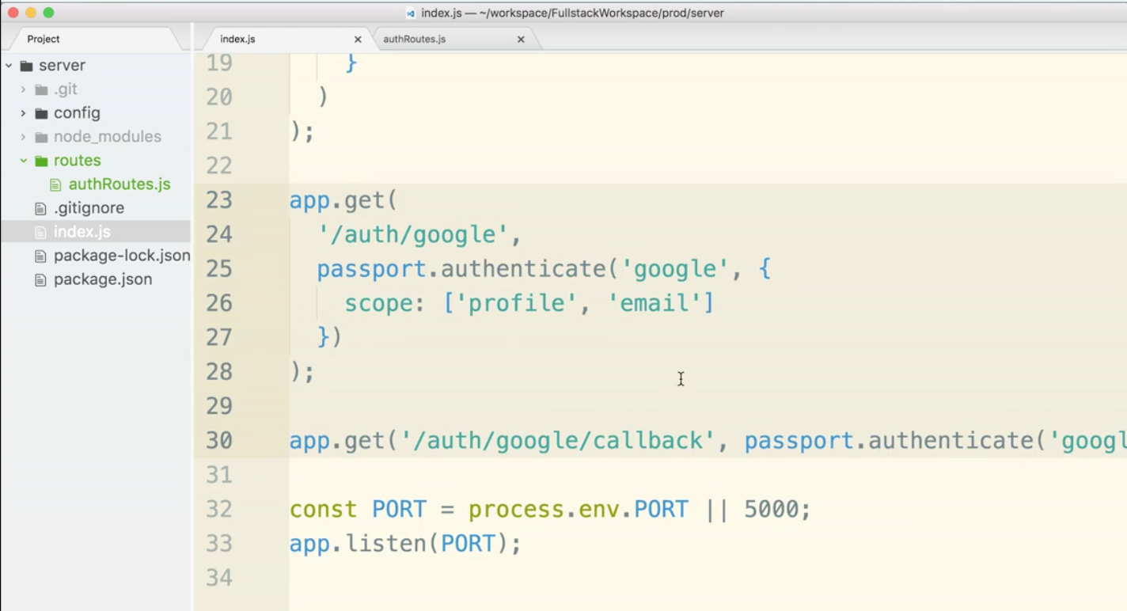

change over to the new authRoutes.js file and paste them in. They will need the proper require statements. We will add that in in just a moment.

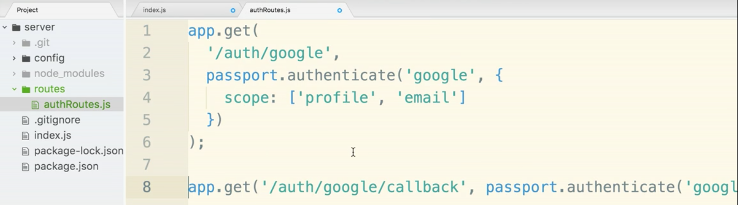

Next create a folder called services and put a new file called passport.js inside.

Go back to index.js and highlight and cut the entire passport.use() statement, cut it, and paste it into passport.js.

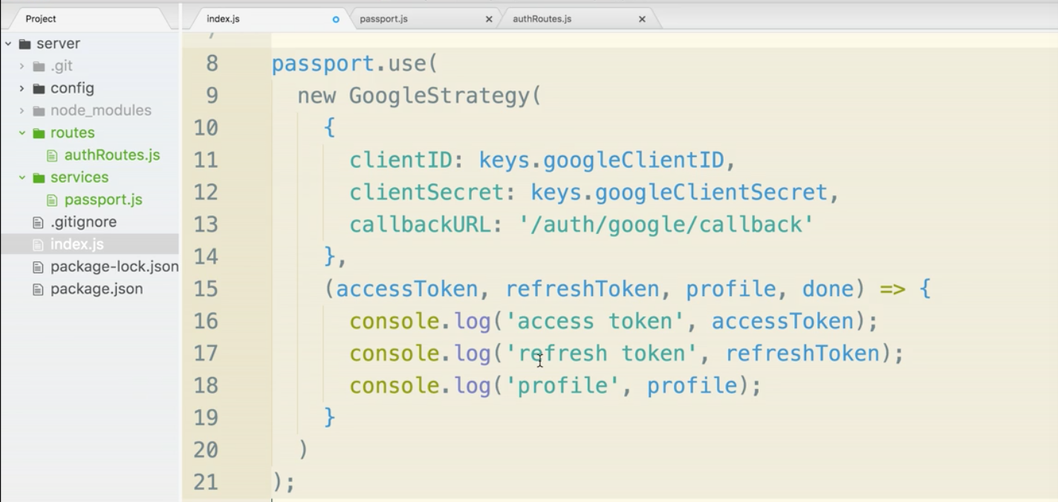

Now, let’s work on require statements beginning in the index.js file. Really, all it needs is express now. So we can cut the three require statements that are no longer useful.

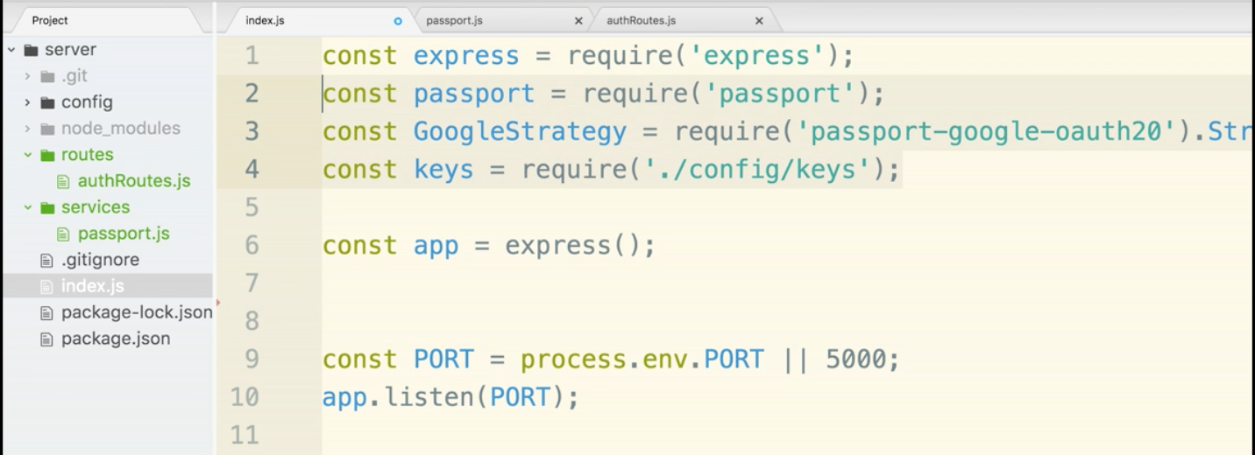

No lets paste it into passport.js.

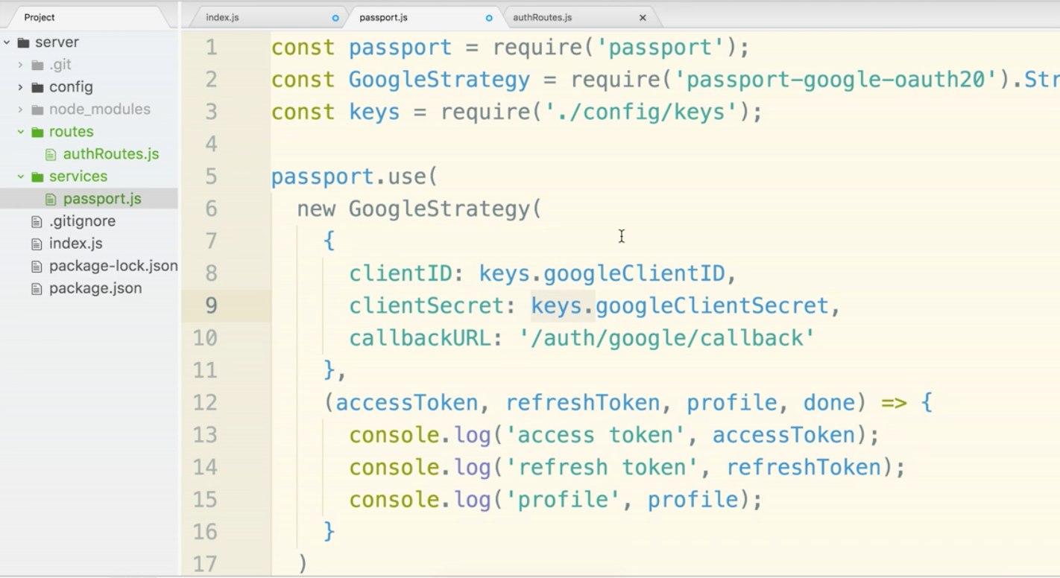

notice that the file path has to be updated for keys. So we need to change it to ‘../config/keys’

the extra period in there tells us to go up a file first.

Now go back to index.js. under require express statement add in line:

const passportConfig = require(‘./services/passport’);

Now the passport.js file does not export anything. There is nothing in the file that is being ‘pulled out’. We just want to make sure that that code is executed. For this reason, we don’t need a named assignment of ‘passportConfig’ . Because we are not actually assigning anything to it, we can get rid of the assignment statement and just keep the require part.

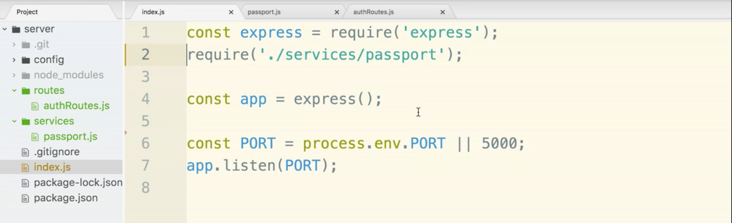

Now that should take care of the passport.js file. Now let’s move to authRoutes.js.

In authRoutes.js we are using passport so we need to require it.

Additionally both functions are using app.get(). app was our express object in the other file. So we need to get these route handler to have access to the express app.

What we will need to do is use module.exports and create an arrow function. We will assume that where we export we will have access to app. For this reason it will be our one argument within the arrow function.

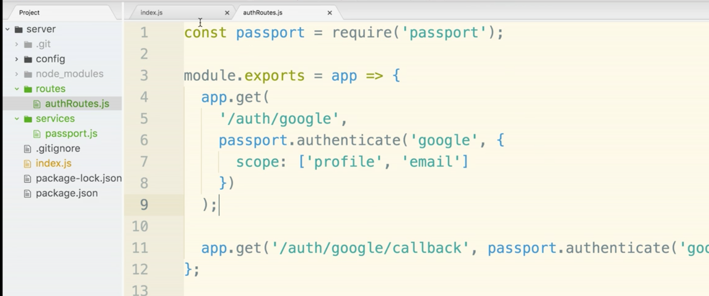

Now let’s move over to index.js. Require authRoutes and then call it with the express app object.

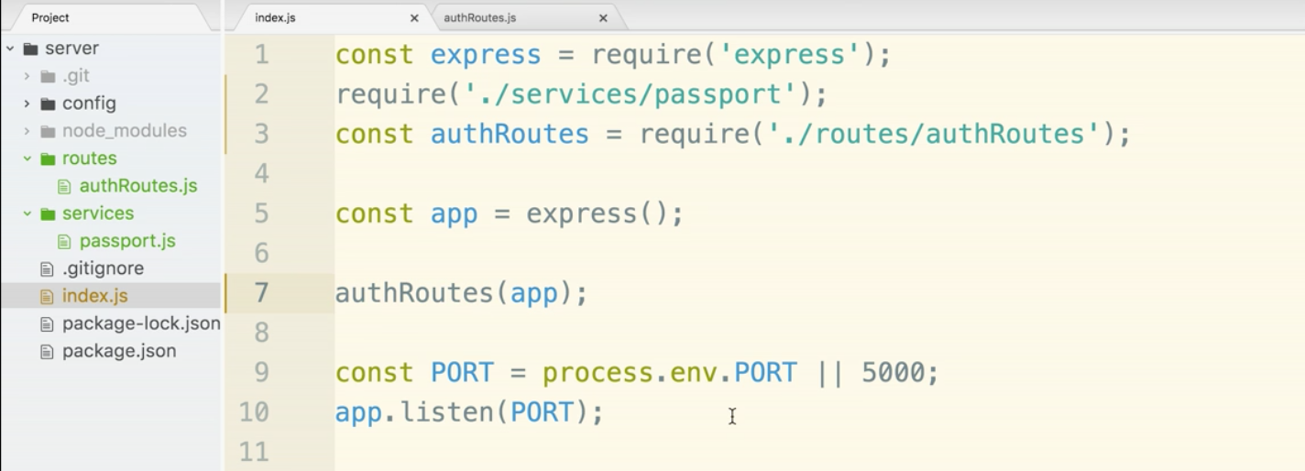

One more sneaky refactor to save a line. We can require and call authRoutes without giving it a name. Notice below on line 6 that we can write the same thing in one line. This will require and call in one swoop.

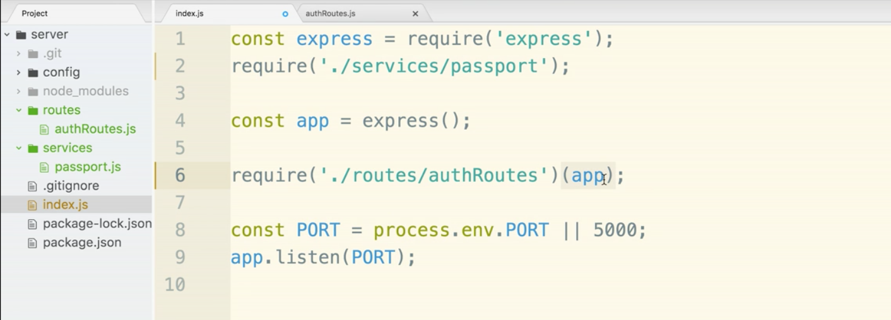

Refactor should be complete. Let’s jump over to the terminal and check though.

$ npm run dev

If there were any typos, a error will pop up. Read the message and debug that sucker.

The Theory of Authentication

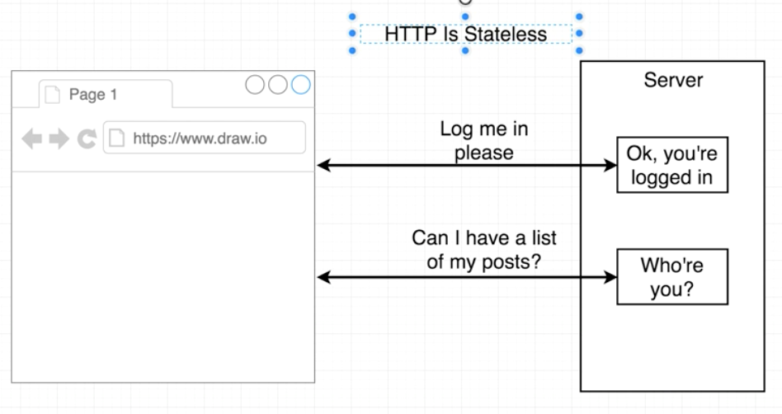

By default each http request will not remember who you even if you just logged in. Each request is stateless.

Login is possible though. We use it every day. This is how it happens in real life:

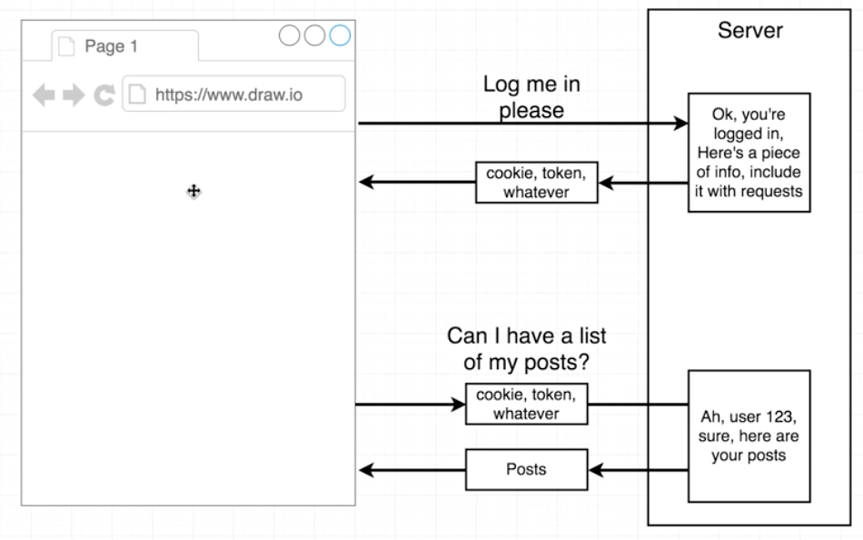

The server will give us back a token. It is the proof that you logged in.

In our app we will use cookie-based authentication. We will place identifying information into the user’s cookie. The cookie will be automatically managed by the browser.

We are using cookies because it is an elegant solution that we do not need to use on the react side of the application. From a React point of view it will almost feel like magic that we are logged in. This is because the browser handles everything cookie-related automatically.

There are some shortcomings to cookies. We will discuss the pros and cons later. For now just trust that this is a good solution for us.

Signing in Users with OAuth (Overview)

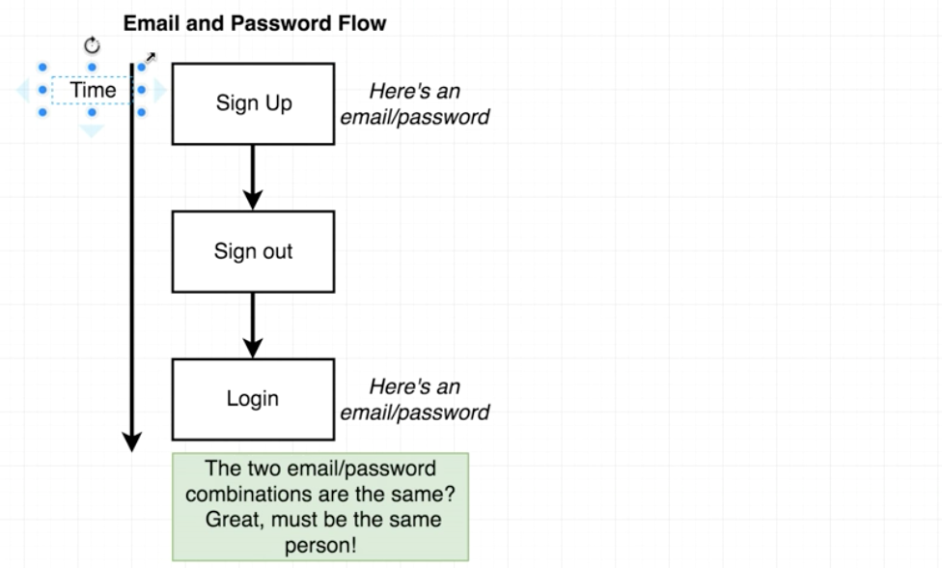

So the idea is that the email and password are always going to be the same and those credentials are what will be used to identify that it is the same person time after time. Now let’s apply this concept to the OAuth Flow.

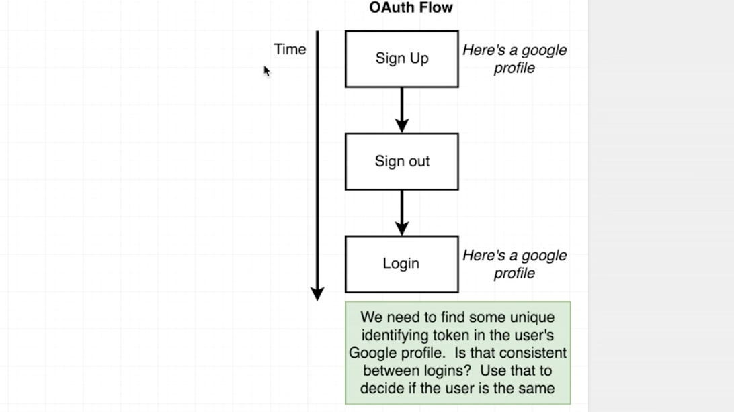

Now if we were to look at the console logged google profile information that came back we would notice all the information it includes. What we want is a unique identifier (just like the email password) that we can use as reference for the user. It turns out that google returns an id for every user. It’s a super long number that corresponds to a specific user. This is perfect for our oAuth flow.

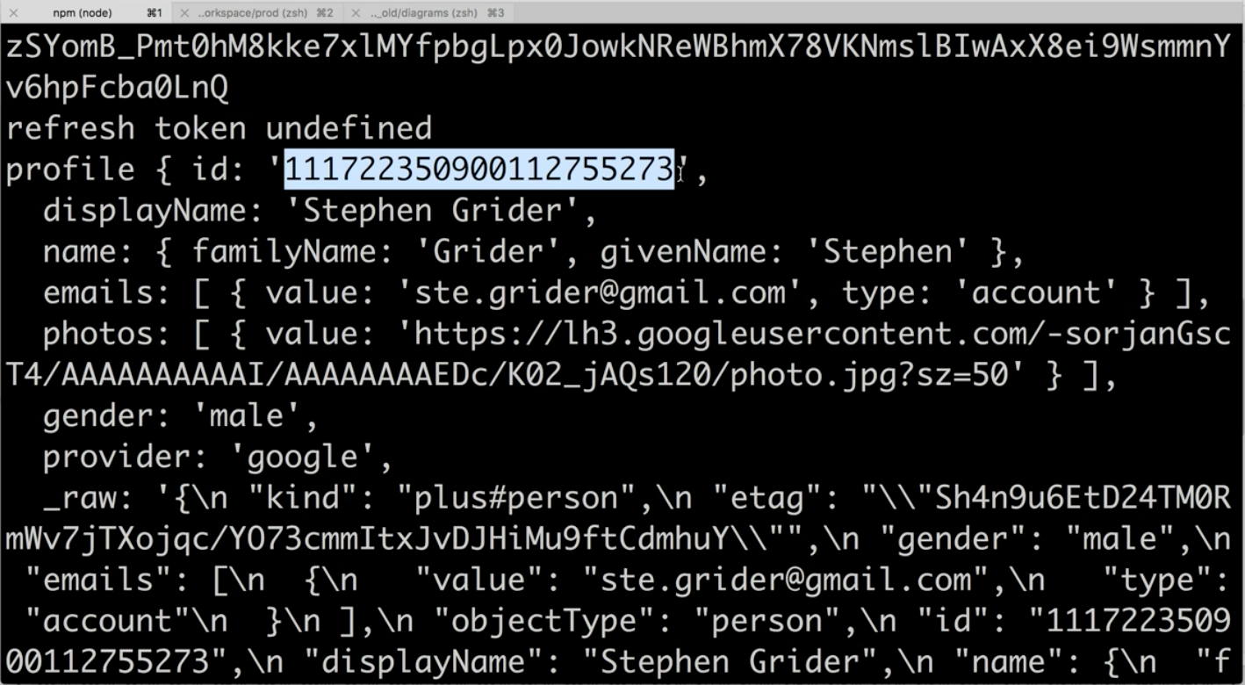

We need to trust that the 3rd party (google) will not change this number. If they did, we would be screwed.

Here is a grand overview of how this will all work:

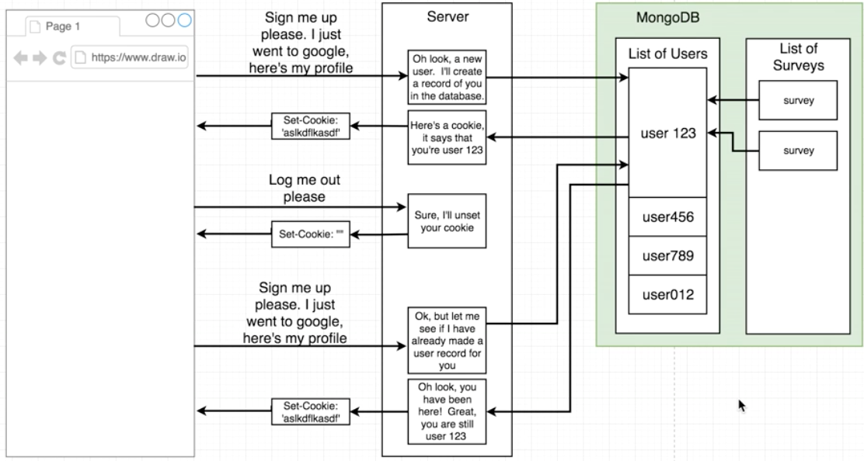

**Intro to MongoDB Section**

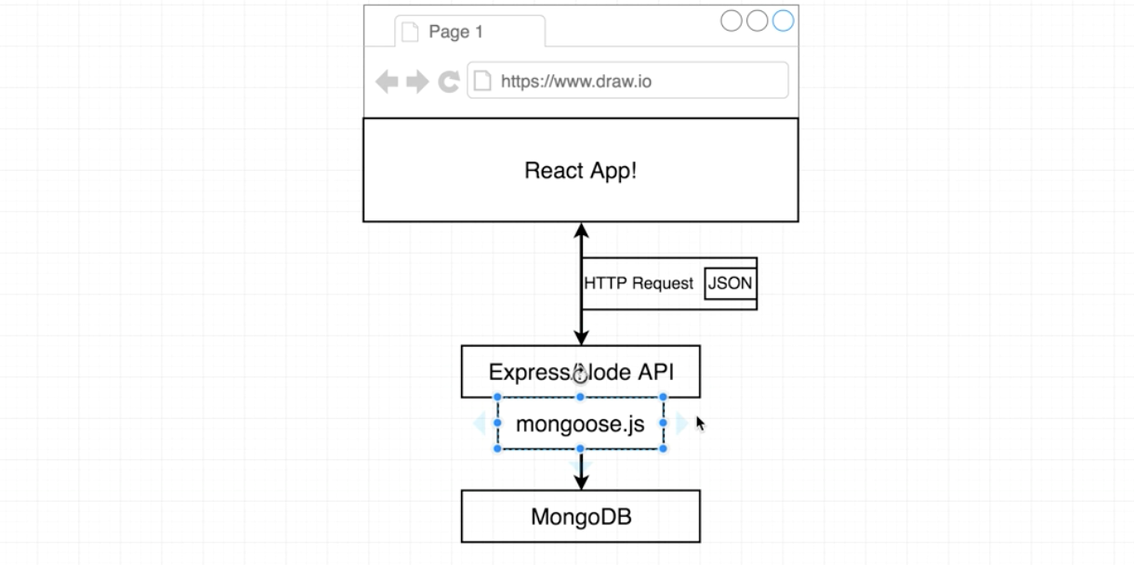

This should look familiar. We have added in mongoose.js It’s a library that is optional but it makes our lives easier when using MongoDB.

MongoDB is schema-less. You will notice that different records can have different properties. This is direct contrast to traditional SQL and relational databases.

How does mongoose relate to MongoDB?

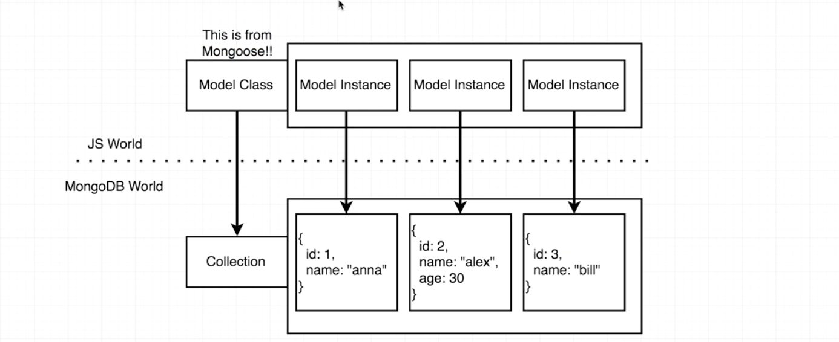

Mongoose uses a model class. This is equivalent to a MongoDB collection. A model class is used to access a single collection with MongoDB. The model class has a bunch of functions attached to it that lets you access data.

Model instances in Mongoose represent a single record within MongoDB.

**Setting up MLab Section**

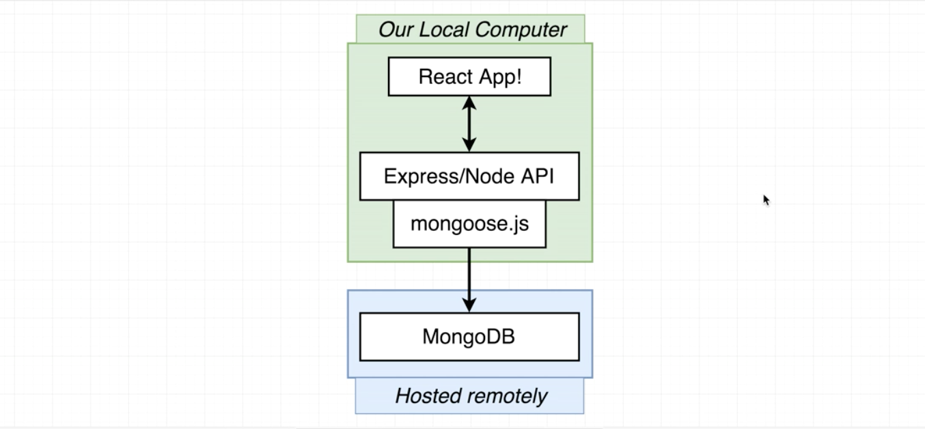

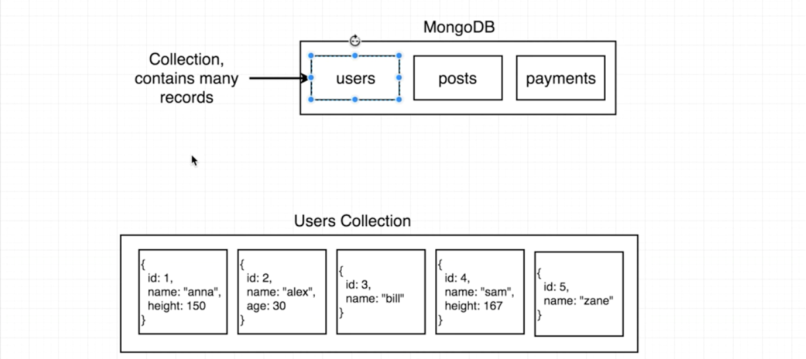

In this course we will use a 3rd party service to host MongoDB for us.

(MongoDB can be installed locally, however it can be a pain.)

Open your browser go to mlab.com

Sign up or Login. No credit card is required.

When you login you will get to a dashboard with all your MongoDB deployments. First-timers will not see anything.

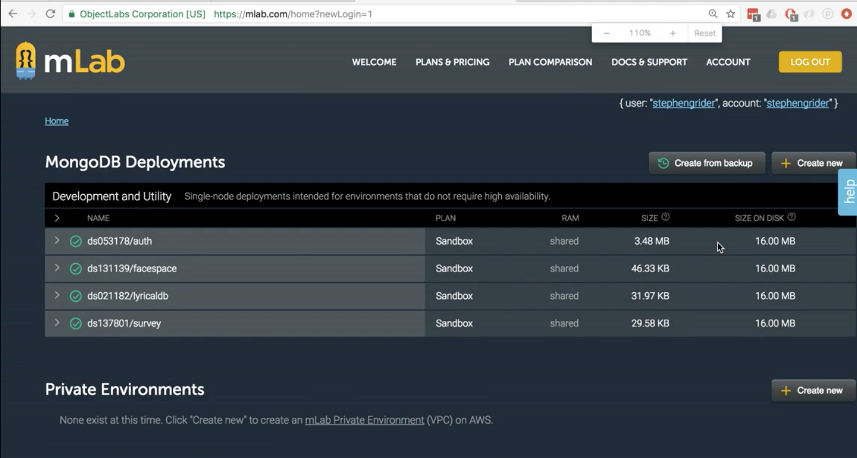

Click the create new button at the upper right. A creation wizard will open.

Choose amazon web services.

Pick the free plan option.

Choose the AWS Region closest to you.

Final Details,

keep the mongodb version what it is already selected.

enter a database name of ‘emaily-dev’

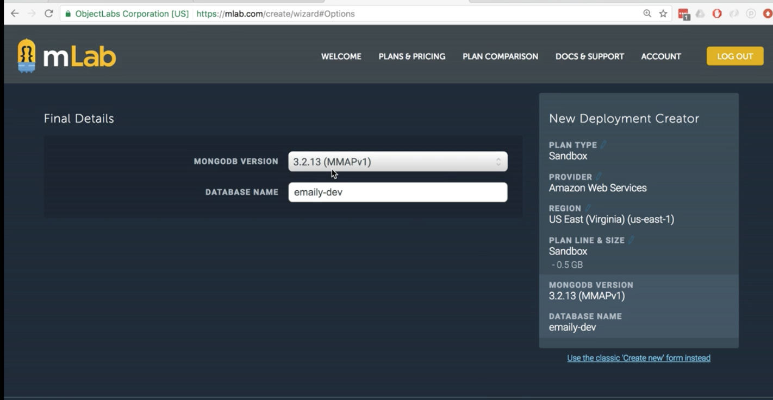

Click continue, submit order.

The new database should pop up on the dashboard. Click the emaily-dev database. You will be taken to it’s individual dashboard.

Couple notifications. This is not a suitable for production. (this is not a big deal)

second notification a data user is required to connect. (this we need to take care of)

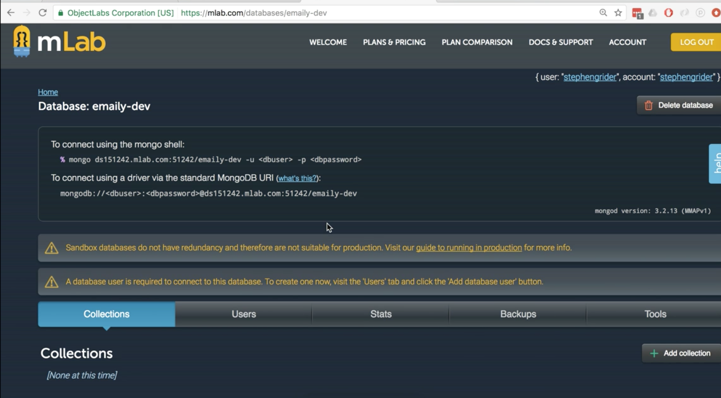

user in this case refers to a database administrator (not a average joe visitor to your site)

Click the Users tab. Then click the button that says Add database user.

select a username and password. Make read-only should NOT be checked.

Click create.

Now there should be one user in the Database Users tab.

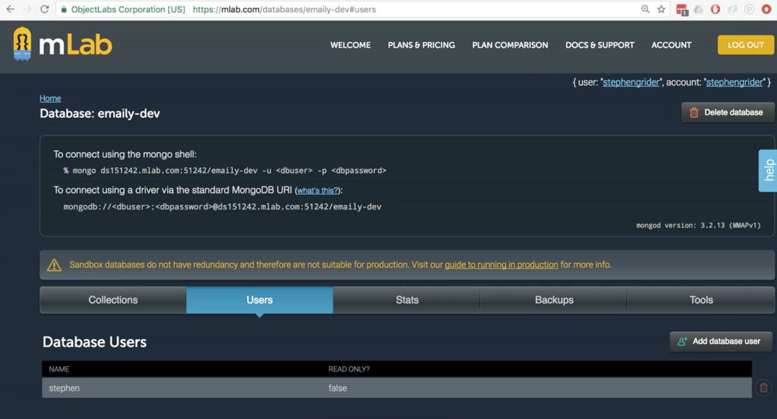

mlab setup should be done now.

**MongoDB Setup**

open the terminal

kill the running server (we do this because we are adding a module)

$ npm install --save mongoose

go to index.js in the editor

under the express require statement, require mongoose

next we need to tell mongoose to connect to the database we just created in the last section using mongoose.connect()

mongoose.connect() needs the database’s identifying info

switch to mlab in the browser. On the emaily-dev dashboard, copy the url under

‘To connect using a driver via the standard MongoDB URI’

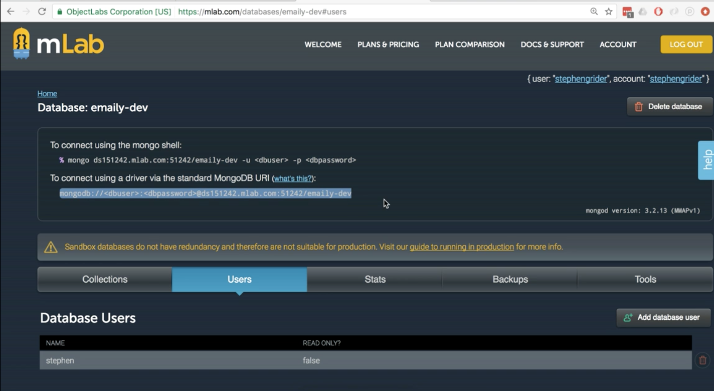

now instead of pasting this directly within mongoose.connect(), we want to keep this a secret and off of git.

For this reason, we will open up keys.js.

Add a comma to the exported object and define mongoURI as the index and paste in the database URI

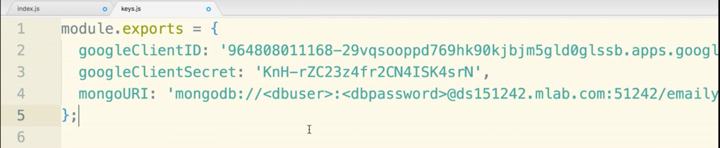

Next step is to replace <dbuser> and <dbpassword>

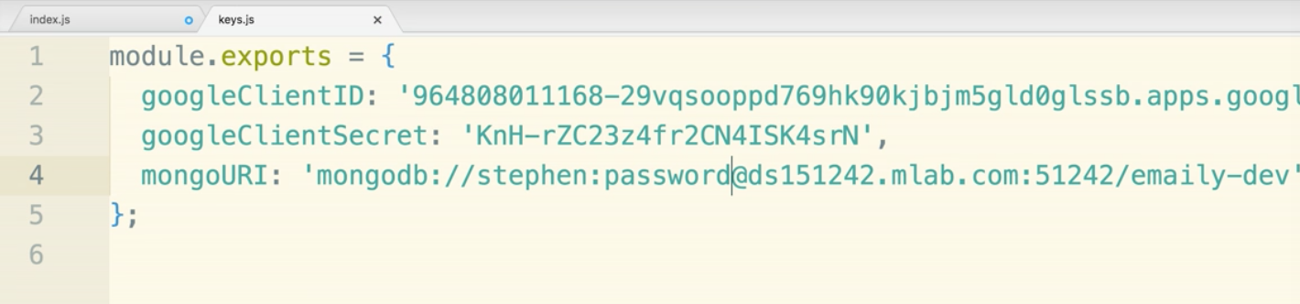

now back in index.js we will require keys in and passing in keys.mongoURI to mongoose.connect()

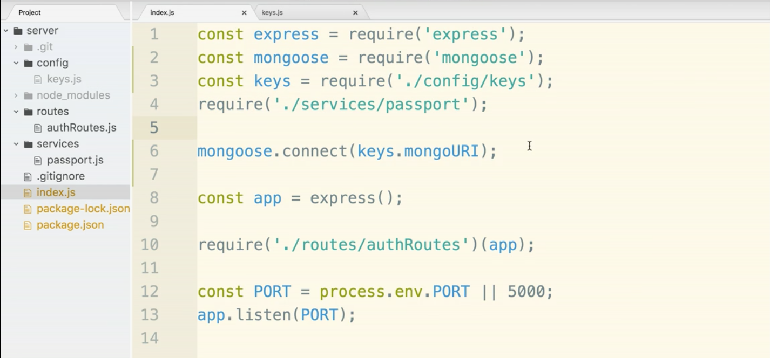

Lets hop back over to the terminal and start the server back up

$ npm run dev

You may get some deprecation warnings. Don’t worry if you get these.

**Mongo Overview Review**

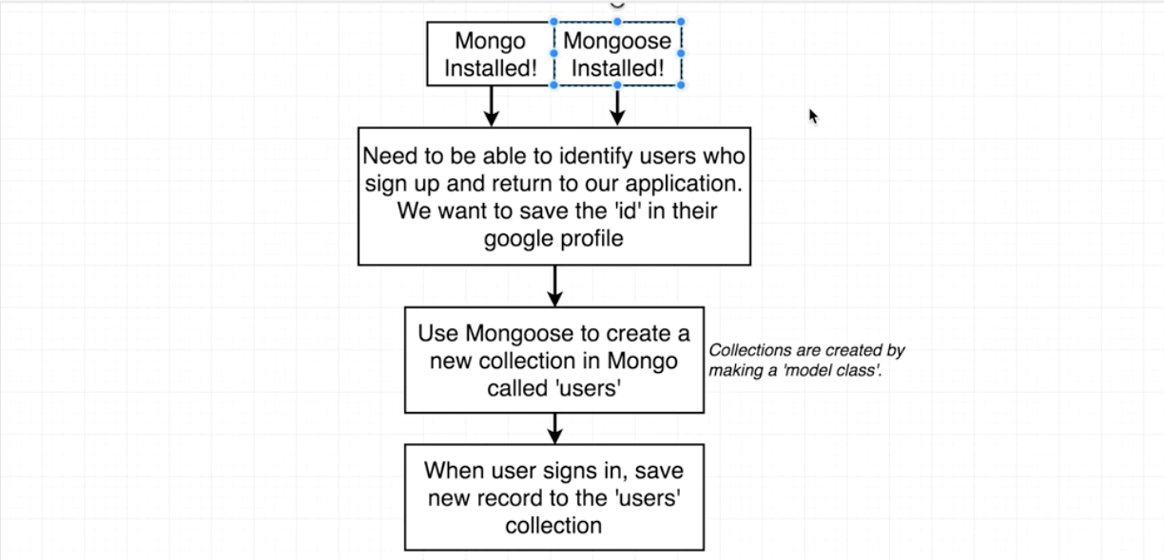

In order to create a collection in Mongo we will use a ‘model class’ in mongoose.

The model class doesn’t seem to logically be a good fit to be in the index.js.

For this reason, create a new folder within server called models. This will hold the model classes we create within mongoose.

Create a new file in models and call it User.js

At the top of the file require the mongoose library and then pull Schema from mongoose.Schema

We will use ES6 destructuring, so to make sure we understand, please note below that line 2 and line 3 are the equal:

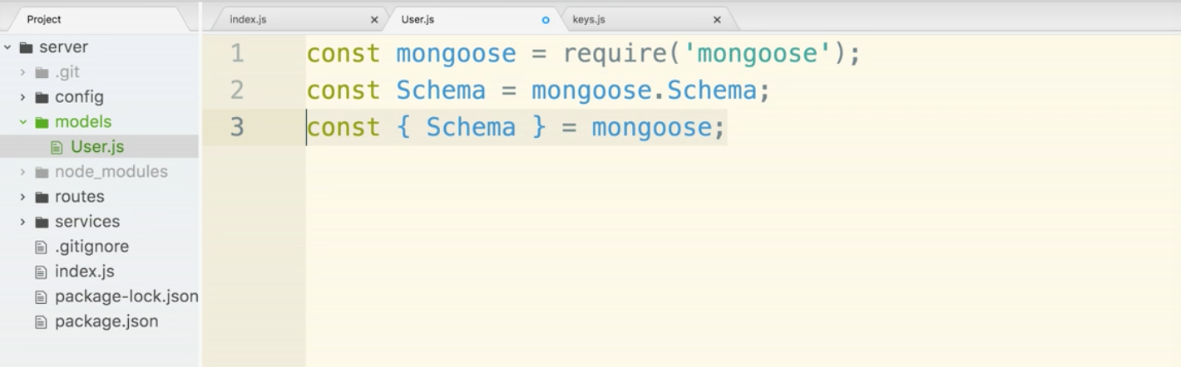

So we will stick with the destructuring line and delete line 2.

Why do we use schema?

mongoose needs to know all the possible properties on each record. This is not like MongoDB where one record can have a property that another does not. mongoose requires all the possible properties to be defined up front.

This MongoDB collection would not fly the way it is:

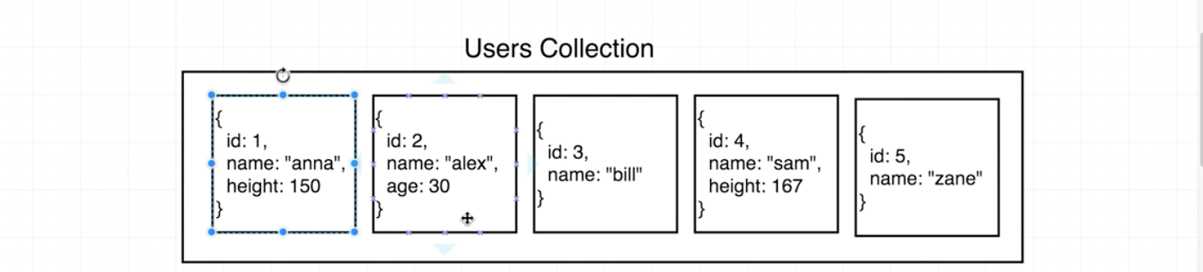

Now let’s use the Schema object to create a schema for this new collection. This will tell us what every individual record will look like.

The only property we know we need right now is the googleId. We will add that to the schema and then specify that the value will be a String.

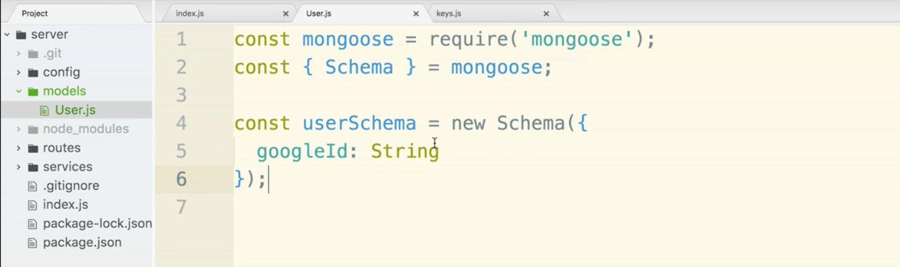

Now to create a model class and to let MongoDB know that a collection needs to be created,

we will add one line of code at the bottom: mongoose.model(‘users’, userSchema);

The first argument is the name of the collection, ‘users’, and the second part is the schema that was just created.

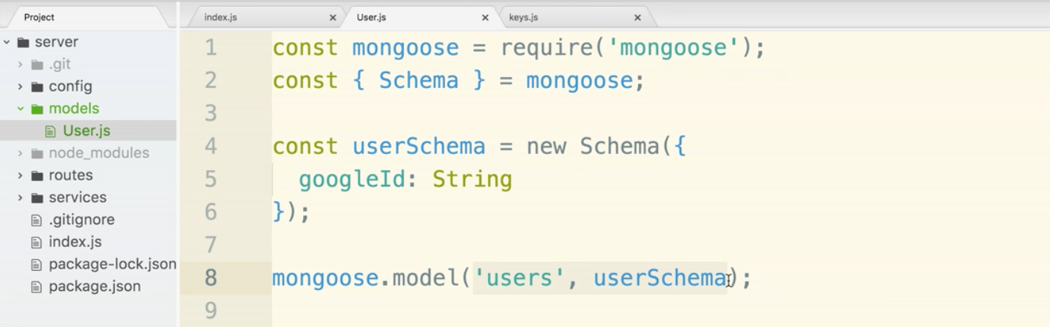

if user already exists, mongoose will not overwrite it. It will just recognize it and associate the schema it was presented with.

In the future, we can change the schema as we see fit. Adding in a name property below googleId would be fine and would not create a mess or issue.

Now we need to make sure this User.js file is required in index.js.

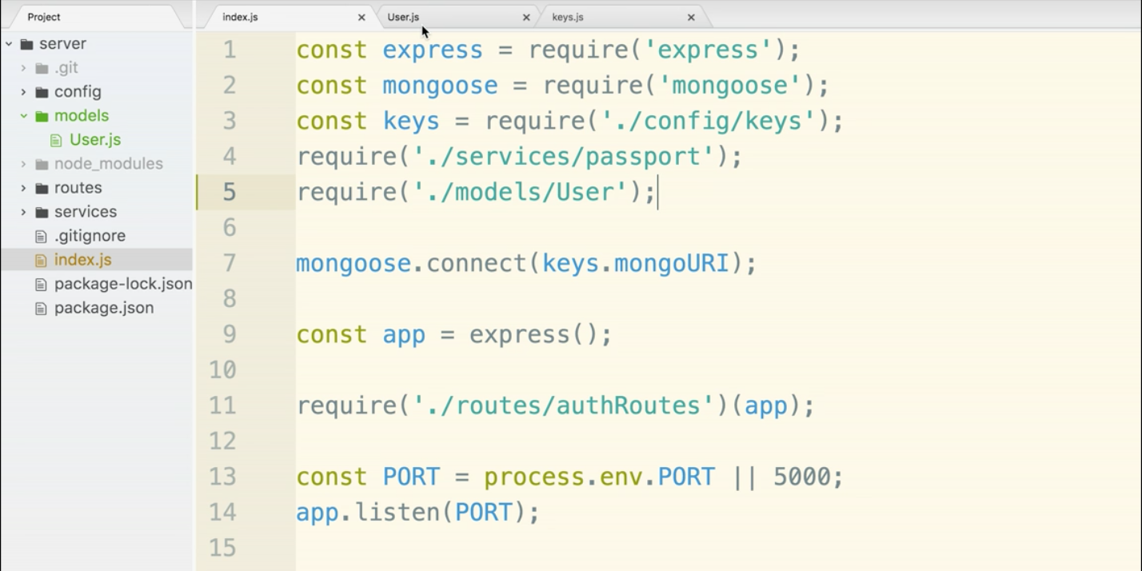

So now when the app boots up User.js will be read in and MongoDB will know it is responsible for creating a collection of users.

Now we want a user collection to be created when a user first signs up to our app. Question is, where is the best place to place the logic that executes for this.

If we go into passport.js in the services folder, you will see the passport.use() function. The argument is the new GoogleStrategy() and the second argument within GoogleStrategy is a callback function that automatically executes when the user is redirected back to ‘/auth/google/callback’ from the Google flow.

The callback function has the accessToken, refreshToken, and google user profile as arguments. You can now delete the console logs within the callback function’s body.

Let’s check that we can get access to our mongoose model.

Quick aside. For every time that we use mongoose model classes, we actually do not require them in anywhere else. Like in User.js for instance, we will not require that anywhere else.

Sometimes when you use mongoose within a testing environment. So like Mocha or Jest being run over your codebase. Your model files will be required into your project multiple times. Mongoose will get very confused and think that you are loading in multiple models named ‘users’ and throw an error.

To make sure we never run into this issue in the future, we will require the mongoose model class of ‘user’ in a slightly different way.

Inside passport.js, require in mongoose library. Then underneath the require statements put the line:

const User = mongoose.model(‘users’);

In the file User.js, we have a line with mongoose.model(‘users’, userSchema);

The key is the number of arguments here.

Because we have two arguments, we are telling mongoose that we are creating a new Schema and loading it in.

When there is one argument, we can pull the schema out of mongoose. That is what the line:

User = mongoose.model(‘users’);

is doing.

1 argument = fetch schema out of mongoose

2 arguments = load schema into mongoose.

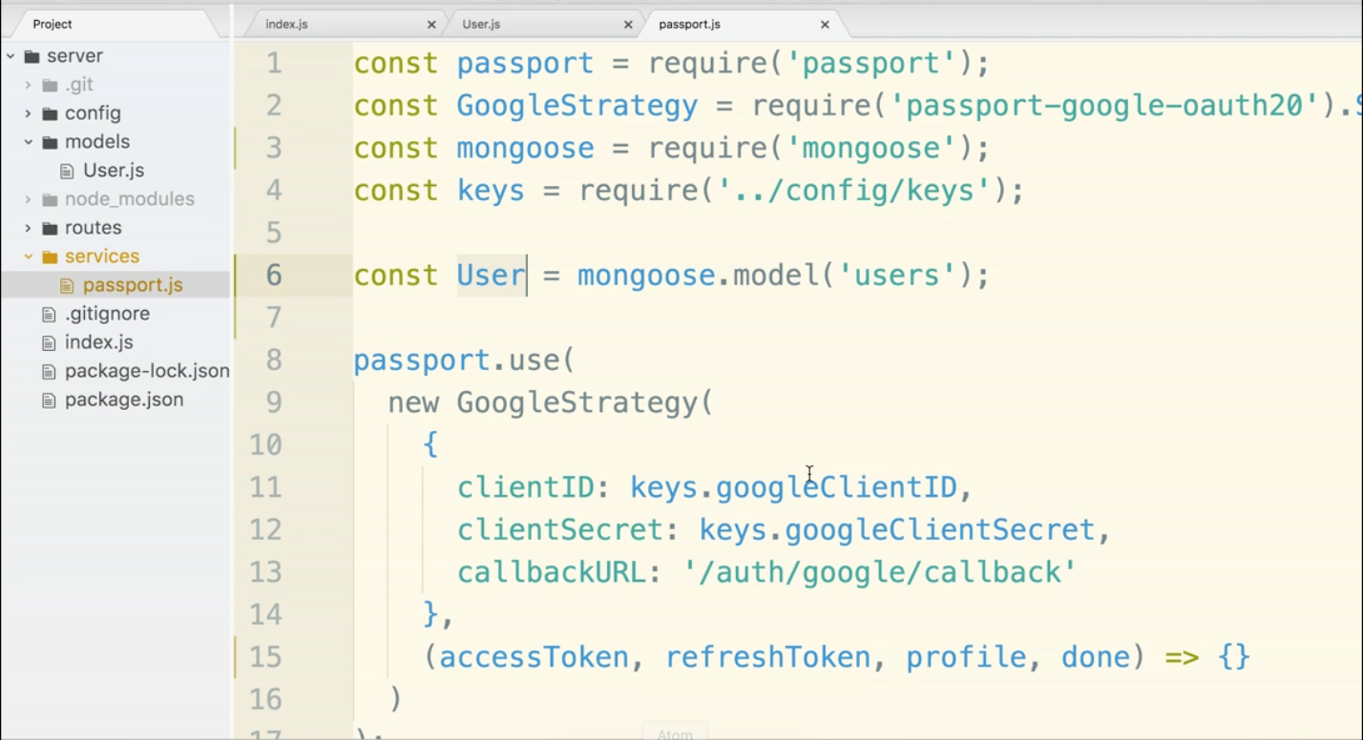

Now we will go within the callback function and allow it to create a new instance of a user and store the gooogleId.

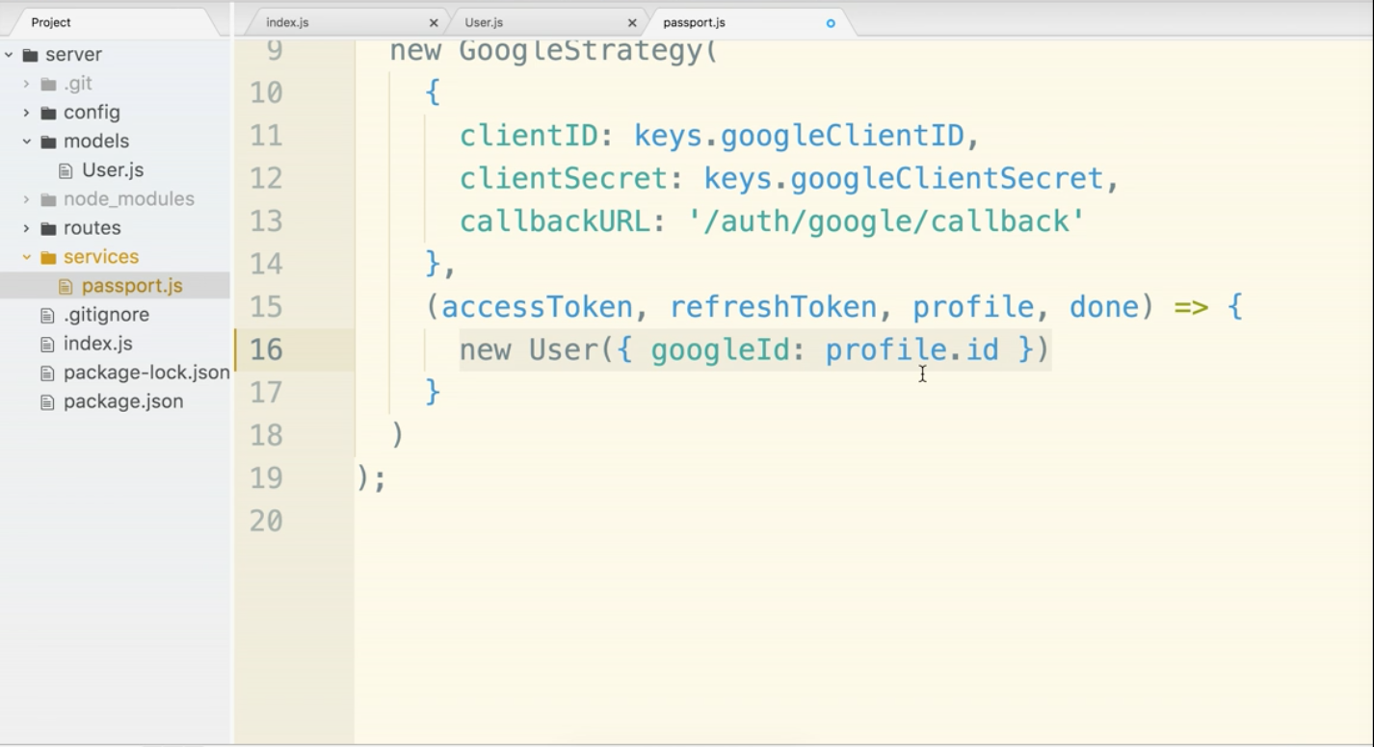

The way things are, this will not save a collection to MongoDB. The data is just in the JS world. In order to allow it to persist, we just add a .save() at the end. That will automatically save to the database for us.

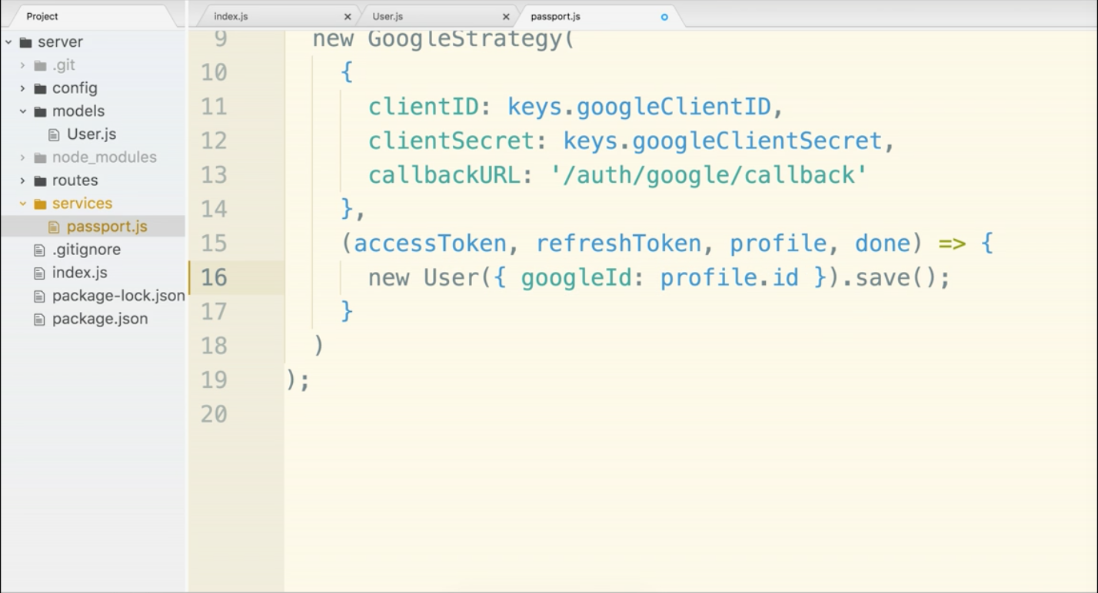

We will now need to test things. But… if we jump over to the terminal, we probably have an error. ‘Schema hasn’t been registered’ error. Tricky error. The problem is because of order of operations. The order in which things are executed.

If you go over to index.js you will notice lines 4 and 5 have to be flipped. The User model needs to be loaded in first before we can require passport.js (which uses the model)

Wrong:

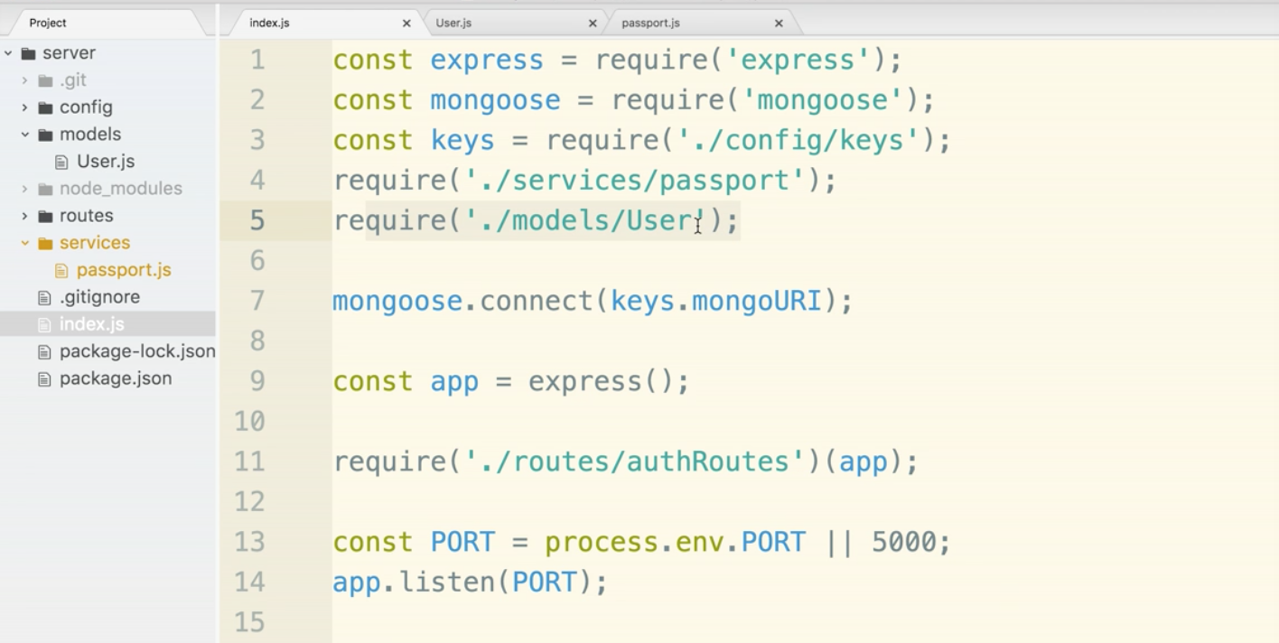

Correct:

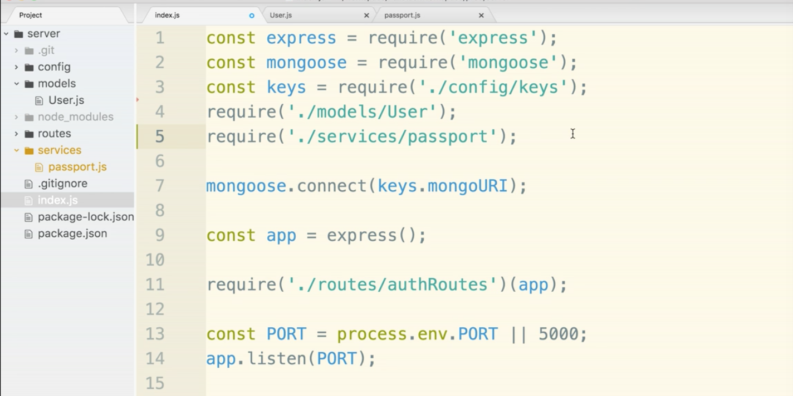

He did this to show that the order matters and how to fix errors like this. Save index.js now and go back to the terminal.

Test time. Go to localhost:5000/auth/google. When you do, things will just being hanging or loading. That’s ok. Now go to mlab and open up emaily-dev database, refresh the page if it was already open. You will have a users collection. Click on it. You should see a record with your googleId.

Success. We have now stored info in the database.

There is an issue however, if you were to do this process again. (Try it.) You will get two entries in the database with the same googleId. This is bad, we want exactly one user account for each googleId.

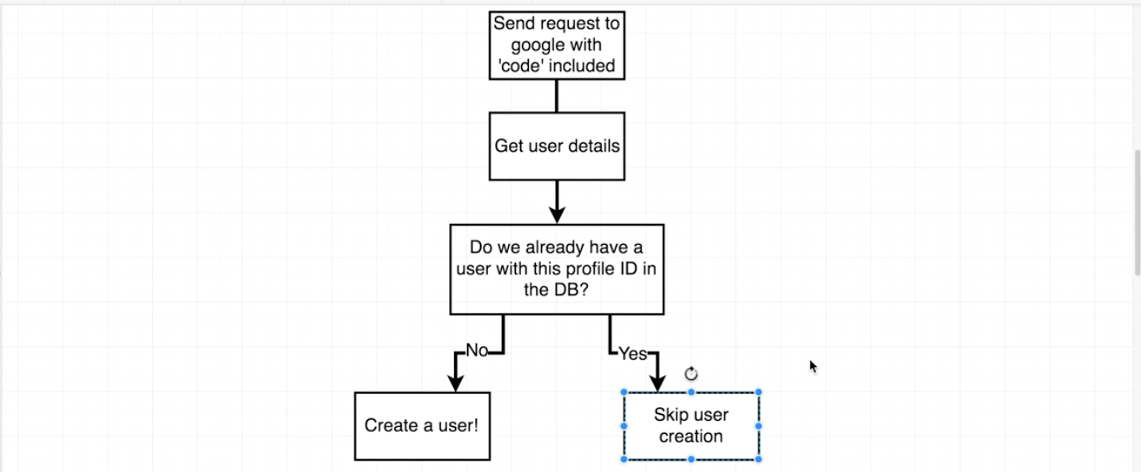

We will have to query our collect to check if the user exists.

**Queries in Mongoose**

We currently have access to a model class. We will use the model class to initiate a search over the entire collection.

We will add a line that uses Users.findOne()

Anytime we reach out to our MongoDB in anyway, beit search a collection, save a new record to it, edit an existing record, or delete a record, we are initiating an asynchronous action. The action towards the database returns a promise. Promise is a tool we use in javascript to deal with async behavior. For this, we will use a promise, but we will come back and refactor later using ES6.

add a .then statement and arrow function. The arrow function will have an argument that is a model instance of a user that was found.

We will create an if statement. If the user already exists, do nothing. Else, the user is new and we should save it to the database. We will move the new User() line into the else statement:

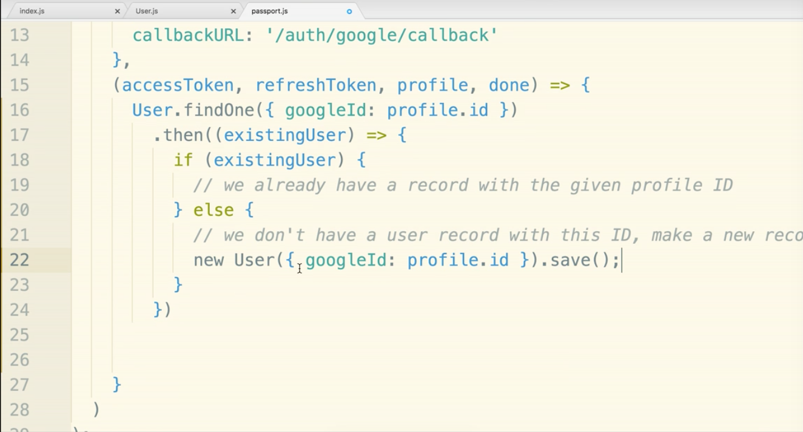

Now you can delete any duplicate users in the database. If you go through your login flow, there will only ever be one user with a given googleId in the database. existingUser is either an existing mongo model instance that represents exactly one record in Mongo, or existingUser will be null if it is not found.

After creating a user we need to tell the GoogleStrategy that we are finished with the done() function.

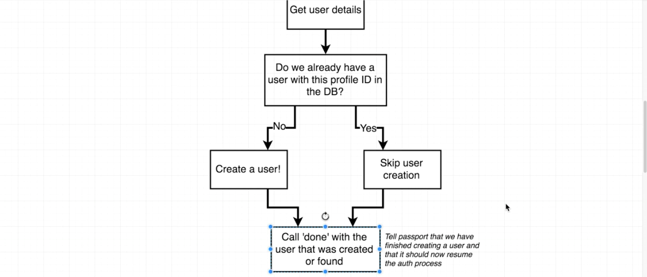

The done function will be in both parts of the if statement. First if the user already exists. The done function needs null as the first argument saying there are no errors, then the existingUser.

The else section is for new users. We want to call done() AFTER the user is saved to the database. This is an asynchronous action, so it is for this reason that we chain on a .then() function to deal with the promise.

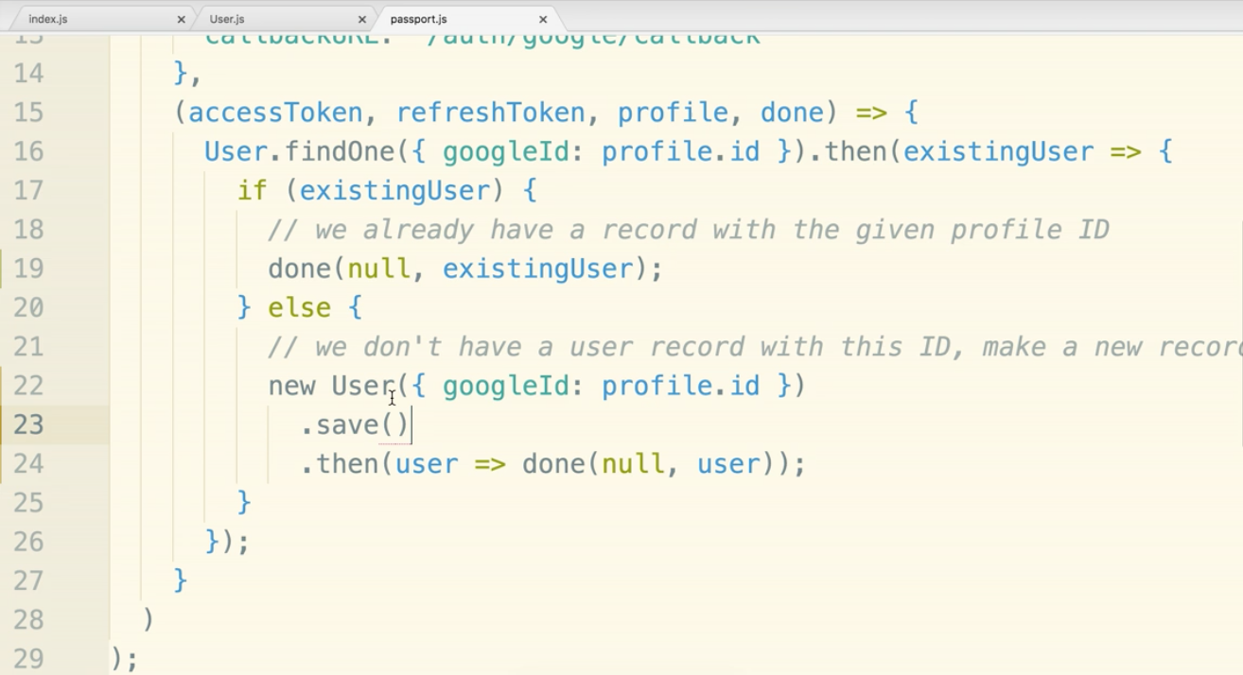

new User() created a new model instance. In the callback, after saving, we get yet another model instance ‘user’. There are two model instances. They both represent the same record in the collection. By convention we always use the one inside the promise callback because it is the most up-to-date coming right from the database.

Now you can test it out if you want.

**Encoding Users**

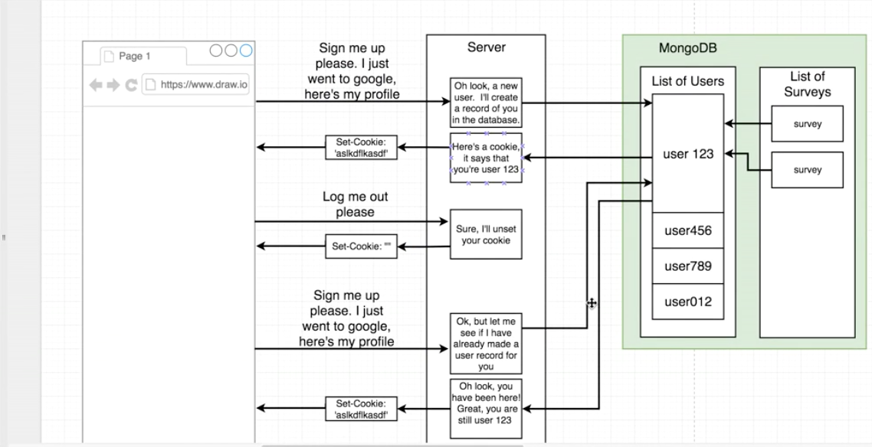

In the diagram we are on the “Here’s a cookie, it says that you’re user 123”. This is one of the more complicated steps, but it should be about the last one for this section.

The diagram is close to the same, it does not have the mongo stuff and has a bit more description.

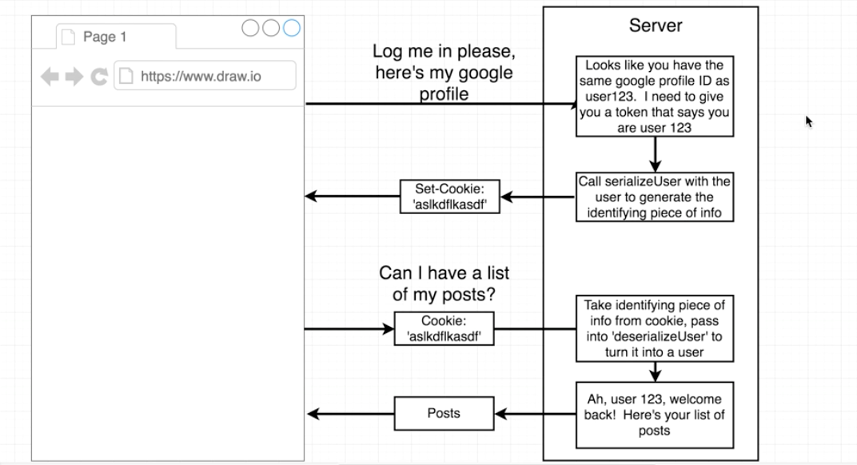

We need a function called serializeUser() that is called with our user model then we stuff the identifying data into a cookie.

When the user then makes a request to the server the cookie will go through a function called deserializeUser() so we can identify who the user is.

**serializeUser() Section**

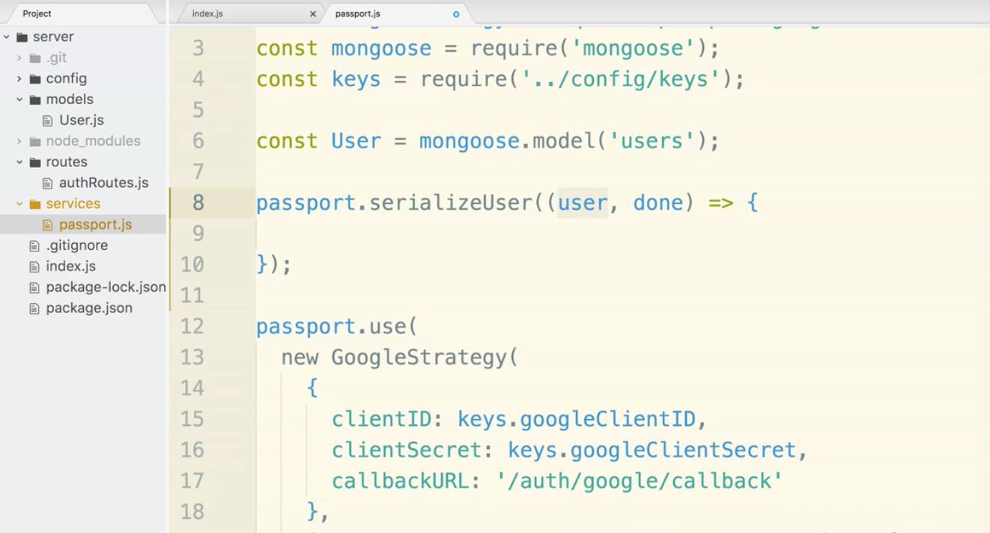

done() is a callback. We see it as a common pattern when using passport. The first argument is there if we run into errors in this process. It is a straightforward process, so we don’t expect errors. The second argument is user.id. This refers to the id associated in mongo, not the google profile id. We are doing that because we may use multiple types of oauth sign-ins like LinkedIn or Facebook. We will always have a mongo Id but not necessarily a google id. In fact we will not use that googleId again once we get that initial authentication out of the way.

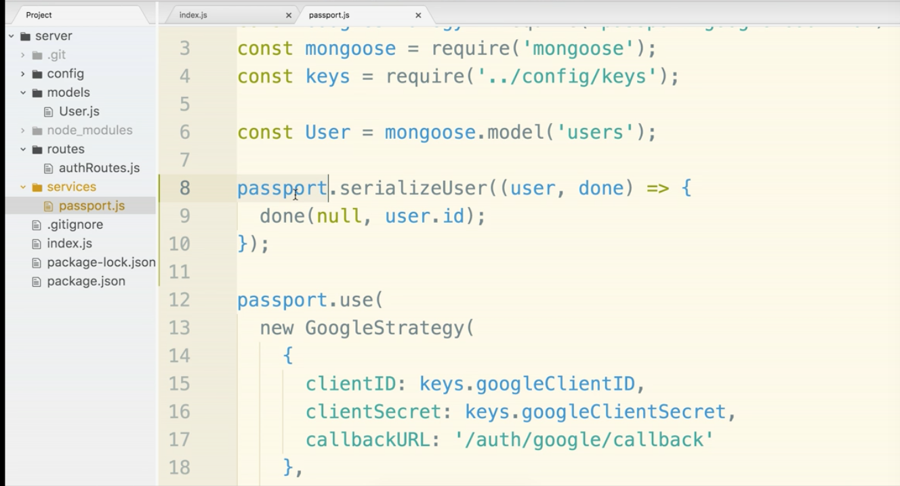

By the way, user.id is a shortcut to the mongo identifying number. If you notice when looking in mlabs the user id is really something like this

_id: { $oid: “1234567788”}

No need for the underscore nested junk, just user.id.

**deserializeUser() Section**

We are turning an id into a mongoose model instance. We will search over our collection for the id then call done when we are finished.

findById() is a function we can use in this case. Similar to findOne() that we used before.

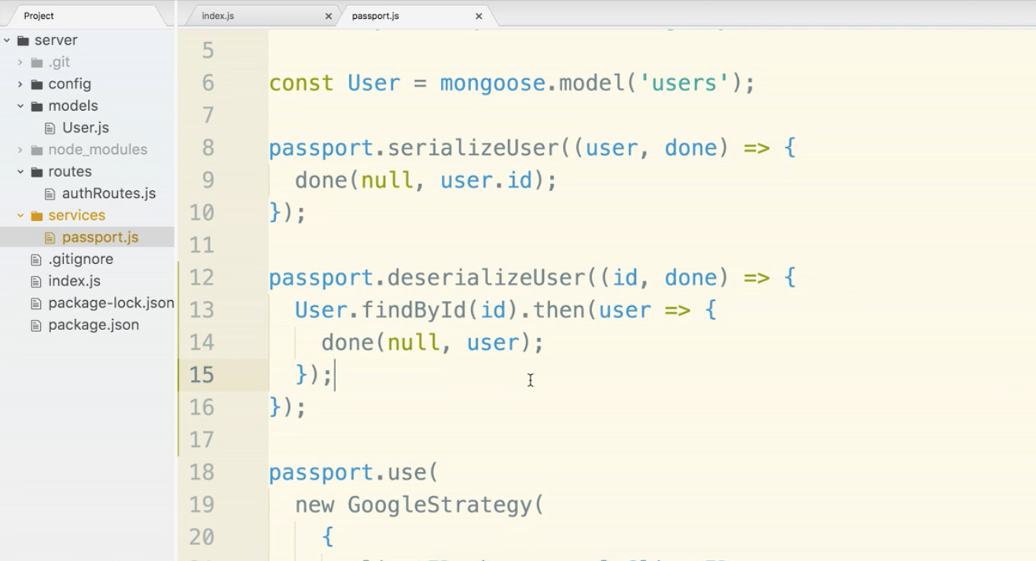

serialize, put it in the cookie. deserialize is pulling the info out and turning it back into a user.

We have to instruct passport that we are using cookies. Passport has different ways of keeping track of users. Cookies is just one way.

**Enable Users**

Out of the box, express does not deal with cookies. We will need to add a module cookie-session.

Kill the server.

$npm install --save cookie-session

now go into index.js and put in two new require lines. Require in cookie-session and passport needs to be loaded in.

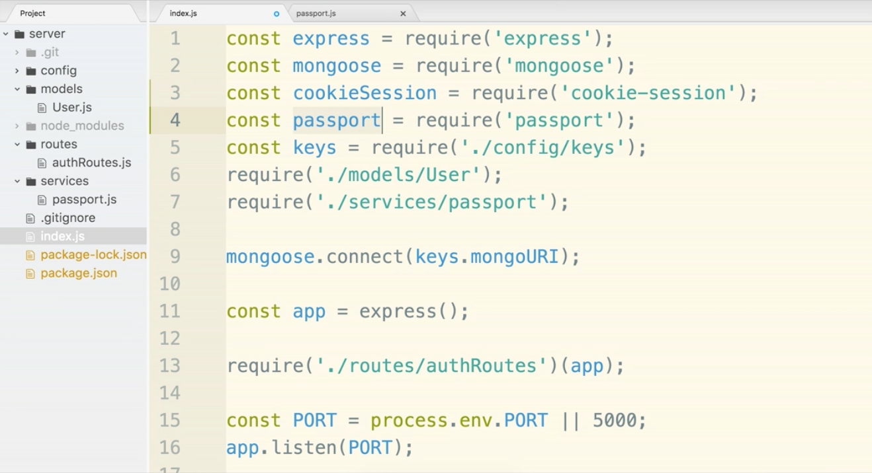

cookieSession will give us access to cookies, and passport will make use of them.

cookieSession need maxAge property measured in milliseconds. The second property encrypts the cookie with a property called keys. When we are talking about secret keys we should think about the other secret keys we have. This is yet another key that should be kept from view.

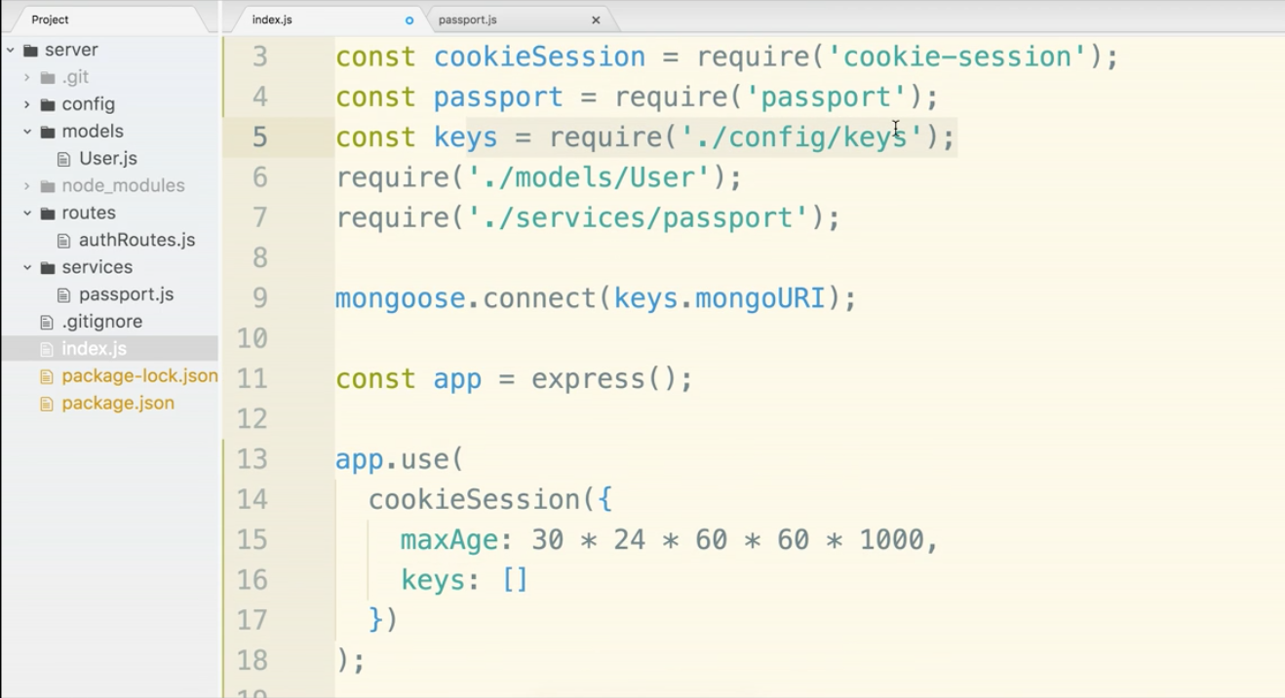

So in config/keys.js add a cookieKey any long string of characters will do. Remember that you are exporting an object and there needs to be a comma at the end of the mongoURI.

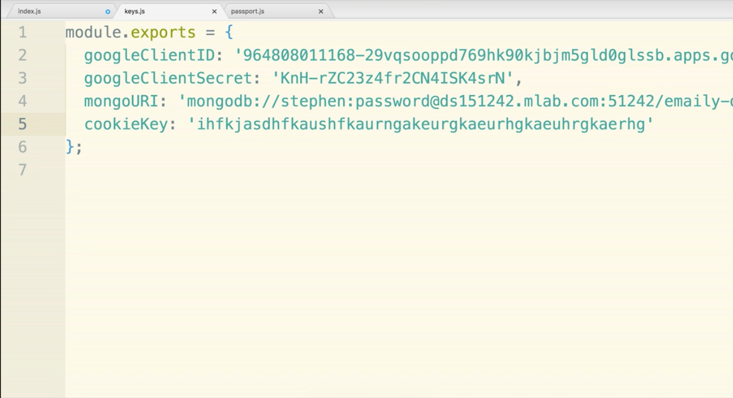

Now add it into index.js The bracket around key.cookieKey indicates an array. The cookie session allows for multiple keys, in this case we only have one. If we had multiple, it would randomly pick one to use.

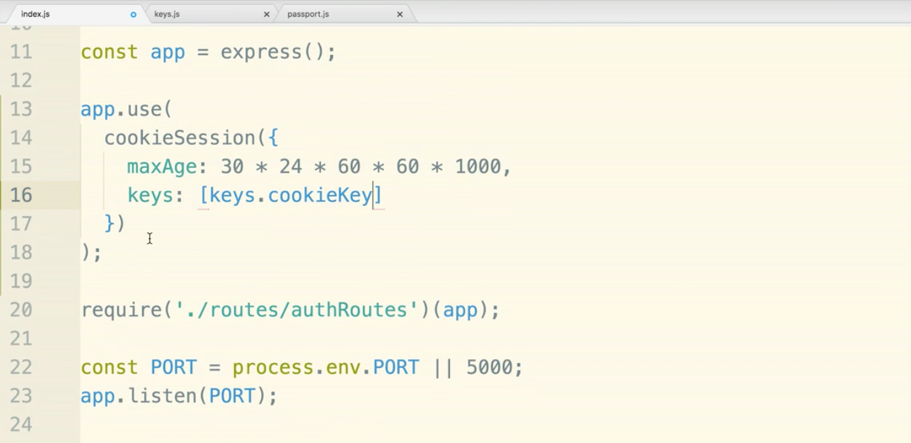

We need to tell passport to use cookies now. We will add in two lines:

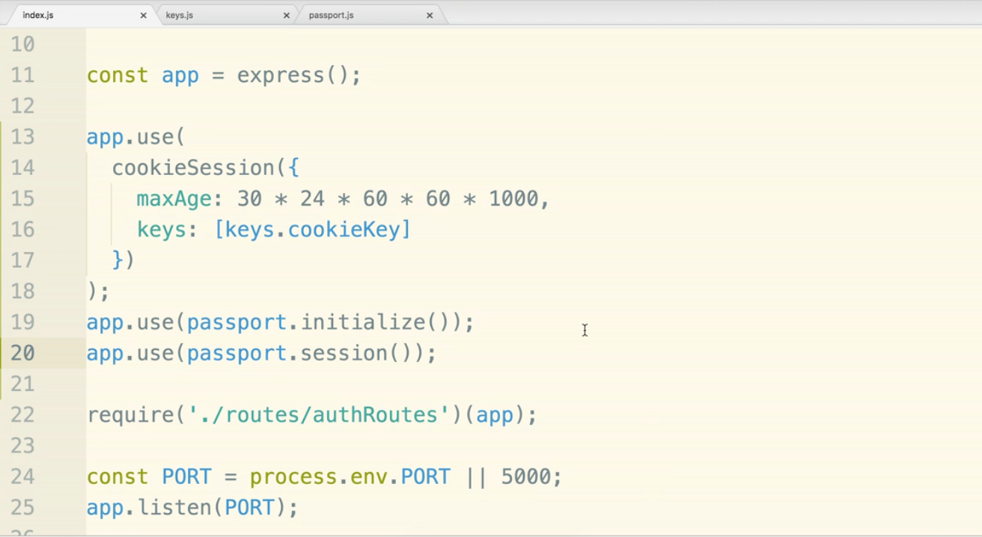

This is what will happen every time after going through the oauth flow.

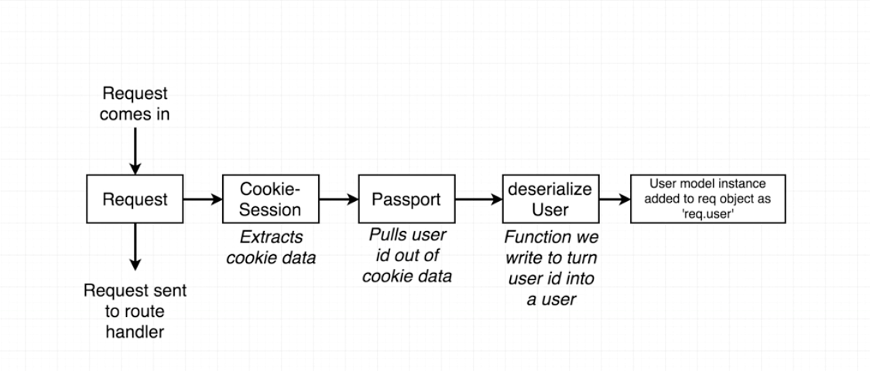

The user model instance is added to the req object as ‘req.user’. This was the goal of this whole long process.

We need to add a new route handler to inspect the req.user property. If our user exists there, it means authentication must be working properly.

Let’s go into authRoutes.js and add a third route handler. This will be for /api/current_user. Remember this is just a made up route, you can make it anything. ‘api/current_user’ is good though, looking ahead to later in the project, this url makes sense.

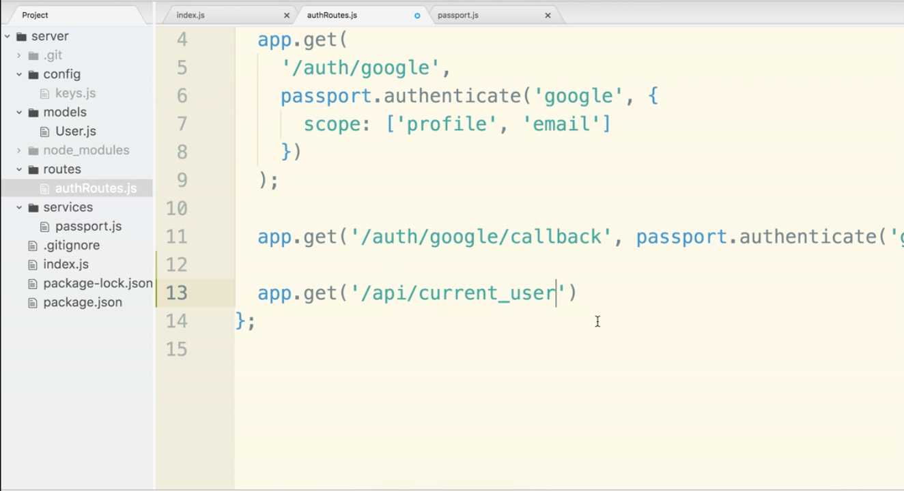

The second argument is an arrow function with req and res.

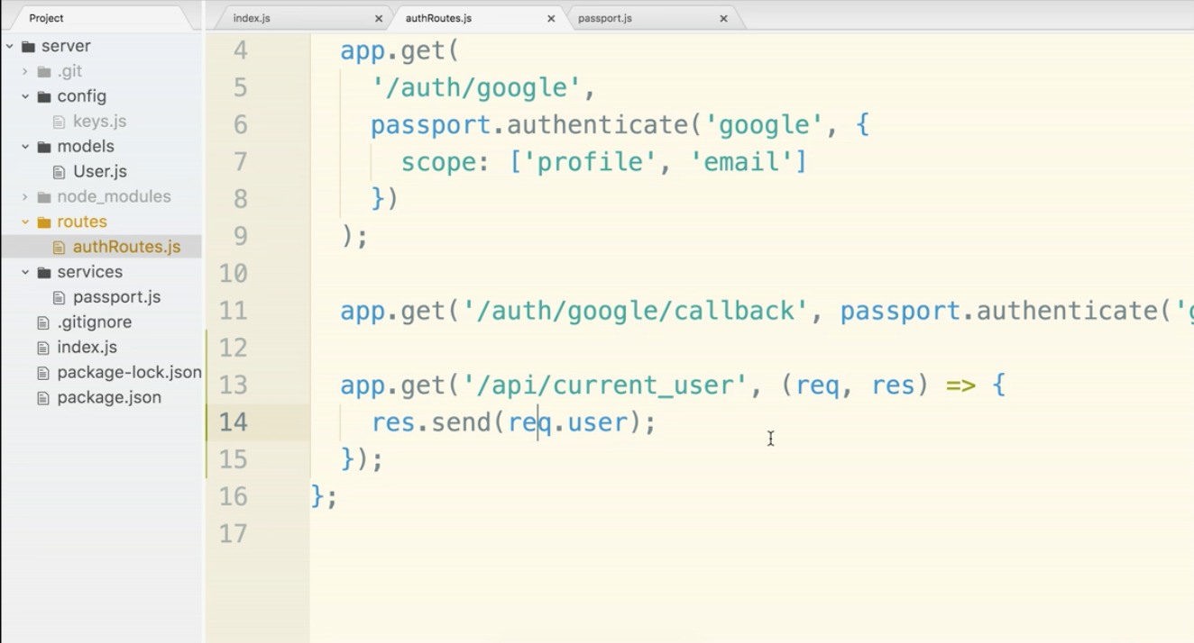

Now we test. Restart your server.

Go to localhost:5000/auth/google - you will get an error

in another tab, open localhost:5000/api/current_user

You should see a json object with the info!

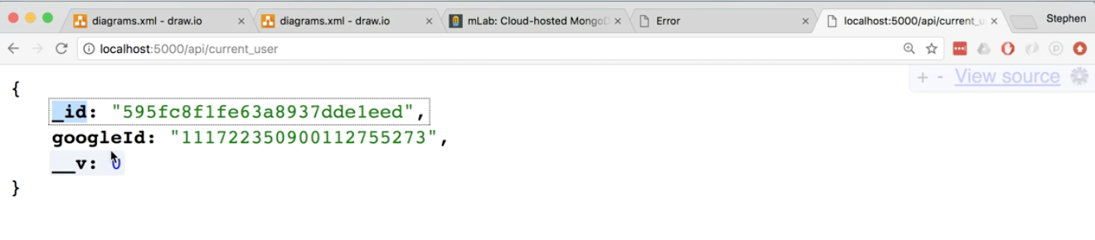

Hooray! A lot of work.

**Logging User Out**

Let’s add another route handler for logging out. Passport adds a function called logout() to req. So we will use it.

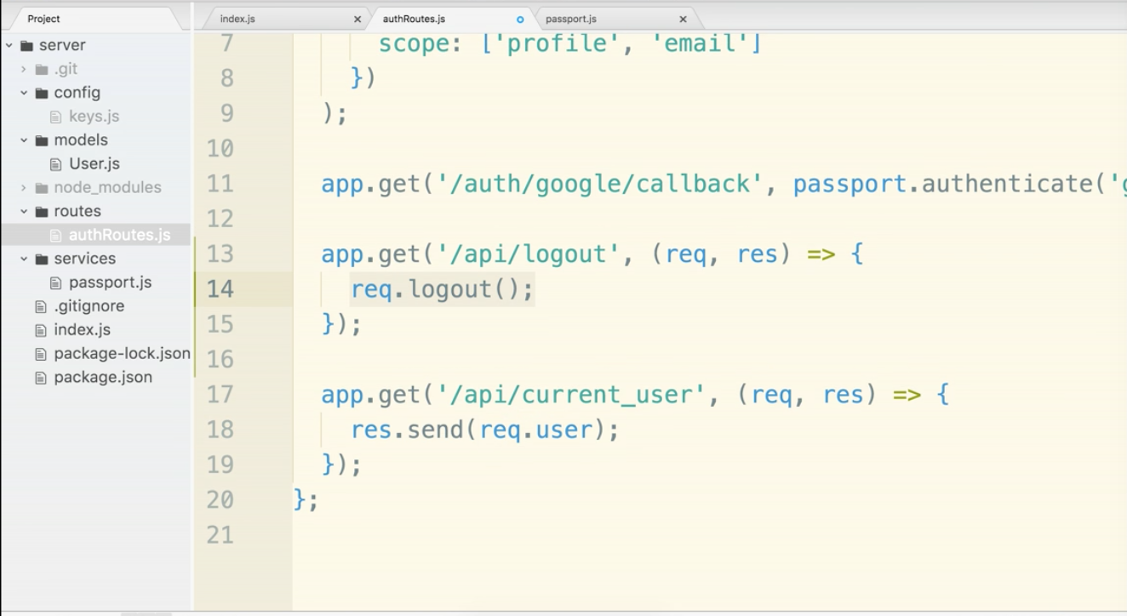

We can test to see that this works.

<http://localhost:5000/api/current_user> should have a the json user info.

go to <http://localhost:5000/api/logout>

now go back to <http://localhost:5000/api/current_user> and refresh.

The json info is no longer available. That means we successfully logged out!

**Optional Lecture For Greater Understanding**

We will compare cookie-session library that we used with express-session. The basic difference is how the identifying information around the user is stored. With cookie-session the cookie IS the session. With express-session the cookie references the session.

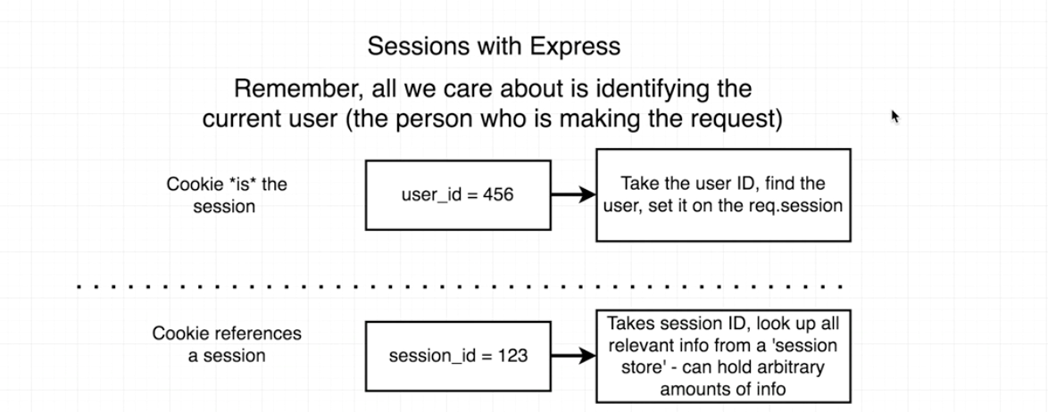

One more look at the difference:

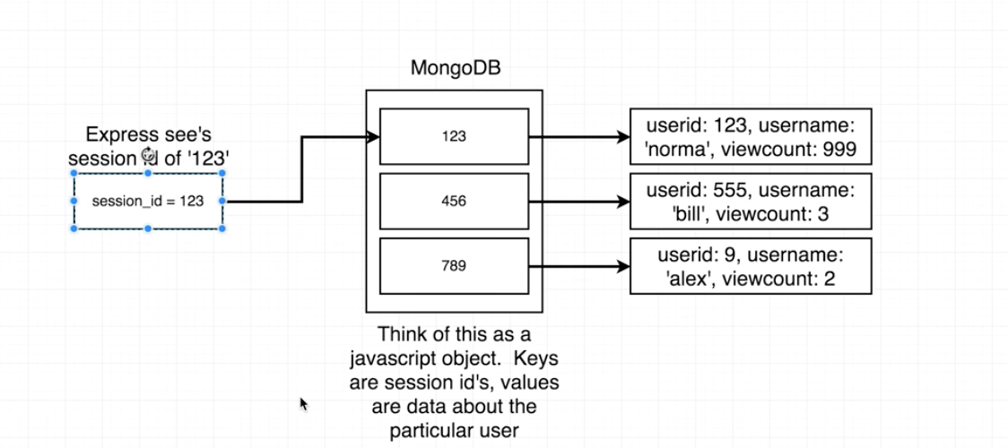

So why do we use one or the other?

express-session allows you to store as much data as you want inside the remote session store

cookie-session has a limit of about 4kb.

For our app, all we need is their id and nothing else. Well below 14kb size limit. (4 or 14?)

**Development vs. Production Environments**

For security reasons, we want to create another set of keys for production. One reason, is that if someone steals or hacks your laptop they have direct access to the dev keys. The production keys can be stored remotely in heroku. The other reason is that it gives us 2 mongo databases. The production database will never be messed with manually. It will be pristine. There really should have two databases for dev and production anywhere you work. It’s dangerous any other way.

This is what will happen:

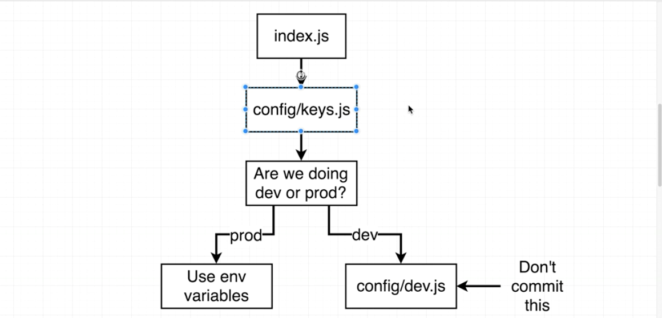

So this is the basic idea, there will be some logic to choose which one. We will talk about how to store the production codes on heroku.

Kind of annoying, but we will have to create a separate database, google api, and cookie key for production.

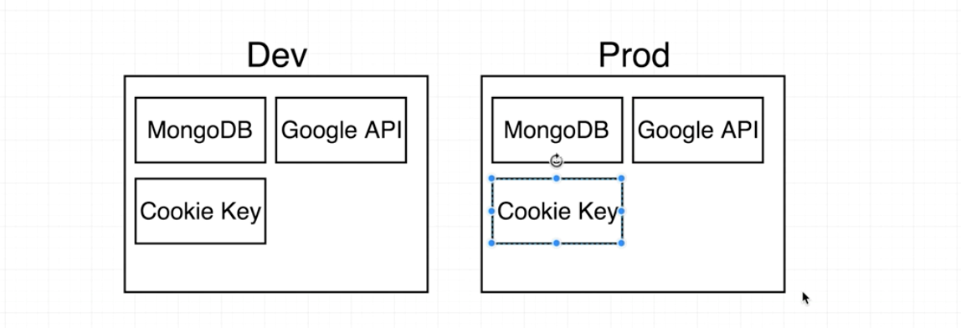

Creating a new mongo database for production:

Head over to mlabs and login.

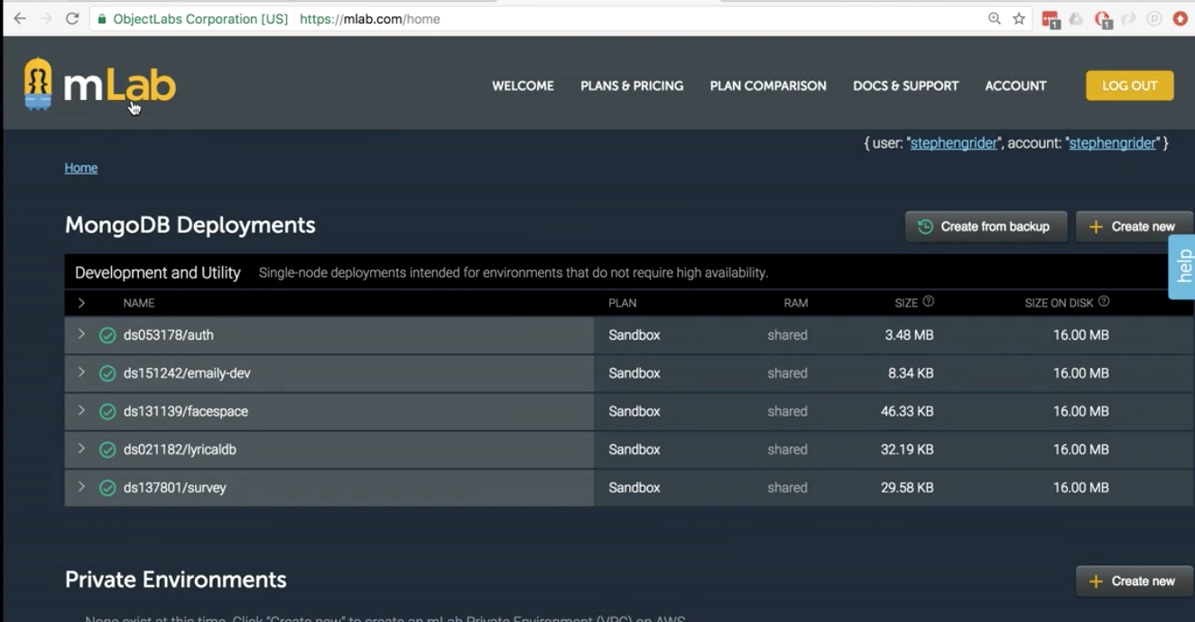

make sure you see emaily-dev.

Click create new on the right-hand side.

Select sandbox and continue.

then select the closest AWS region and then click continue.

Name the project ‘emaily-prod’

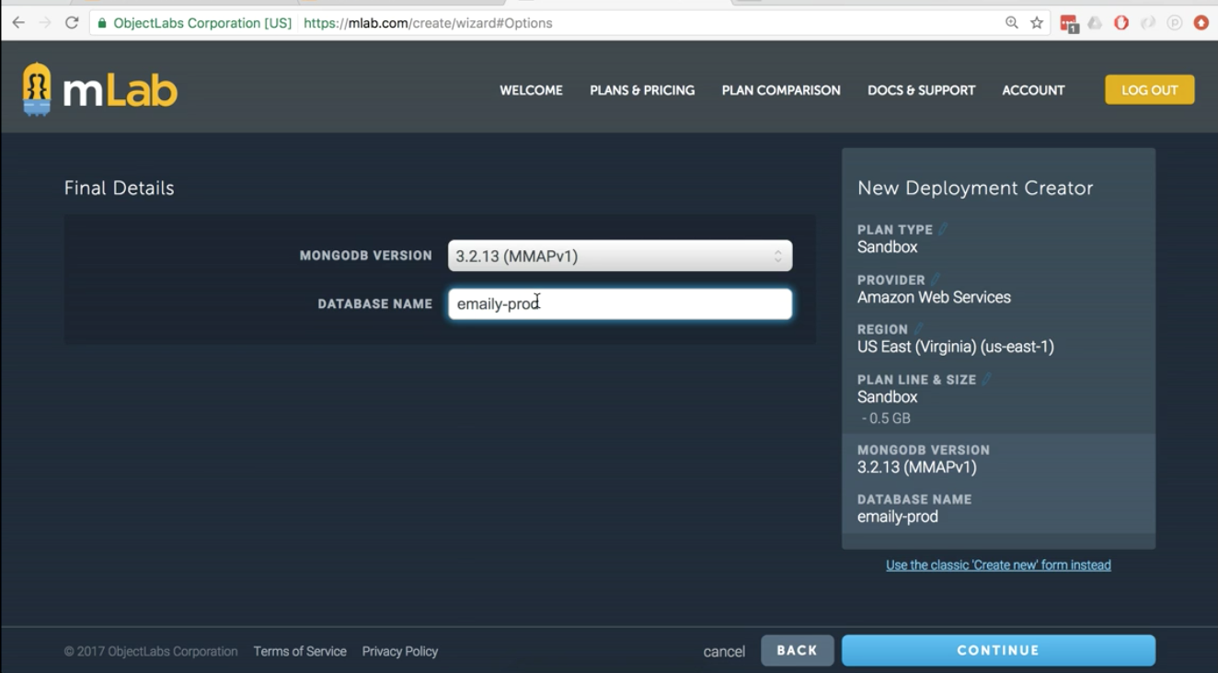

Then continue and submit order.

On the home dashboard click emaily-prod

click on Users tab.

Make a new username and password that no one could guess. Don’t use the same credentials as the dev version.

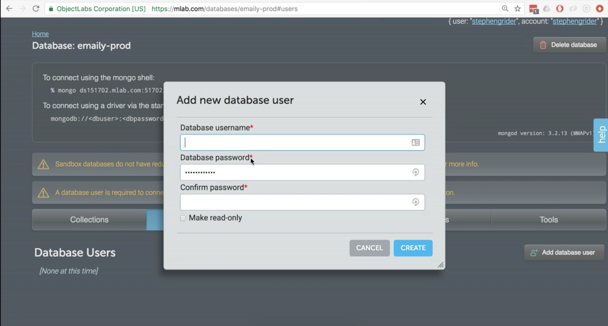

Once you click ‘Create’ you should be set.

Leave the mlabs tab open we will need the connection URI in a moment.

Now we need a separate set of google api credentials.

Go to console.developers.google.com

By default our emaily-dev will probably come up. We want a separate api though.

One quick note: You many want to go as far a creating a new google account and mlab acccount for production. Depends on how security focused you are. If someone gains access to your google account or one email, they could get the dev and production info.

Now click the drop-down at the top left that probably says emaily-dev.

Then click the plus button at the top right of the project modal that pops up.

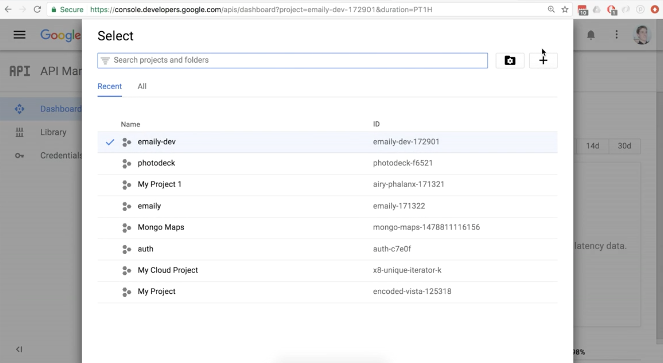Enter emaily-prod for the Project name

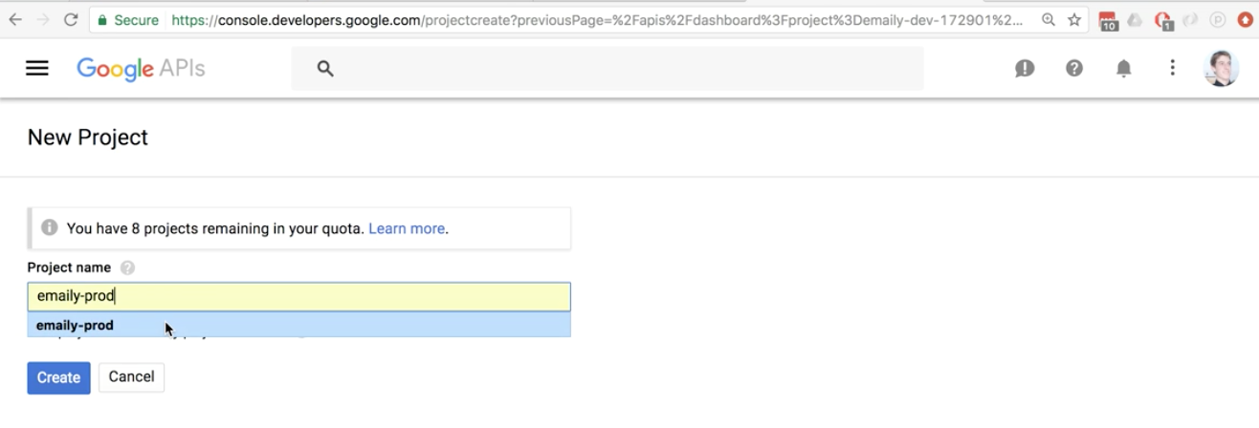

click create. Then wait a moment for it to load. There may be a spinning loading wheel at the top right.

Now go back up the project selector at the top left and change from emaily-dev to emaily-prod.

Once on the dashboard click Enable API

Then search for google+

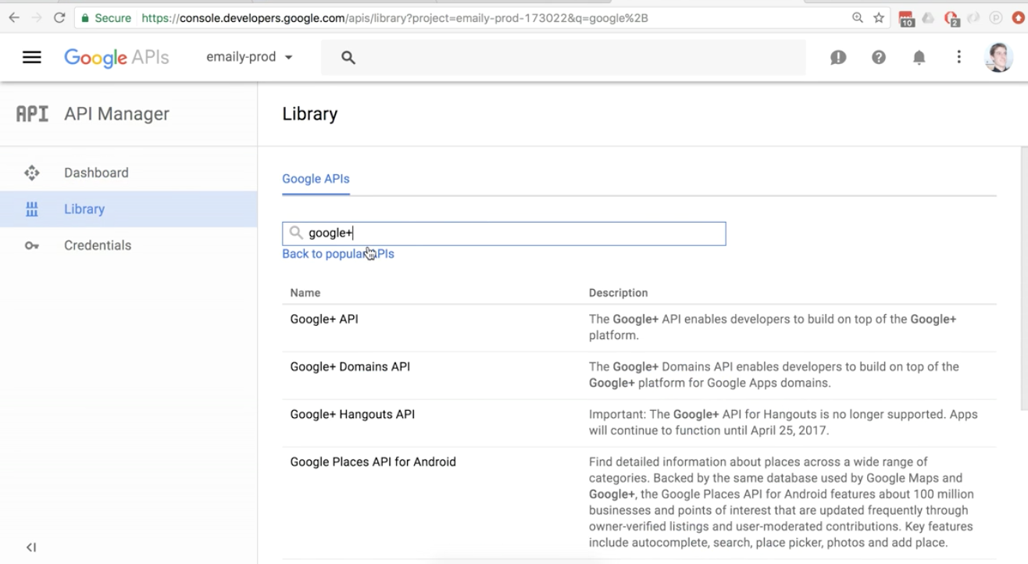

then click Enable

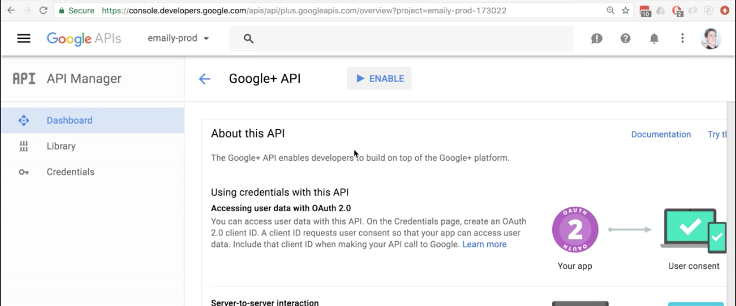

Now on the left sidebar click Credentials

Then click the button to Create credentials

then select OAuth client ID

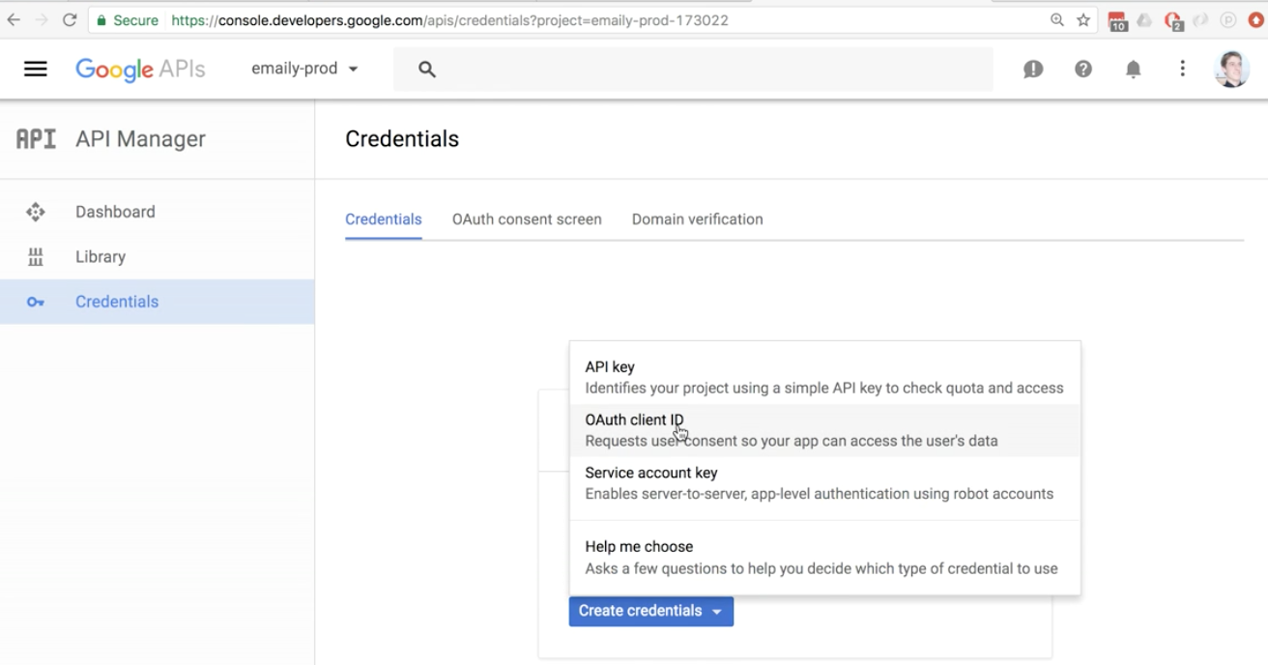

Now click the configure consent screen button.

Now for the production application, it makes sense to take the time and add a logo and home url, ect. For this project we won’t. We can always come back.

Fill in the Product name as Emaily

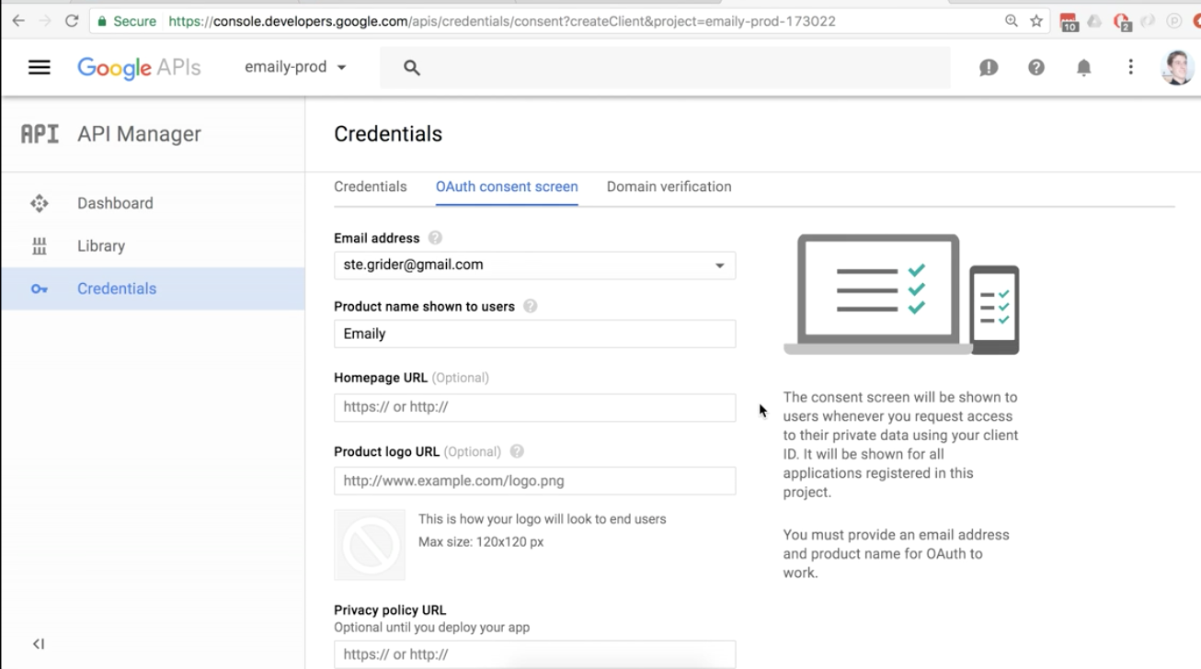

That all you need for now. Click save at the bottom.

Select Web application on the next screen.

You can leave the Name as Web client 1

The Restrictions section is a little tricky this time. We will not use localhost:5000 urls, we have to know the exact heroku urls. The long urls with things like icy-bayou-12345.

Open the terminal.

Kill the server, control+c

$ heroku open

This will open the app in the browser. Copy the address. Then flip back over to the google tab.

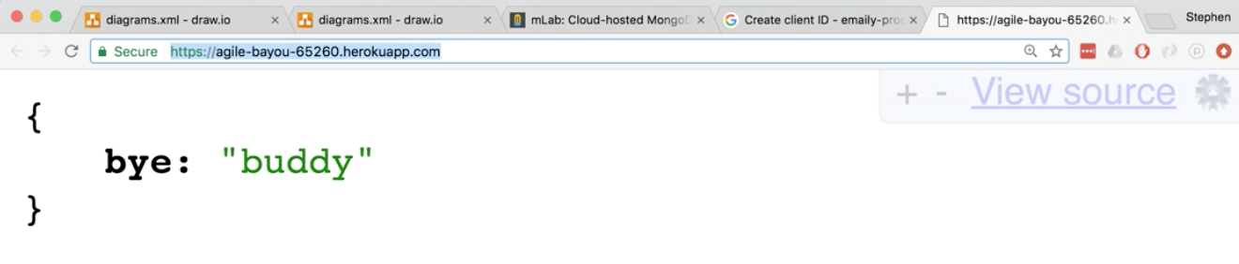

Fill out the uri textbox with the domain. (make sure it does not have a trailing slash)

Then the Authorized redirect textbox with the domain /auth/google/callback at the end.

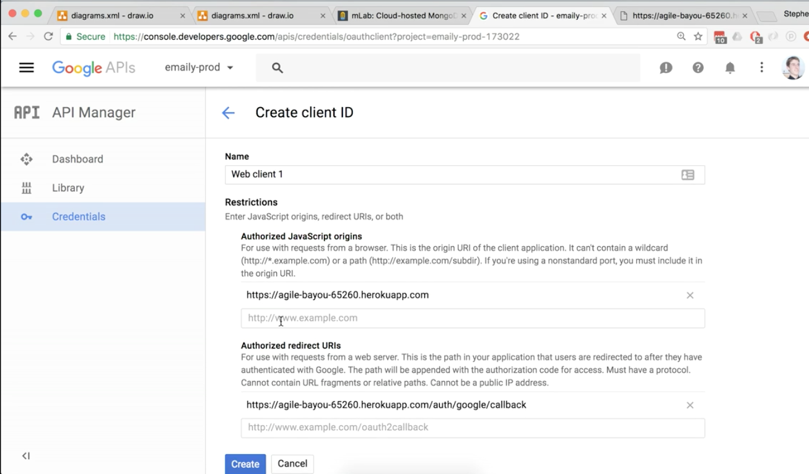

Click create at the bottom.

We will get a modal pop-up with the production credentials.

Now we will use the new production info in the code. Remember that all the credentials are currently in config/keys.js and it is not being committed to source control. This will actually change, and this file WILL be committed. That way our application will at least have something to point it to the right set of keys to use. keys.js will no longer contain actual keys, but it will have logic to point in the right direction.

Now, create a new file in the config folder called dev.js.

This is where all the dev keys will now go.

Cut the code out of keys.js and into dev.js.

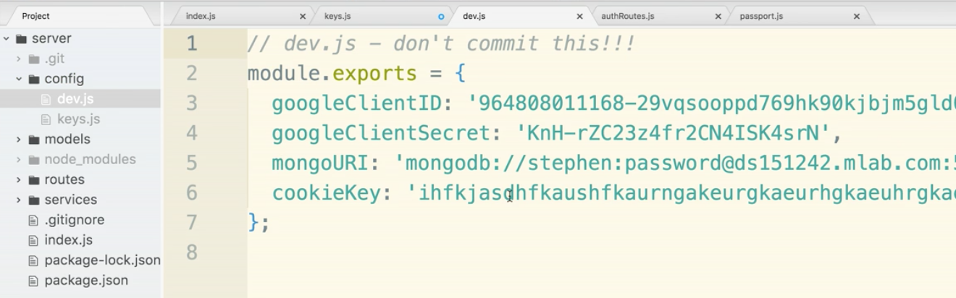

Now in key.js we need logic. This is the basic layout we need:

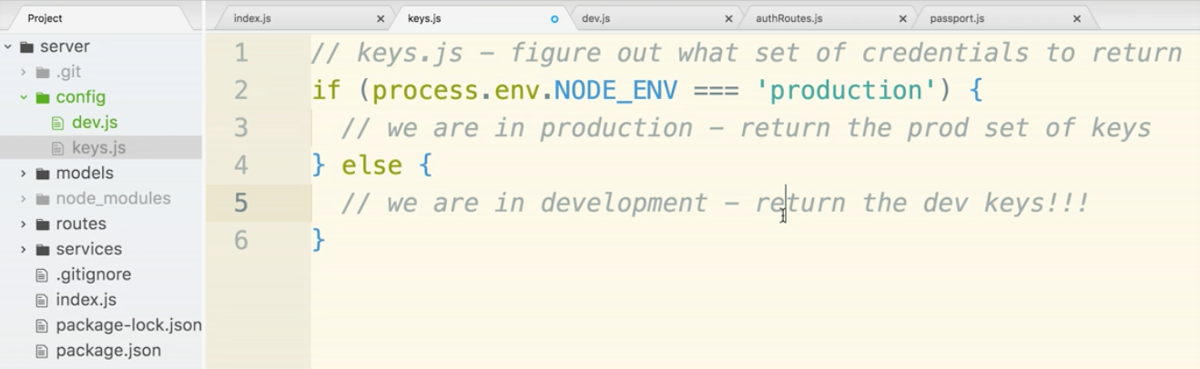

When we use heroku, the process.env.NODE_ENV will automatically be set to production.

If we were on our local machine, process.env.NODE_ENV would most likely not be defined and definitely won’t be equal to production.

In our else statement we will require in our dev keys. This will allow other files in our app to access them.

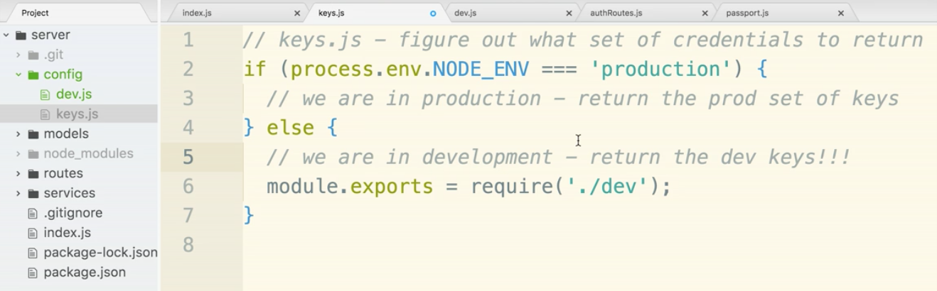

Now let’s take care of the production keys. We start by making a prod.js file in the config folder. Just create it for now, we will come back to it in a moment.

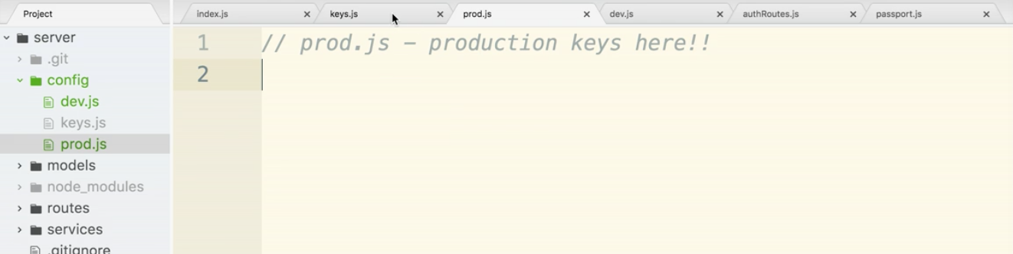

In keys.js, let’s require in the prod.js file.

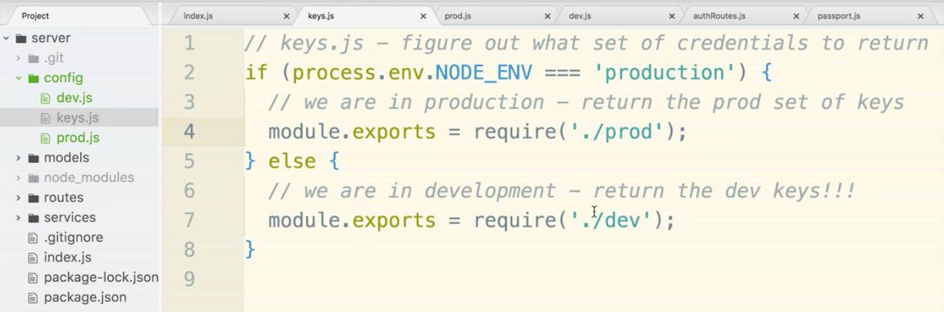

Now go back to prod.js. We will paste in the code from dev.js keys. Copy the module.exports statement from dev.js and paste it into prod.js. This is just a starting point, we will NOT keep the same keys. The only reason we pasted in the code here is so that we have identical property names. Less likely we will have a typo or miss a property.

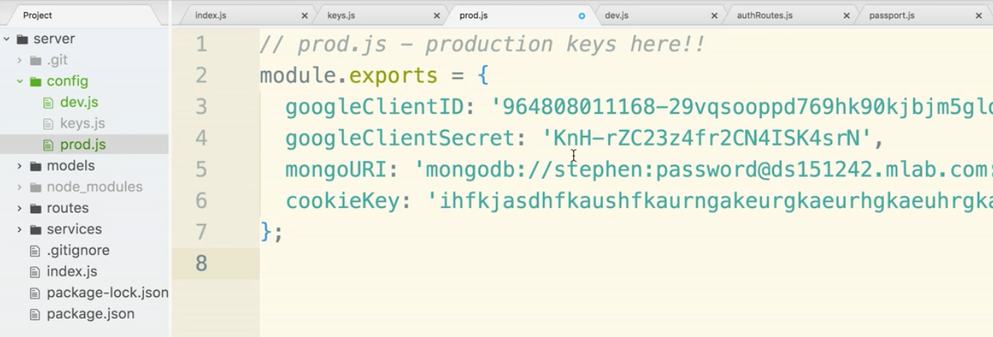

Delete the key values in prod.js.

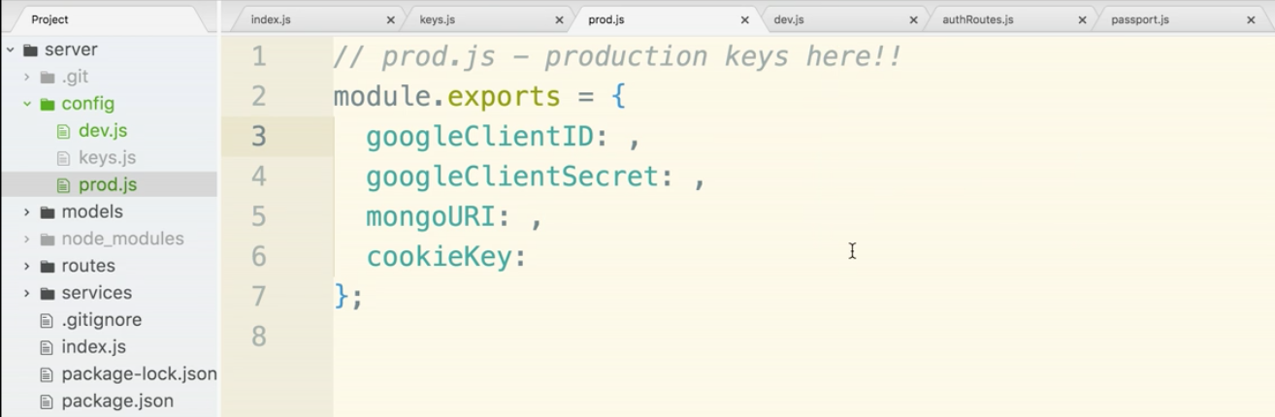

We will add in environment variables. Notice that we use all caps and underscores after .env. We don’t necessarily HAVE to do this, but it is the convention.

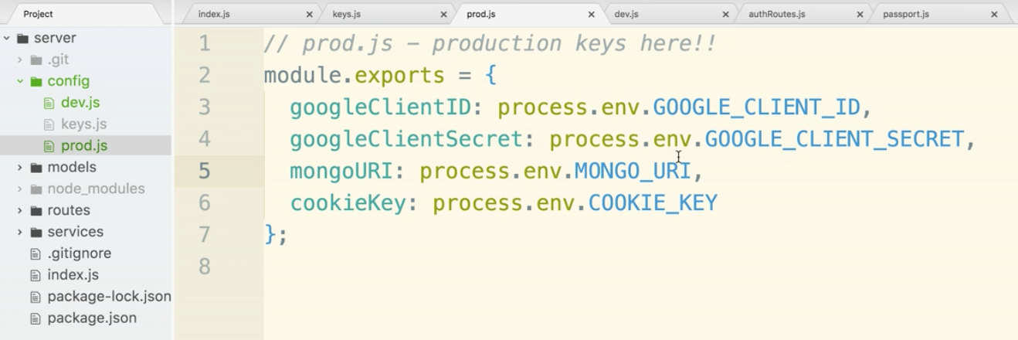

Now we need to make sure our version control is all straightened out. We said earlier that dev.js will not be committed. This holds true.

keys.js now WILL be committed. So the app can always ask keys.

We ARE going to commit the prod.js file.

The reason is that prod.js points to all the environment variables and you’ll notice it actually doesn’t have codes, only references.

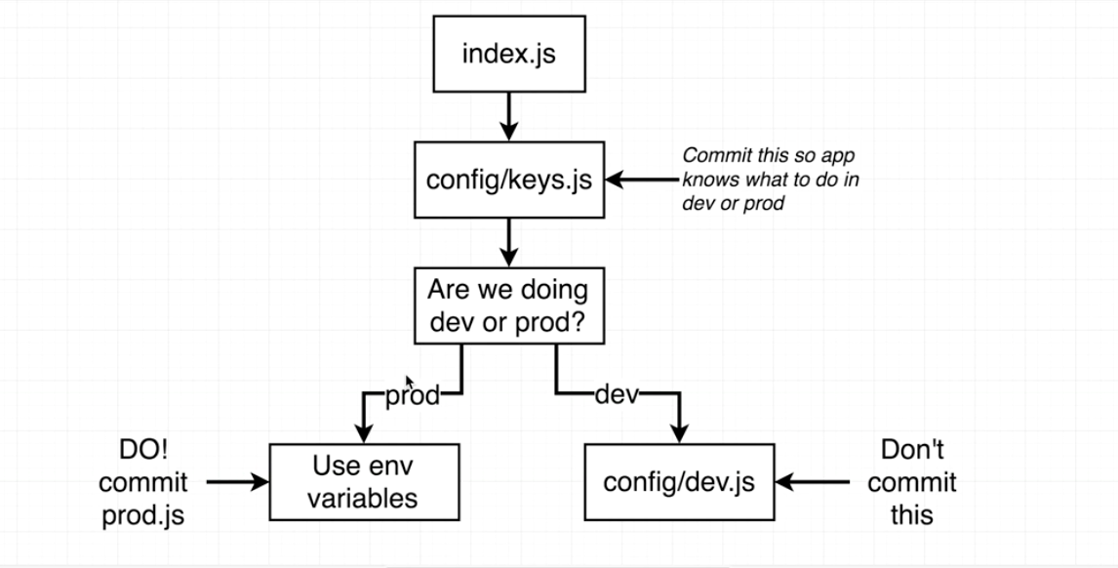

Now go to .gitignore

delete keys.js

and add dev.js

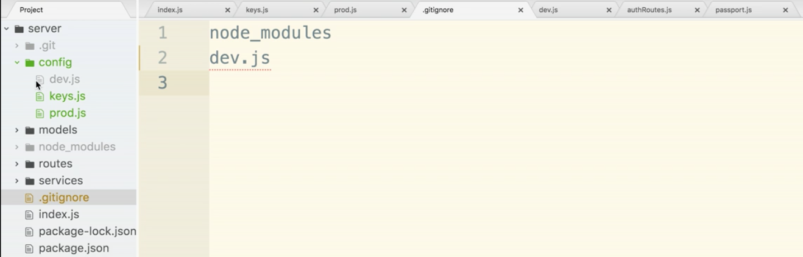

Next step is to go over to heroku and setup the environment variables.

Open up your browser and go to heroku.com

Sign in.

When on the dashboard, select our app.

agile-bayou on the screenshot, but whatever yours was called in your case.

Select Settings on the nav bar

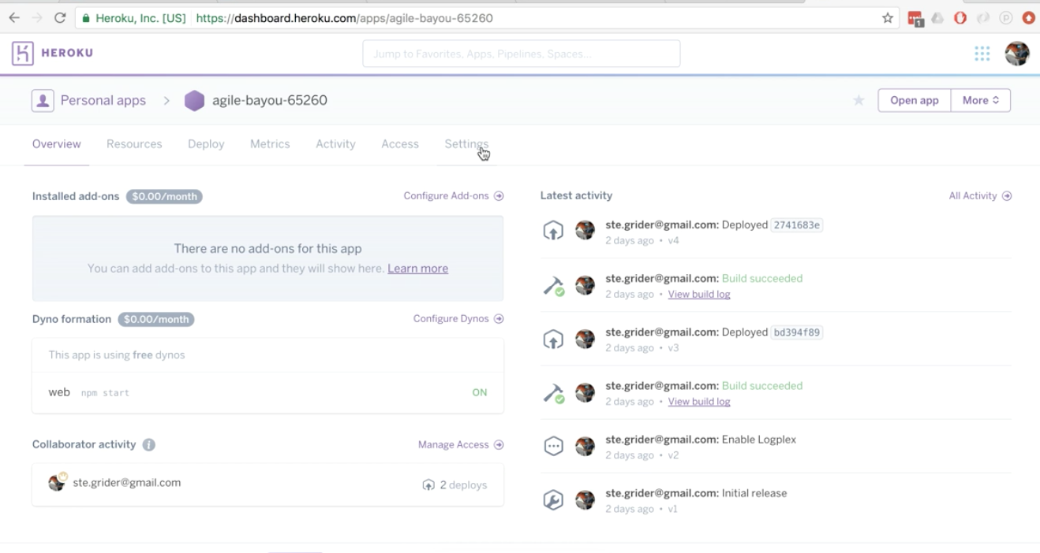

Then click Reveal Config Vars.

It will give us an interface to enter in all of our keys.

You can go to prod.js and copy the capitalized and underscored variables so you don’t make typos of mistakes. Then paste it in for the heroku key

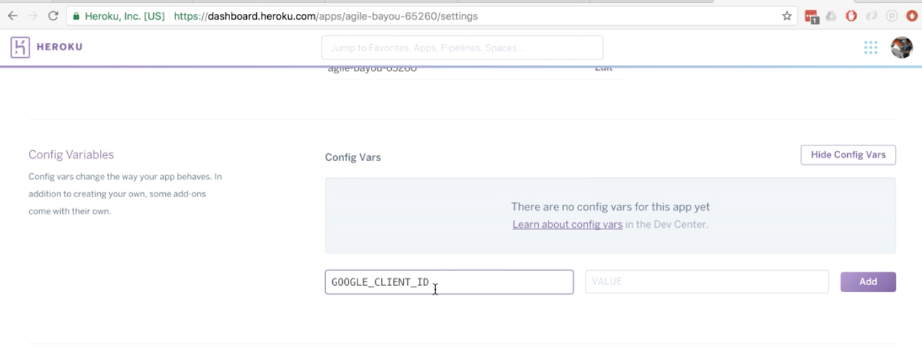

hop over to the google credentials page. (you may still have this open)

copy the clientID and paste it into heroku. Repeat the process for GOOGLE_CLIENT_SECRET

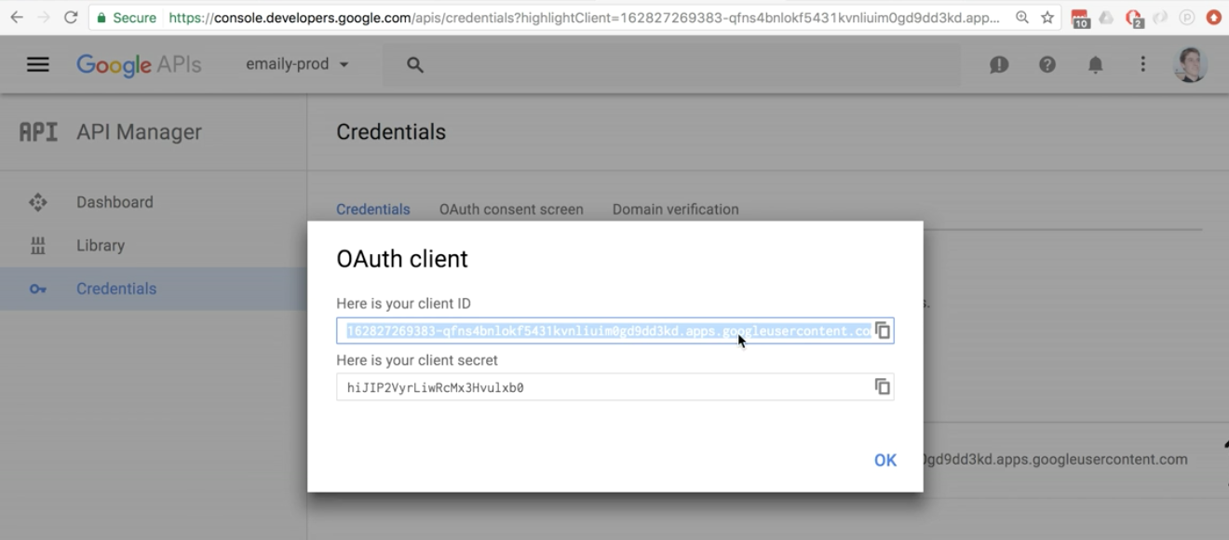

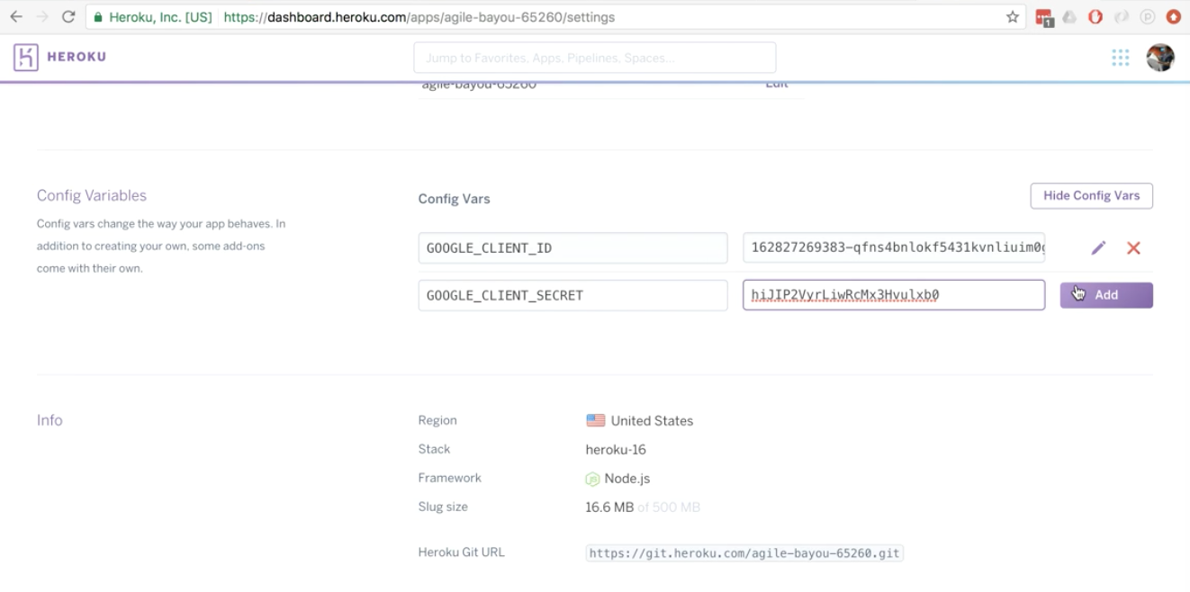

Next do the COOKIE_KEY

The value should be a very long string of letters and numbers. It can be totally made up.

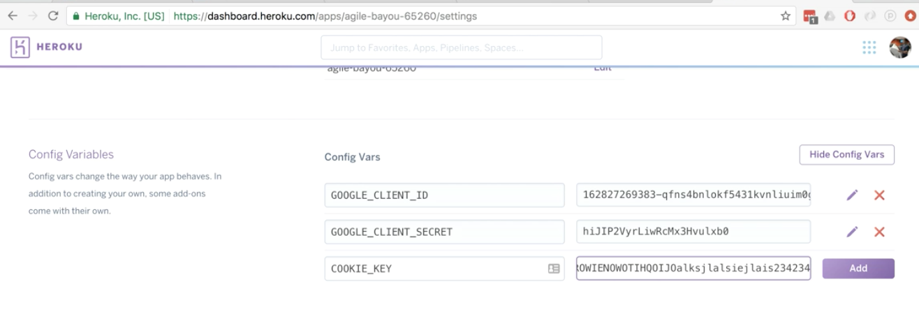

next is MONGO_URI

flip over to mlaps emaily-prod, copy the MongoDB URI

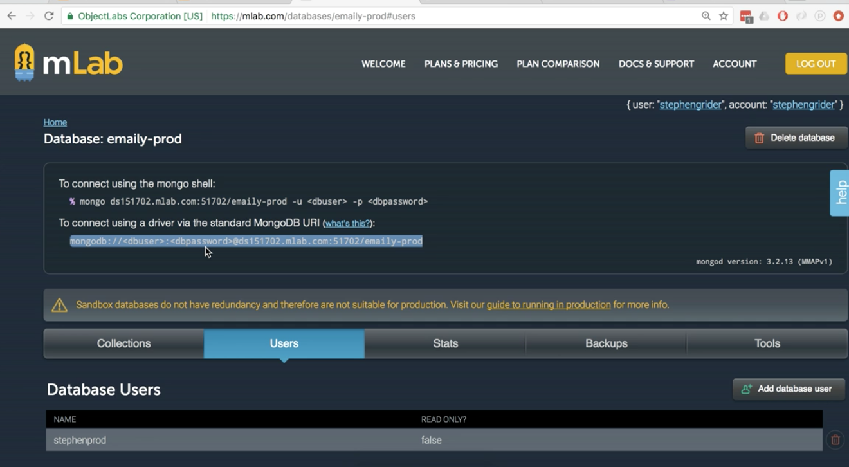

Fill in the username and password for the PRODUCTION LOGIN not the dev database.

This means replace <dbuser> and <dbpassword>

Make sure of no typos, no < or > signs should be in there, and a ‘:’ should be in between.

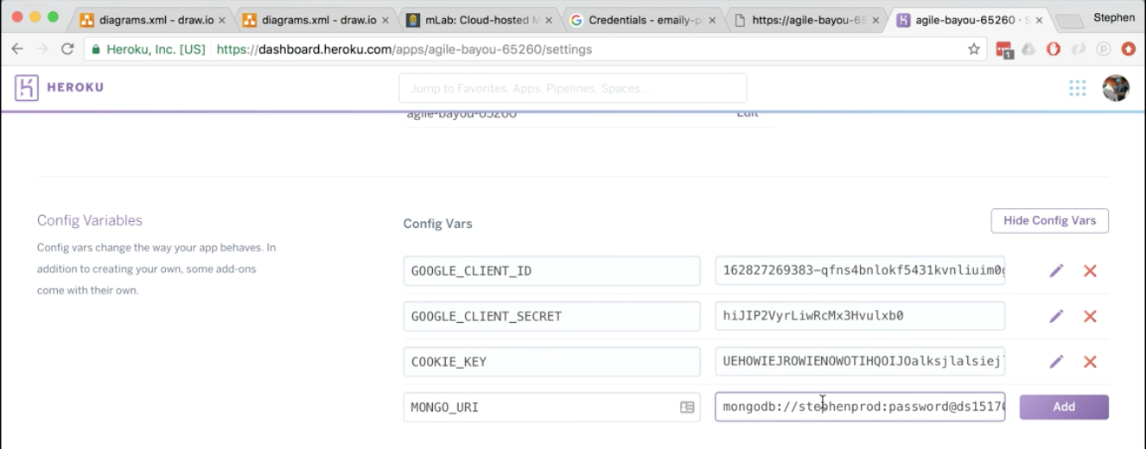

Once all of the variable are added. Click Hide Config Variables at the top right.

Now we deploy.

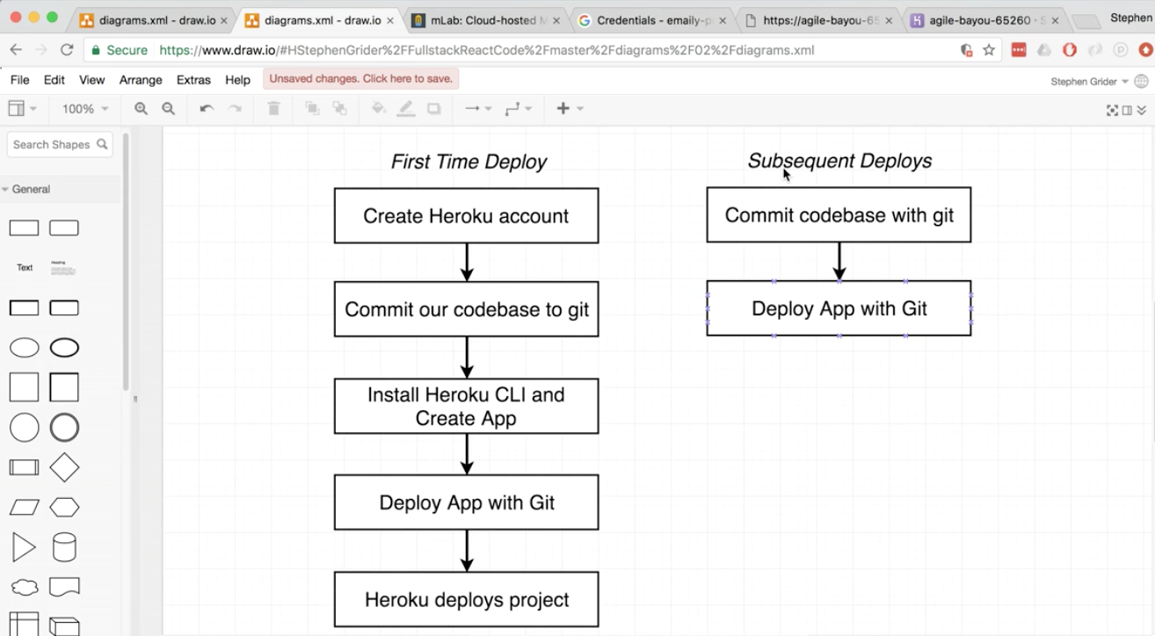

go to the terminal

$ git status

$ git add .

$ git commit -m “finished auth flow”

$ git push heroku master

$ heroku open

The browser should open to home page. “Cannot GET /” error may show. That’s ok.

go to /auth/google

You will get a google error message. We need to fix this. So hold on a moment.

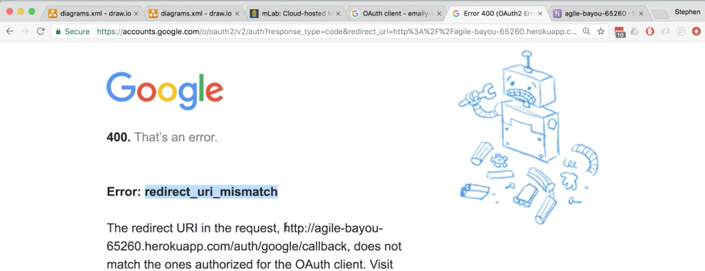

Probably an http and https issue with heroku.

Something is breaking and reverting back to http instead of https

jumping back into the editor, let’s open passport.js

If you look into the GoogleStrategy() function our callback is a relative path.

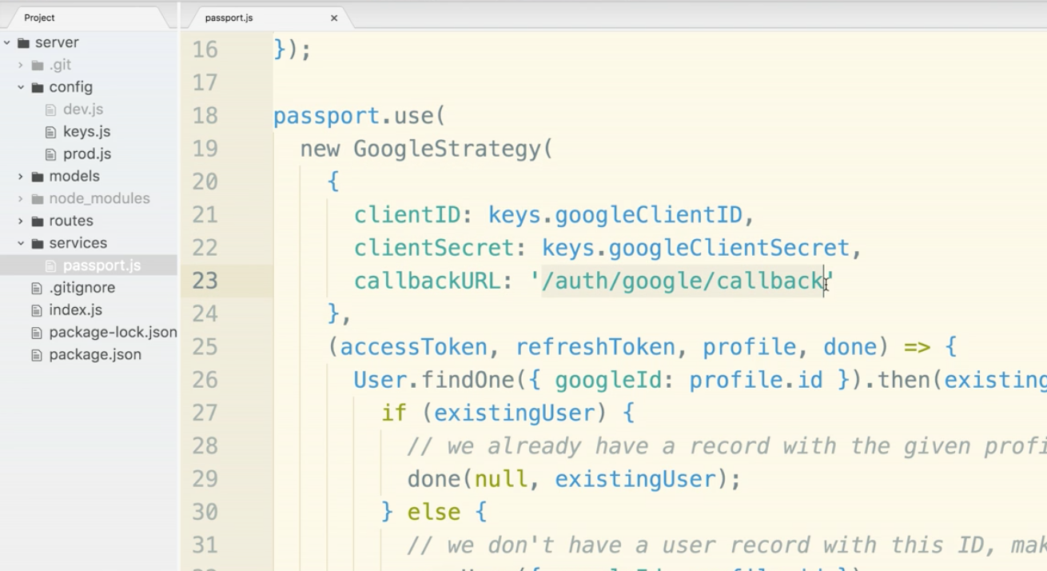

Now the fact that it is relative is issue number one. That is causing GoogleStrategy to use http instead of https.

The second factor causing the issue is very complex.

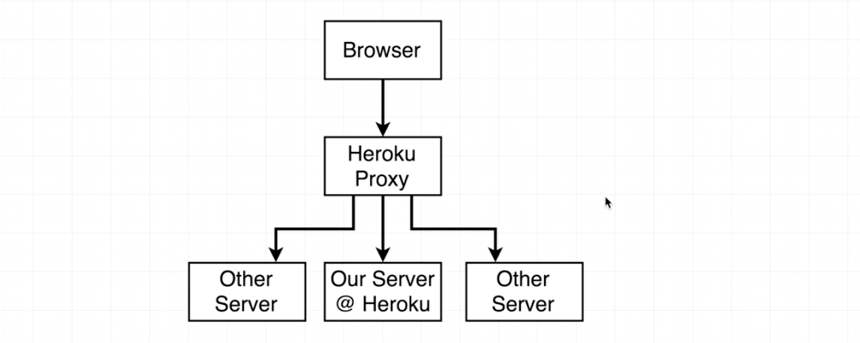

Heroku has to use a proxy. Because traffic goes through the proxy google does not want to trust it as https. Thing is though we DO trust the heroku proxy. The question becomes, how do we fix this? Two choices, make the relative path not relative and make some sort of logic to decide if we are in dev mode, localhost:5000 or agile-bayou.herokuapp.com. Or the other solution is to change a setting in GoogleStrategy to trust the heroku proxy.

Let’s do the second solution, add in proxy: true to the strategy:

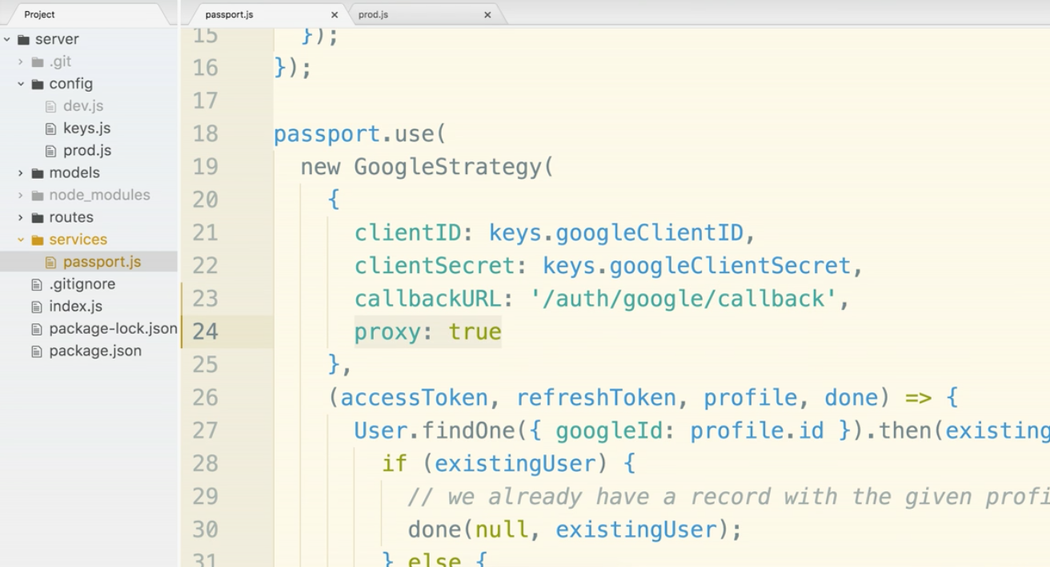

so now save. go to the terminal

$ git status

$ git add .

$ git commit -m “Tweaked google strategy settings.”

$ git push heroku master

Go back to the browser.

Go to the heroku domain specific to your project.

By the way, your project is always hosted at herokuapp.com not heroku.

Once the deployment is complete, go to /auth/google of your app.

‘Cannot GET’ error should show. (that’s ok)

go to /api/current_user

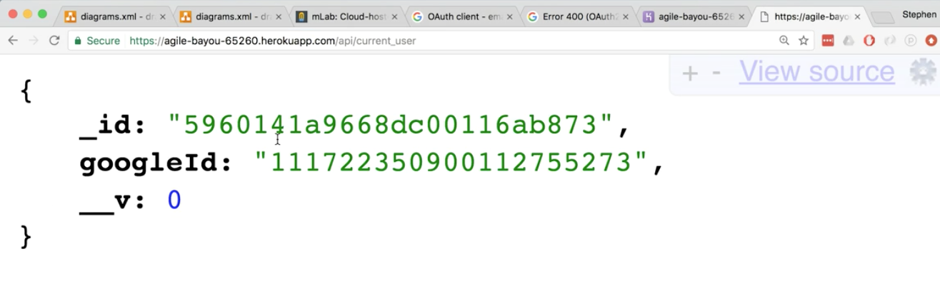

Shows you are logged in.

Then go to /api/logout

Should log you out.

This concludes the Dev vs Production section. Let’s move to the client side.

**React Section**

Doing the setup for the client side will be very easy, but understanding what is going on behind the scenes and understanding how the server is working with the client is very complicated and hard.

When we do the ‘easy setup’ we will take the time to explain what is happening behind the scenes. It will seem hard because we will be trying to figure out what happens behind the scenes. You don’t really need to understand the behind-the-scenes stuff. You can take an ignorance is bliss approach, but the course is meant to teach you what happens behind the scenes, so we will.

Don’t be scared, let’s do it!

Go to the terminal. make sure you are inside the server directory.

$ sudo npm install -g create-react-app

$ create-react app client

$ ls

This should list out all the files in server, including the new client folder. woohoo.

$ cd client

$ ls

The client has it’s own built in server. Now that we are in the client folder:

$ npm start

This will kick us over to the browser localhost:3000. We will get the React boilerplate. You can go into the editor and change App.js if you want to see it change with live reloading.

So we have now have a client side server running. We already had a nodemon server for the server side code. We are going to use both!

Why two servers and not just nodemon? Well, because create-react-app is super baller. It does a lot of things automatically. It makes sense to just go with it. The configuration between the server and client side will be easy to set up. We could try to wire up just one server but it will save time just to go with it.

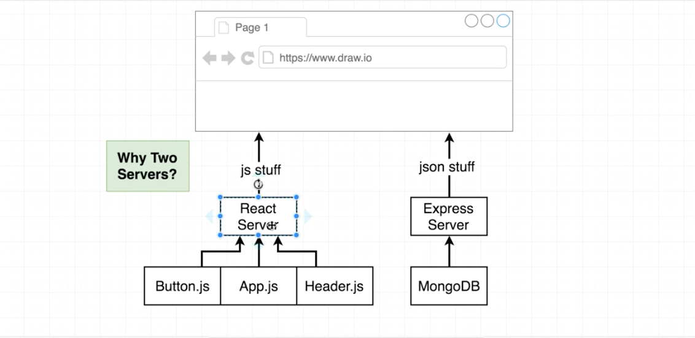

Now to get both servers up and running, we could open up two separate terminal windows and run the client and backend servers at the same time that way. Instead of that, we are going to download a package called concurrently, that allows us to run one command and spin up both servers.

Go to the package.json file in the server directory. NOT the package.json in the client folder. THIS IS IMPORTANT.

We will fiddle with the scripts in package.json. We want a script for the client server, the backend server, and both.

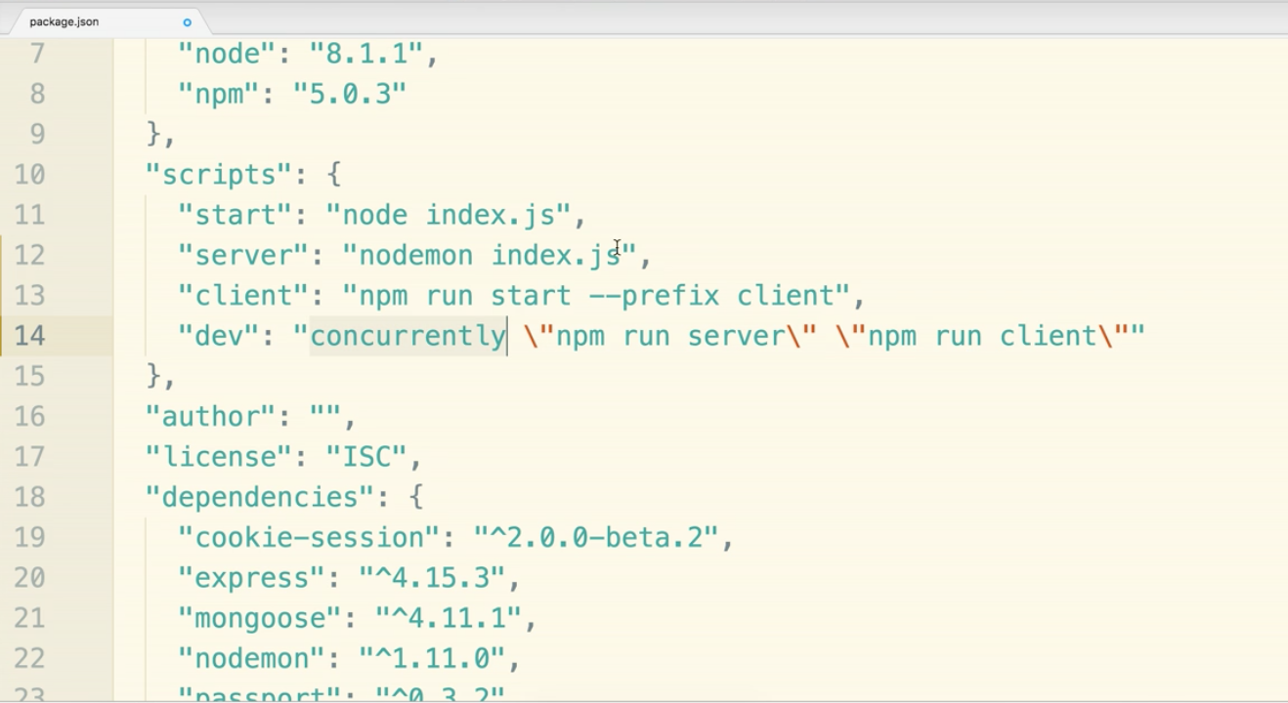

Notice a couple things. The dev command uses the concurrently package. The script has two commands that should be in double quotes. We use backslashes to “escape” the the character. We do this because the script starts with a double quote, so this would cause a syntax error and not read in the whole line correctly.

The “dev” command was changed from before. So there are 3 commands that are either new or changed here. Make sure your scripts match the screenshot.

Head over to the terminal.

$ npm install --save concurrently

$ npm run dev

You can now go to localhost:3000 and localhost:5000/api/current_user to see if both servers are up and running.

In the next section, we are going to hit a stumbling block. We have an easy fix to get the client and backend server working together.

We want to put in a button on the homepage that says something like ‘click here to sign in with google oauth’.

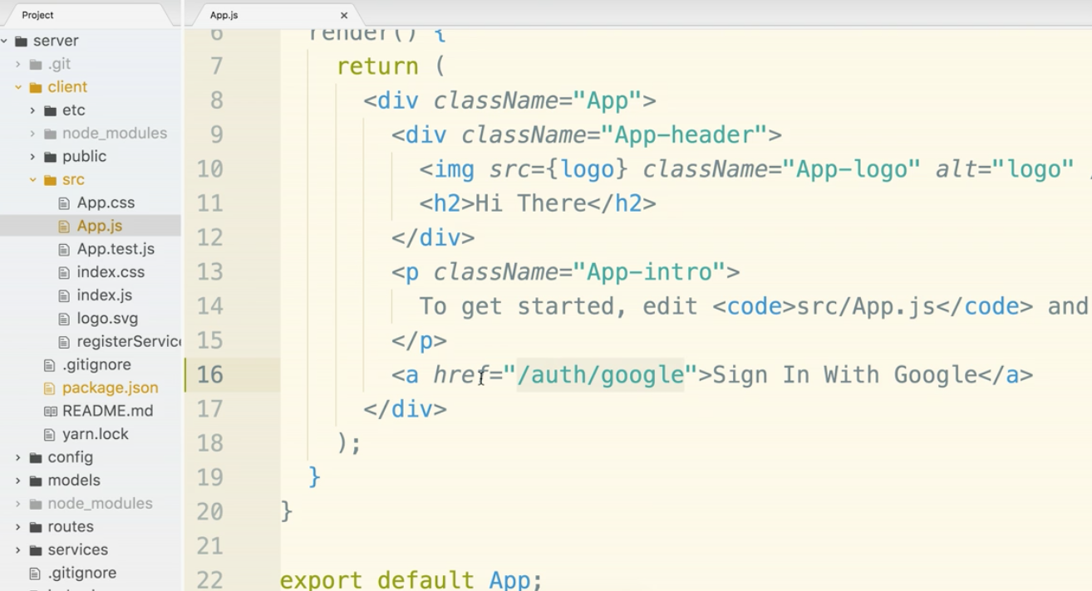

Notice that the link is a relative link. The /auth/google will go to localhost:3000 instead of localhost:5000. If we hard-code localhost:5000 however, the app will not work in production. This is an issue. We can fix it simply, but understanding what the heck is actually happening is a whole other story. Here is the simple fix:

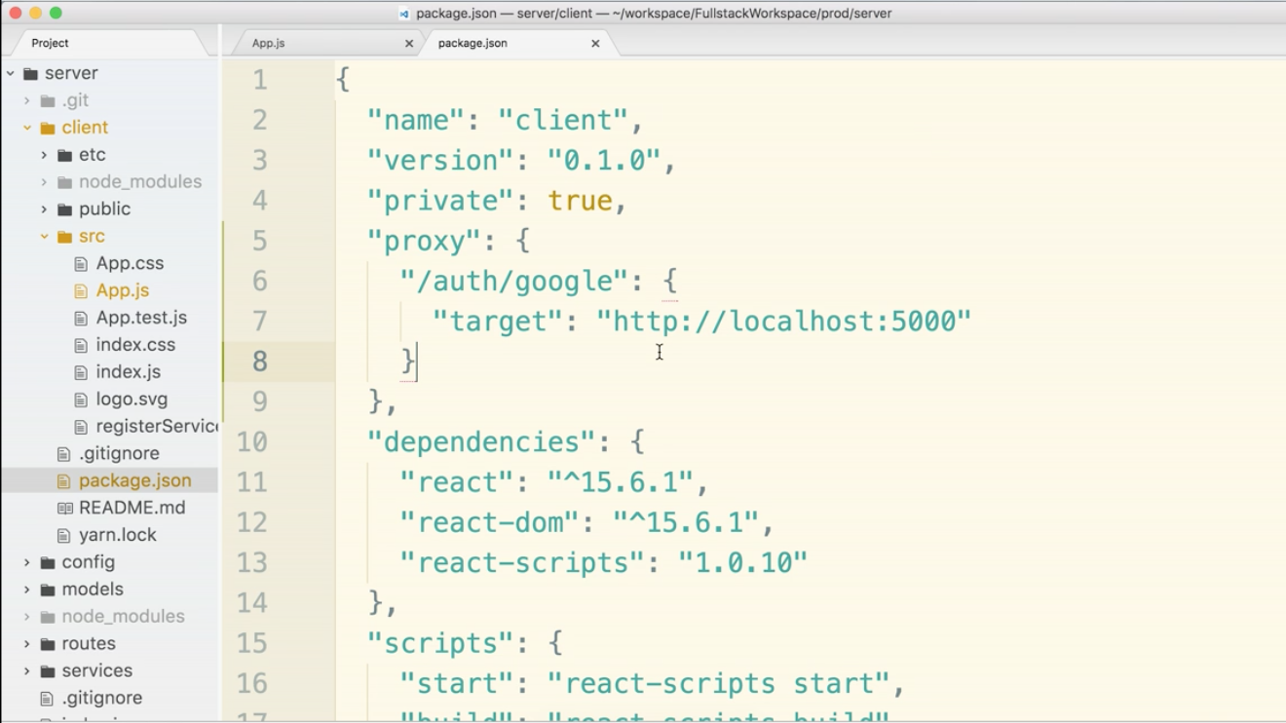

If you were to try this at this point, it doesn’t work perfectly there is a redirect error mismatch, but the fact that we got into the oauth flow at all is a miracle. The link oddly goes to localhost:3000/auth/google and actually kicks into the oauth flow. We would expect localhost:5000. This will be explained next.

First things first. Let’s fix the redirect issue in the dev environment. Clicking that link will cause a 400 error.

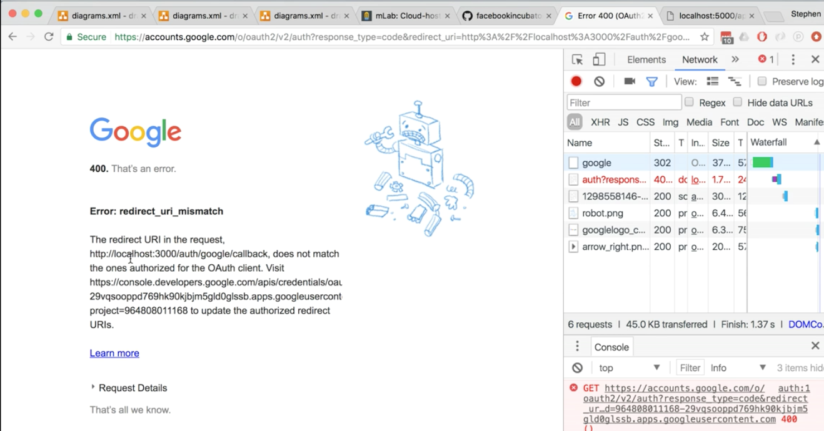Copy the console.developers link in the error and paste into the browser. Then copy the redirect URI request that we want to whitelist.

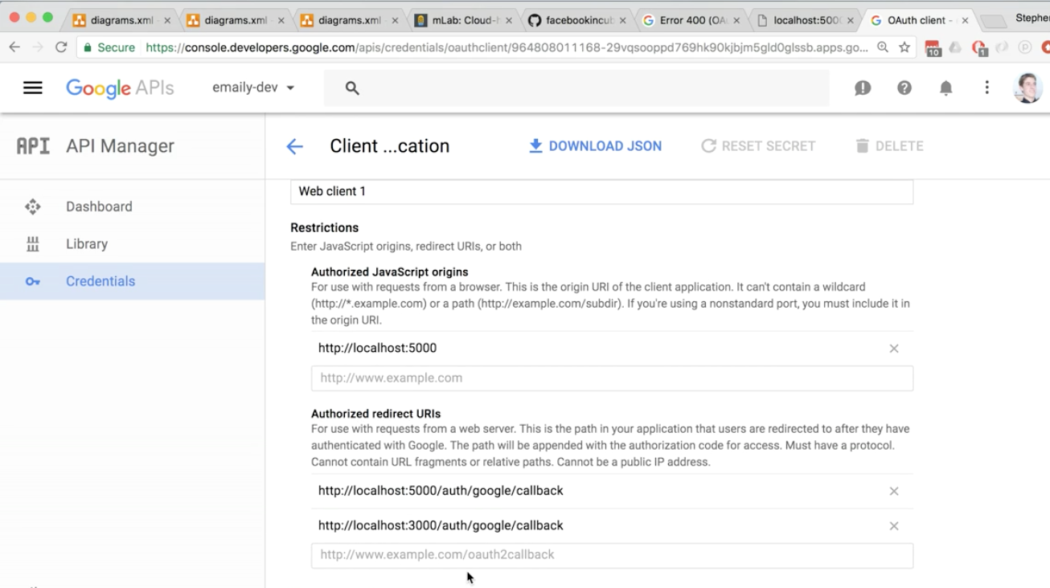

Let’s talk about the proxy thing.

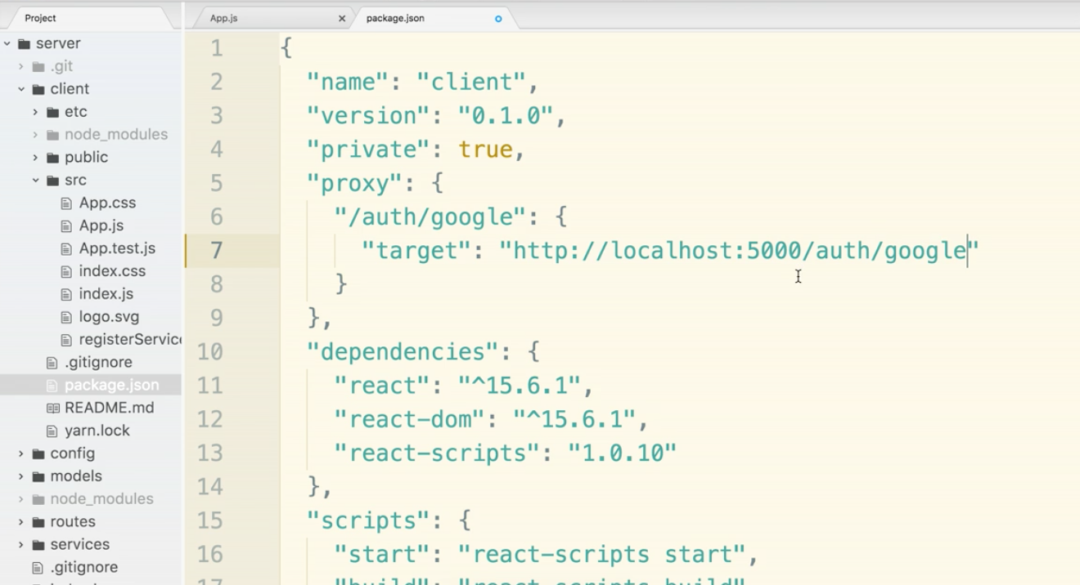

The create-react-app server has a proxy included. It allows us to automatically forward that request on to localhost:5000.

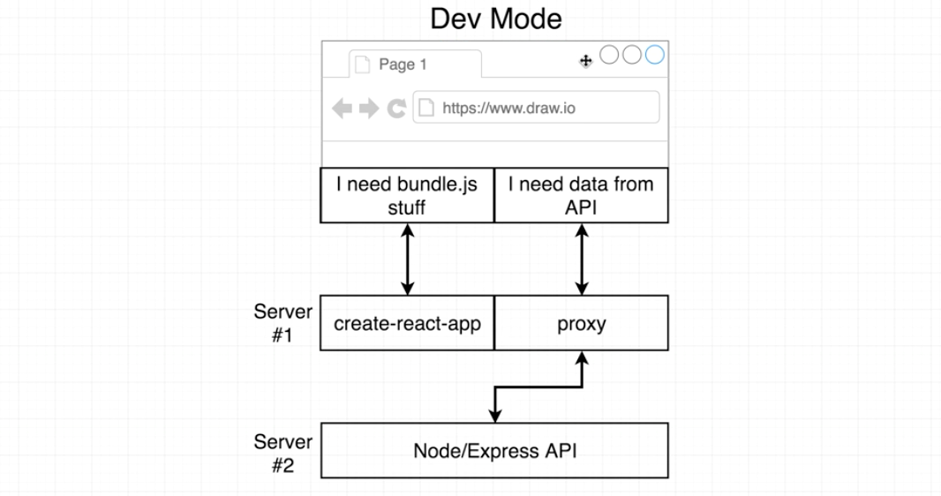

In production, the create-react-server does not exist. This works really nice for what we are doing. The relative links can now stay and it will work in both production and development.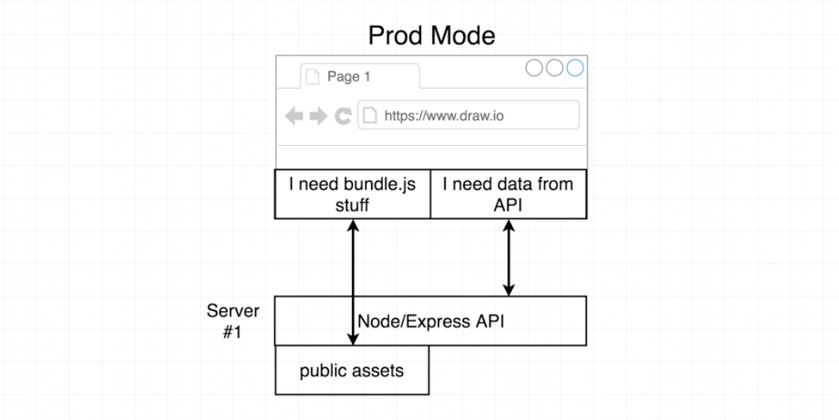

**Async/Await**

We will create a little test code to work with async await outside the project so that we learn the concept. Then we will go back into the project and implement it.

We want to write a function that makes an ajax request and returns a blob of json using the fetch function. Now, important to note, fetch returns a promise.

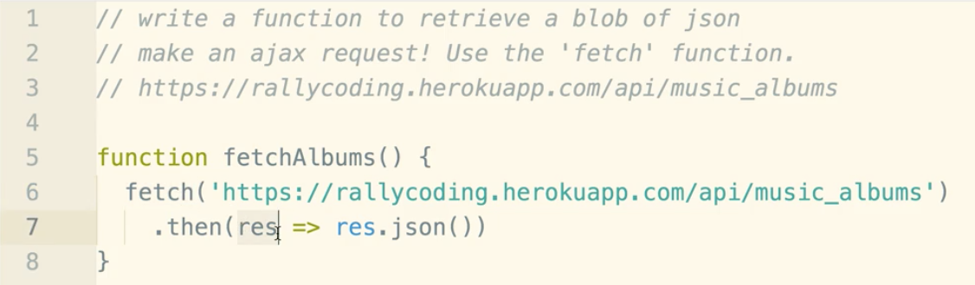

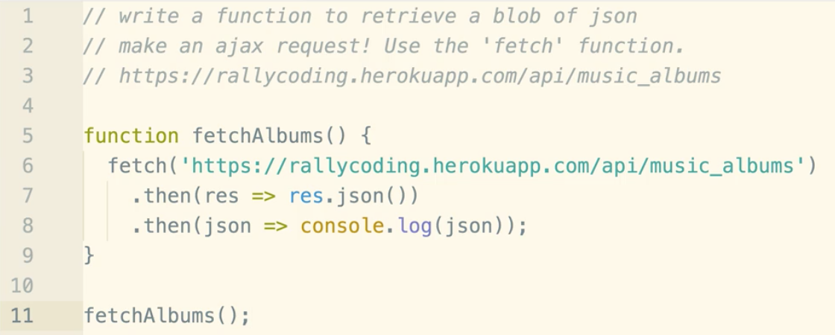

Copy this entire blob, go over to the browser and paste in the console.

You should get 5 albums returned. This should make sense so far.

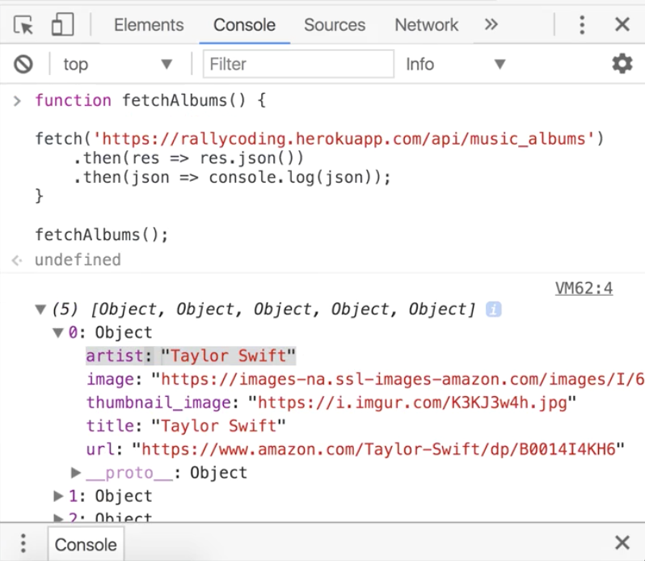



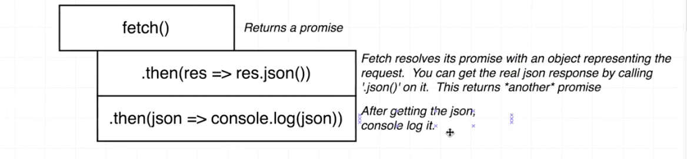

Now lets refactor the code with async await.

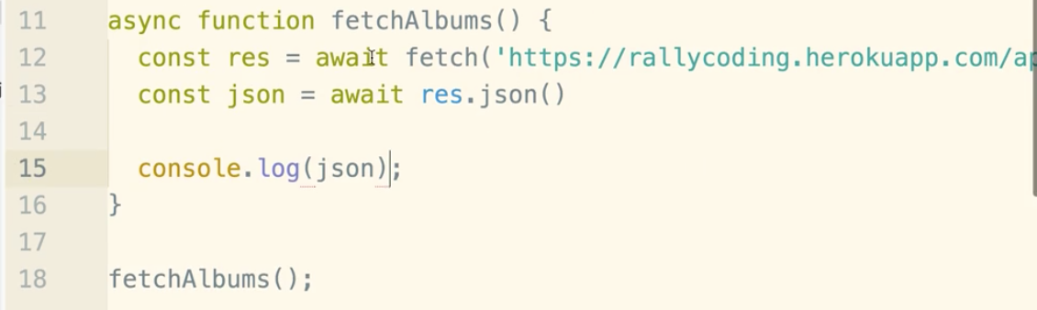

Taking it a step further, we can use an arrow function.

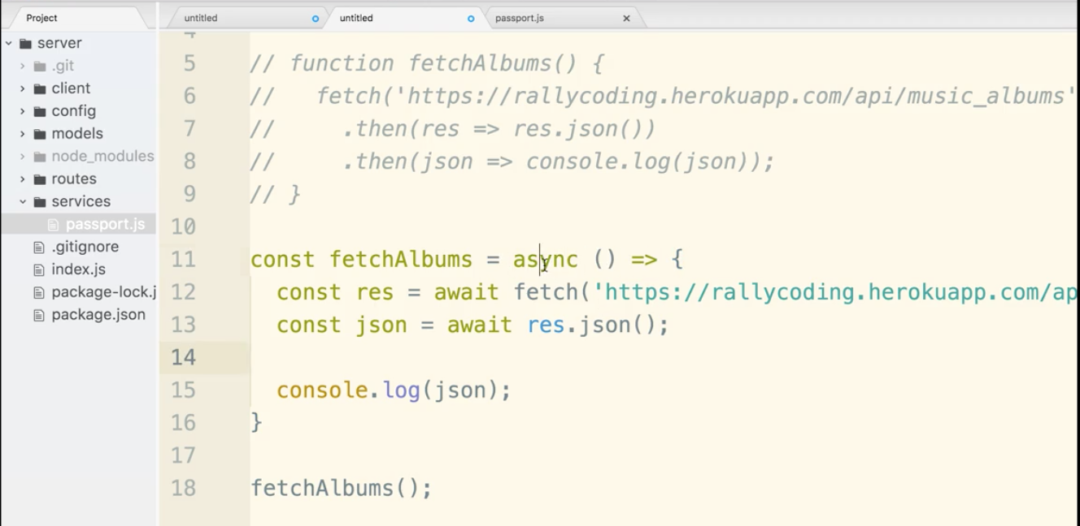

Now let’s apply that ability to use async await instead of promises in the passport.js file.

We will refactor the function highlighted below:

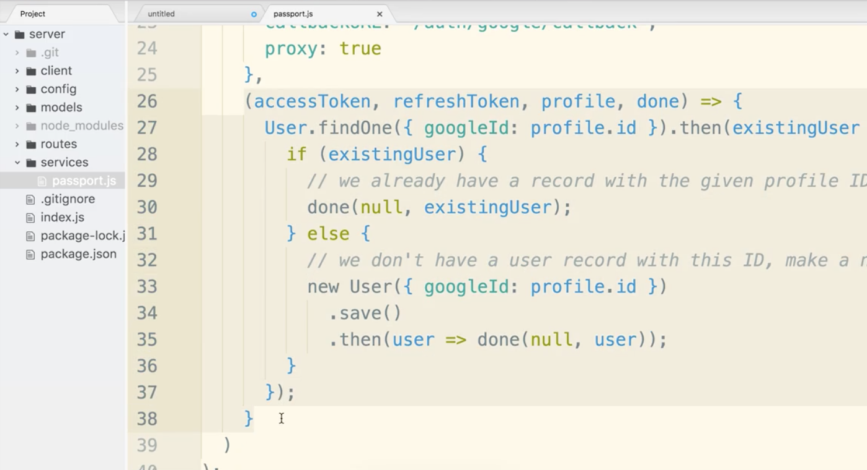

Begin by putting async in front of the function that has promises.

Then, remove the .then() statement but take the argument that it had and make it it’s own variable.

Then delete the .then() line and the matching }); below.

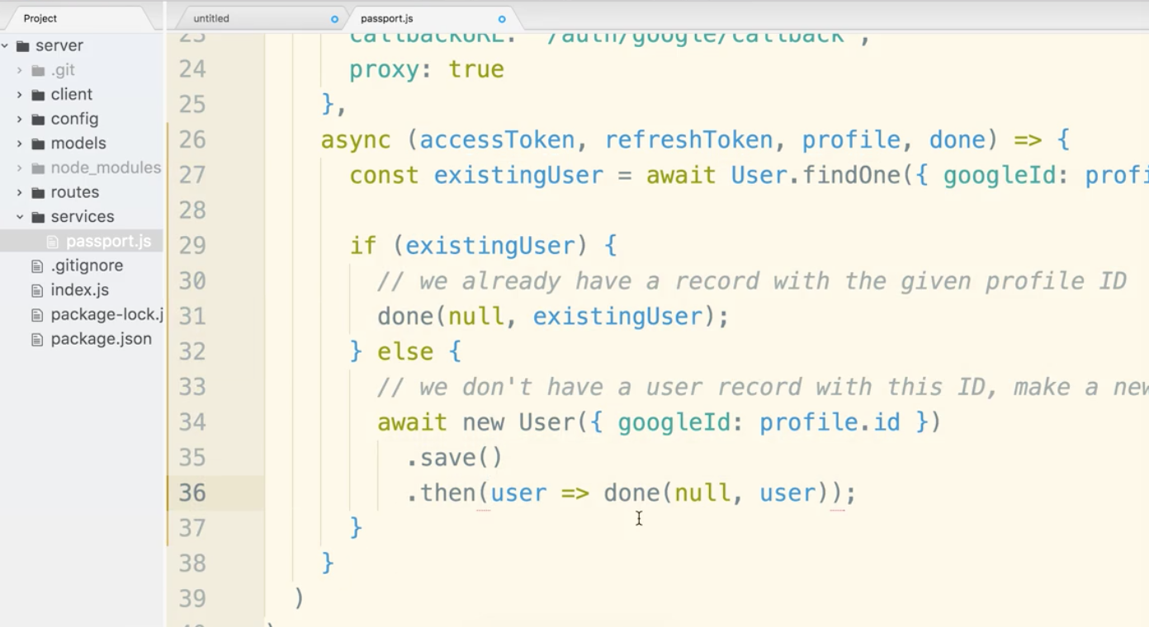

Now if you save, you should not get any syntax errors.

Now .save() and .then() promise needs to be taken care of.

We will add .save() to the end of the await line and take the argument user and make it a variable that get’s assigned to the async result.

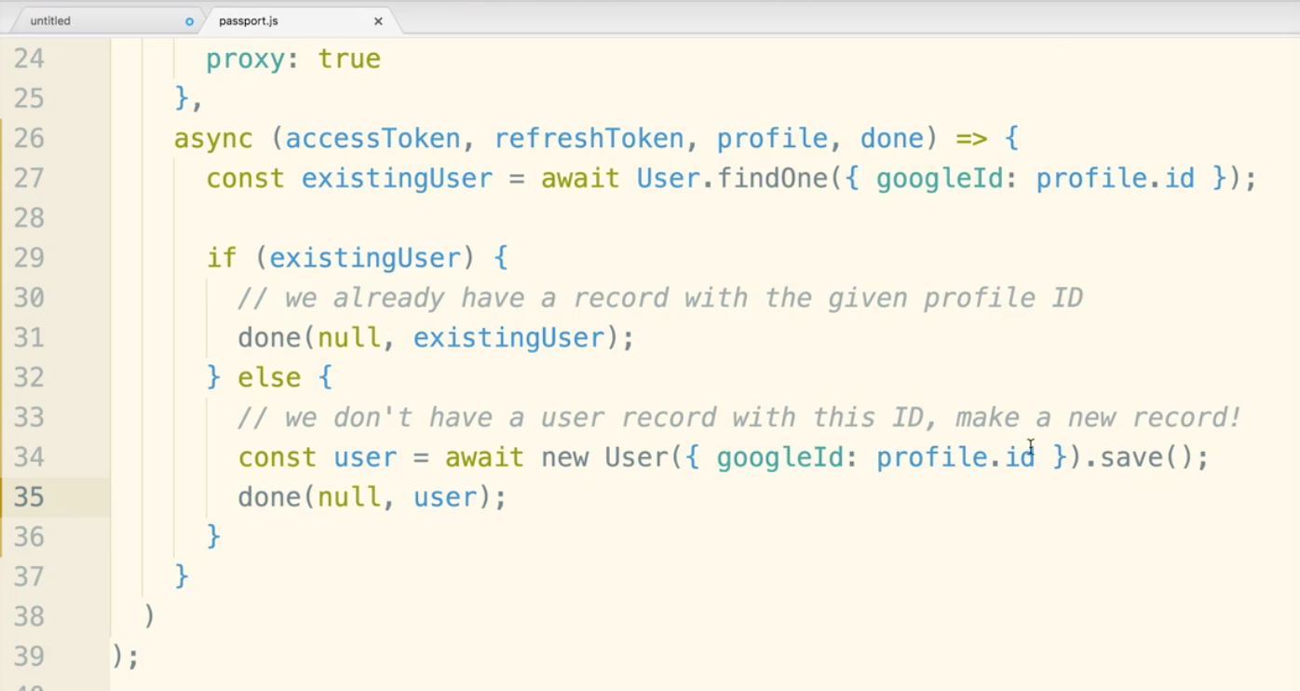

If you flip over to the terminal and your server is running, if should not show any errors. If it does, check for syntax issues. Another problem could be that you are running an old version of node. You could check your version as node -v

Should be above version 8. Async await came into play in the late version 7 of node.

If you clean up the comments front the last part it really looks clean and more simple then before

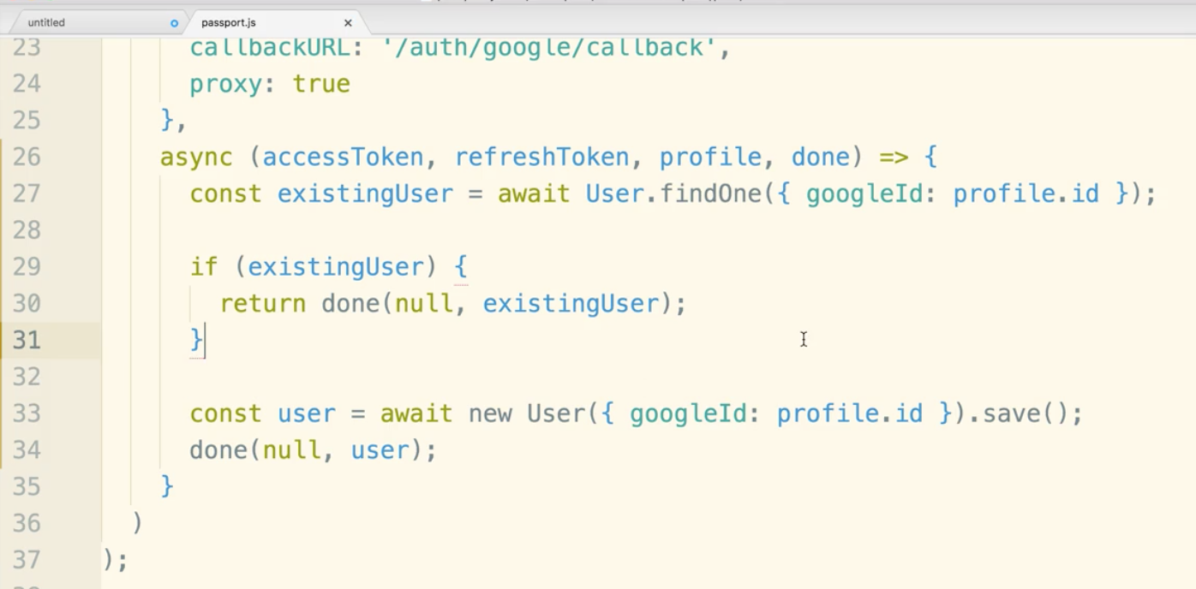

**Developing the Client Side**

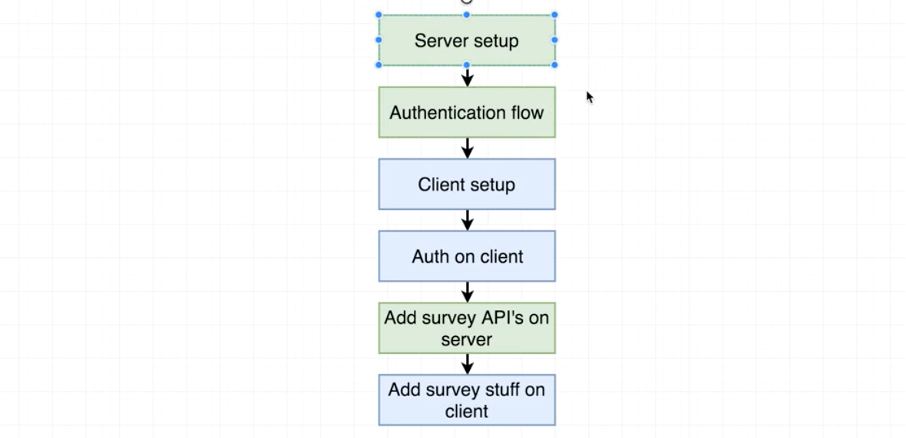

In general, you should stick to the front-end or backend and not jump back and forth too often. You end up with spaghetti code.

App Mock-up

Root Route:

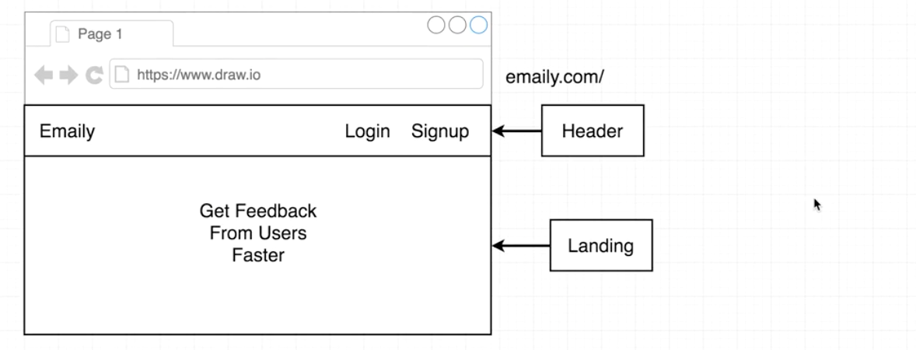

/surveys

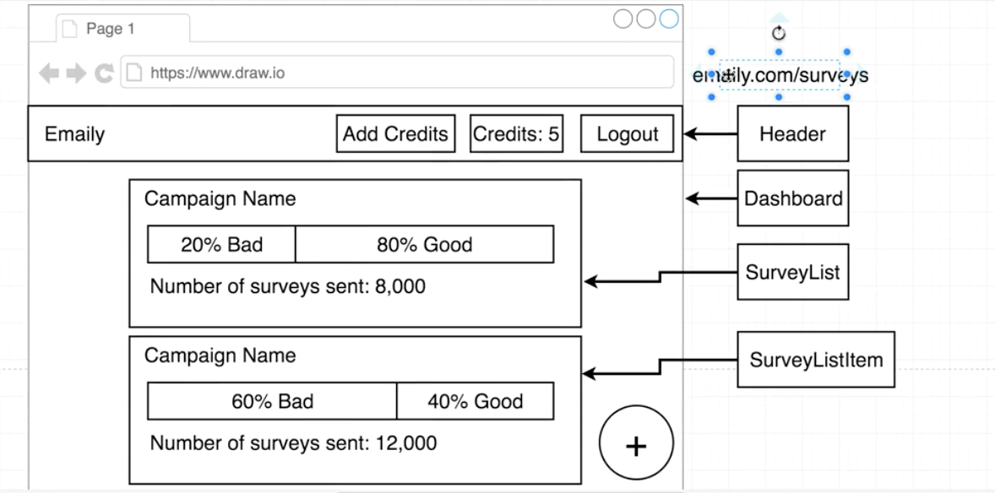

/surveys/new

shows a form

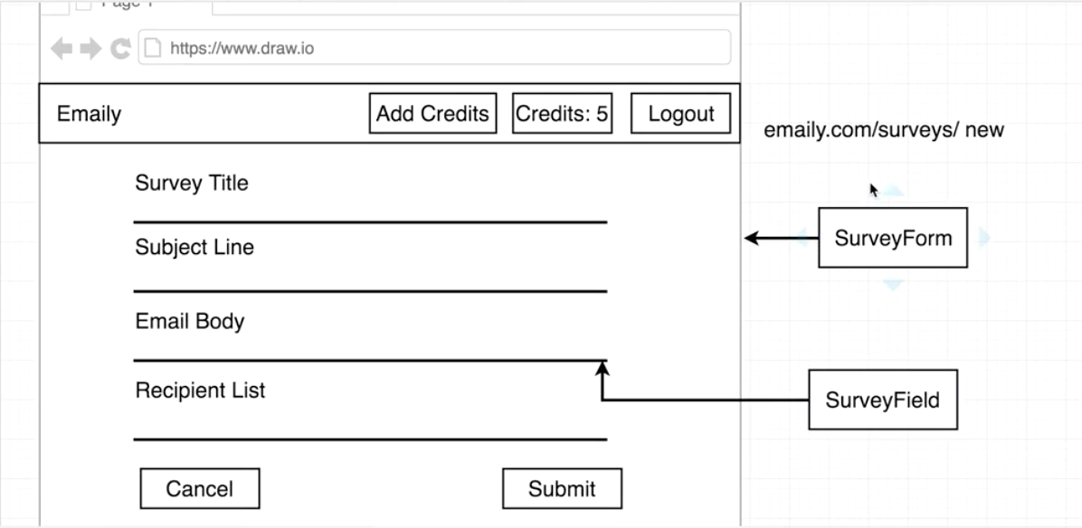

Within the client/src folder delete most of the files, you can leave registerServiceWorker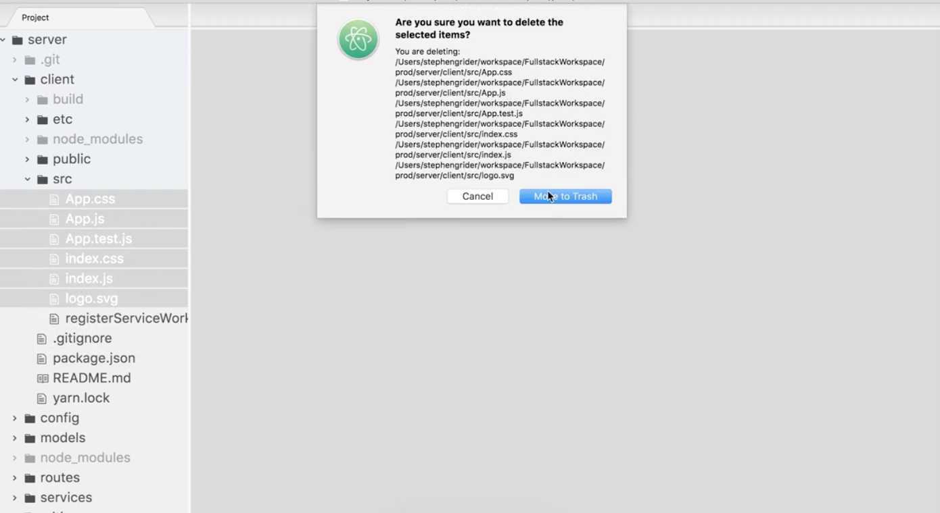

There will basically be two root files. index.js is all about redux. Separating the two files makes things less confusing.



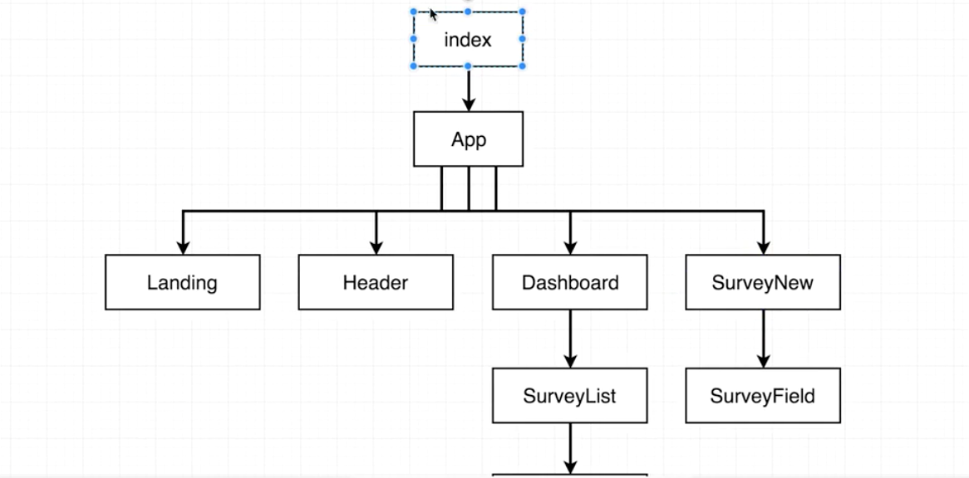

Go to the terminal and kill any running servers. You may see an error because we deleted all those React files.

**Important:** Remember we have two package.json files. When we add in redux and react router we have to be sure we are in the client folder of our app.

$ cd client

$ npm install --save redux react-redux react-router-dom

Now that all the files are deleted, you can make a fresh index.js file within src.

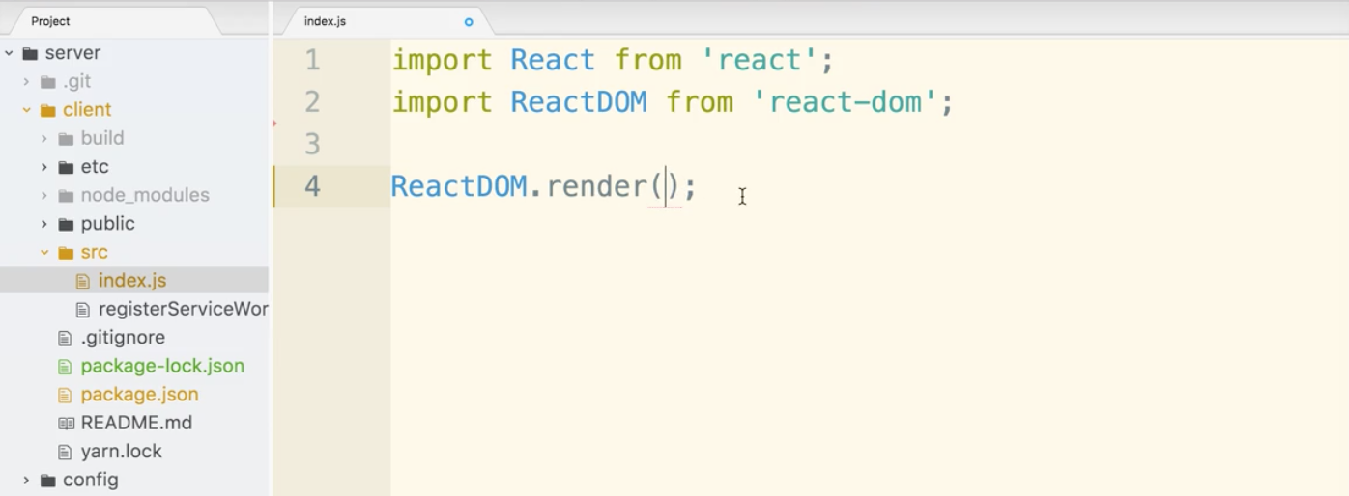

Just a note that create-react-app enforces that the file index.js is the root.

Now, add a new folder called ‘components’ inside src and create a new file called App.js.

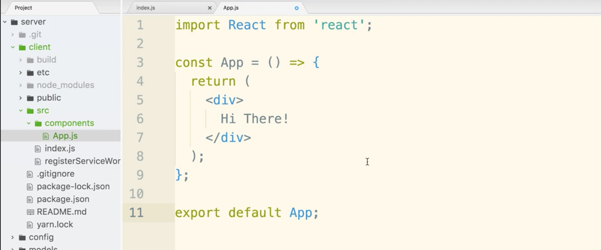

Now let’s get it to render at index.js

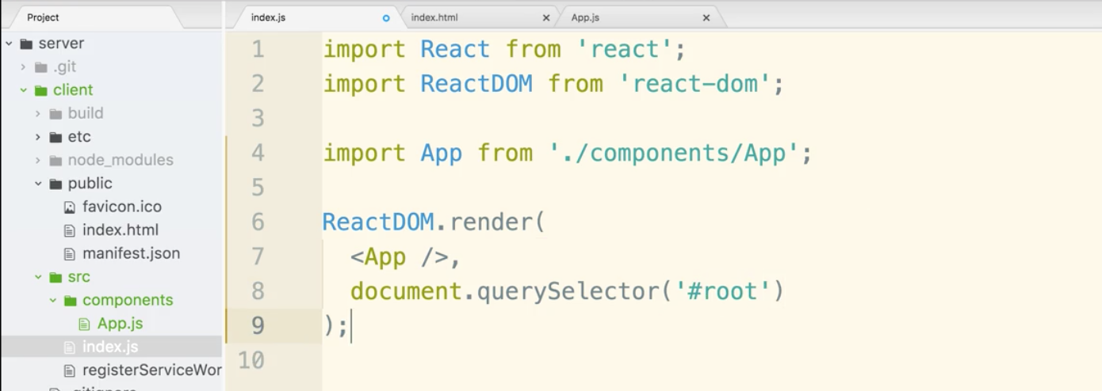

now let’s go back to the terminal.

The 3 new packages should be installed now.

Go back to the server directory

$ cd ..

Then inside the server folder:

$ npm run dev

React client errors might pop up. We will fix that up.

***If there was an error:

kill the server control c

then go into client directory

$ cd client

$ ls

delete package-lock.json. An easy way to do this is to just jump in your editor, right click and delete. (I think $ rm <file> is how you do it from terminal)

$ npm install

$ npm run dev

***End of error troubleshooting

Now go to localhost:3000, if you see “hi there” message, you are in good shape.

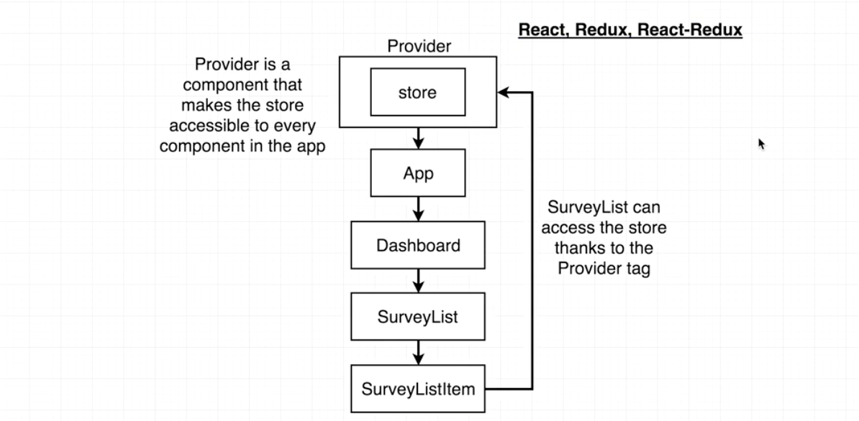

Two reducers is the plan, but we could have more once we get into it.

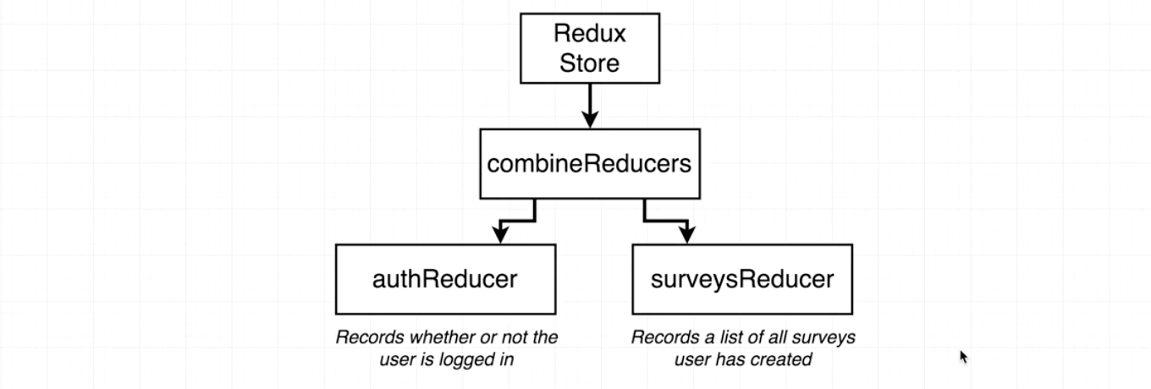

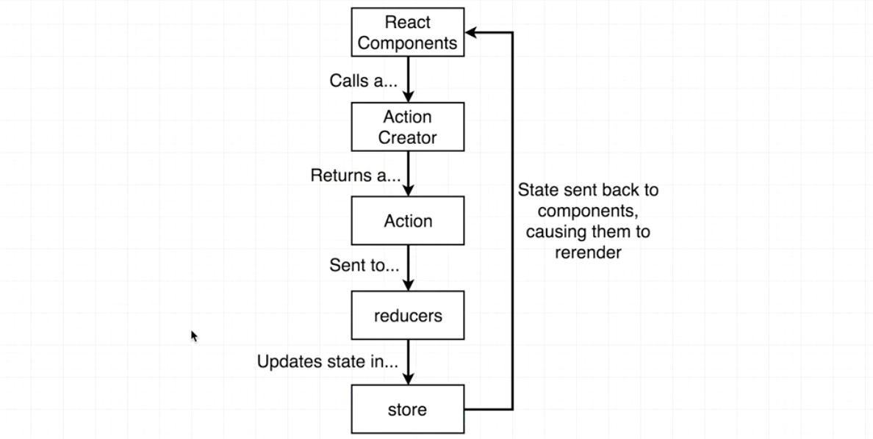

Let’s get index.js setup. When we use create store, we are putting in a dummy arrow function instead of an actual reducer. We are doing this so we can get things up and running. The second argument is an empty object, that represents the empty initial state.

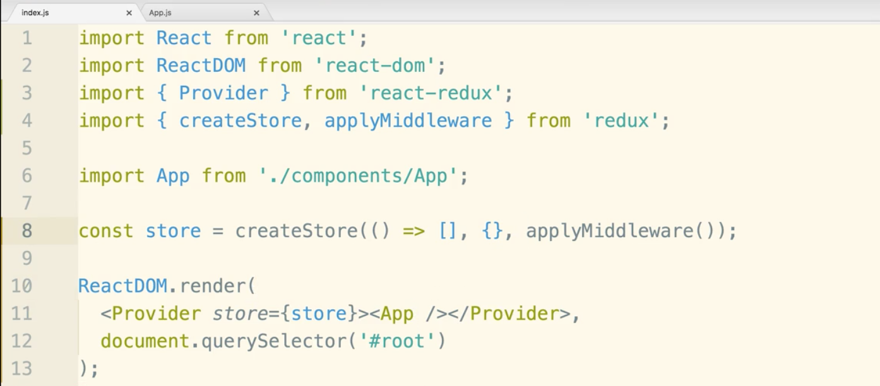

If we go to the browser, localhost:3000, we should still see it running with Hi There!

Now let’s create a reducer to replace the dummy reducer in createStore()

We will have at least 2 distinct reducers before we are done.

Let’s do the authReducer.

Create a folder called ‘reducers’ inside of the src directory.

Now create a new file in there called authReducer.js.

Quick note, the ‘a’ is lowercase because we are exporting a function here and not a Component class.

Now create another file in reducers called index.js. (This may seem odd, because we now have multiple index.js files in different folders of our project. This is normal convention in react redux projects and it will allow us to import files more easily.)

Now open your editor in authReducer.js

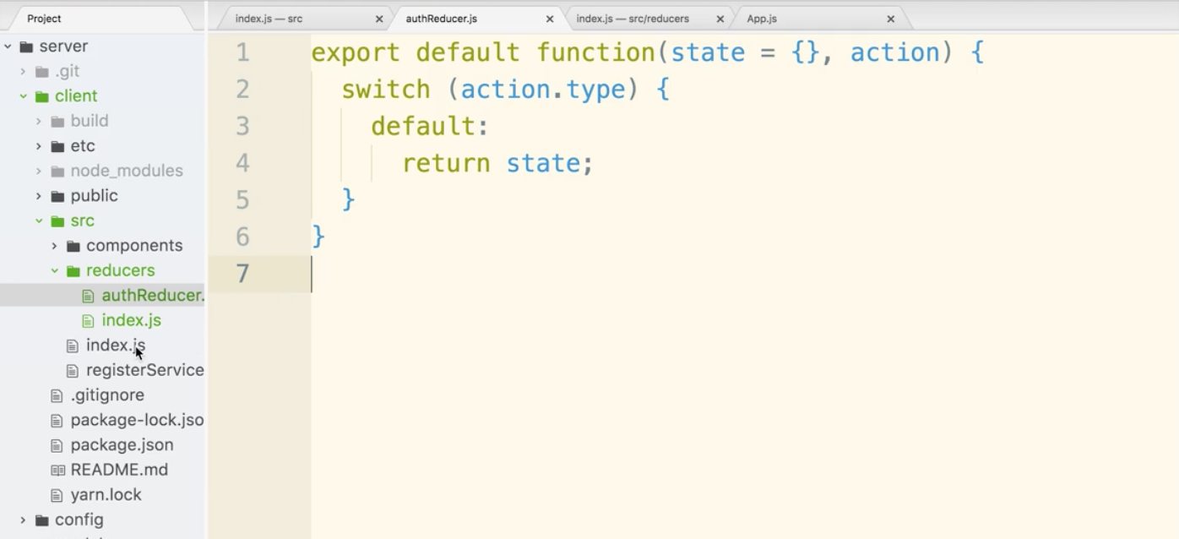

Now let’s work in index.js. We will combine reducers and export it. The key in state will be auth. You should put time into what you want to name the key. auth makes sense.

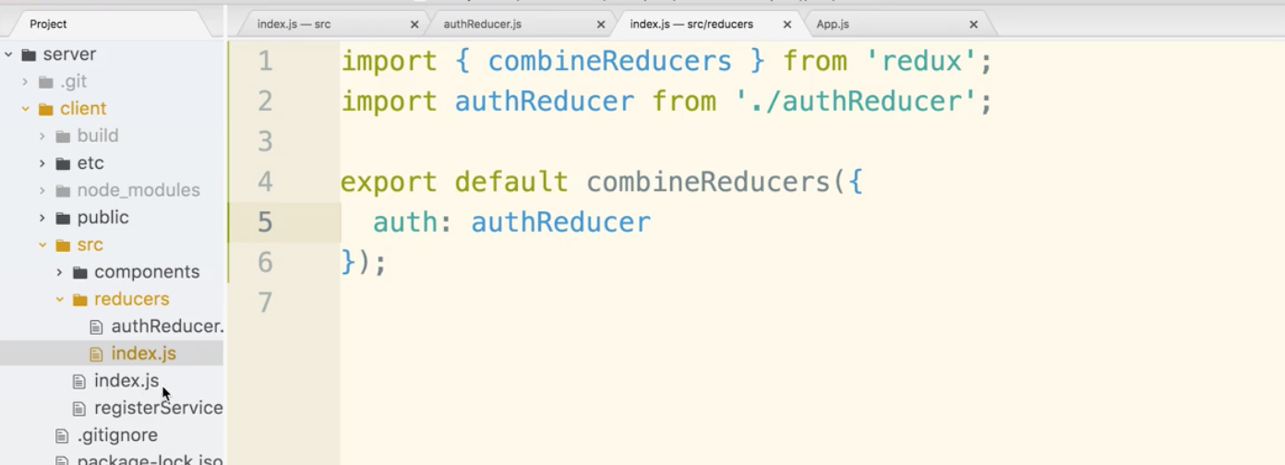

Go back to the other index.js file.

import reducers from the reducers file and then pass it as the first argument in createStore()

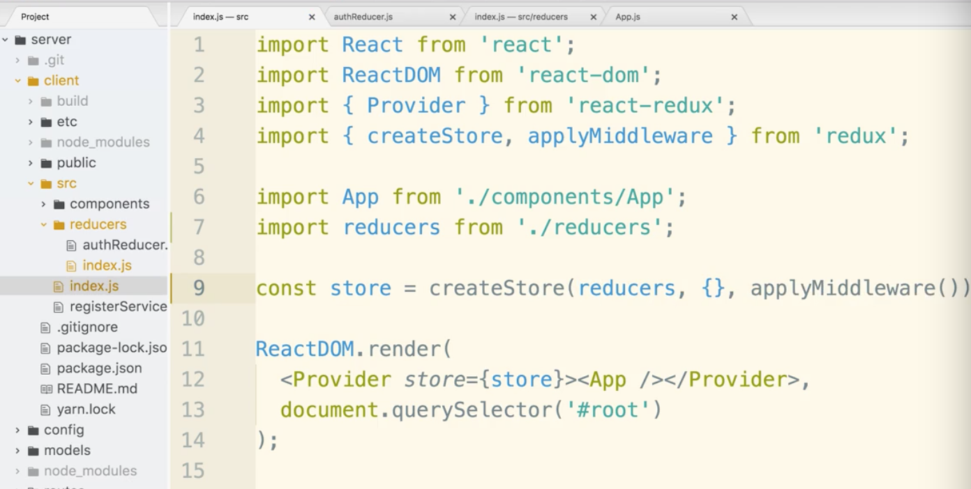

Now we can test to make sure the server runs.

You can check the terminal and the browser. No errors should show in the terminal and Hi There! should be at localhost:3000.

At this point we have a single reducer, the authReducer.

Looking at our diagram we can notice that Header component will change based on the the auth data.

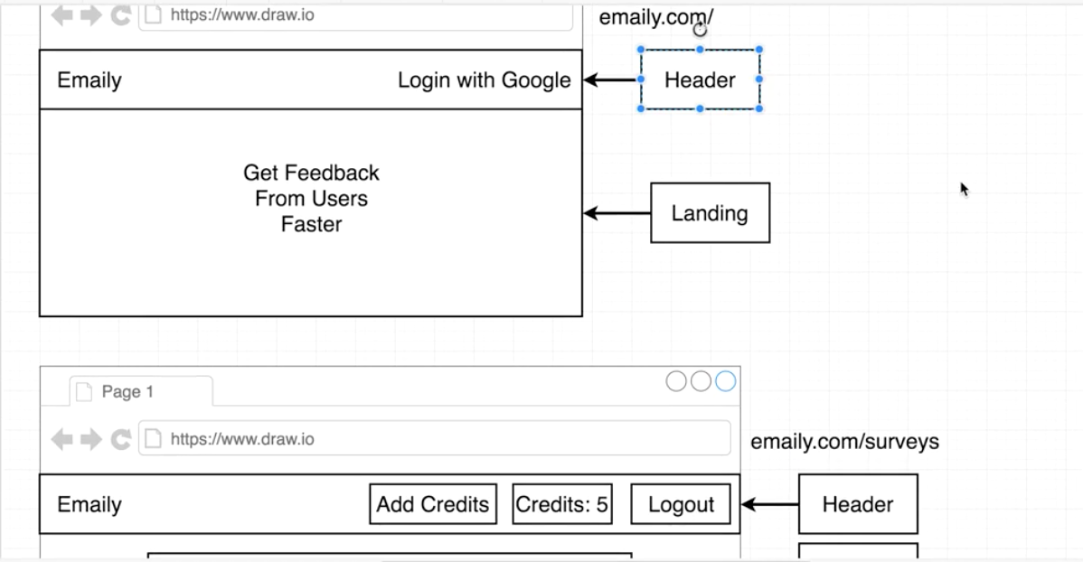

Looking at the diagram, we notice that the Header and Landing components can be viewed by any user, but we want the other components shown to be hidden until logged in.

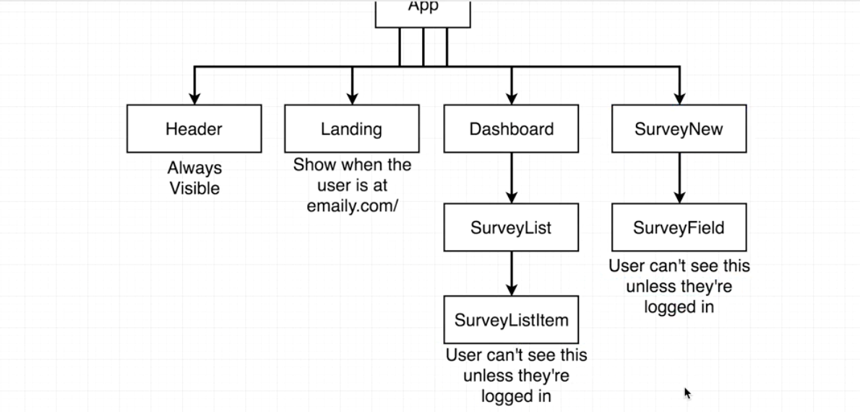

All the configuration around the navigation states of our application in App.js.

App.js is responsible for all that initial view layer setup.

index.js will be more for redux.

Start by importing BrowserRouter and Route from react-router-dom into App.js.

BrowserRouter is the brains of react-router, it tell the app how to behave. It looks at the current url and then changes the components that are visible on the screen.

The Route is used to set up a certain rule between a url and a set of components that will be visible on the screen.

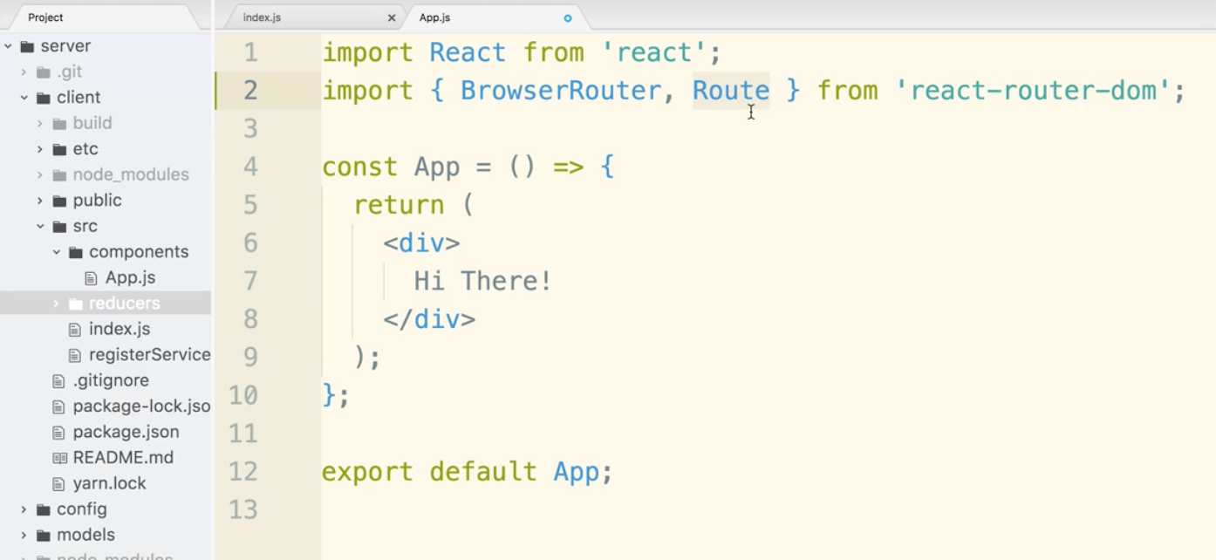

Let’s begin by setting up some dummy components to get an idea of how this works. We can come back later and change them.

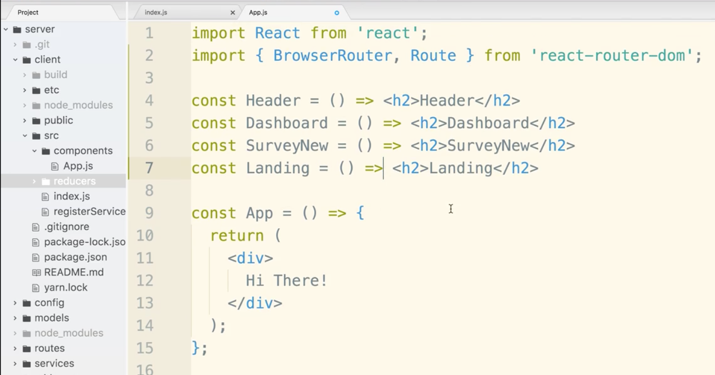

delete Hi There! Leave the top level div.

We will now place BrowserRouter in the div. (It is a React component by the way).

Now, we will place several routes in there.

BrowserRouter can only have AT MOST one child. So let’s put in one div to satisfy this requirement.

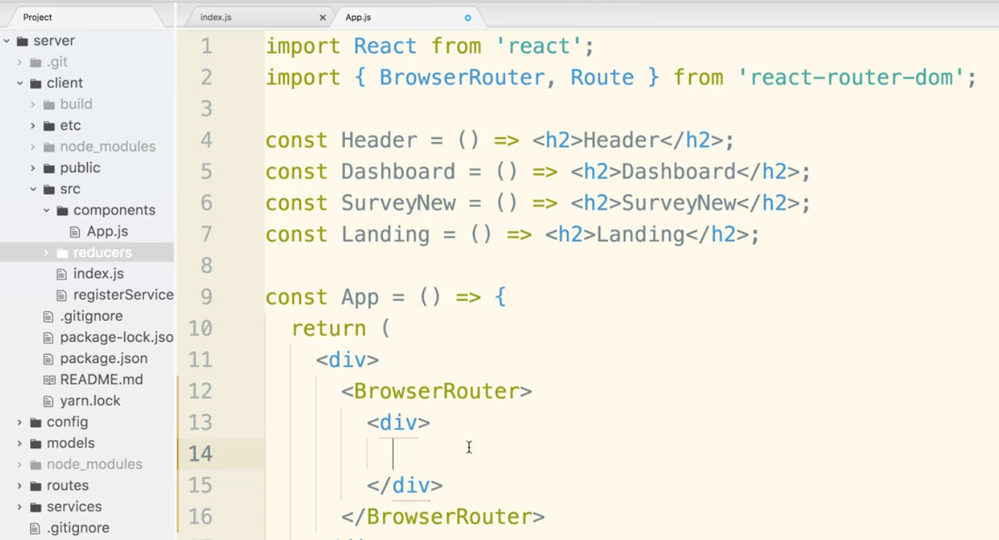

Let’s start with the root file path and point it to the Landing component.

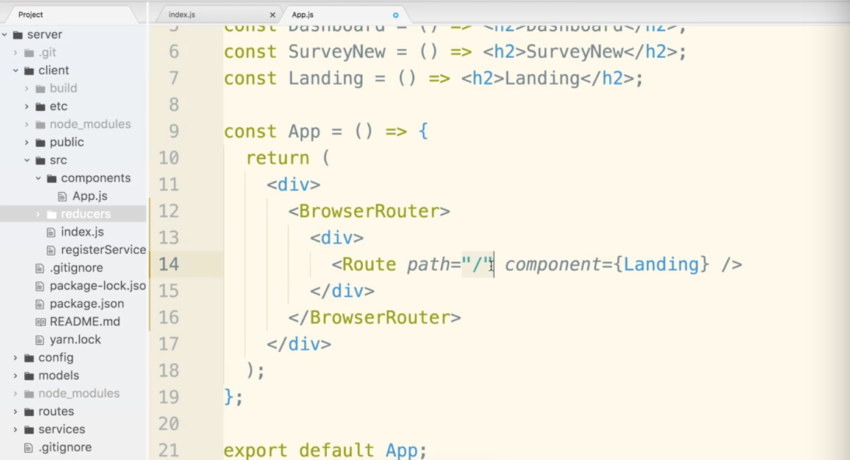

Now you can go to localhost:3000 to check this out. You may see some warnings if you have the console open. We declared components and never used them. That’s ok for now. You should see Landing on the home page.

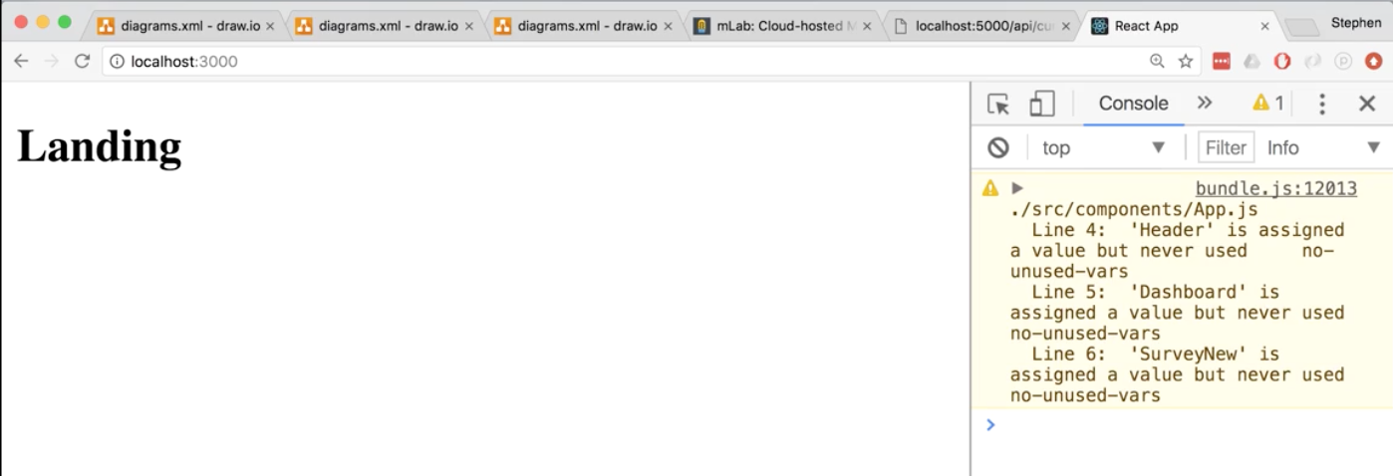

Now let’s try some more advanced routing. You may see some behavior that seems unusual.

Lets add a route under “/”.

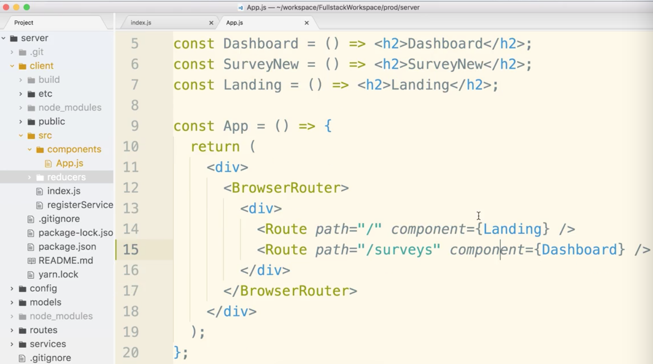

Notice what happens at localhost:3000/surveys :

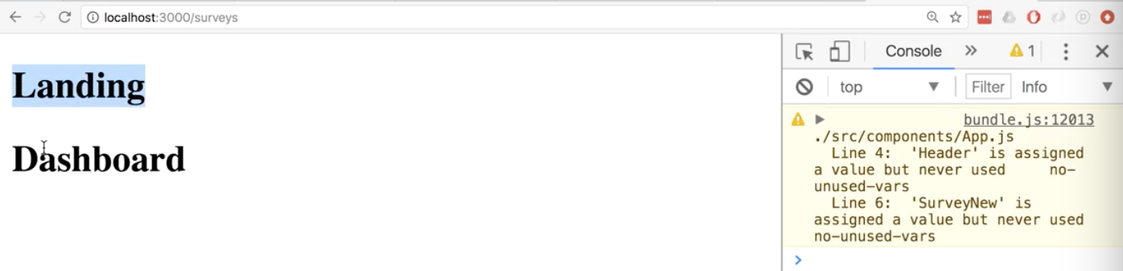

That’s not what we want!

React router takes the string “/surveys” and matches if the url is in the path. So the root “/” is in the path, it’s in all paths that start with “/”. It does a “greedy match”.

We need to pass an additional property to prevent this. exact={true}

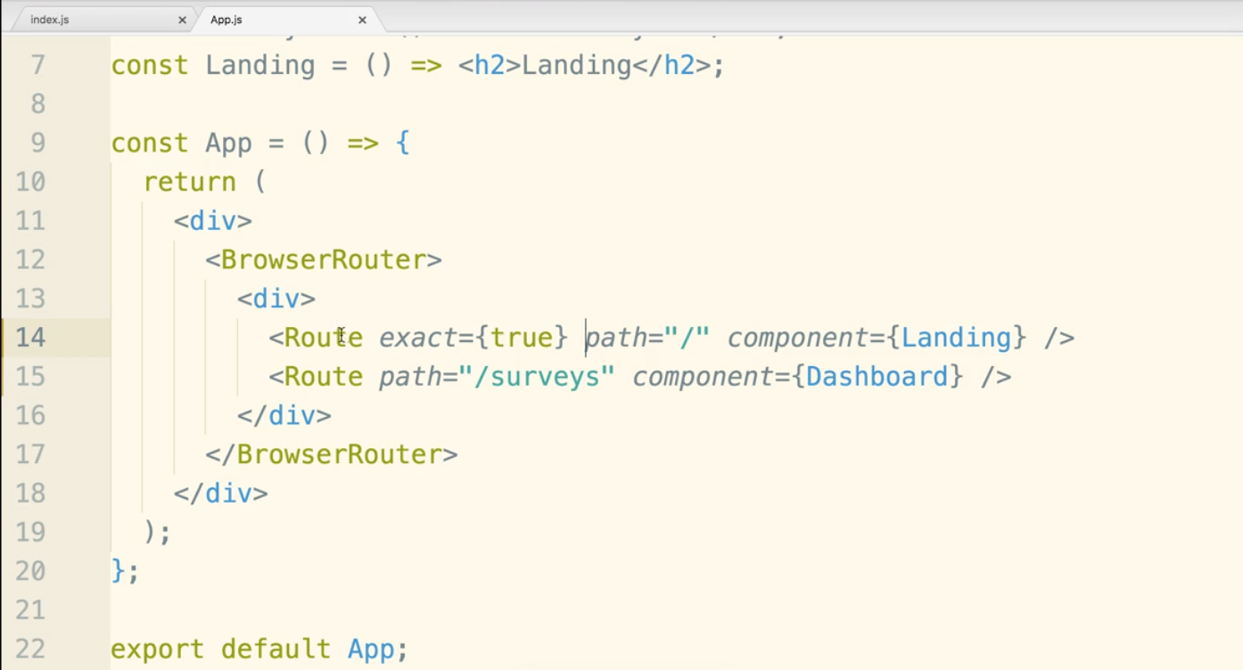

Now, a little jsx trick. If you pass a prop with not ={} it will assume you meant that prop is equal to true. So you can just write exact and it will do the same thing:

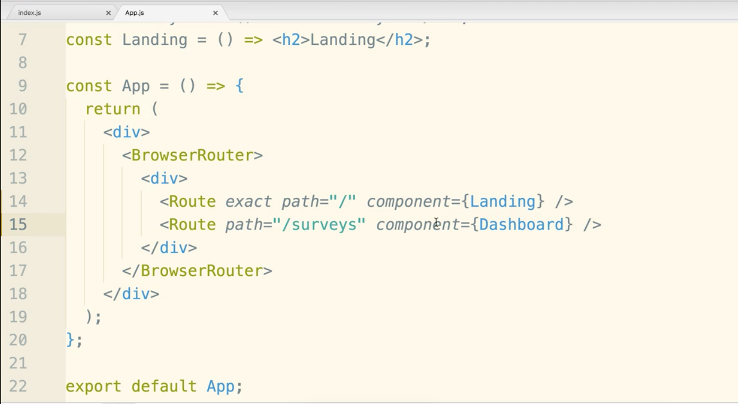

Now SurveyNew will share a similar path to Dashboard, for that reason we need to use exact again.

<Header /> is cool. It will render on top of all routes if you place it above like so:

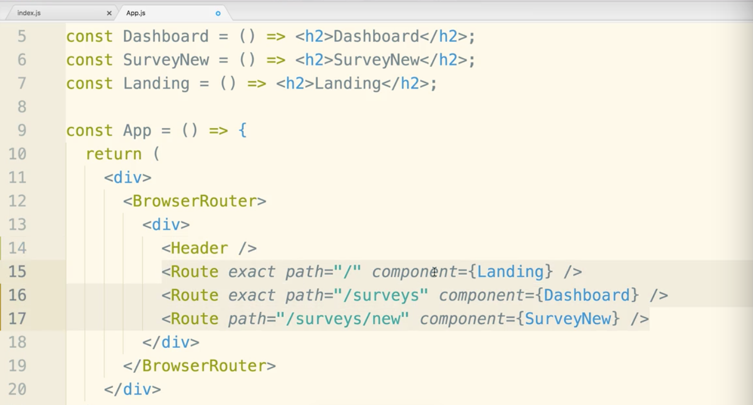

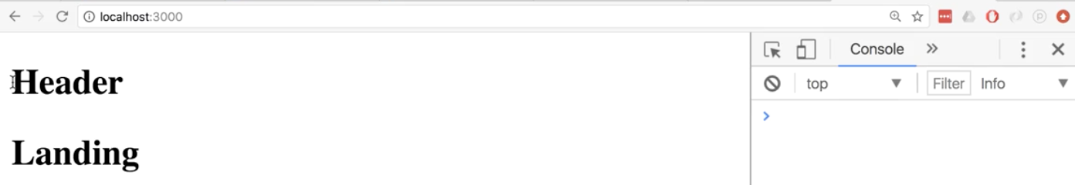

Let’s focus on Header. We will break it out to a separate file.

Delete it from App.js and create Header.js

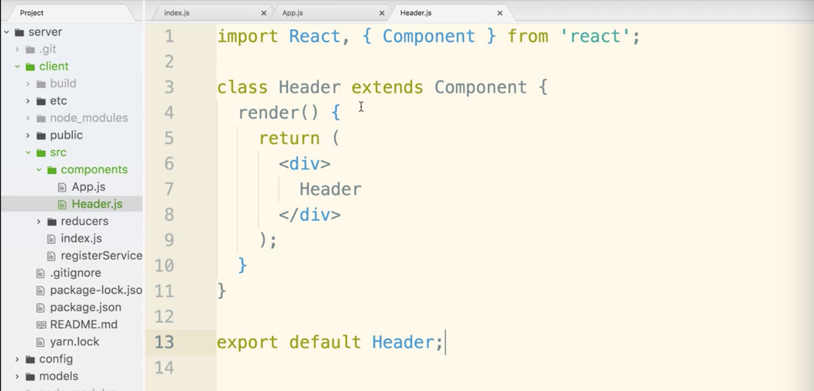

Be sure to put an import statement in App.js:

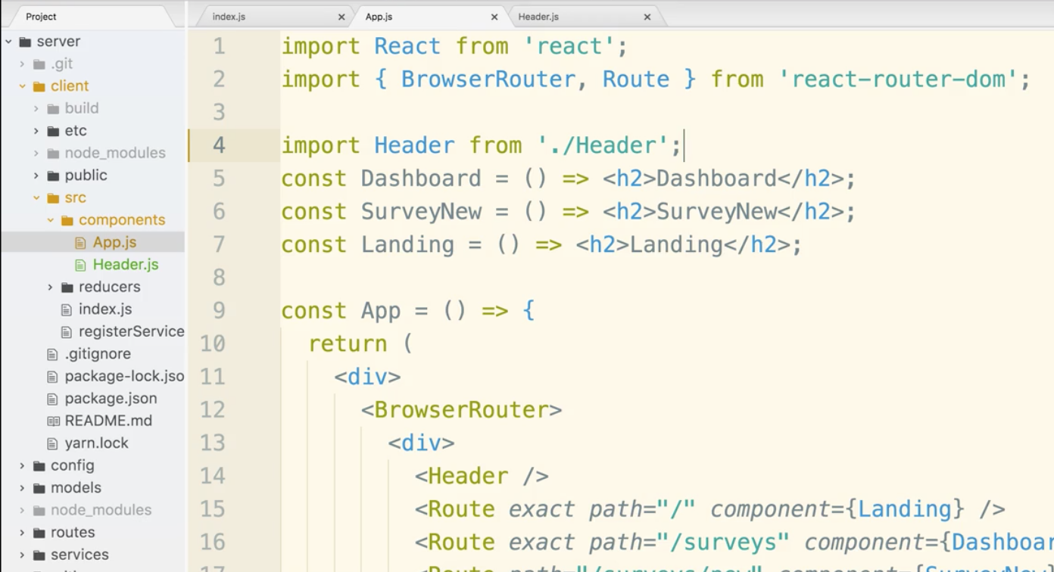

We know it works if it looks like this live:

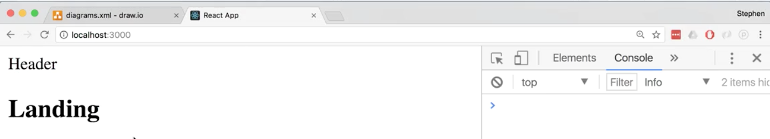

We will use materialize css. It is a service that provides css and a few javascript plugins that you can optionally use. materializecss.com

Materialize only has partial compatibility with React. A lot of the plugins won’t work out of the box.

Material-UI is a library that is similar and is built for React, however, we will not use it. The big reason is that it uses javascript styling and not css styling. CSS is way better and built for style. The javascript styling can be hard to overwrite the CSS. Life is not straightforward with JS styling. A lot of styling is inline and not good.

Two ways to use materializecss.cmo

CDN with a link tag or npm. We will use NPM

$ cd client

Make sure you are in the client directory!

$ npm install --save materialize-css

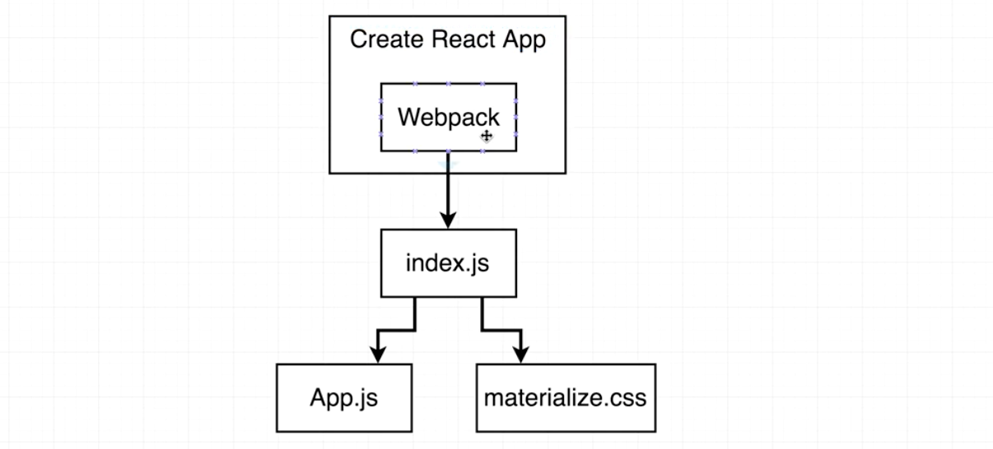

Webpack is a module loader. It takes several javascript files and condenses it one or very few files. It doesn’t just process JS, it can also use what are called ‘loaders’ into webpack that instruct how to deal with other types of files as well. Out of the box, webpack handles css.

So in the code editor, go into the client directory. Pop into the node_modules folder.

Open materialize-css folder, then dist folder, then css folder.

You will see the css and file and minimized css file in there. The minimize folder is the one we want.

We will import the css file in index.js, but it can actually go in any of the files.

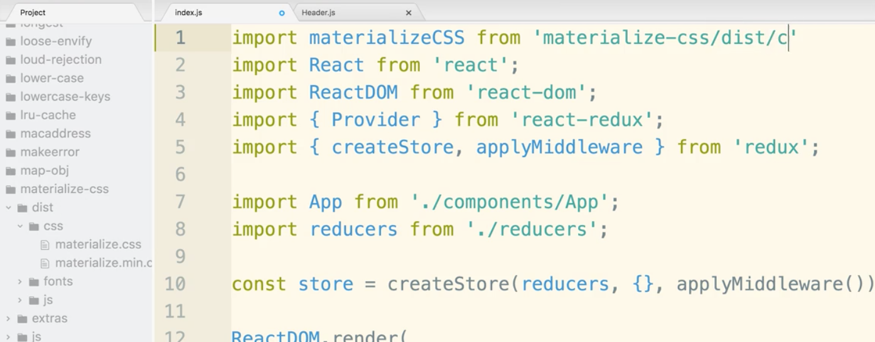

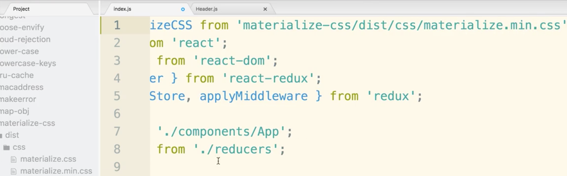

When we import non-JS files we HAVE TO include the file extension at the end. Hence the .css.

You will also notice that we did not use any relative path name, it is assumes that you are looking in node_modules. No “./” stuff needed.

Last point, we do not need the variable materializeCSS or the from. We are just reading in the whole file so we can shorten that line.

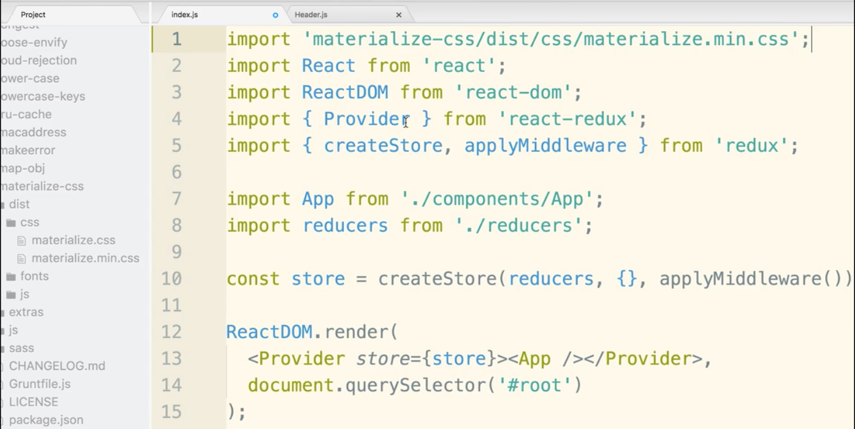

Now, restart the server.

$ npm run dev

You will see the subtle change to the css: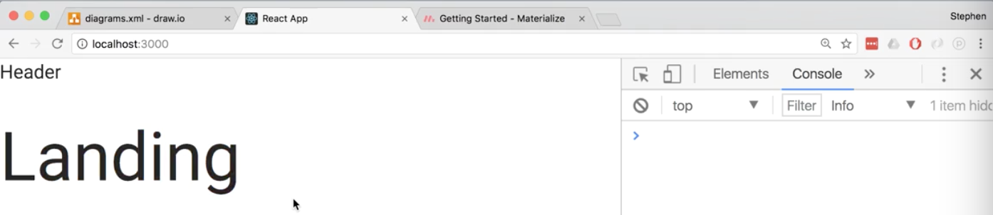

Materialcss has a bunch of “components” listed on their website that have snippets to create things like the navbar. NOT a React component. When they say component they mean a snippet for a part of a website in html with css classes and ids.

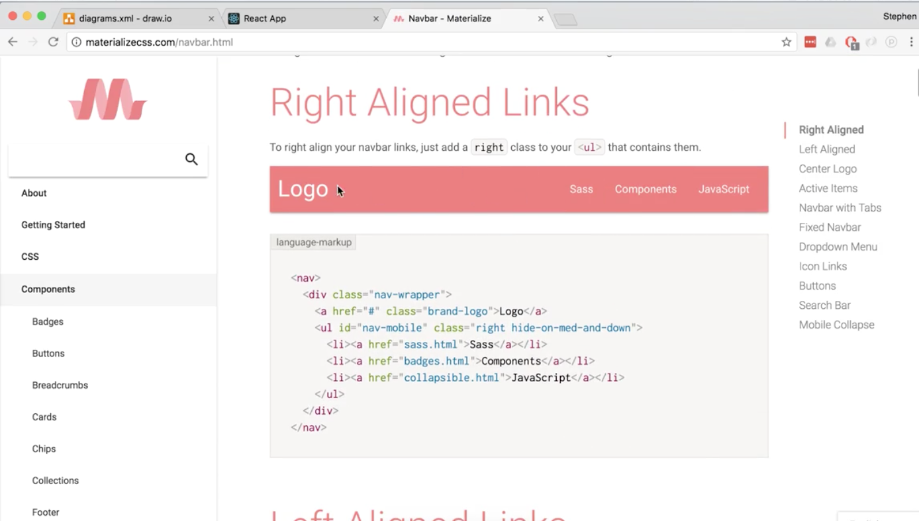

You could copy and paste or use it as a guide. In Header.js add a nav:

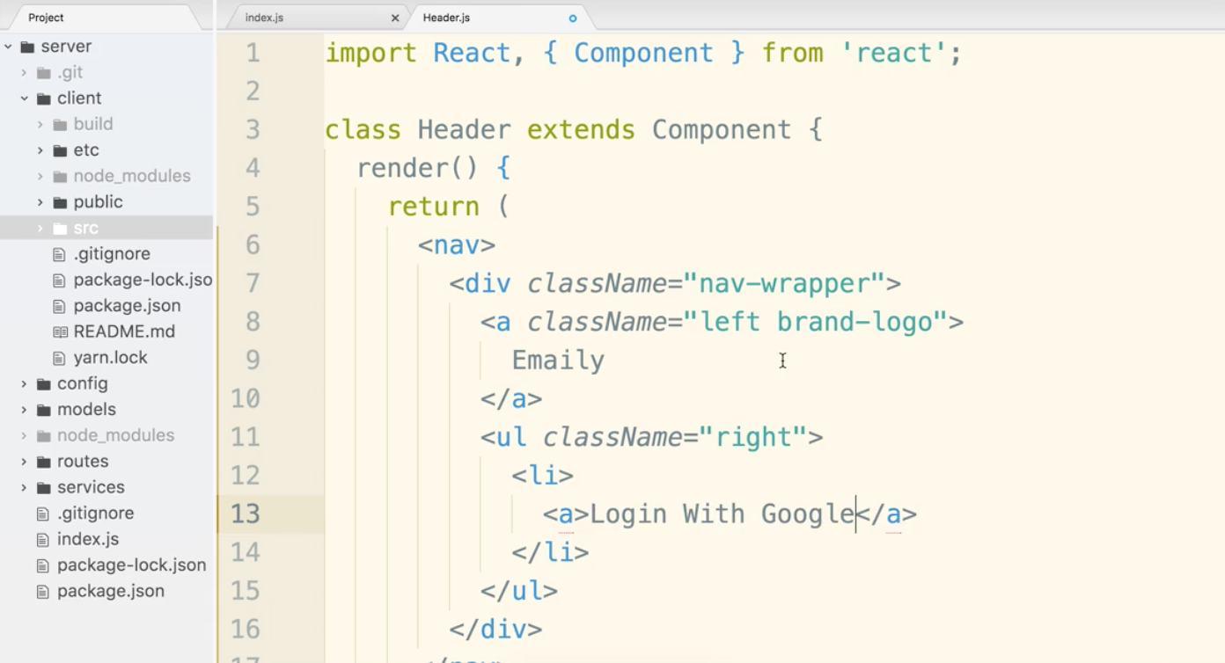

Should now look like this:

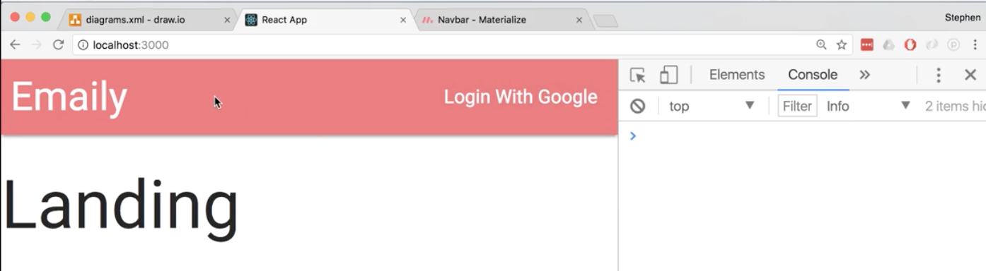

Let’s add a container to give ourselves a gutter on the left and right.

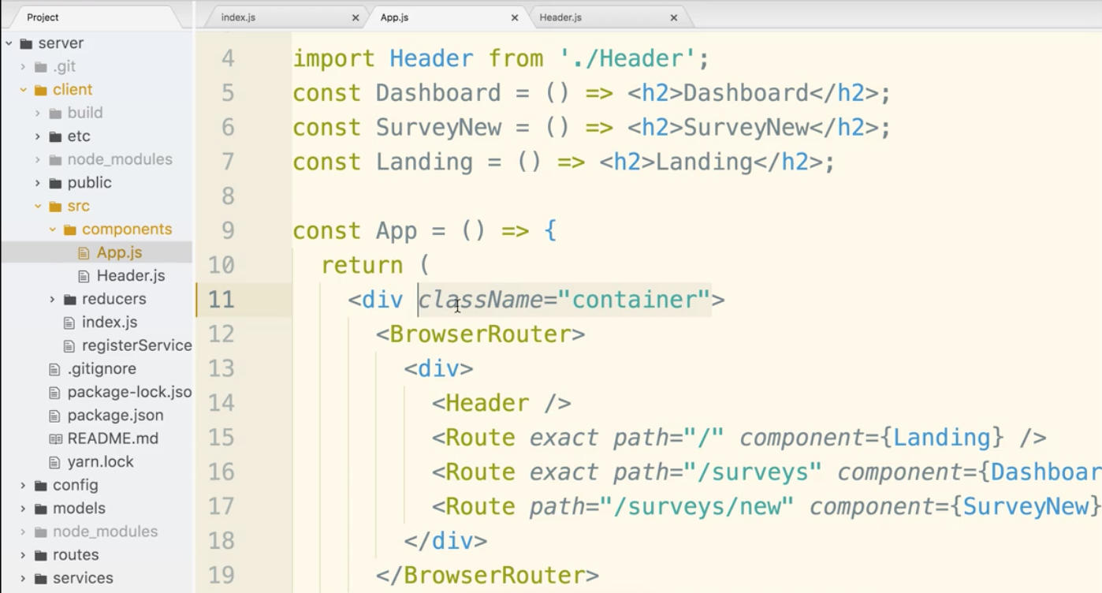

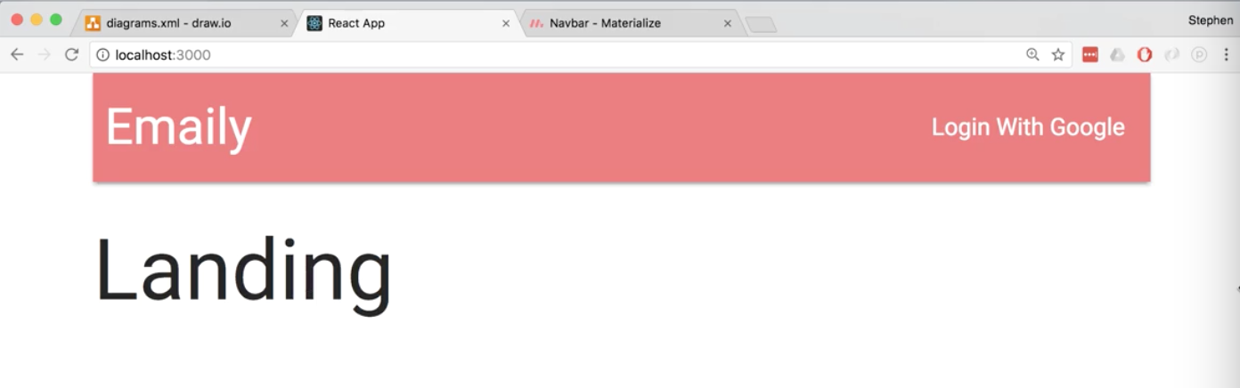

Let make sure the header displays the correct content based on login status.

The key to this is in the server folder/routes/authRoutes.js

There is a route that checks the status when the app boots up of whether the user is logged in or not. Line 18:

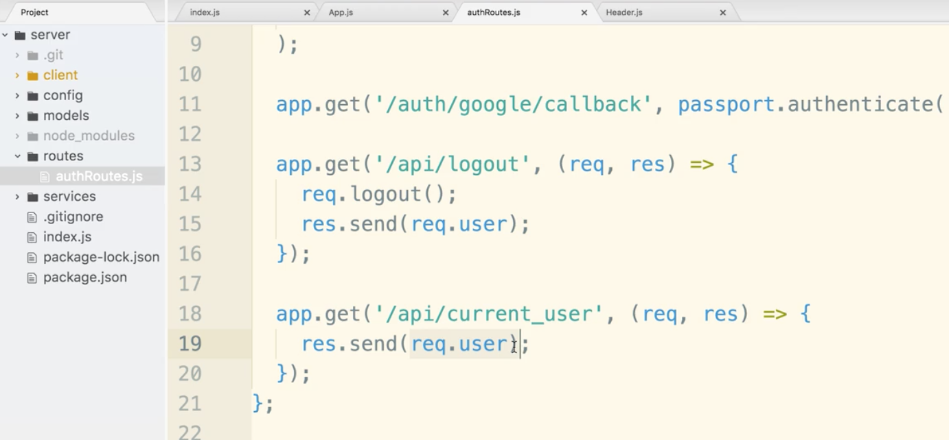

We need to make an action creator that will make an ajax request over to ‘/api/current_user’ route handler authRoutes.js. This will be our first exposure to communicating between the React and server side of our app.

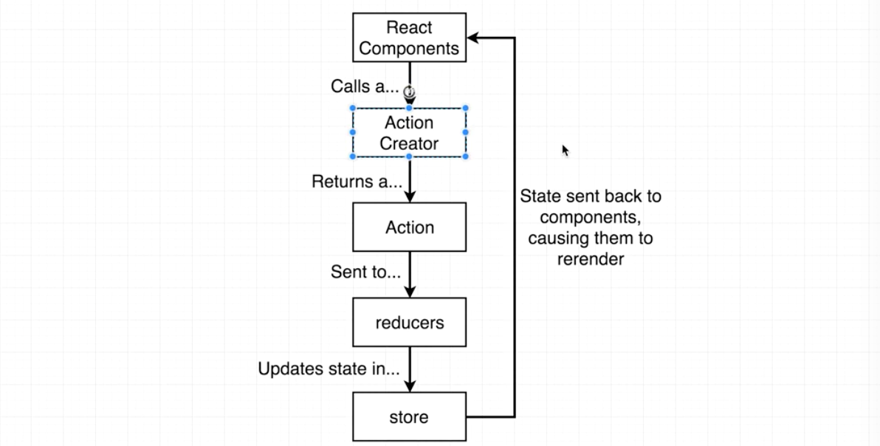

This is how we are going to pull this off:

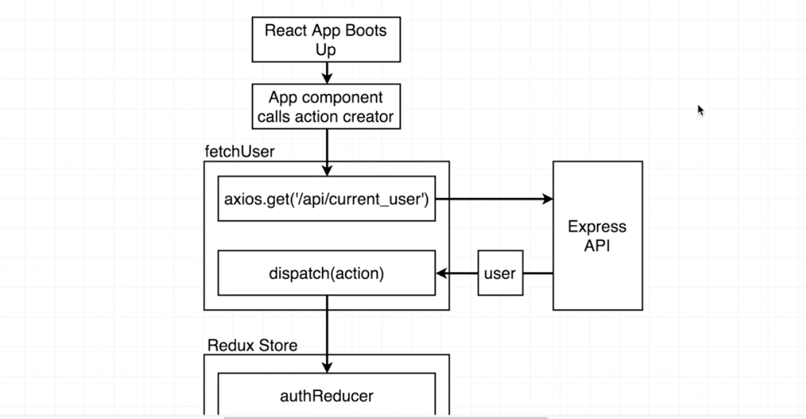

We will install axios. It is responsible for helping us make api and ajax requests to our backend api.

We will also install redux thunk. Redux thunk allows asynchronous action creator behave the way we would expect.

$ cd client

(these are client modules so make sure you are in that directory)

$ npm install --save axios redux-thunk

Inside client/src/index.js file we will import redux thunk and then pass it into the applyMiddleware call.

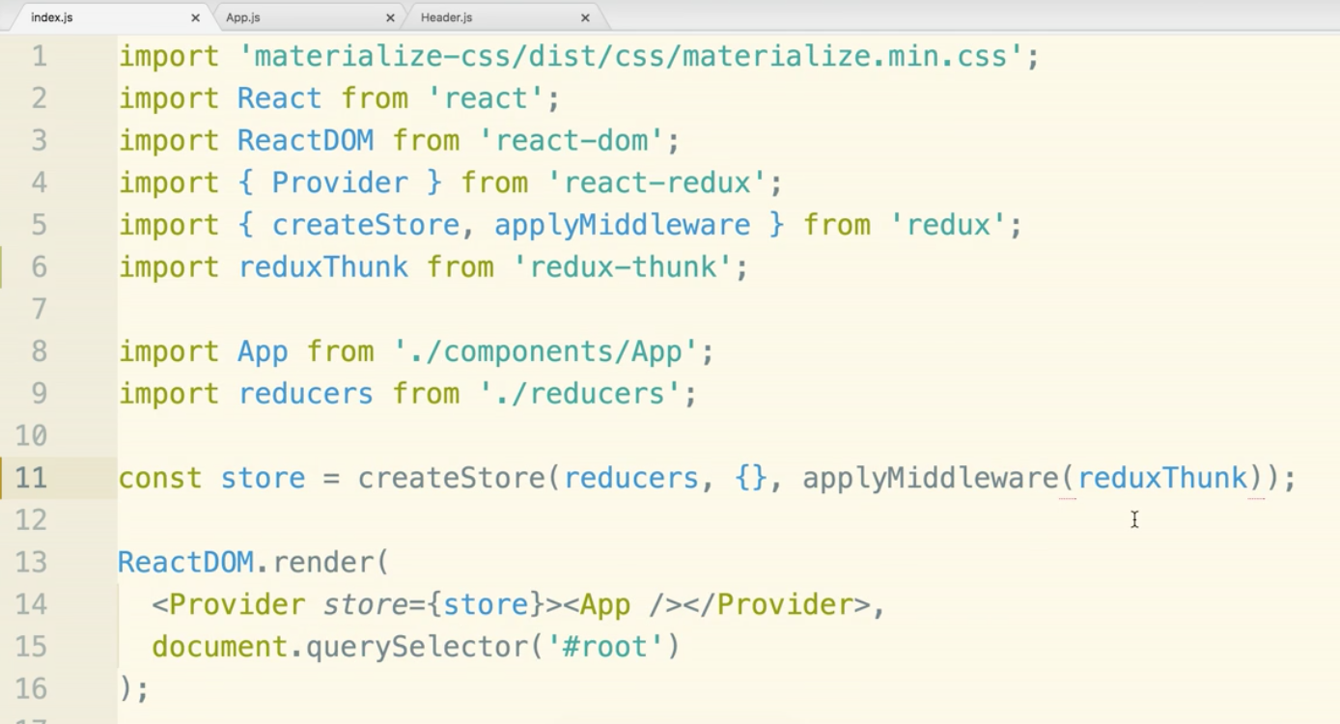

Create a new folder called actions inside of src directory. Add a file called index.js as well as file called types.js.

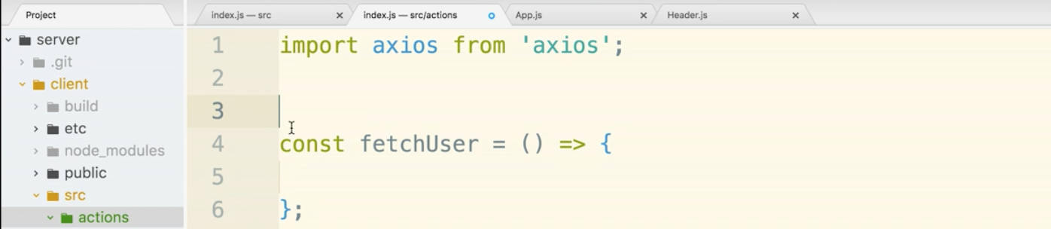

action types go into types.js:

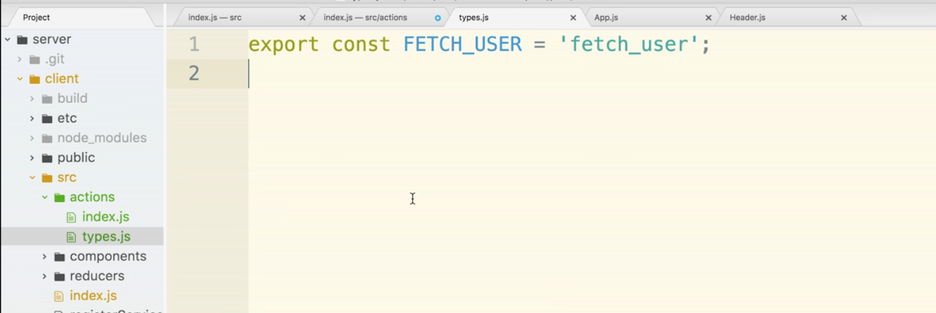

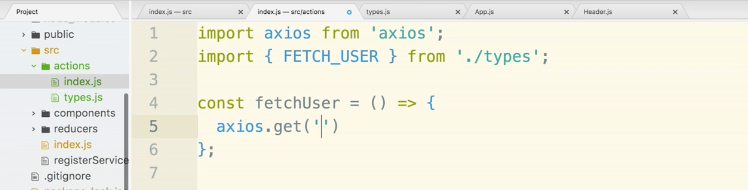

Remember where the api is located, path-wise:

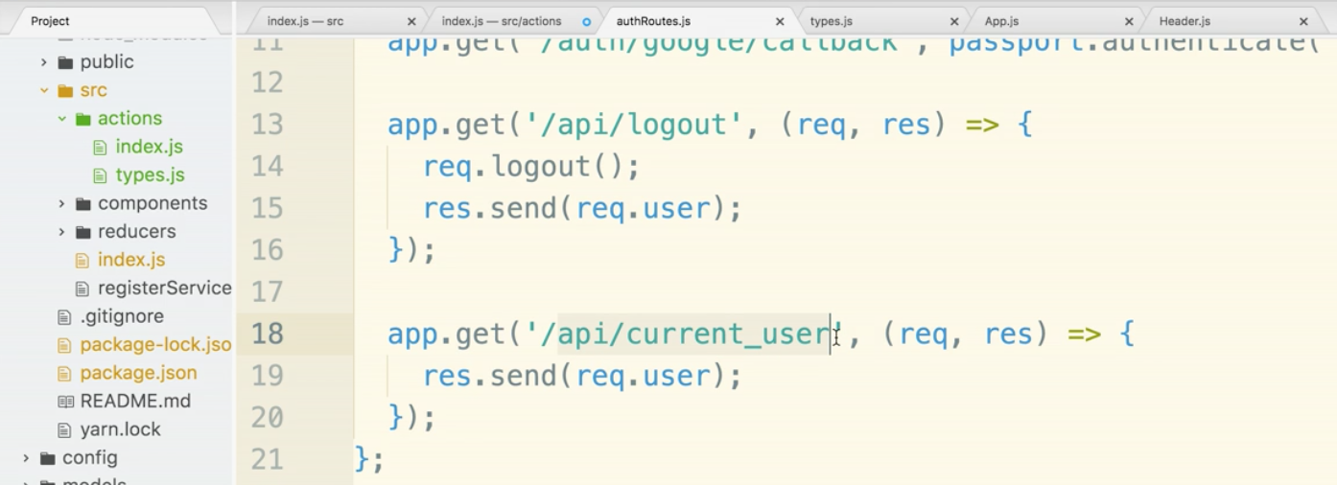

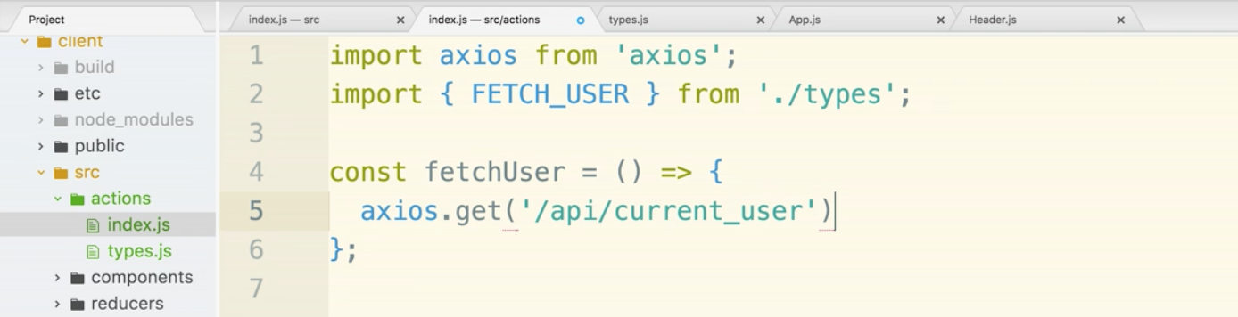

This will work smoothly production, but remember the proxy crap we had to deal in dev mode with with localhost:3000 and localhost:5000 between the front and backend. We solved this before.

Go into the client folder’s package.json file. You will see the current proxy rule for /auth/google.

We will add a rule that will be used for ANY url with /api/ in it. This will avoid us having to put in annoying rules for every url to the backend. The * symbol is the key.

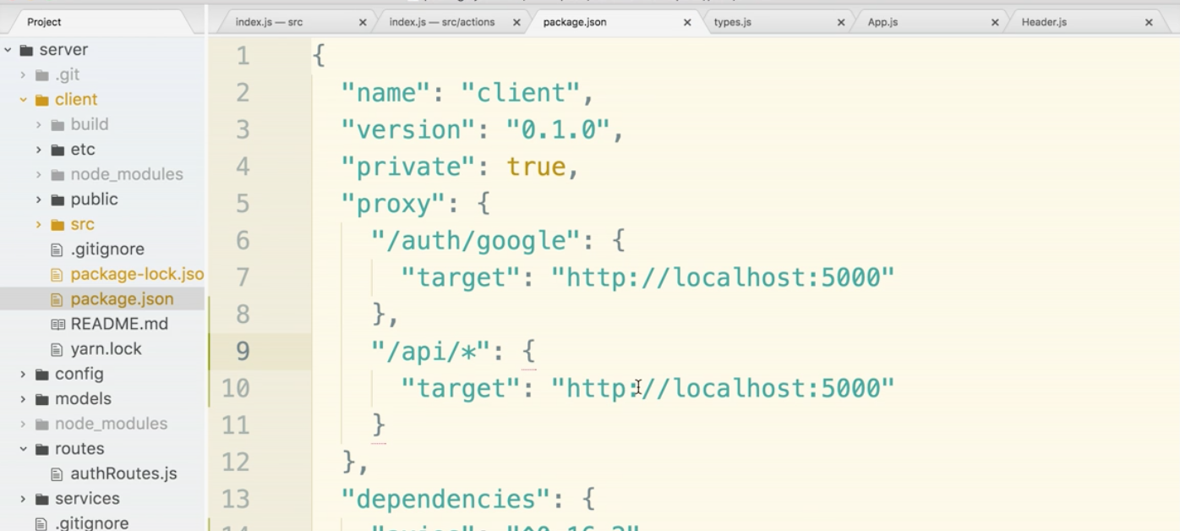

Redux Thunk’s purpose is to allows us to break the rule that action creators return actions.

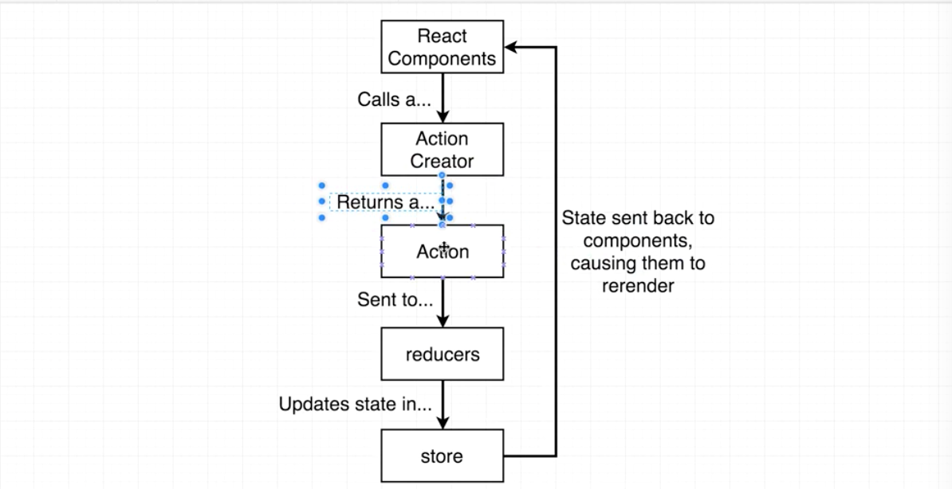

This is what redux thunk does:

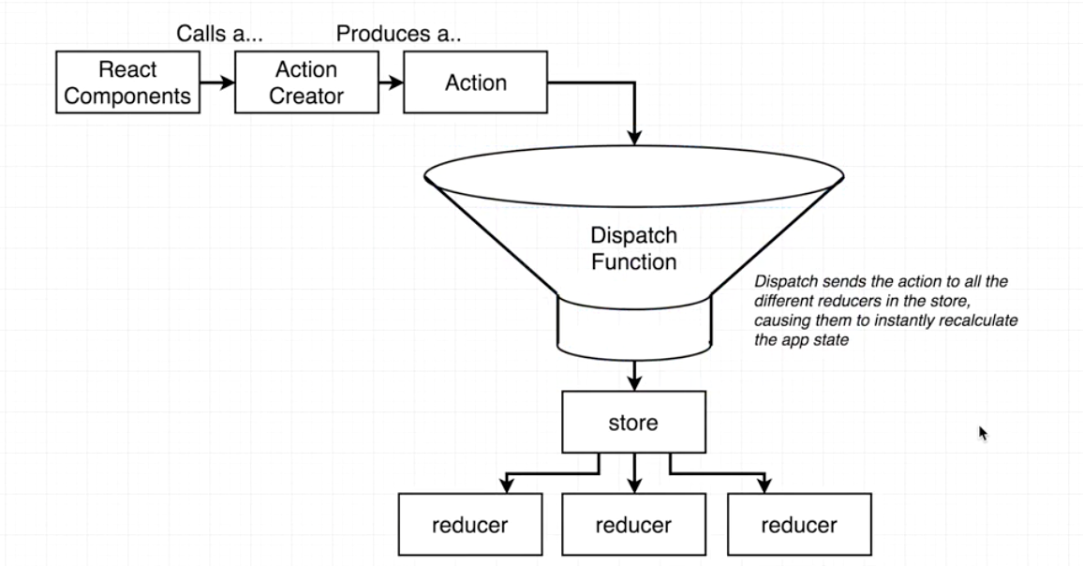

action creator produces an action rather than creates one. The action creator will pass the action to the dispatch function. The dispatch function always exists, but thunk gives us direct access to the dispatch function. Thunk allows us to bend the rules a bit and dispatch a function any time that we wish.

We are going to get this running roughly. We will call it version 1, then comeback and refactor.

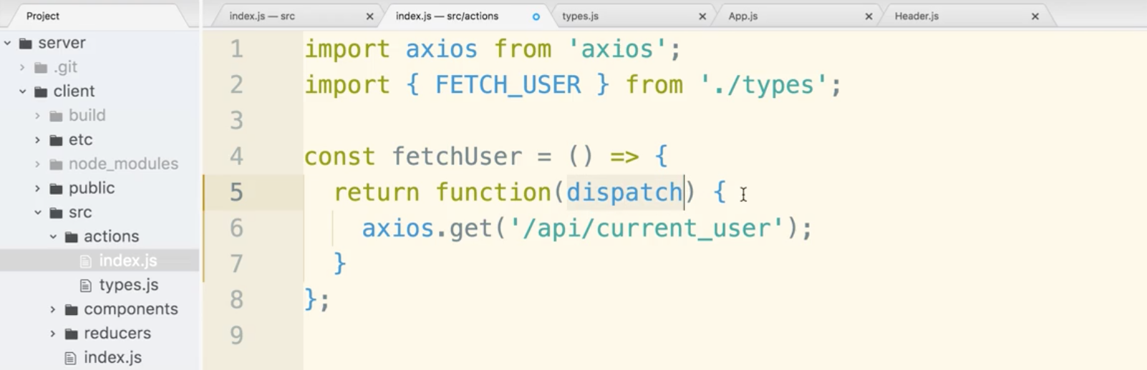

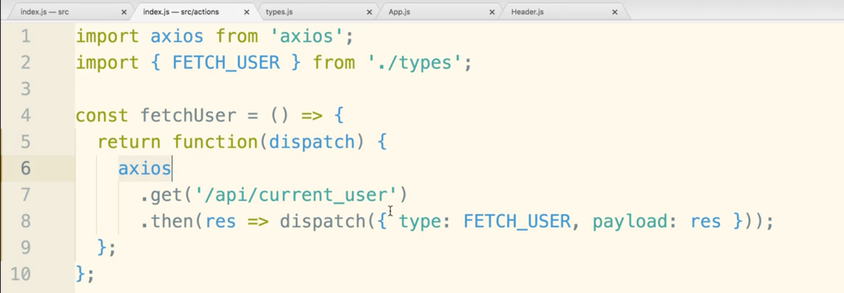

We want to call the action creator the instant our app boots up.

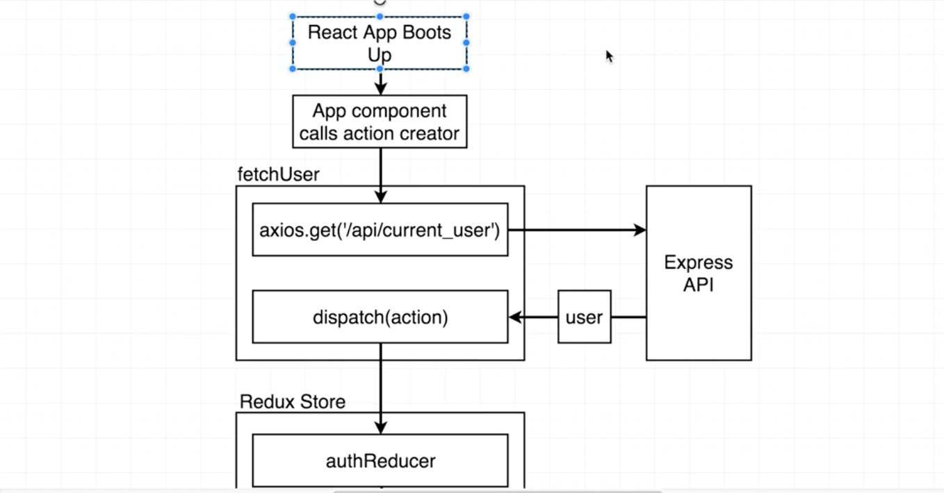

We should do this in App.js. The reason being is that many components throughout our app will want to know if we are logged in.

Let’s make the functional component App into a class-based component. The first line changes and the render() section with open and curly braces around the whole return statement.

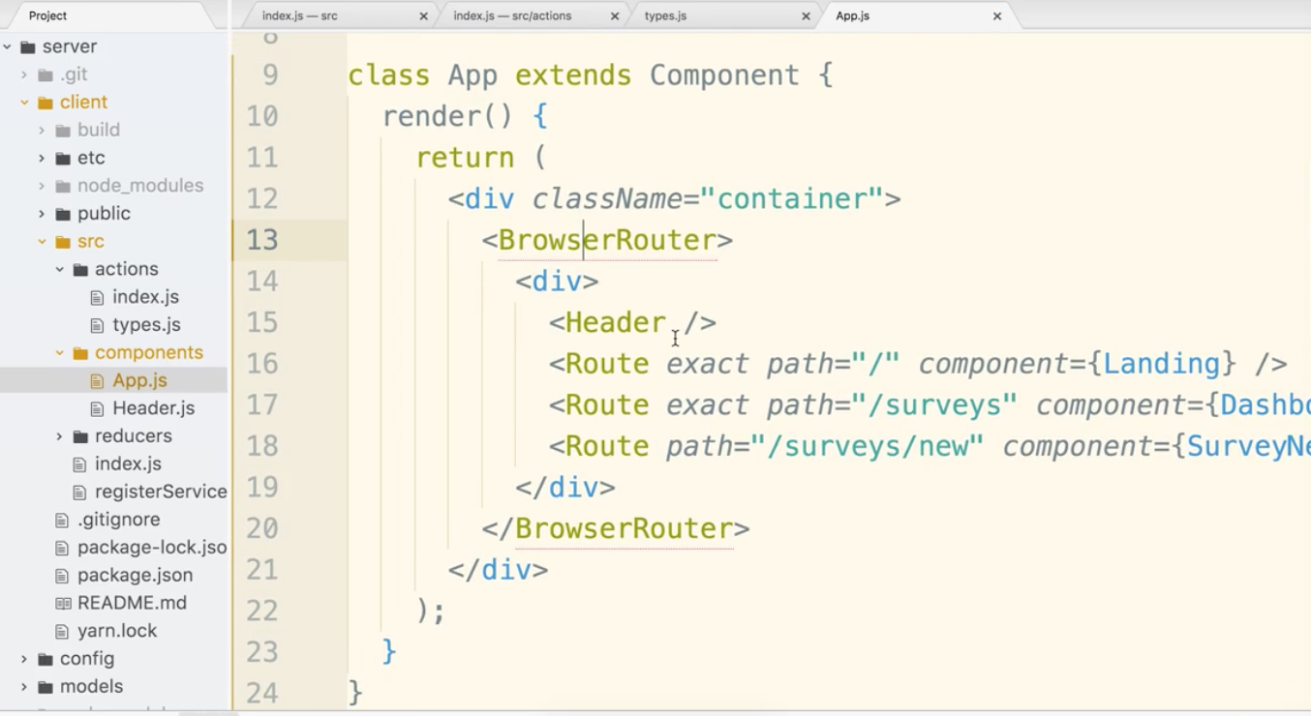

Add a component life cycle method. We will use componentDidMount(). This is the preferred location to make any ajax requests, even more so the componentWillMount(). componentWillMount() may be called multiple times in future versions of React. There is essentially no time difference between when the two lifecycle methods fire. Go with componentDidMount().

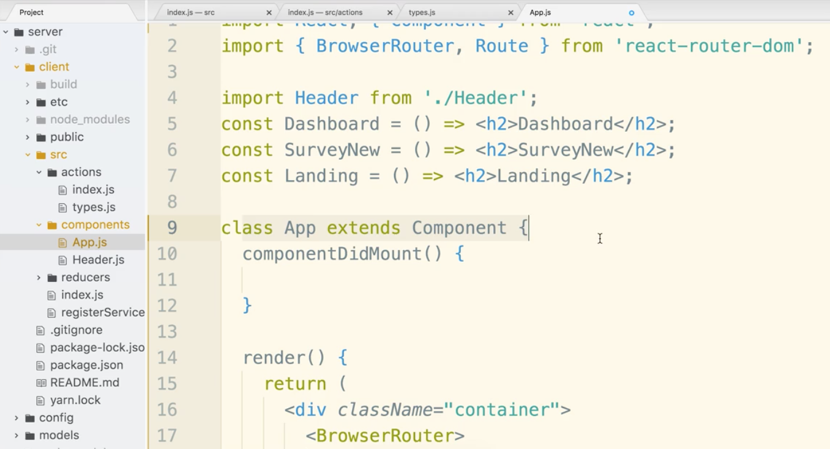

Now let’s import the connect helper from the react-redux library as well as all the actions from the actions file.

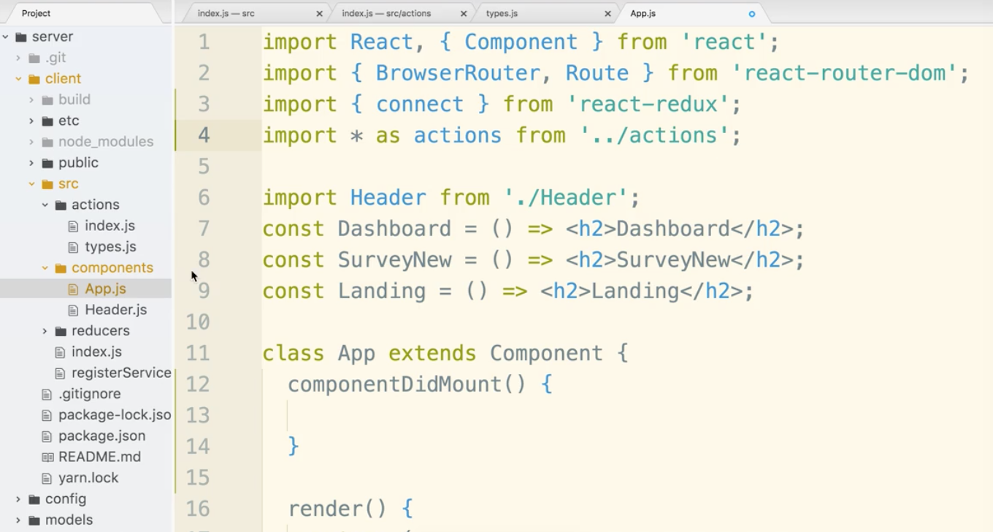

The first argument of connect is map state to prop, that is null in this case. Second argument we pass in all the action creators we want to wire up. The actions are assigned to App as props.

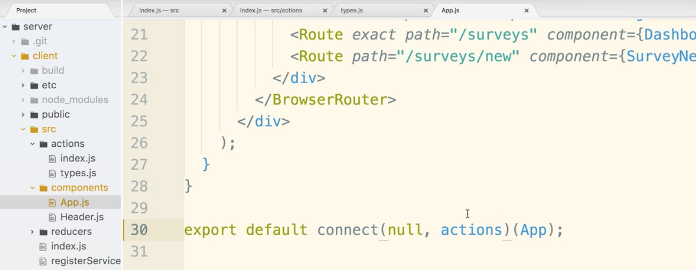

We can now reference this action creator in App as this.props.fetchUser()

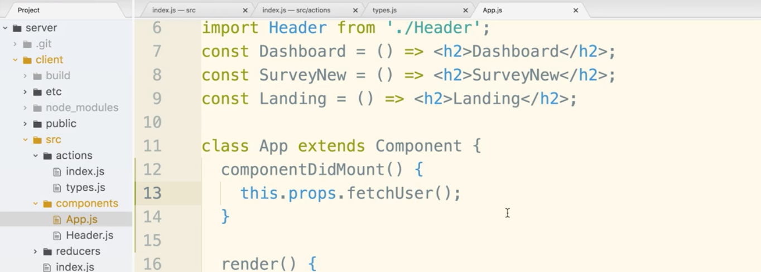

Now open authReducers.js in the reducers folder. Add in a console.log statement to log every action this reducer gets called with.

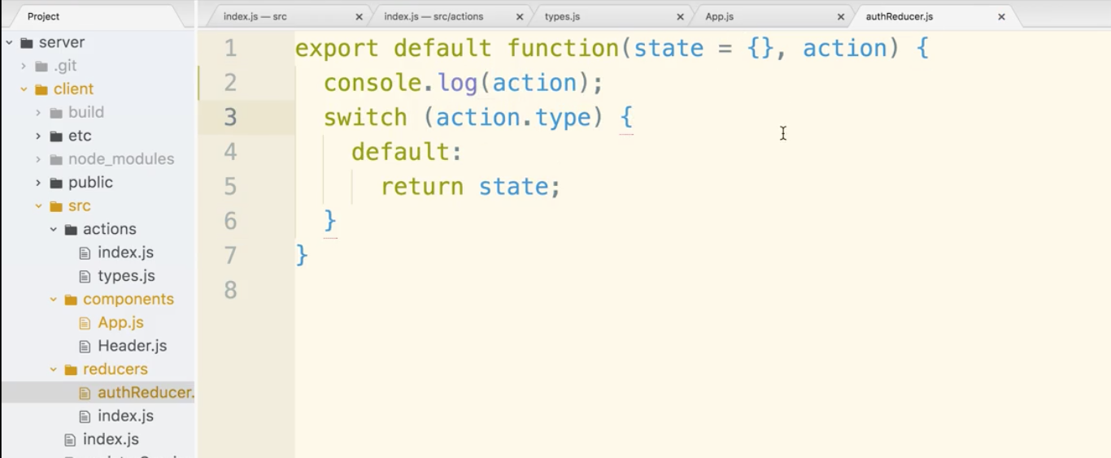

There are a lot of steps being tested in the diagram below we are up to the authReducer box:

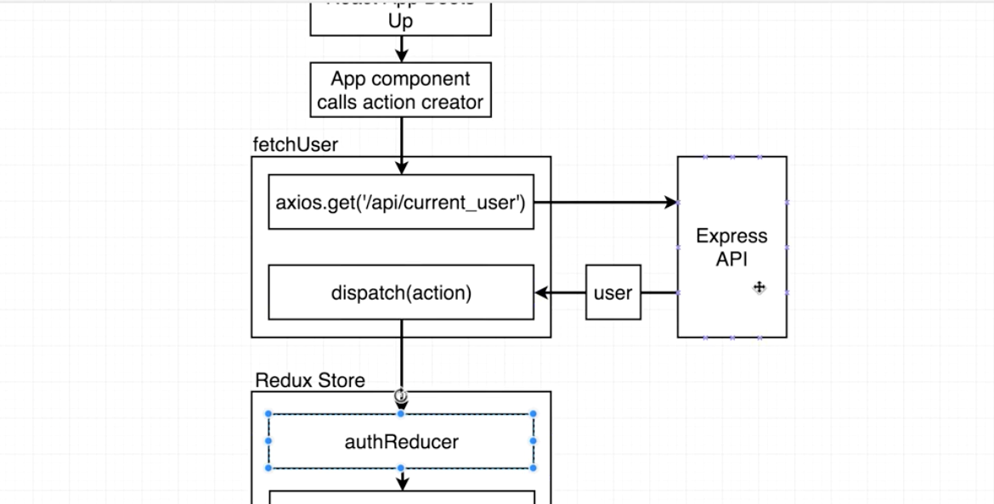

There may be some console logs related to the bootup process. The last one shown is indicating that it worked successfully.

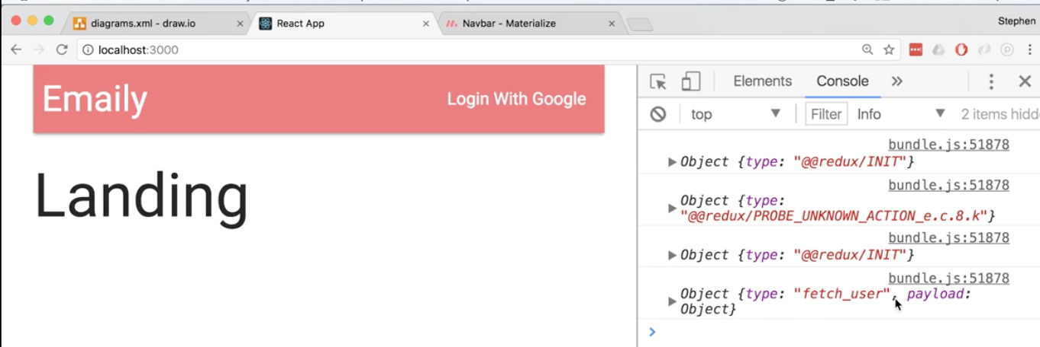

Google info is within the object.

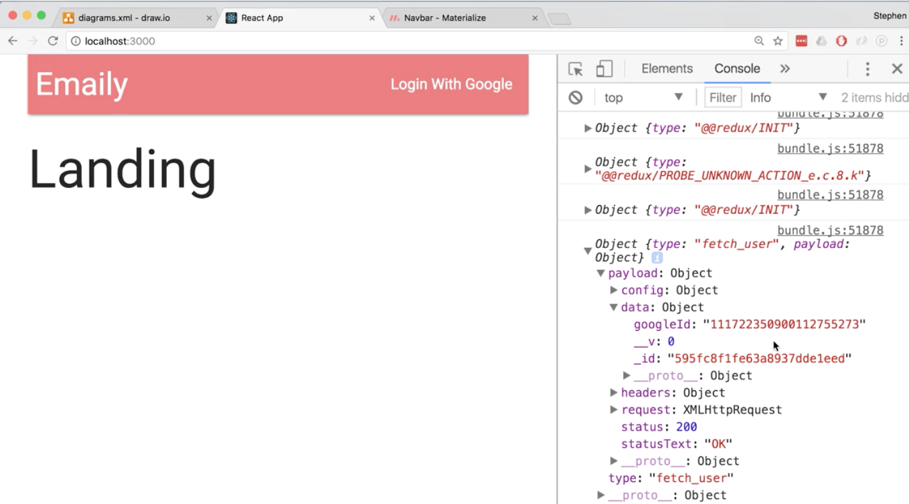

If you do not see the info, don’t panic. You may not be logged into the express side of the application. You have to be logged in to see this info.

Now let’s refactor the action creator with async await.

First let’s focus on the outside arrow function. Because there is only one statement inside it and it has return surrounding it, you can actually delete it and with arrow functions it will automatically return.

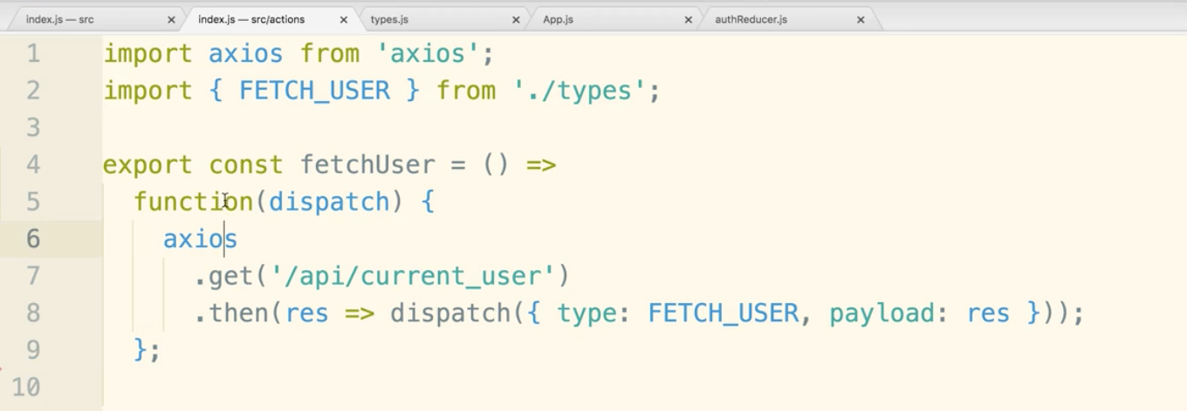

now lets change the function keyword to arrow function

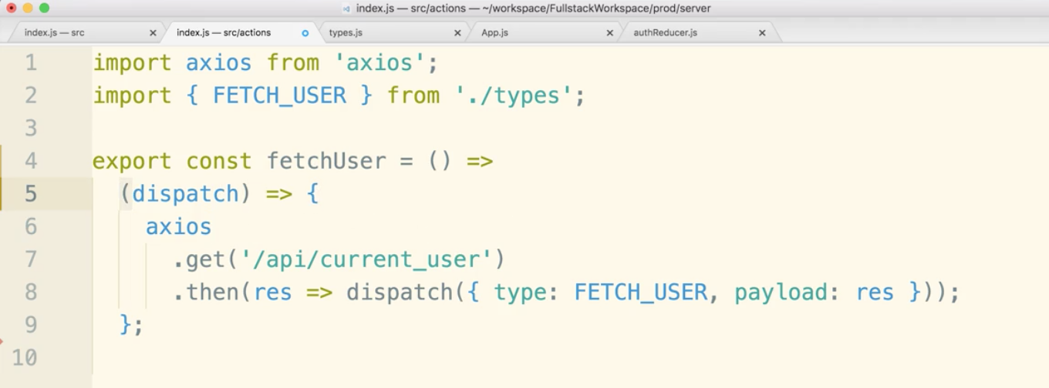

One argument doesn’t need parentheses in an arrow function.

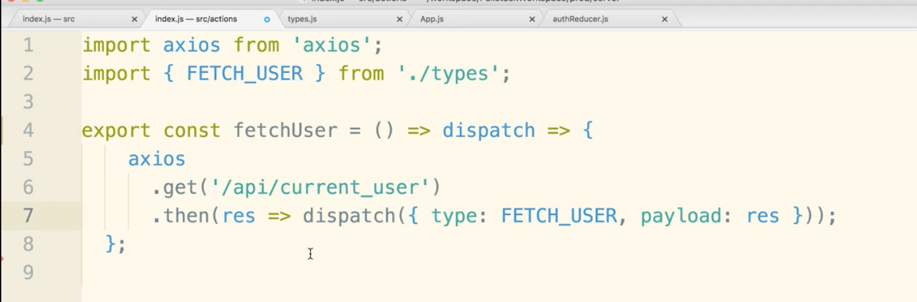

Now let’s find the function generating the promise.

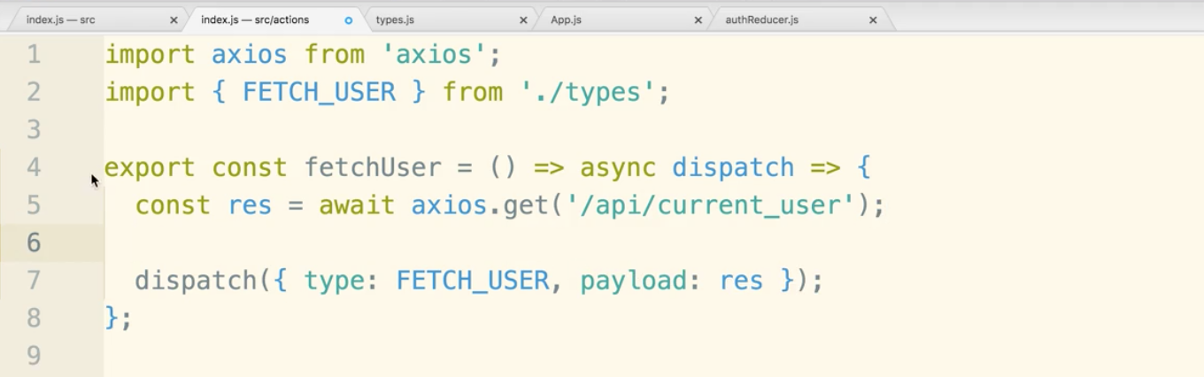

async and dispatch next to each other looks odd, but it would look less odd if it were async (dispatch) or async function dispatch.

The object returned from google has a lot of properties, but we only want ‘data’

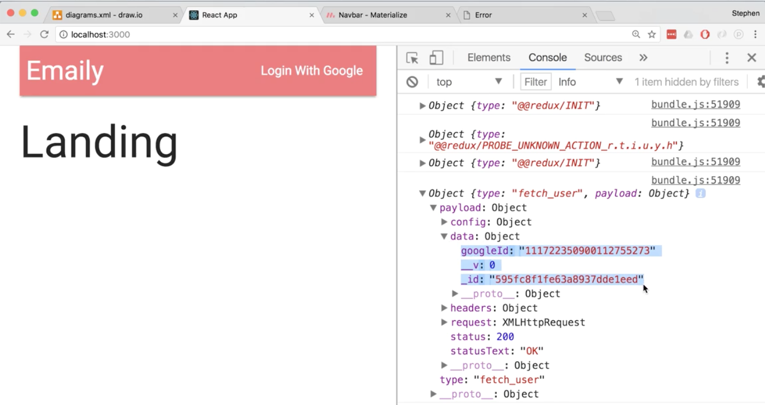

For this reason let’s modify the payload to res.data

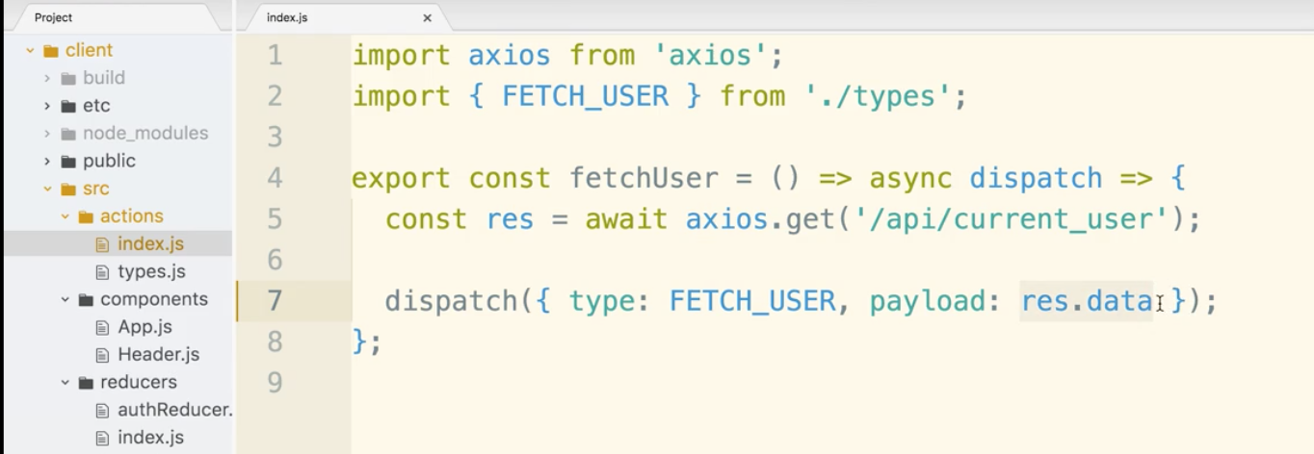

3 situations to consider.

What if a request is made to the backend to get the current user and it is just loading. When things are sort of in limbo, the response should be null.

When logged in, return User model

When is not logged in, return false.

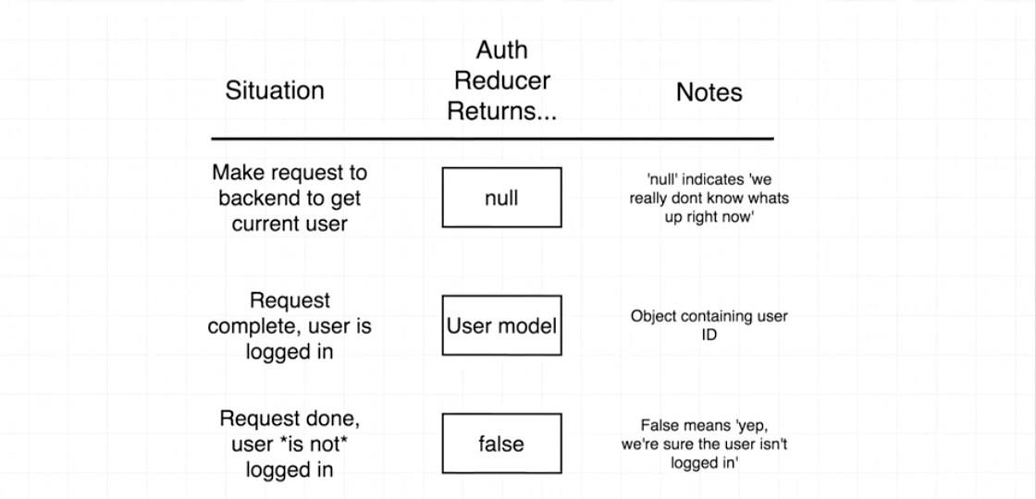

In authReducer, instead of making state default return {}, we can have it return null.

We also create a case for FETCH_USER, we return the action.payload, but by defualt it returns an empty string, so instead of that, which is not useful we put an or statement so it returns false.

empty string is falsy combine with || false returns false as a whole statement.

remove console.log statement.

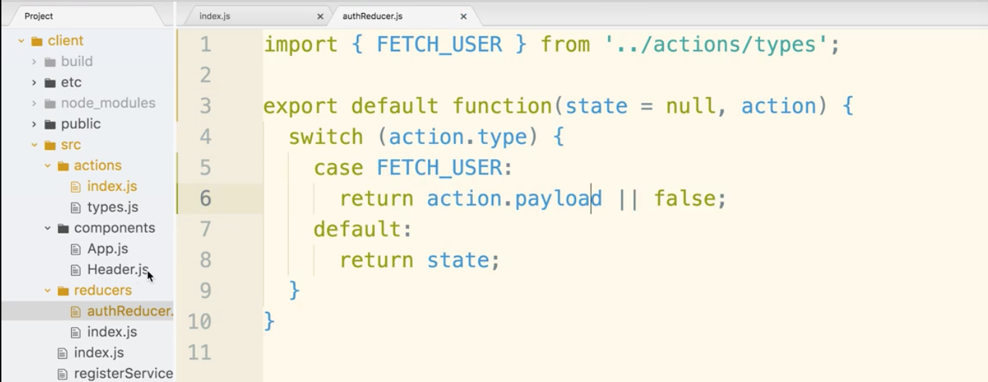

Now the redux store is aware of whether the user is logged in.

Now let’s hook up the Header.js to the redux store and give it the auth piece of state.

import connect from react-redux

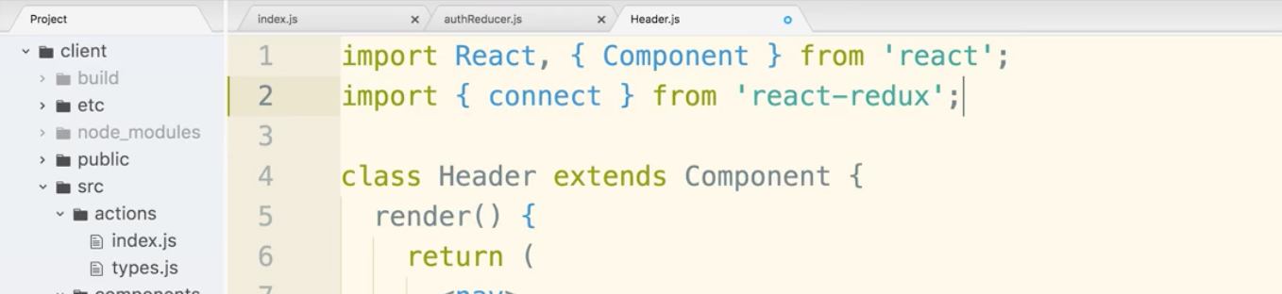

Then set up the connect helper at the bottom of the file.

We will have a map state to props function that focuses on the auth property of state. We get the property from the reducer:

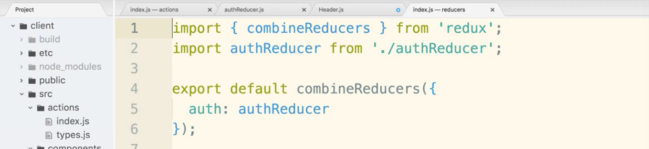

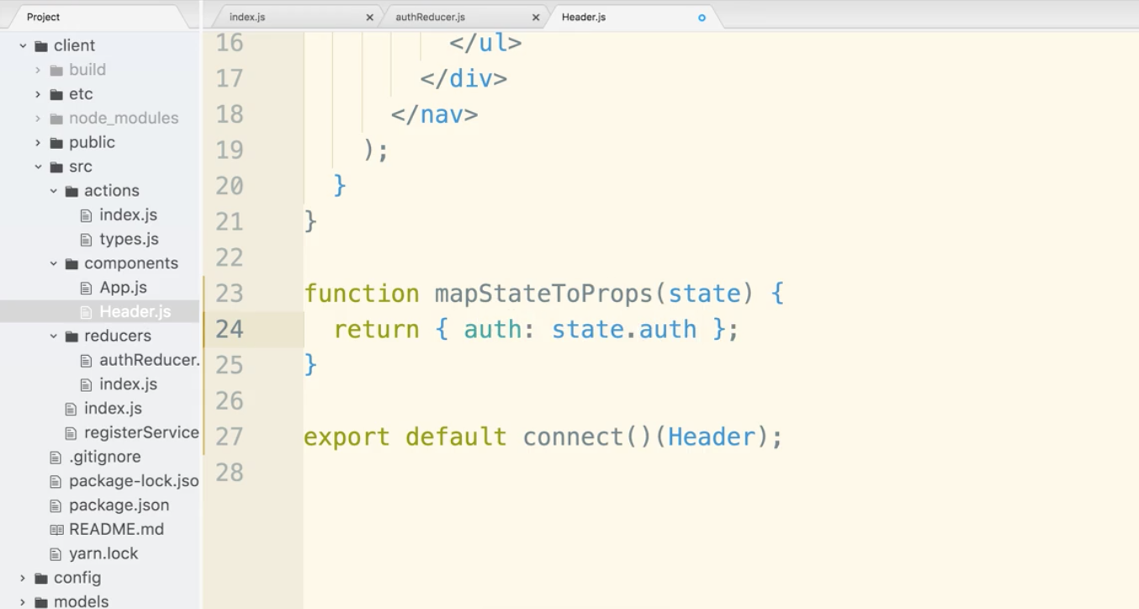

Now state can be destructured taking out auth. And, auth: auth can be written as just auth. So refactor looks like this:

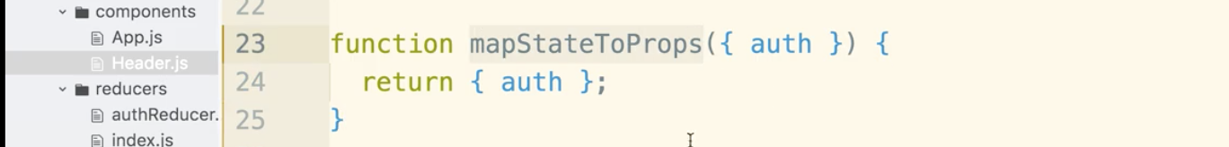

Insert mapStateToProps into connect()

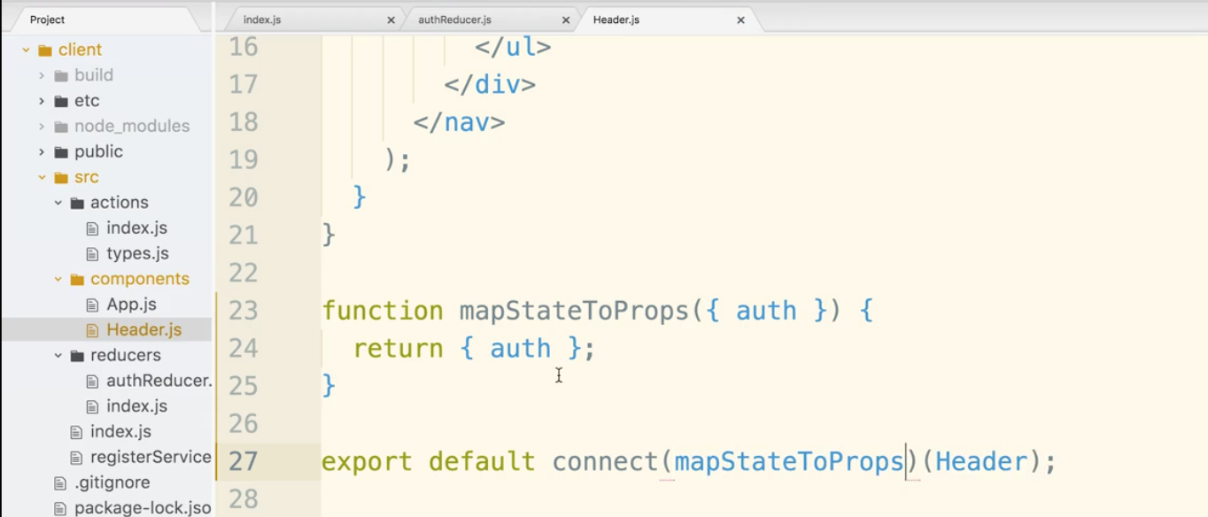

Then put in a console log at the top to test.

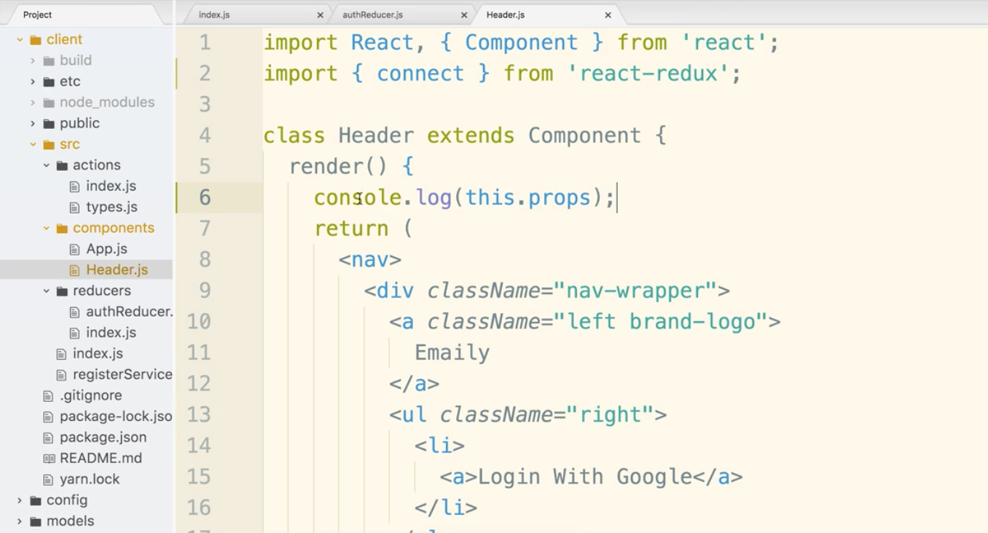

Notice the two returns, the null (in limbo)

Second log shows the auth property set to the the user model.

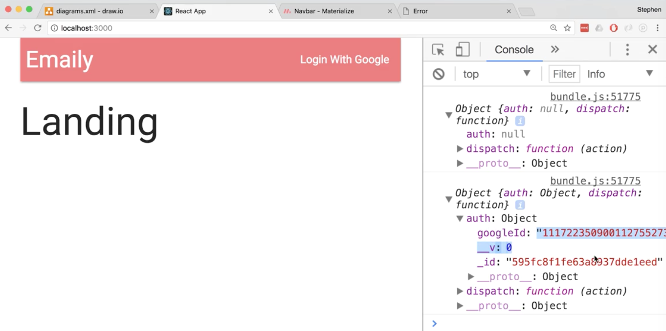

Now, let’s remove the console.log statement.

We need a helper function that will help us display the proper header based on auth in state.

Let’s create a switch statement for the 3 cases.

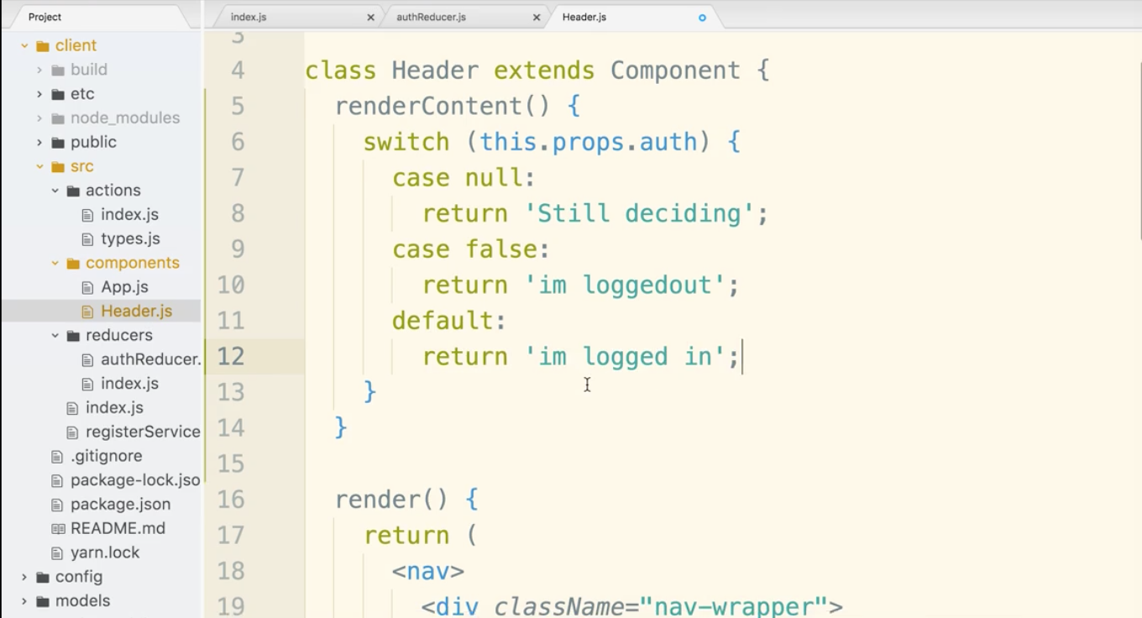

Now to test, let’s insert the return value into the ul of the navigation and see what happens.

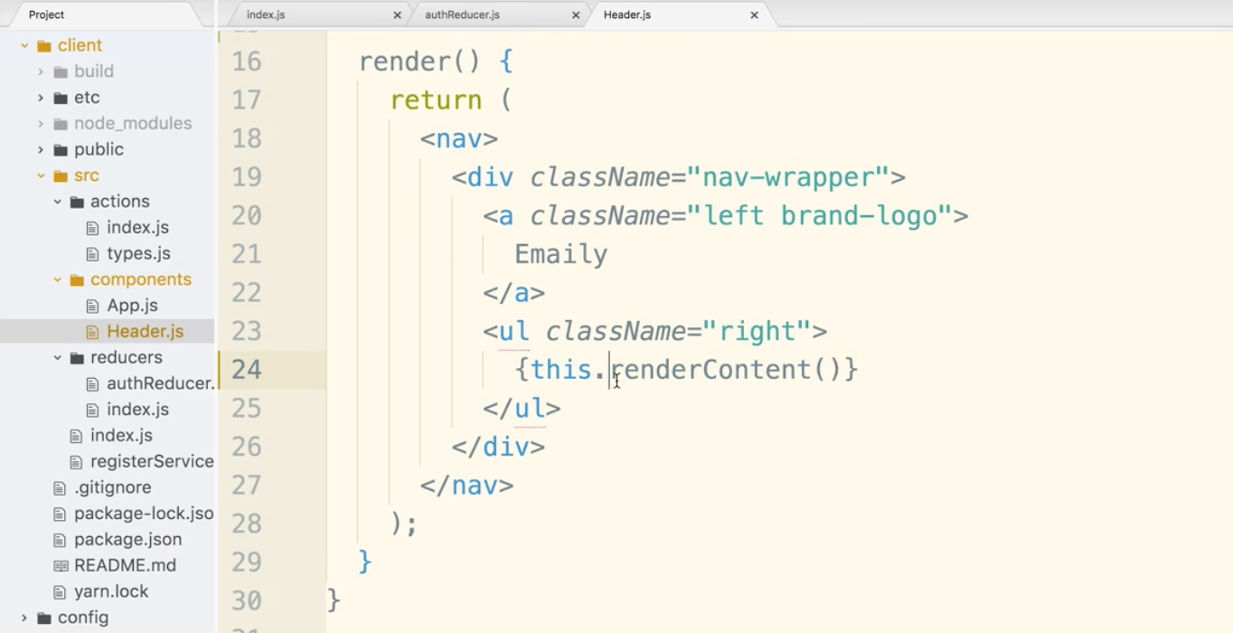

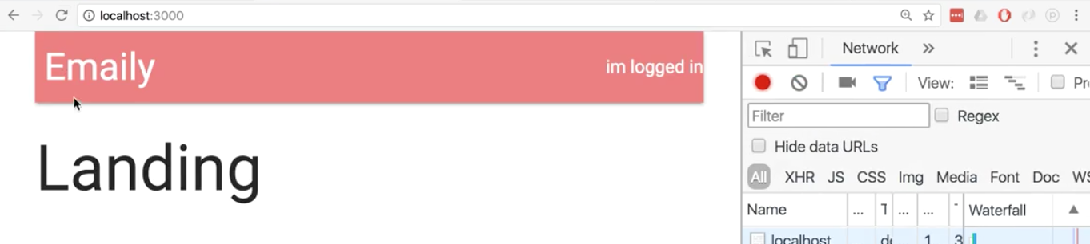

Now let’s alter the switch statement. When the response is pending, we don’t want the text changing so we will not return anything. When false we will have a Login as Google.

and when login we will have a Logout. Logout will be worked on later. The link is blank for now.

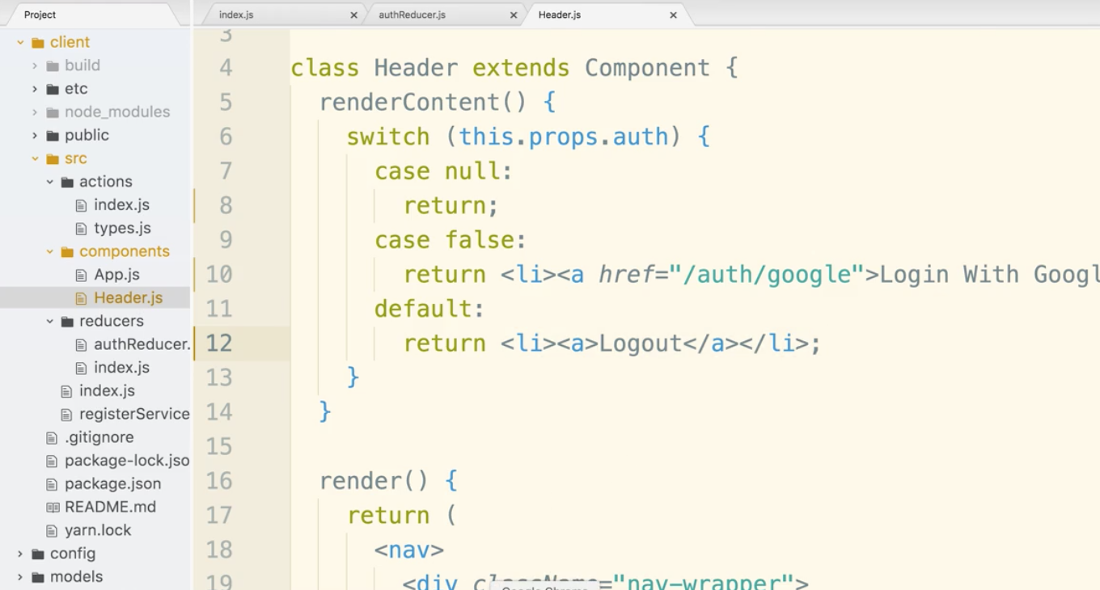

If you login in the browser we still have this nagging error from early on. 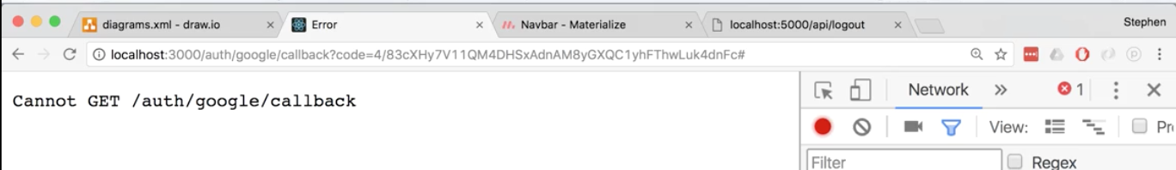

This is a backend issue. We will have to deal with the backend for a moment, even though we are making an effort to stick to one side or the other for long periods of time.

In authRoutes.js we want to focus on the /auth/google/callback route. Currently we are not telling the app to send it somewhere after logging in and it is causing an error. We are change this however, and redirect the user to the dashboard at /surveys

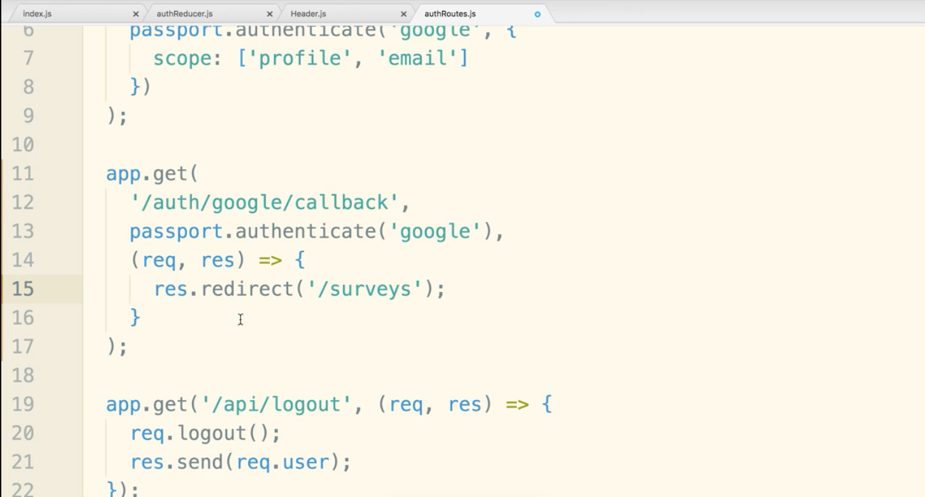

So to review, after the oath flow at auth/google/callback, passport middleware takes over. It completes its process and passes the request on to the next handler in the chain, which is the arrow function we take the request in, and we tell the response to inform the browser that it needs to go to /surveys

Now to test. Logout at localhost:5000/api/logout

Now go to localhost:3000, Click to login at the top. Select your google account. The redirect should now kick in and you should be at /surveys

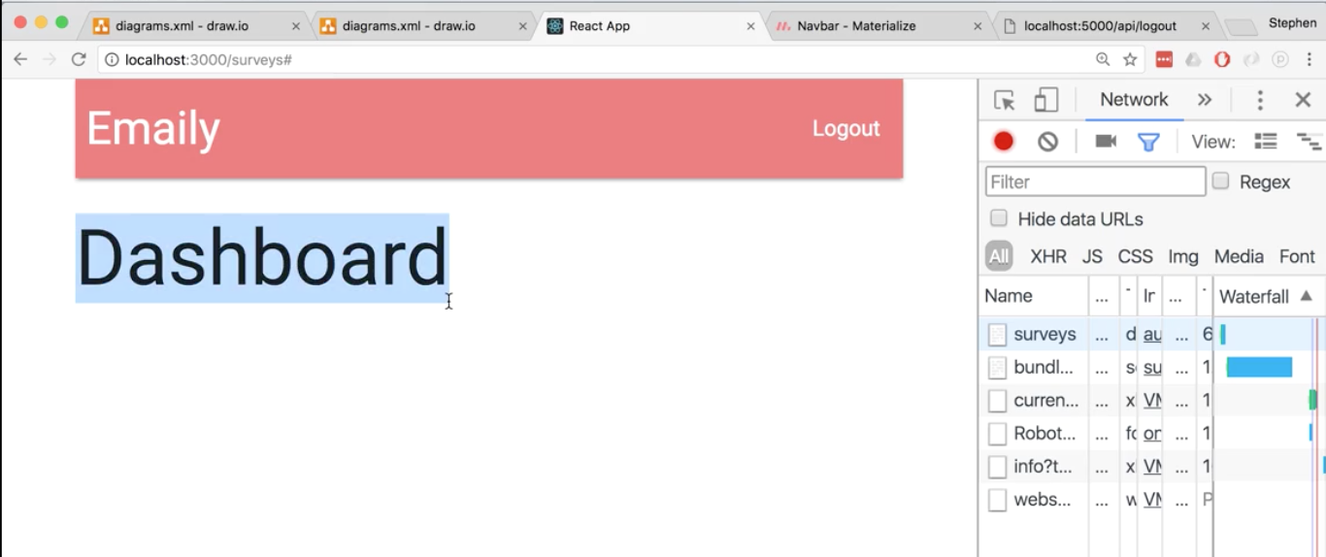

Logout is next. It’s harder than you would think.

Here’s a reminder of how login with cookies works:

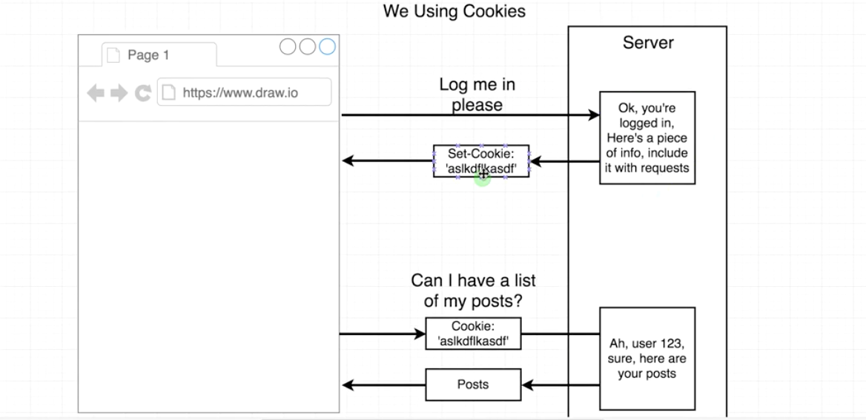

When a user clicks logout, how do we want to handle it?

1. Make the logout in the nav a traditional anchor tag that will cause the entire browser to go to the logout route and then kick the user somewhere back in the application. (full http request)
2. Make an ajax request that will go to that logout route.

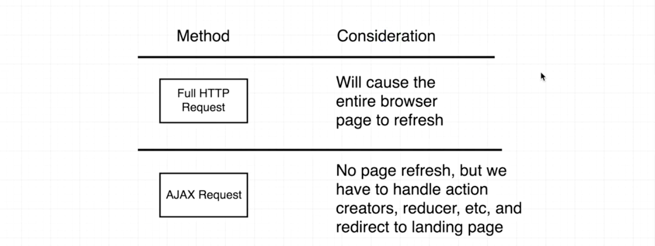

Full HTTP request may take a bit longer. But is much easier. No need for action creators and messing with redux this way. But once a user is logging out, it’s not a big deal it takes a little extra time to logout.

Update the link in Header.js:

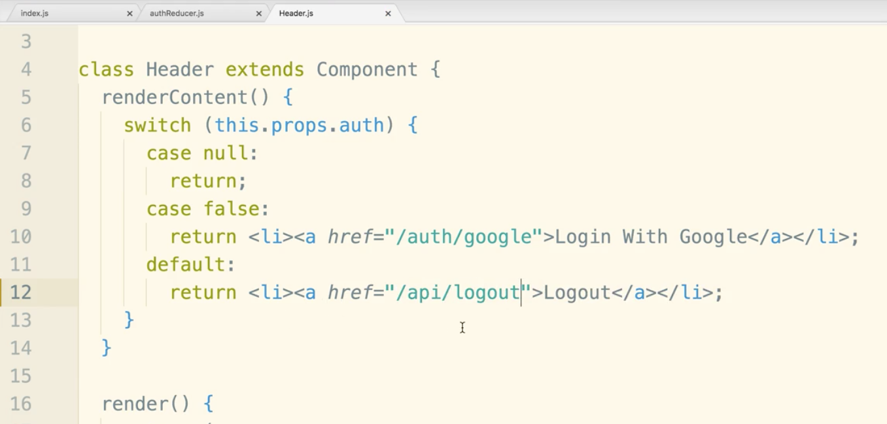

Open routes/authRoutes.js and delete the line that return the user (when you logout it won’t return a user) and put a redirect statement in going back to the homepage.

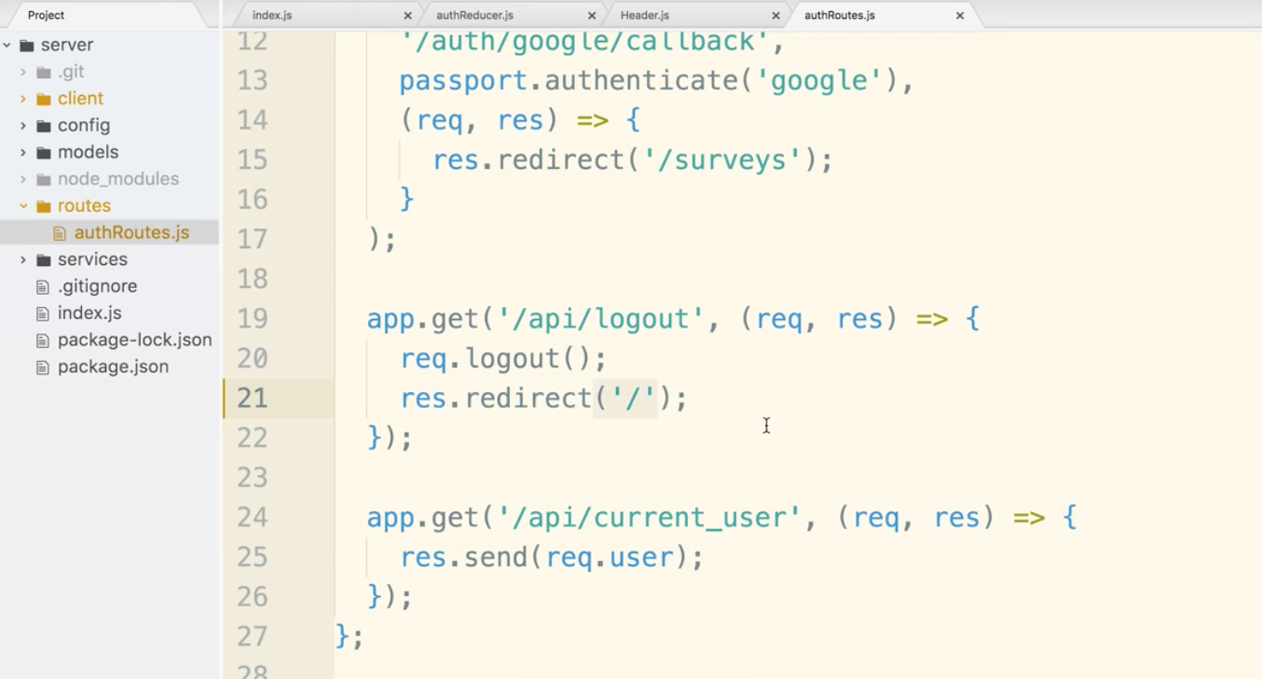

Let’s open client/src/components/App.js We have a dummy component for Landing, let’s make a separate file.

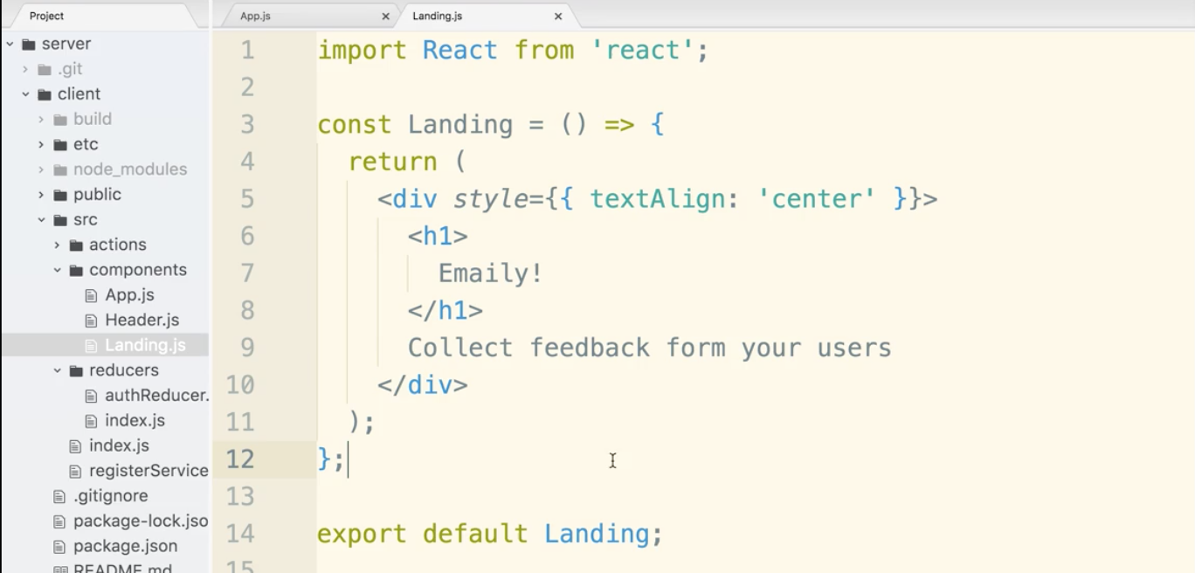

Now go back to App.js and replace the dummy file with an import statement and scoot it up with the other import statements.

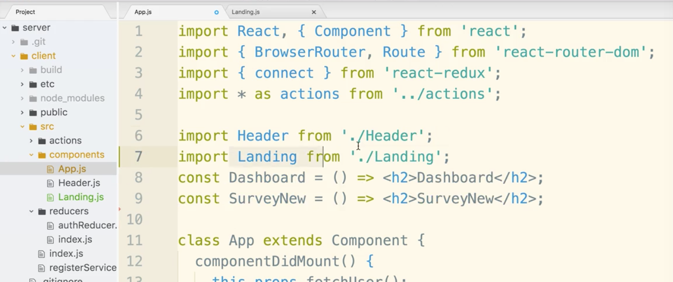

Now let’s make the logo clickable. We want a little logic in here. If the user is logged in, the logo should take us to the dashboard. If the user is not logged in, they will go to the landing page.

Now, currently there is an ‘a’ tag around the logo in the nav. a tags are for traditional navigation, but our app uses react and react-router. Instead of navigating to a new page, we really want react-router to tell the app which components should be seen.

With react-router, we are given access to the Link tag or component. We use it to go to routes hosted by react-router.

Ok, let go into Header.js. import Link from react-router-dom

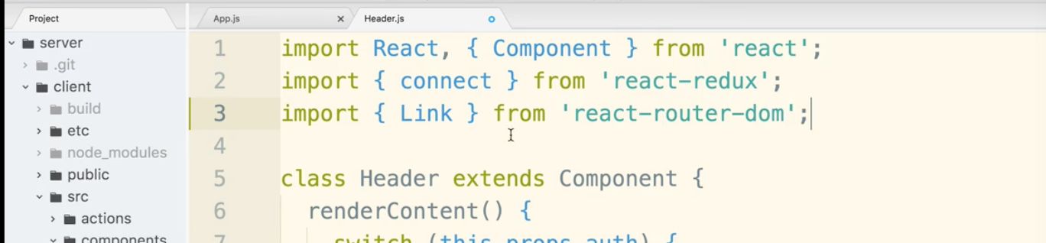

Now scroll down and replace the ‘a’ tag with ‘Link’ tag. Add a property of to={} We have the props telling us the auth status, so we will use that to make basic logic telling us which path to go to.

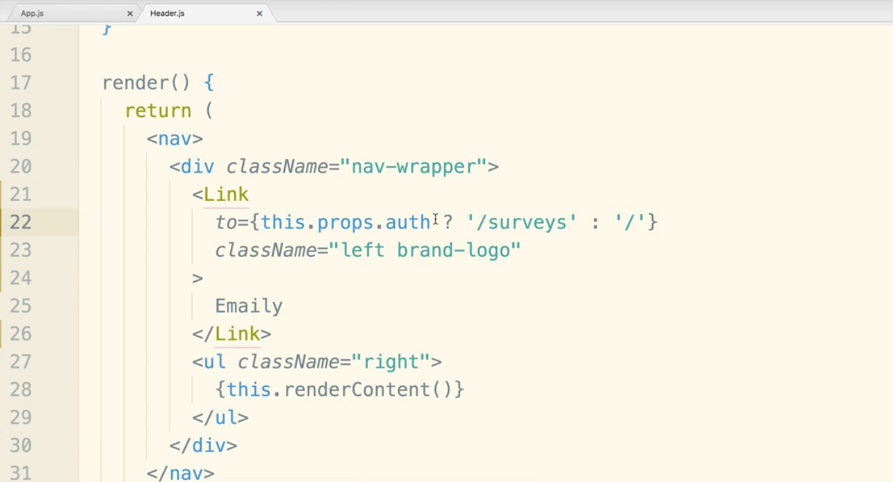

Client side billing.

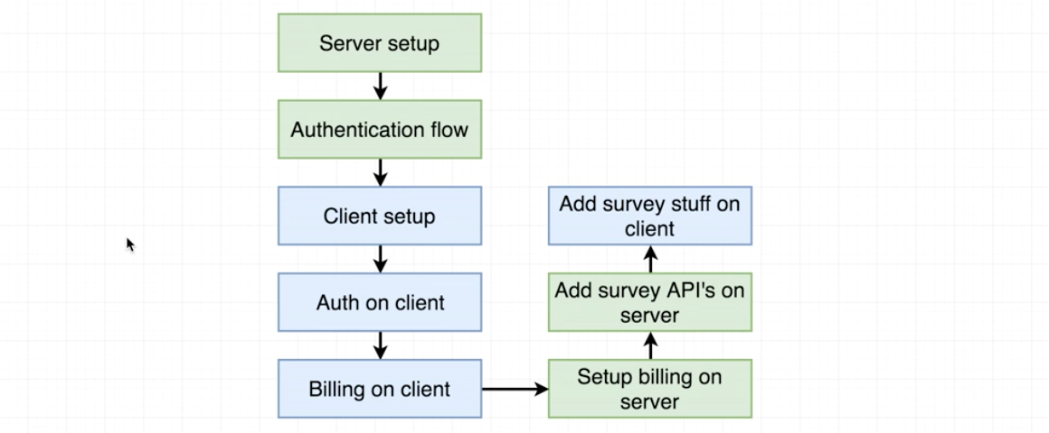

This is a reminder of the mock-up.

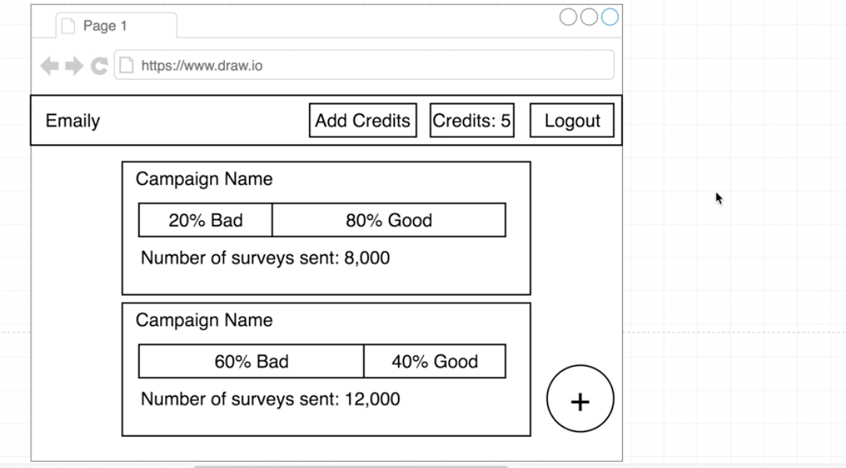

This is a general mock-up of the credit card accepting screen.

These are some recommendations around billing:

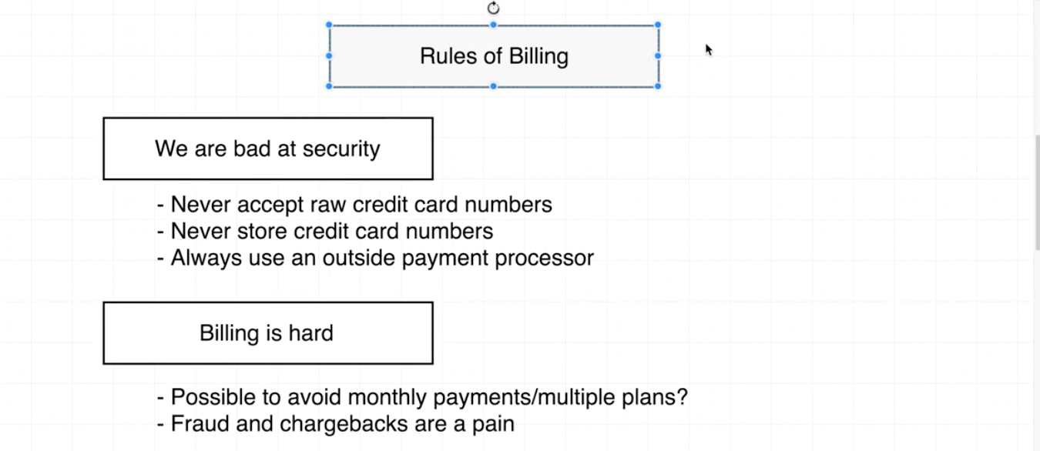

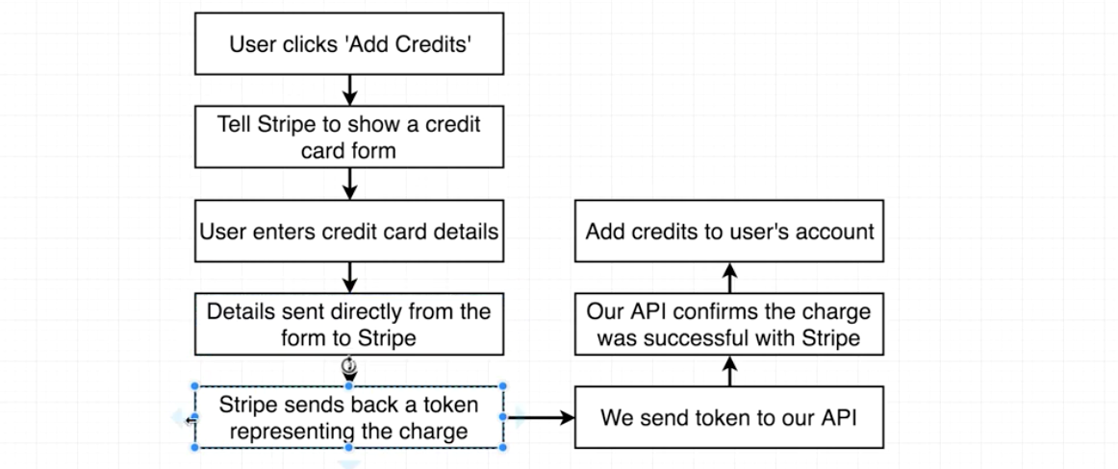

Stripe will generate the form and handle the credit card payment. We have to install the Stripe library into our project

Let’s head over to Stripe.com

Create an account and sign in.

You’ll be taken to a dashboard.

You may notice [test] popping up from time to time. When you first sign-up, you are put into test mode. We will be given test credit card numbers that we can use.

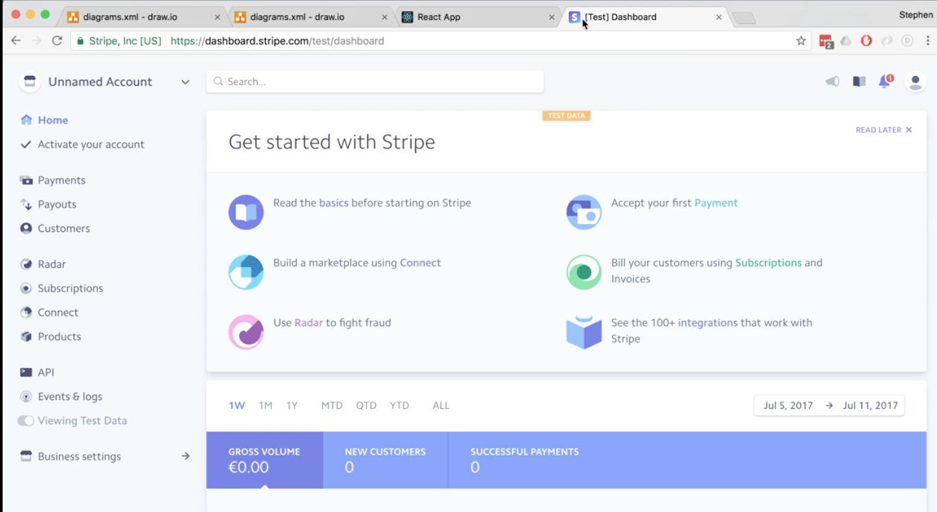

To get out of test mode you will have to click activate account on the right and put in tax data. (don’t do this for this project)

Now do go click API at the bottom left.

Right off the bat you have a publishable key and a secret key.

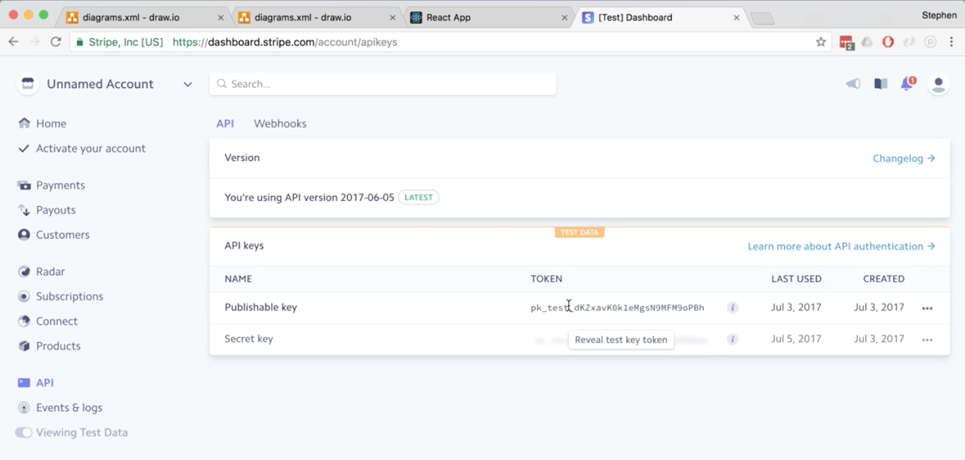

Now in a separate tab search for stripe checkout. click on the result.

Billing in react is unlike any other front-end app. we can’t use straight ‘checkout js’ from the plugin. it is slightly more challenging. We have to use stripe checkout react.

Google stripe checkout react.

You will find a library by azmenak.

Go over to the console. kill the running servers.

$ cd client

$ npm install --save react-stripe-checkout

after it is loaded, change back into the server directory

$ cd ..

$ npm run dev

Let’s put in the keys we need for stripe, both in the server and client side.

Let’s start with the server side.

Start by copying the publishable key

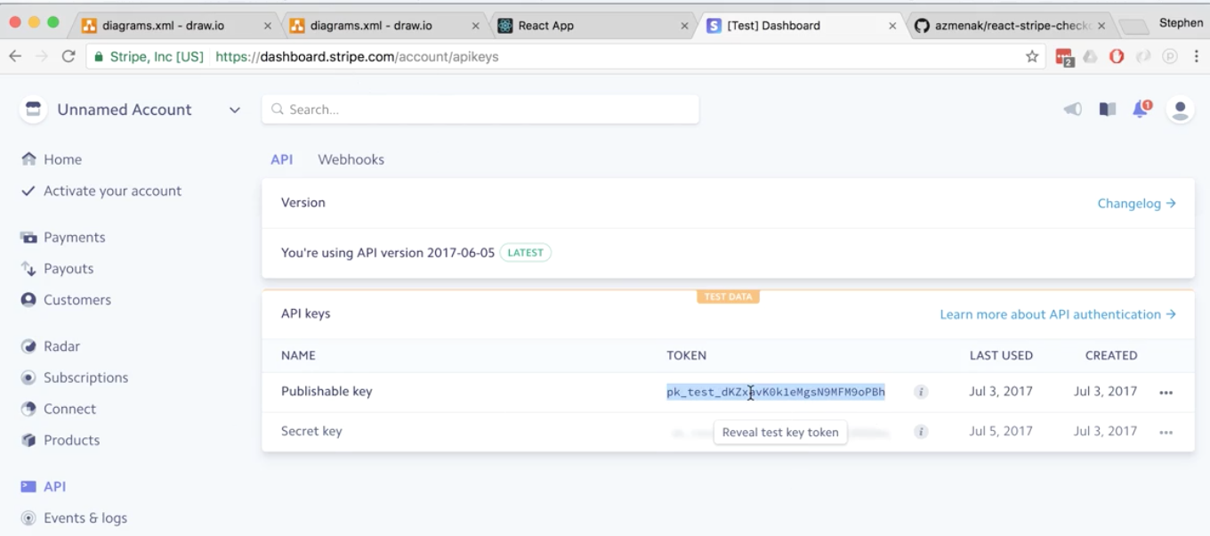

go into server/config/dev.js

put in a comma at the end of cookieKey

add in the publishable key, then repeat with the secret key.

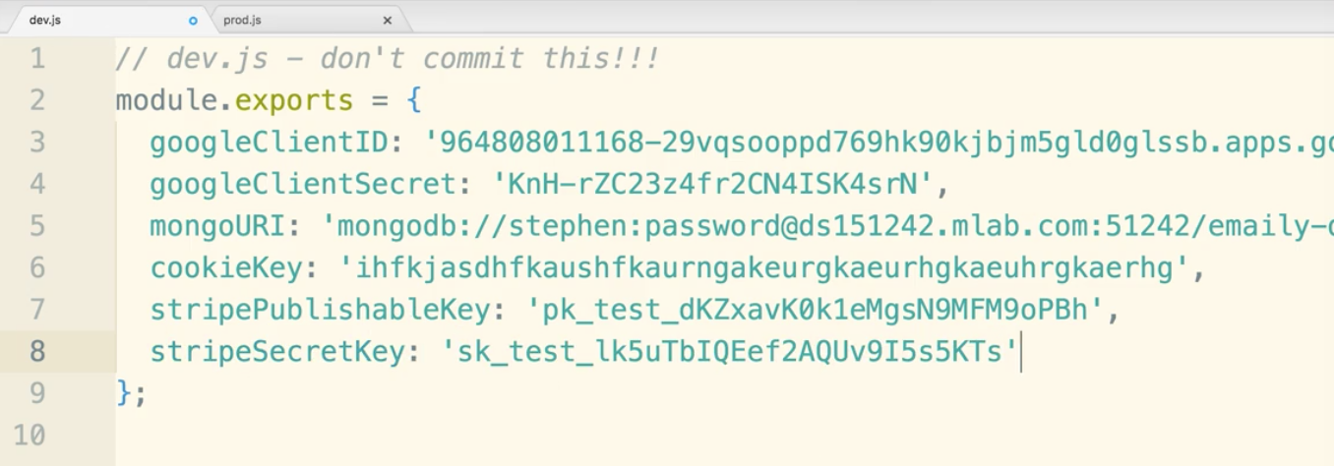

watch typos here. comma and the word Publishable are common mistakes.

Now open prod.js and update it:

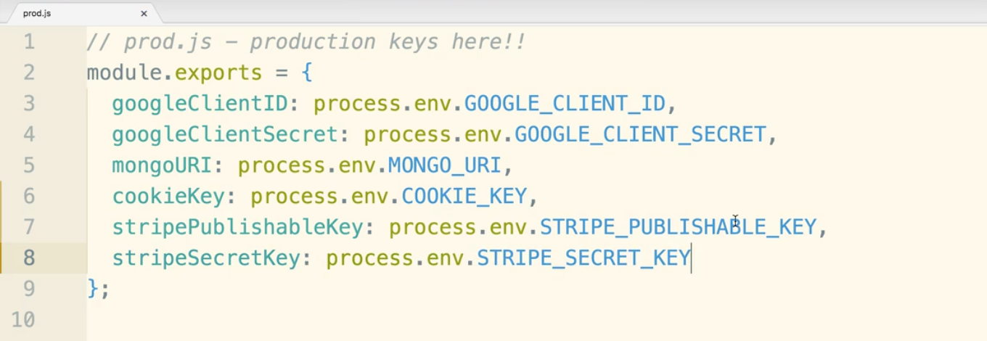

Now go to heroku.com. Open the dashboard for emaily ‘agile-bayou’ in the example.

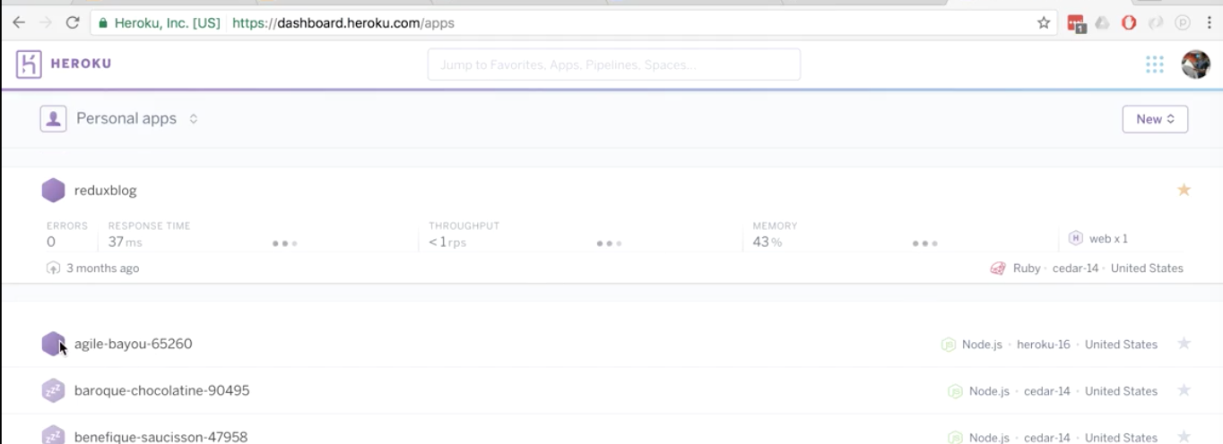

Settings tab, then click button reveal config vars

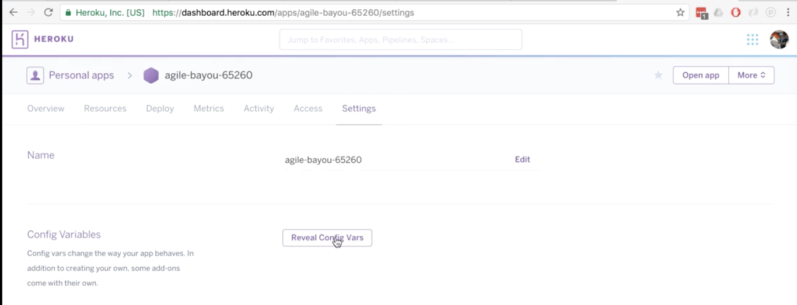

In this case we will use the same key values as the dev site.

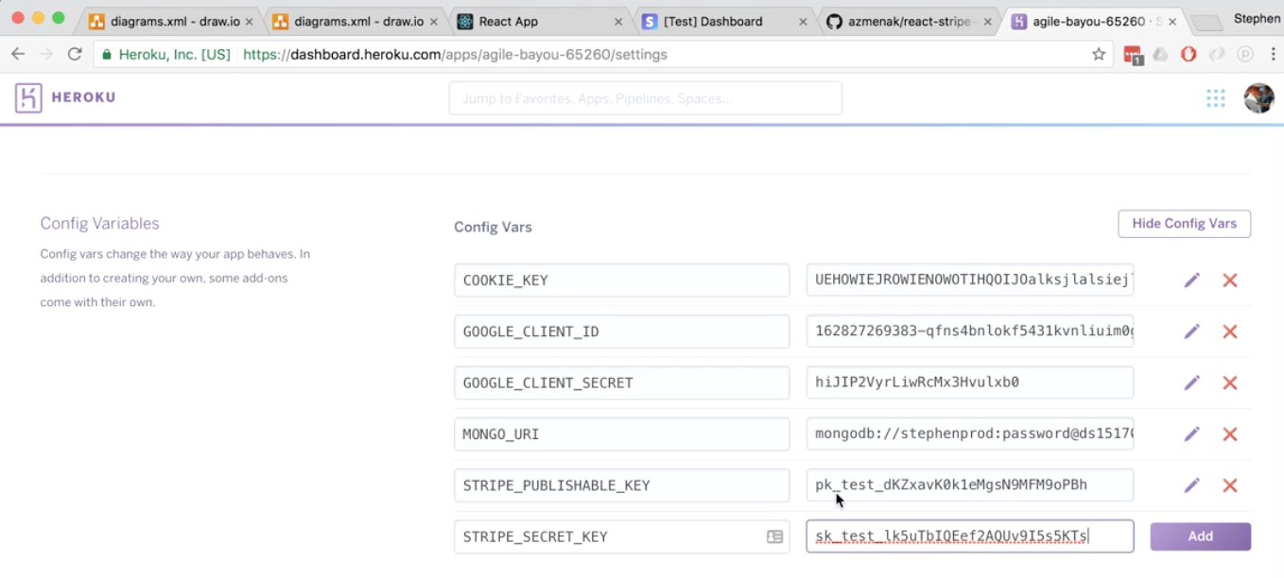

make sure you click add.

On the backend we use require statements. We are able to use logic to import the correct keys.

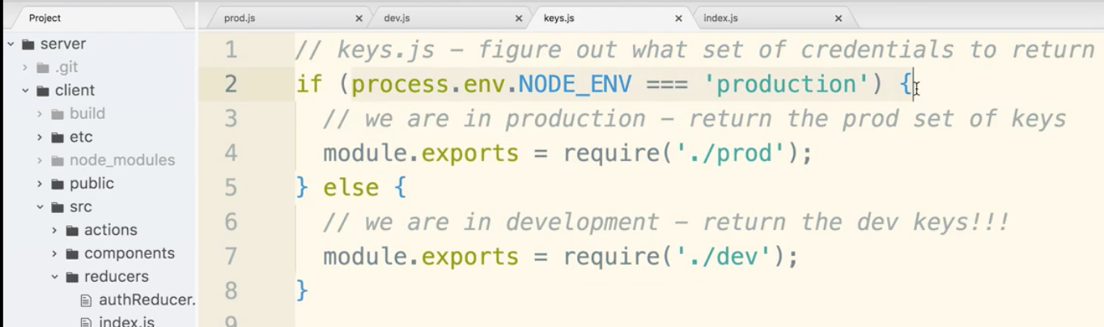

on the front-end we use import statements. We actually cannot combine import statements with logic like this! This is going to complicate our lives on the client side.

There is some documentation you can check out about create-react-app and environment variables. A quick google search will get you there.

One thing to note react environment variable must start with process.env.REACT_APP_

To define permanent environment variable, create a file called .env in the root of your project.

files can be .env or .env.development or .env.production, and a few others…

Now important for the next part, let’s make sure we are in the client directory. make a file called

“.env.development” and “.env.production”

Note the dot in front. (may look odd)

add the publishable key in. You do not need to put “PUBLISHABLE” in the name this time.

No quotes needed.

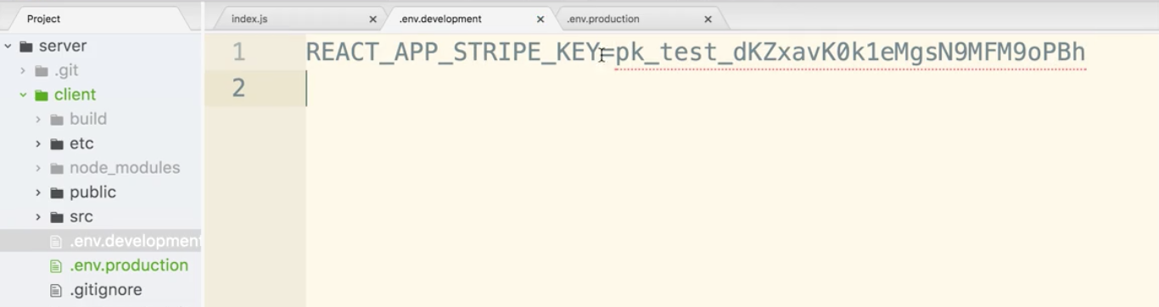

Do the same in production.

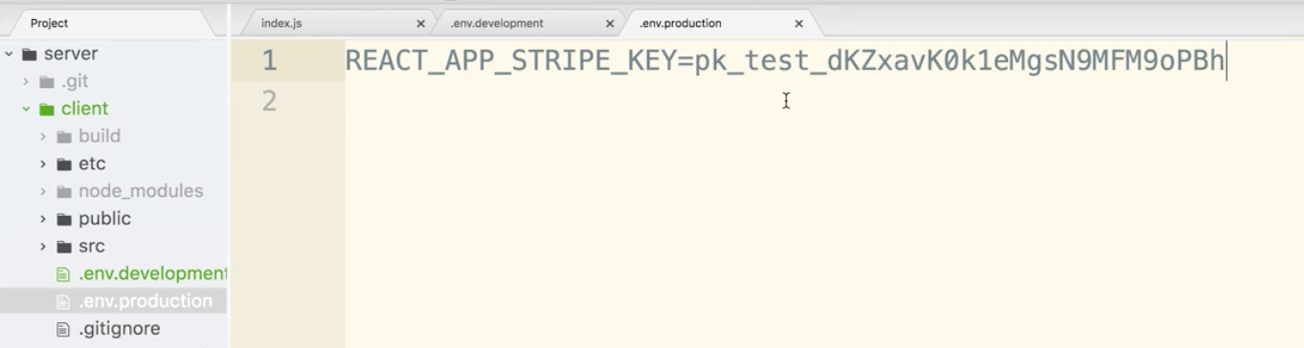

Now in client/src/index.js let’s put a couple console logs at the bottom to check if we are reading this stuff in.

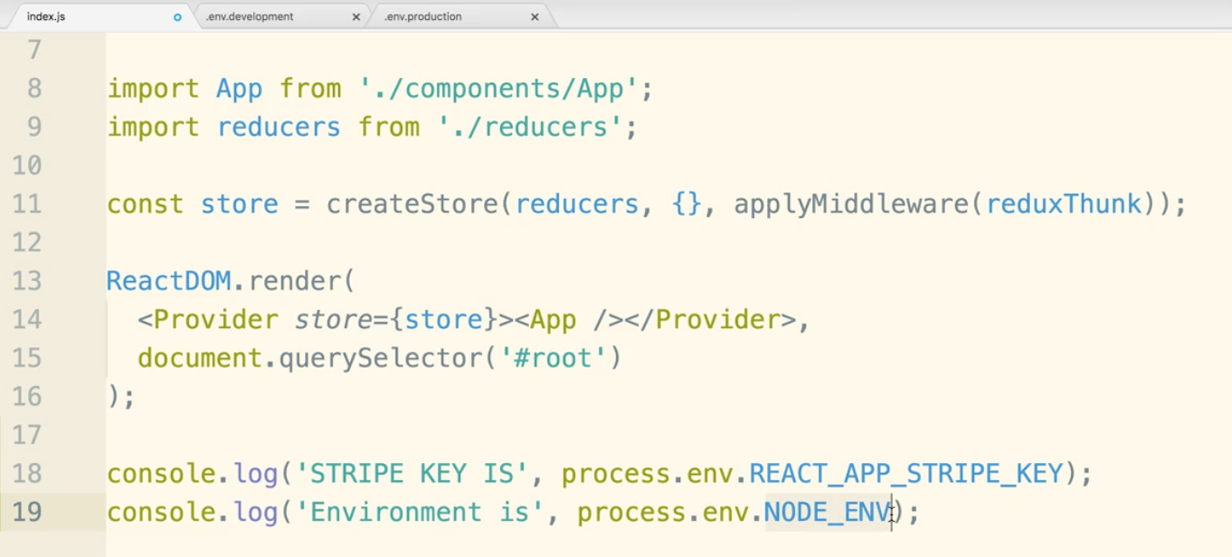

Go to the terminal kill and restart the server.

On the server directory,

$ npm run dev

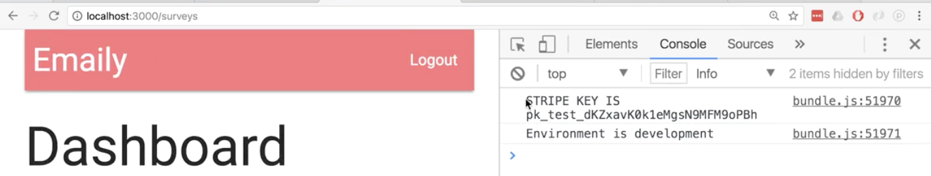

remember we are using the test account both on dev and production. You can change this by signing up and filling in the tax and billing info on stripe.

Another note. MacOS makes files that start with a dot invisible on the finder. This will screw you up with want to drag and drop files in another location. Beware that you will not have those dot files like the env files. This will mess everything up.

**Payments Component**

Create Payments.js in components folder.

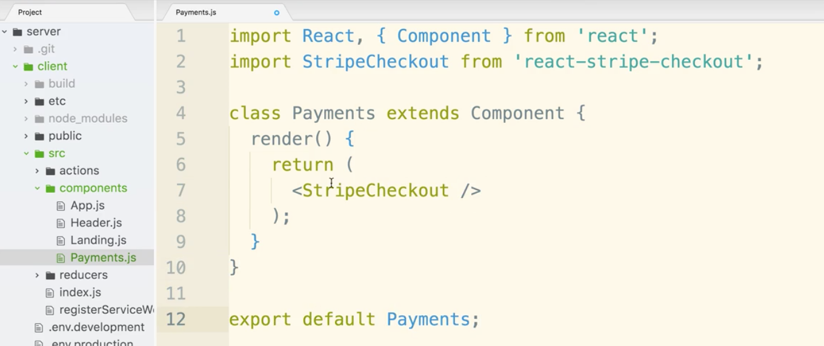

The component name can be called whatever you want. Notice that it is not ReactStripeCheckout and just StripeCheckout. We chose this because the react part seems redundant in our app.

StripeCheckout has some required properties. amount is one of them. US Dollar is the default by the way or more precisely, US cents. amount={500} is 500 cents or 5 dollars.

The next property is poorly named. It is ‘token’. Token is what we get back from Stripe once the customer is charged.

The last prop is stripeKey and it will take in the publishable key.

lastly we can add debugger statement.

This will allow us to see the actual JS code generated by this statement.

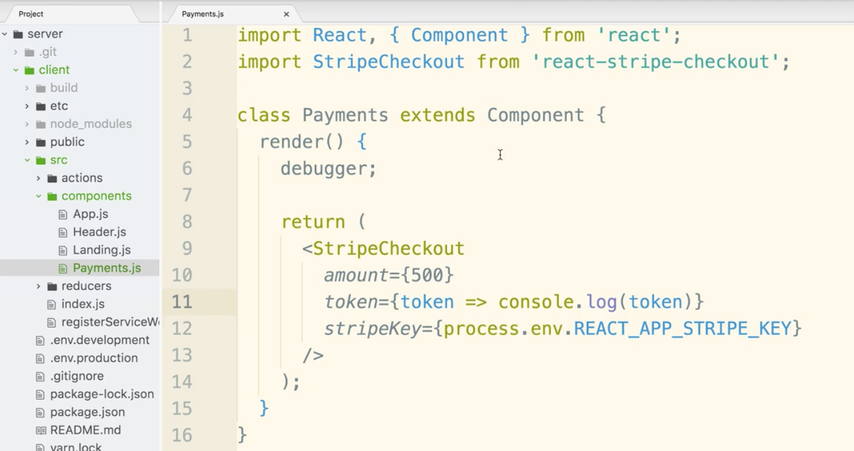

remember to export default Payments at the end.



Now let’s go into the header component and import Payments at the top.

Then update the default of the switch statement (logged in scenario)

We will have an array of li tags. We need unique keys (this won’t change) any key will do.

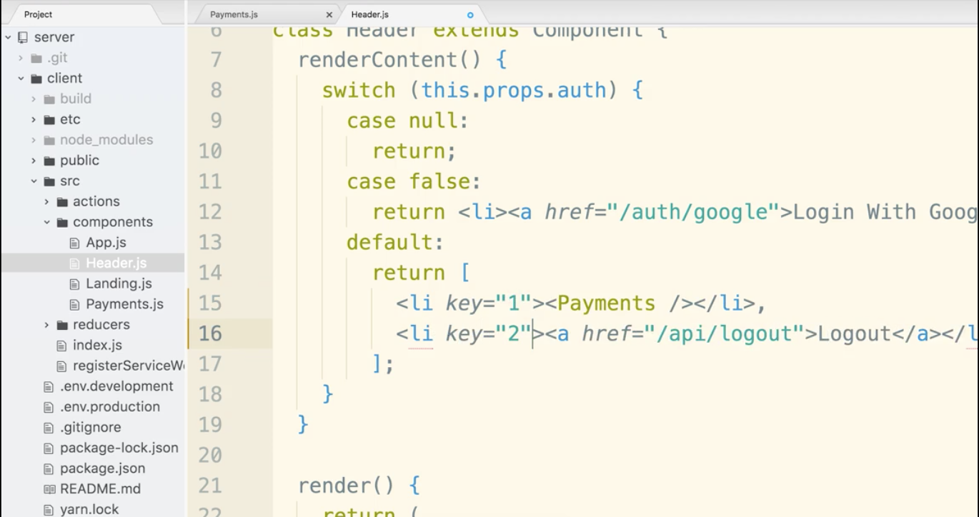

We will get an ugly button in the nav if all is correct.

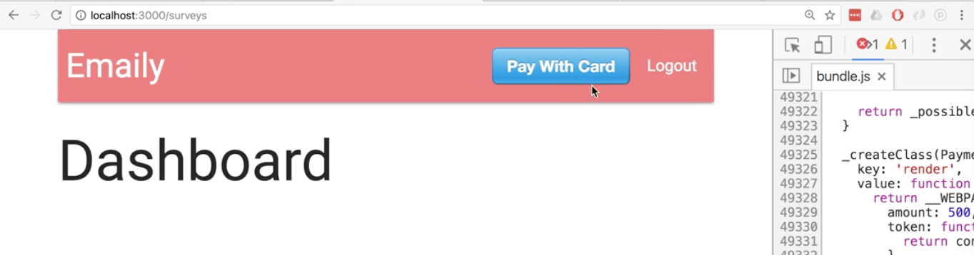

Cool modal pops up though when you click it.

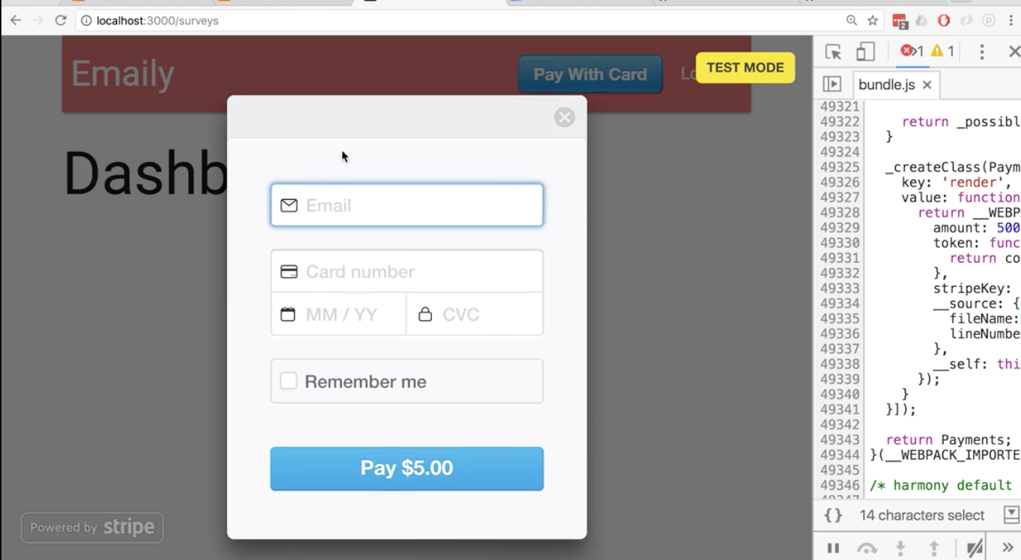

to test just put in 4242424242424242

the date has to be in the future and cv code can be anything, like 123

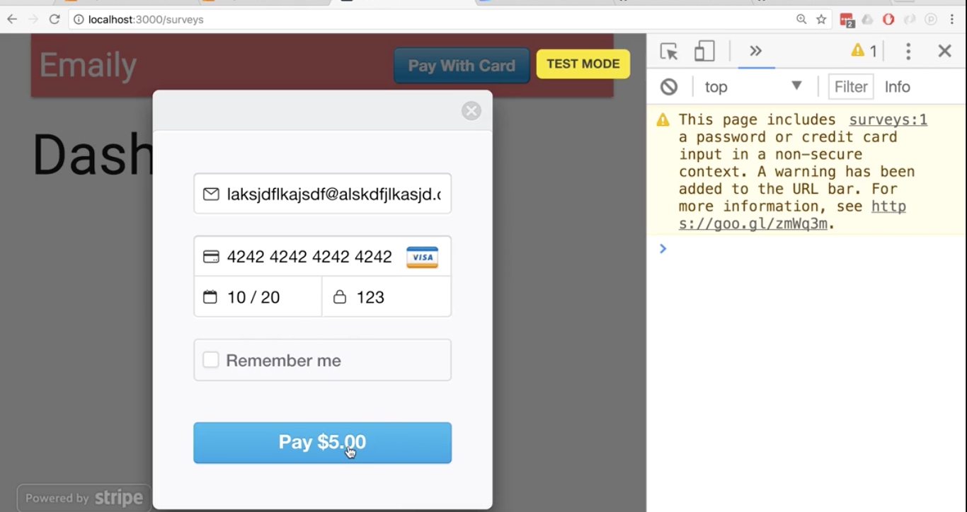

So the console will show the token. It’s a bit more than a token really. It’s an object that represents the entire charge. The id is the closest thing to a token.

Reminder of our app:

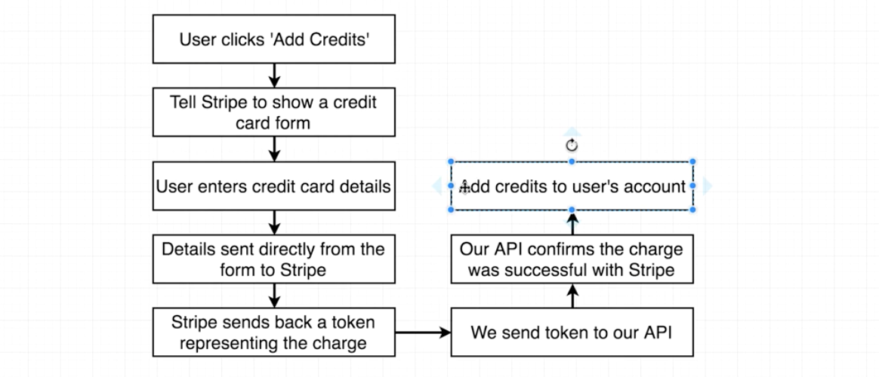

Credits will be added to the user’s account, that is, the user model.

Let’s customize the billing modal. Right now it does not really tell us what we are paying 5 dollars for. We can add two more optional props to fix this.

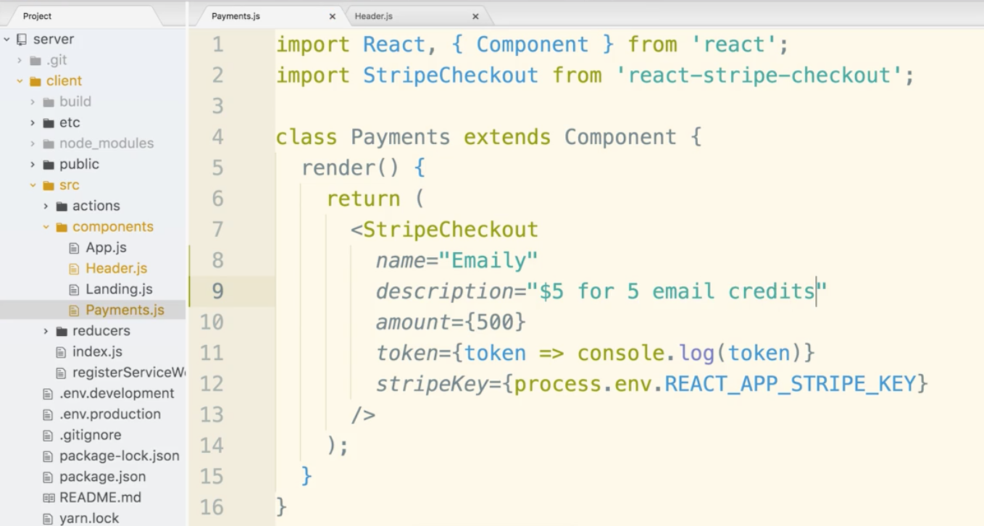

Now let’s fix the ugly button that does not match the rest of our site.

Let’s change <StripeCheckout /> from a self closing tag to a regular tag and give it a child component.

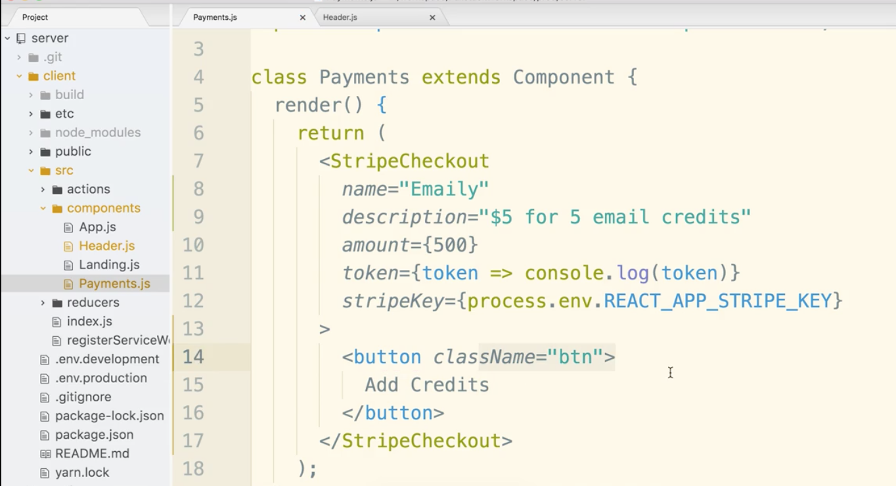

(It still looks ugly but it calls to action)

Now when someone adds credits the header should update with that info.

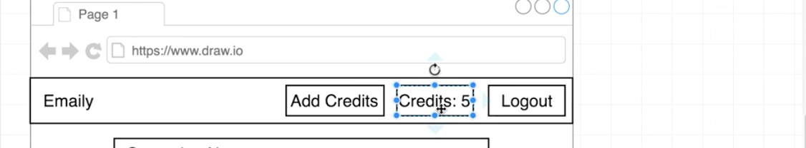

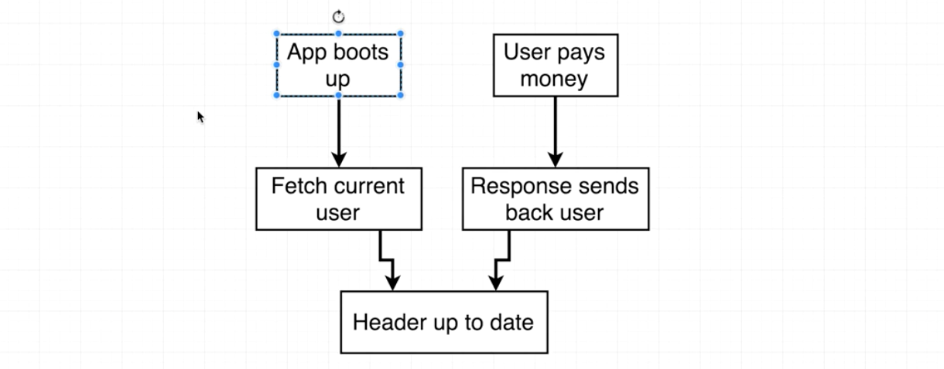

We need a new action creator to update the credits of the user model.

Open client/src/actions/index.js

Our new action creator will look very very similar to the one created already.

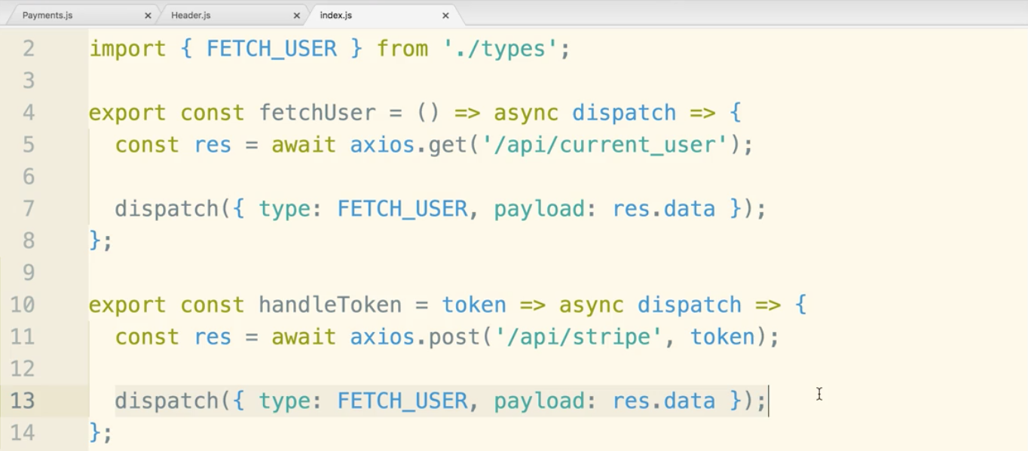

In fact we will be fetching the user again. It’s almost like we could refactor or something. Best not to. Keep them separate.

handleToken will take the token we get back from Stripe and send it off to the backend server.

Open Payments.js

import connect and the actions

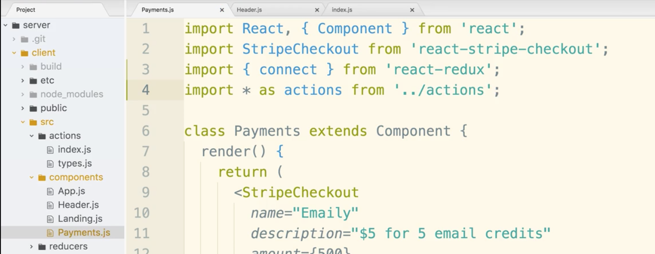

Then, wire up connect() at the bottom.

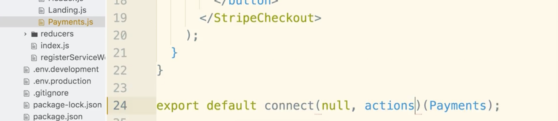

Now for the token prop, insert this.props.handleToken(token)

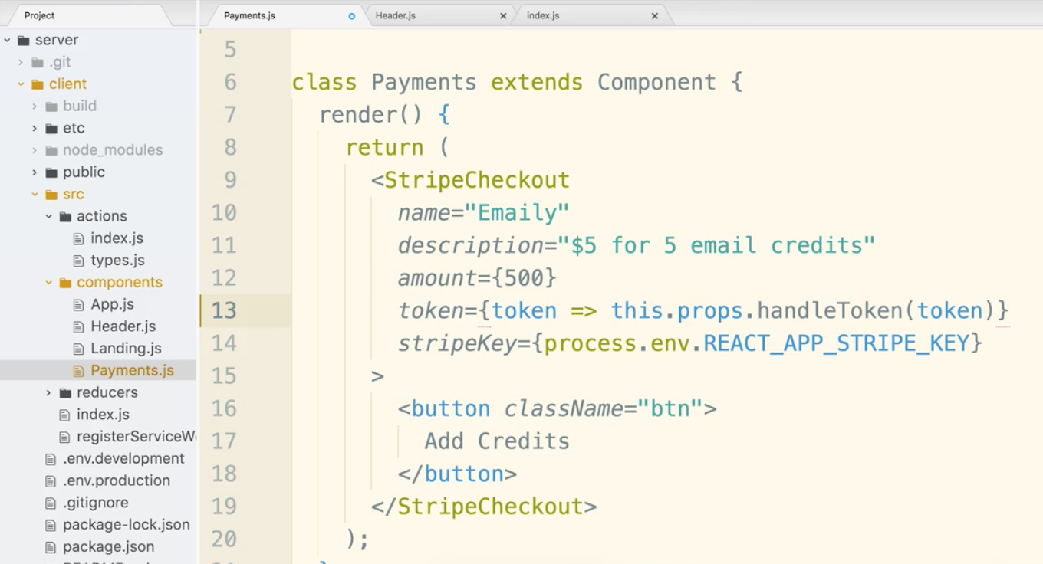

Now the front end is as wired up as we can go at the moment.

Let’s create a new routes file in the server/routes directory. Call it billingRoutes.js

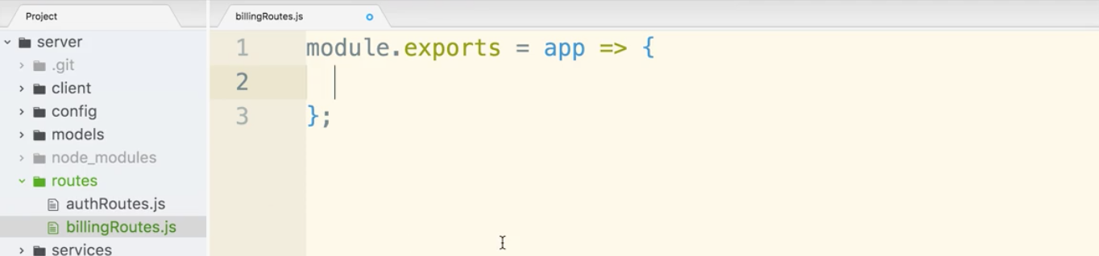

Before we add in more code, pop into index.js and add a require statement that turns into a function and gets called right away with the express app.

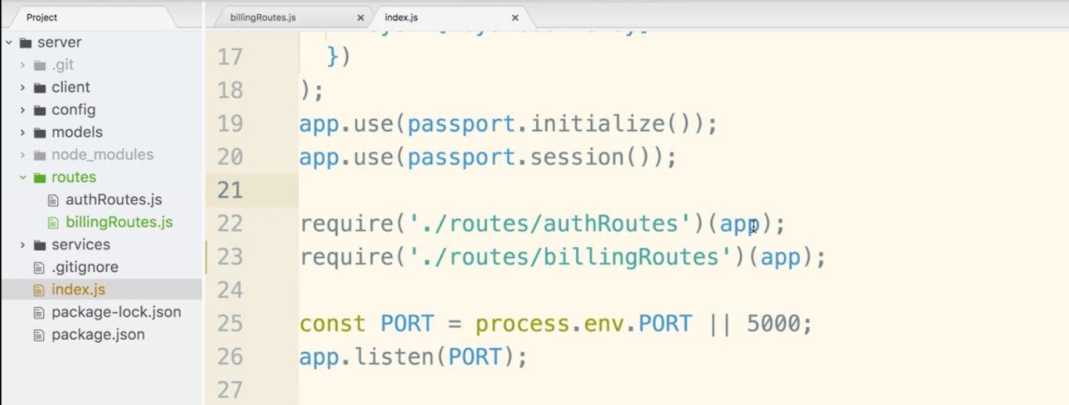

Now you can update billingRoutes.js.

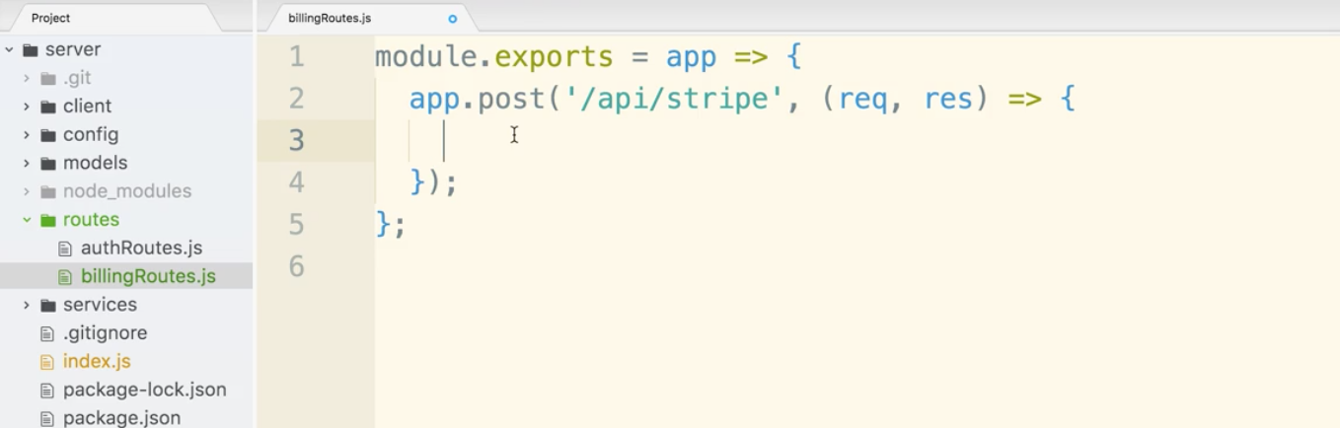

Now we need a module to help us deal with the stripe token on the backend.

Let’s go to our terminal make sure you’re in the server directory.

$ npm install --save stripe

Documentation:

<https://stripe.com/docs/api/node#create_charge>

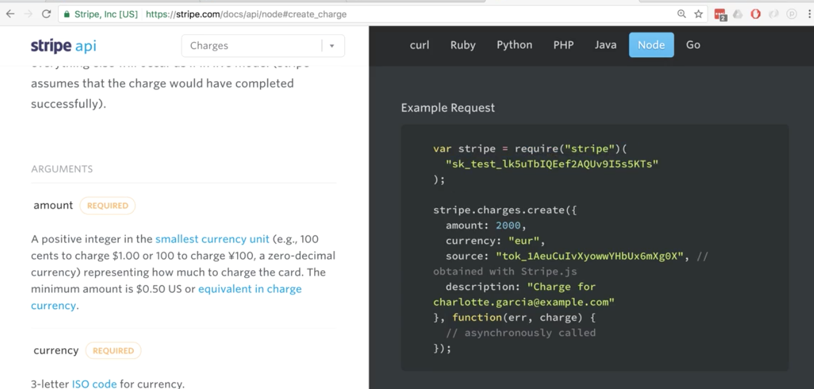

Now go to your editor and require stripe. Note that a second set of parentheses go in there with the secret key.

open billingRoutes.js import keys (note you go up a directory then down)

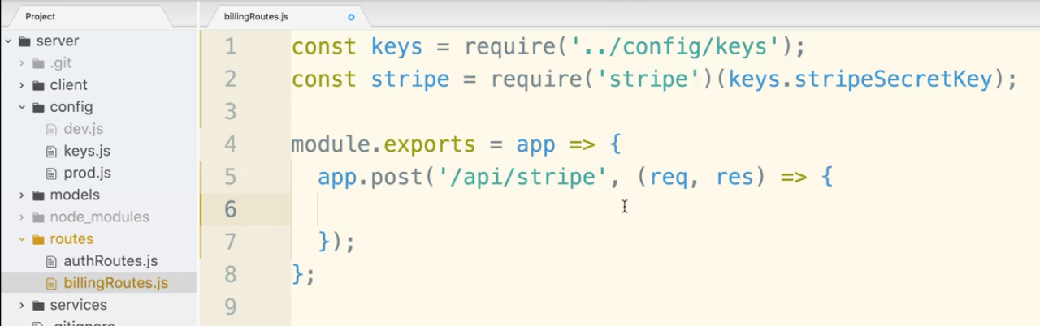

Now let’s put together the logic we need to take the card, etc. When you make a post to a express server it does not parse the request payload by default. We will need a module.

Hop over to the terminal, kill the server.

$ npm install --save body-parser

Now open index.js and require in body-parser

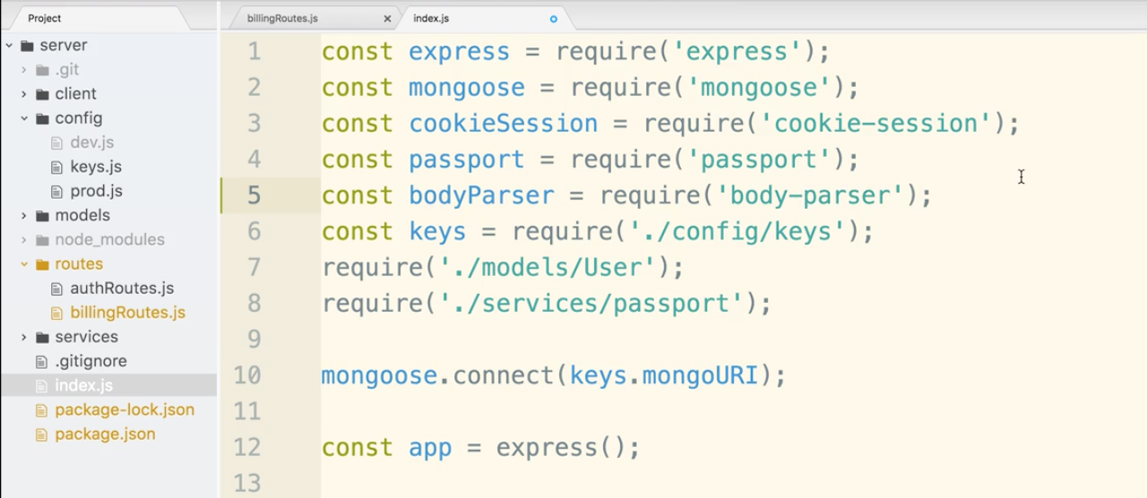

Remember that this is a middleware it middlewares are wired up by app.use()

Add a call for bodyParser.json()

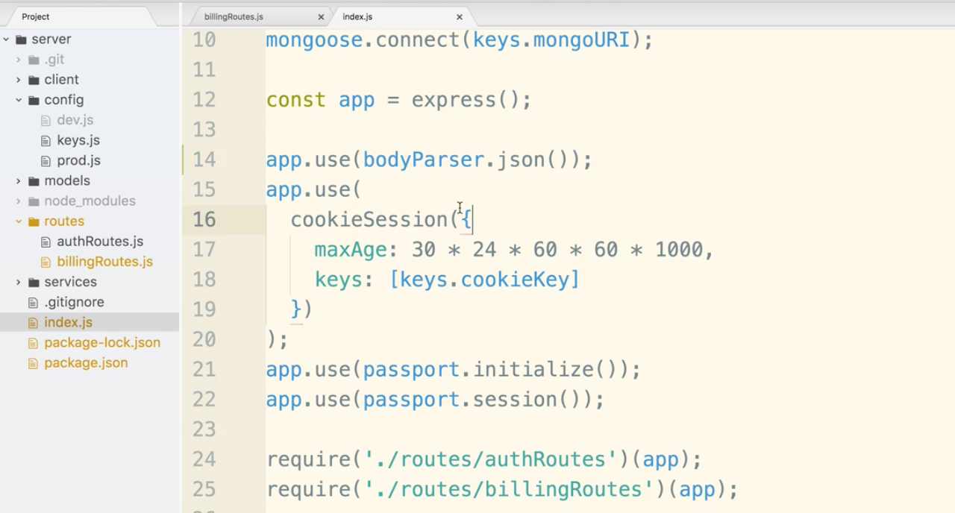

Let’s test to see that it is all working by doing a console.log(req.body)

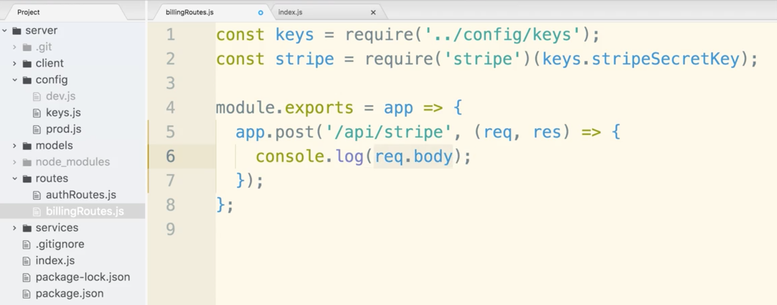

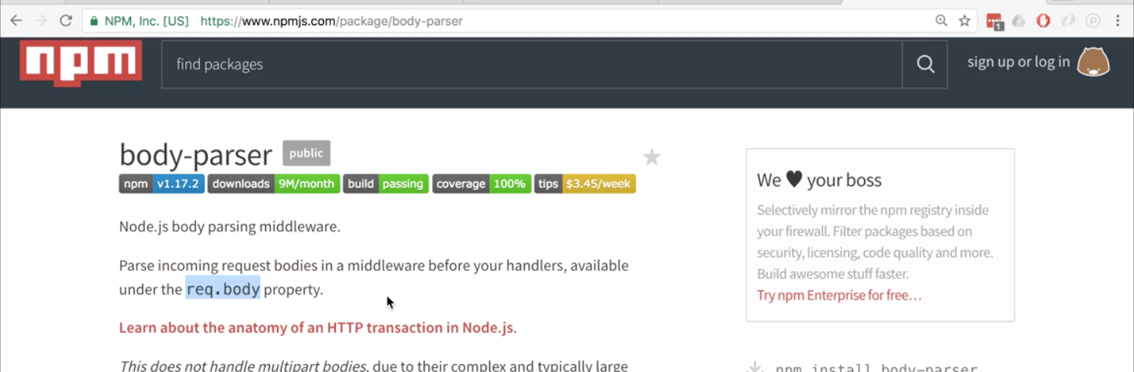

head over to the terminal and make sure the server is running

$ npm run dev

Go into the browser, make sure your chrome console is open. Network tab, then select XHR. Hit the clear button (circle with line through it.)

Click the add credits button at the top. Enter the Credit card info.

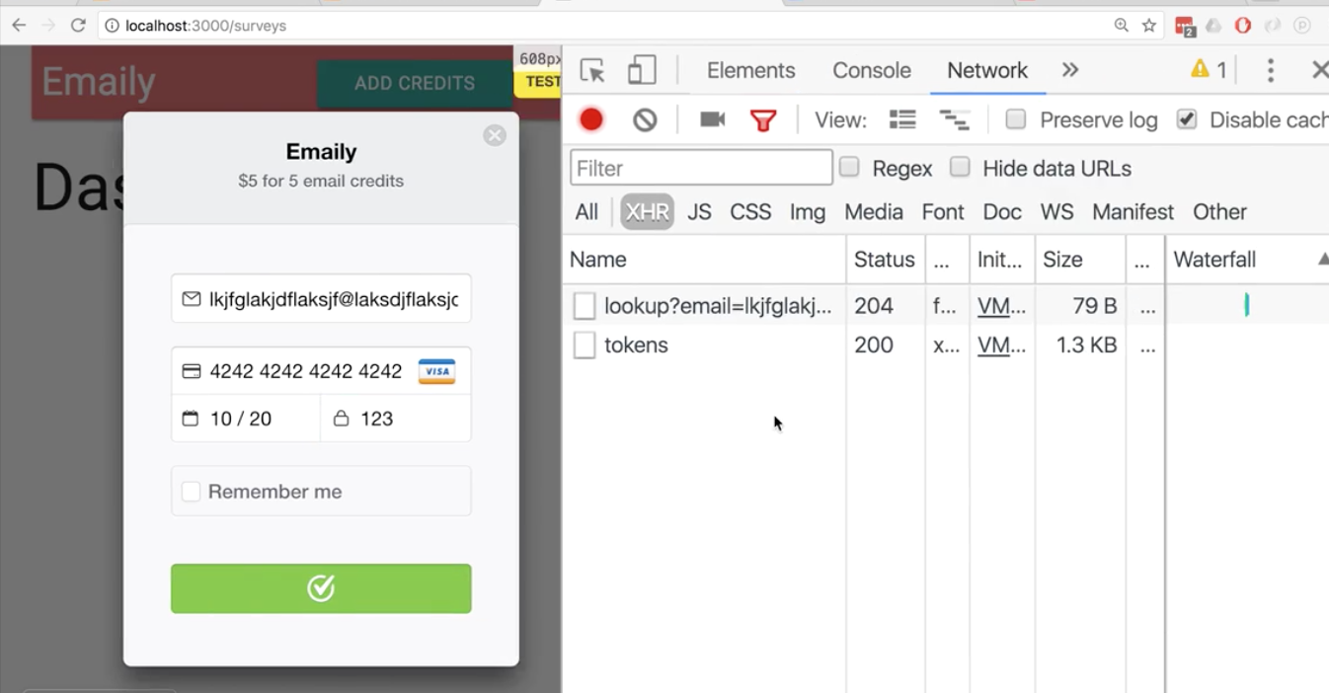

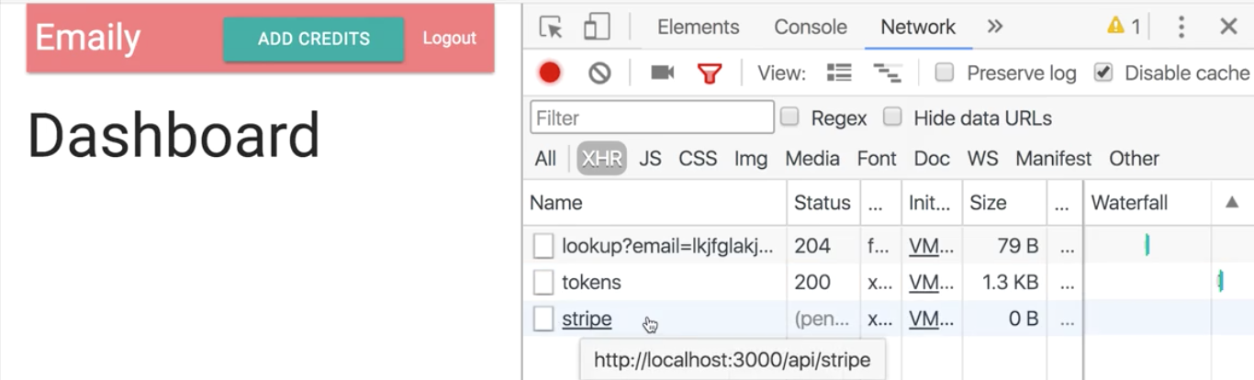

You may notice that the request status is listed as pending, because we are not currently handling it on the back end.

If you got to the terminal you will see the console log of the request body.

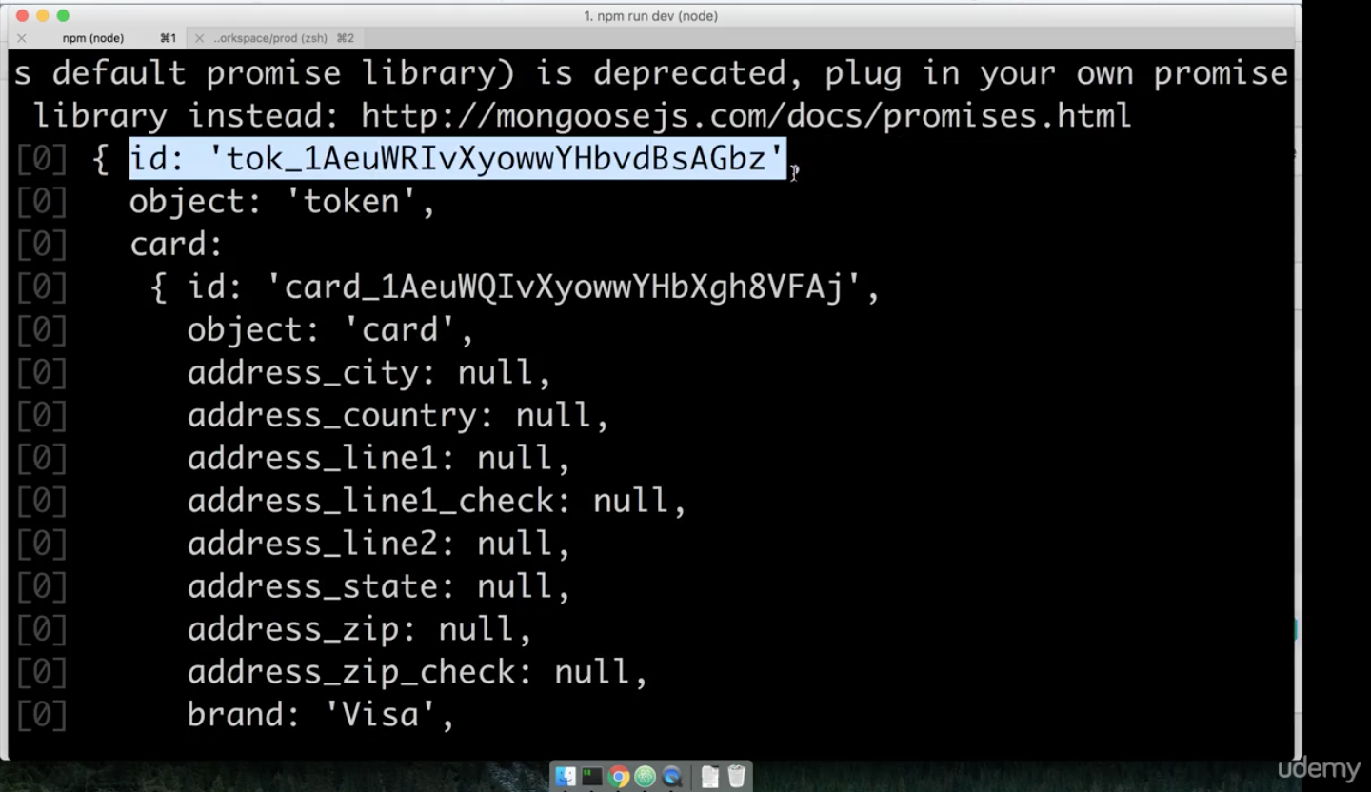

We need to again list the amount. This needs to be verified on the backend. The stripe docs tell us what we need. We need the amount (in cents), currency, description, and source (which is what we just saw in the console.log req.body.id

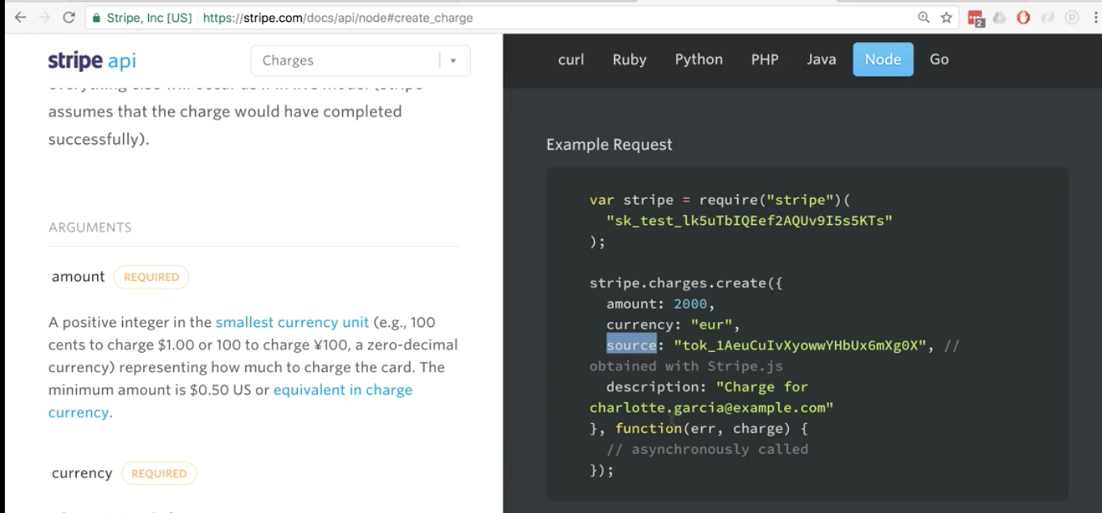

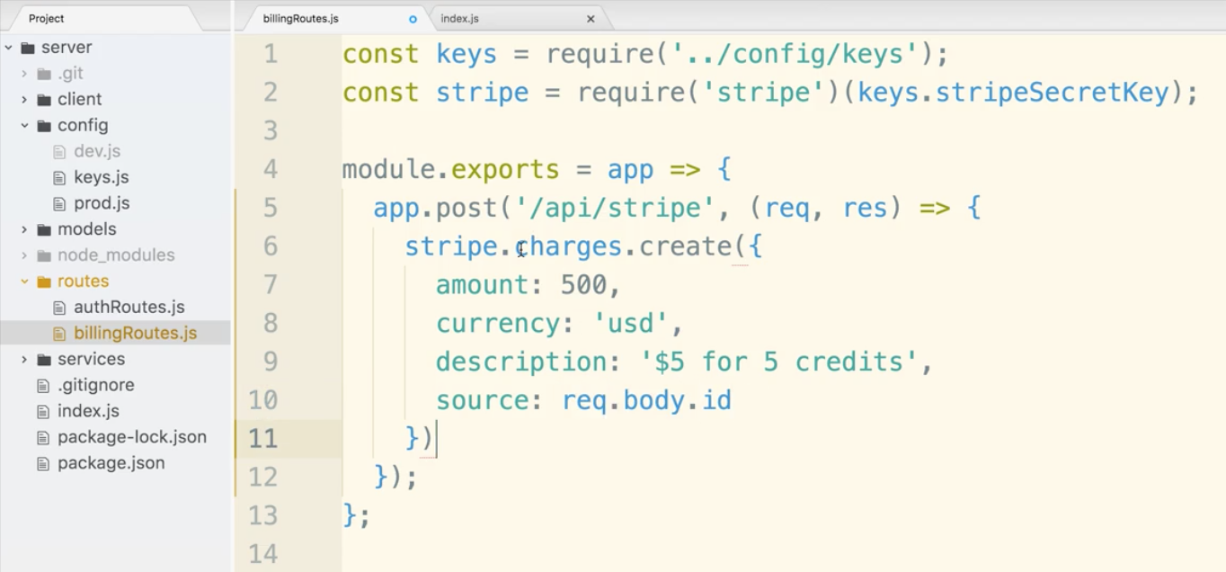

There is a callback function we could use in create() if you look carefully at the documentation.

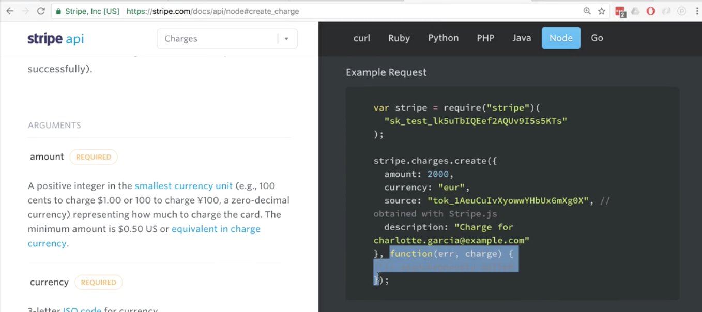

The stripe library returns promises. If you take a peek at the npm documentation of stripe it shows you can use promises instead of a regular callback.

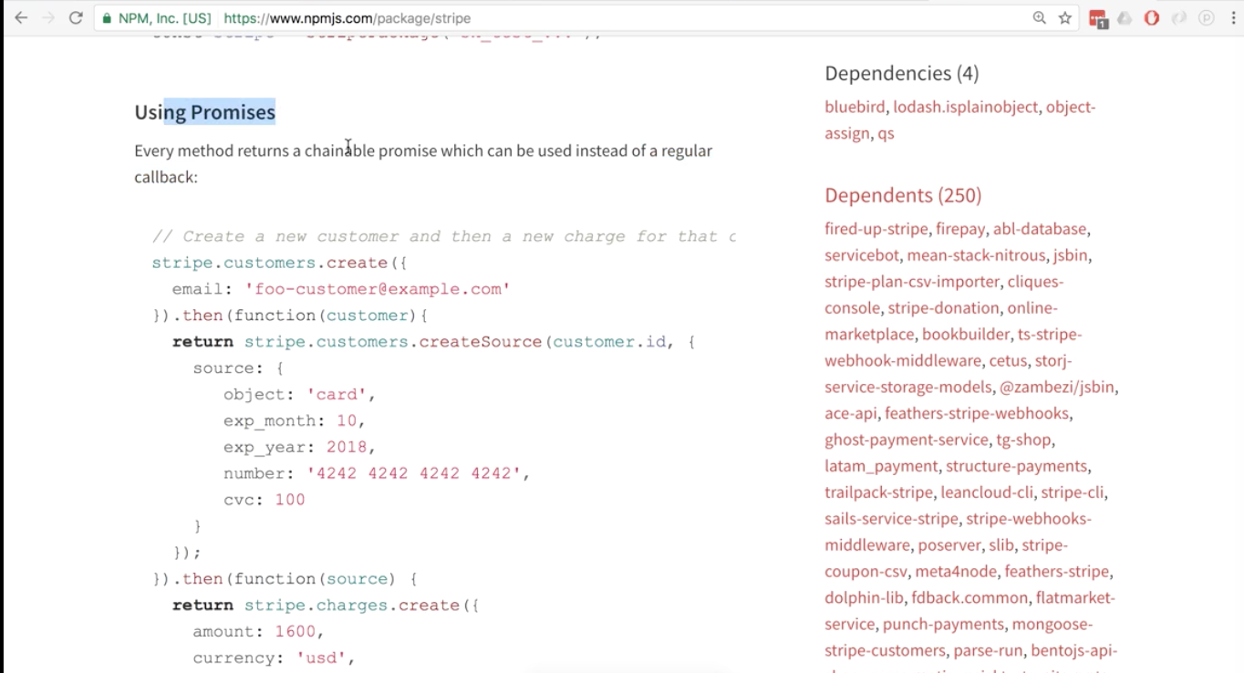

So first let’s find the place in the code that has asynchronous calls, and that is the request handler (the second argument of app.post()) Then let’s modify the code a bit with async await. We will create a variable we will call const charge and assign it the function that returns the charge object.

Add a console log at the end for testing.

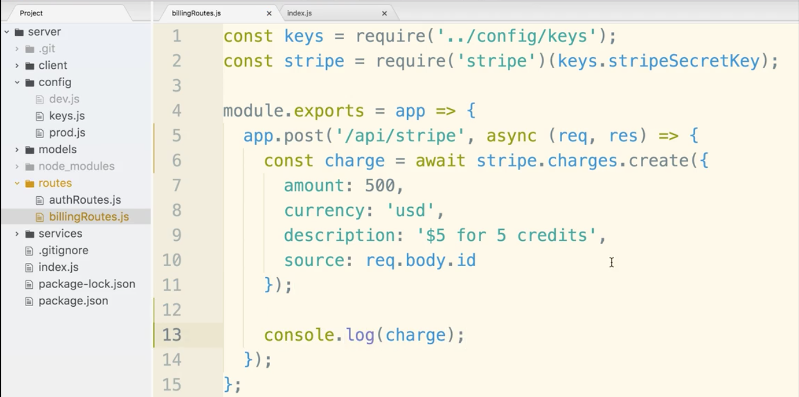

Go over to the terminal to check that there are not any errors.

go through a fake credit card payment on the site.

Now if you go back to the terminal, you should see a large object that describes the charge.

**Adding Credits to a User**

We are going to add another property to our User Model and call it credits.



go into the models directory and then the User.js file. This is where our userSchema lives and it creates a new mongoose model. We are now going to add another property called credits.

We need to tell this property that it will be of the number type AND that it must be assigned zero credits to start.

So when you are building your schema you can just assign the type property or you can assign an object that will allow you to assign multiple properties. We will use ‘type’ and ‘default’ here. You can check out the mongoose documentation for more options.

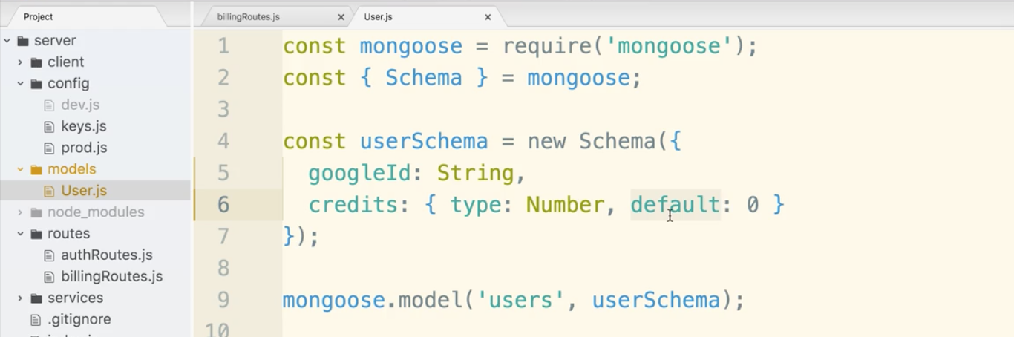

Now back in billingRoutes.js we will need to write a response that updated the amount of credits to the current user model.

We are going to access req.user which is available to us when a user logs in with passport. This is set up automatically by passport. Passport is wired up inside the index.js file with passport.initialize() and passport.session() calls.

We will add 5 credits to the credits property and then user.save(). .save() is one of the functions on the User Model that takes the model and persists it to our database. The += 5 line does not actually persist on the database until it is saved. .save() is asynchronous, so we will use our await keyword.

The reason we assign the variable const user, is so that if we want to use the data we have the most up to date copy of the user model.

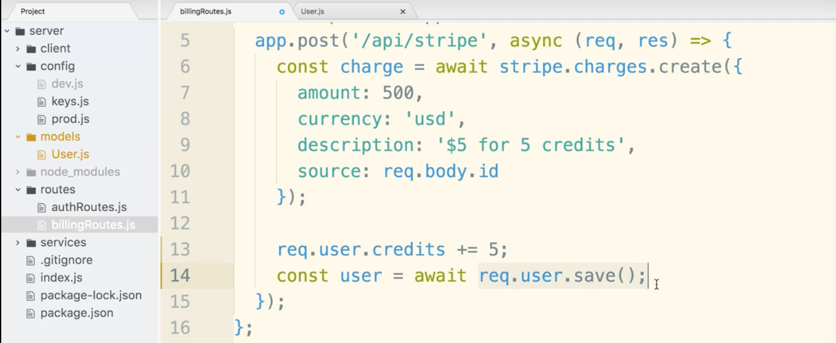

The last line will be .send() that sends back that data we want to communicate back to the browser.

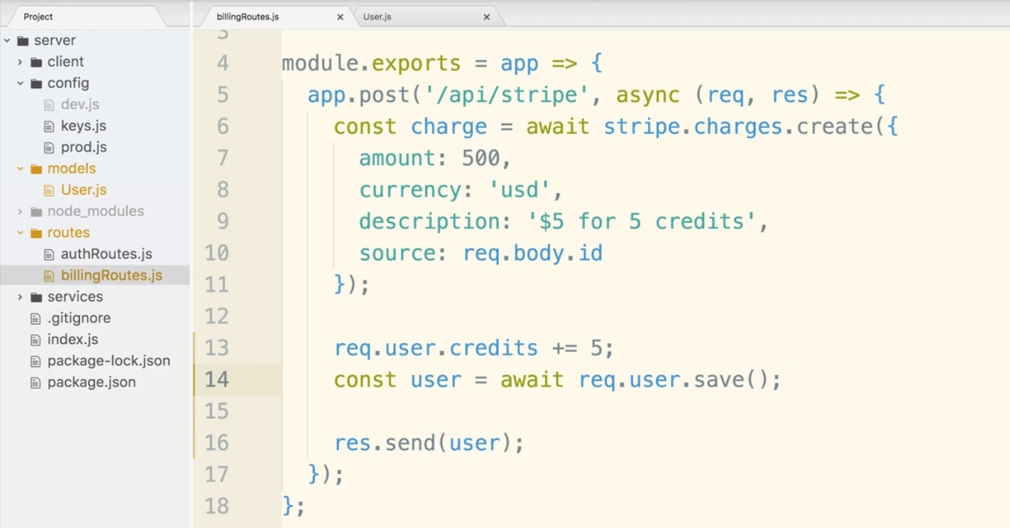

go back to the terminal. Make sure you are in the server directory.

$ npm run dev

flip over to the browser, click the add credits button and put in the fake credit card info.

Using dev tools, network, preview, you can see that credits were added to the object.

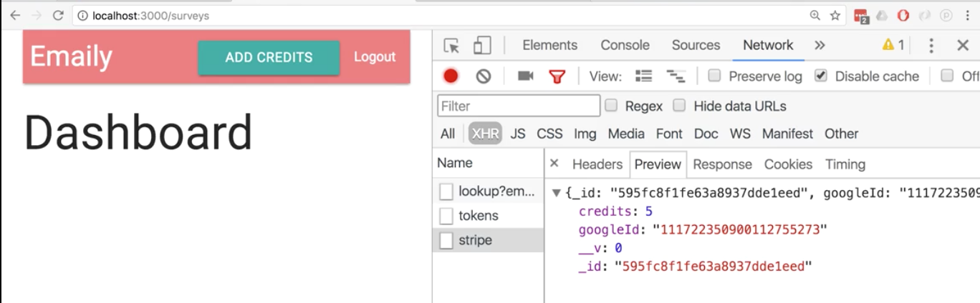

Looks good, but we may have a gap in our logic. A bug in certain situations. What if you are not logged in using passport. In that case req.user would be undefined. In that case, an error would be thrown. There is nothing in our route handler that makes sure the user is logged in.

Naive approach to solve this:

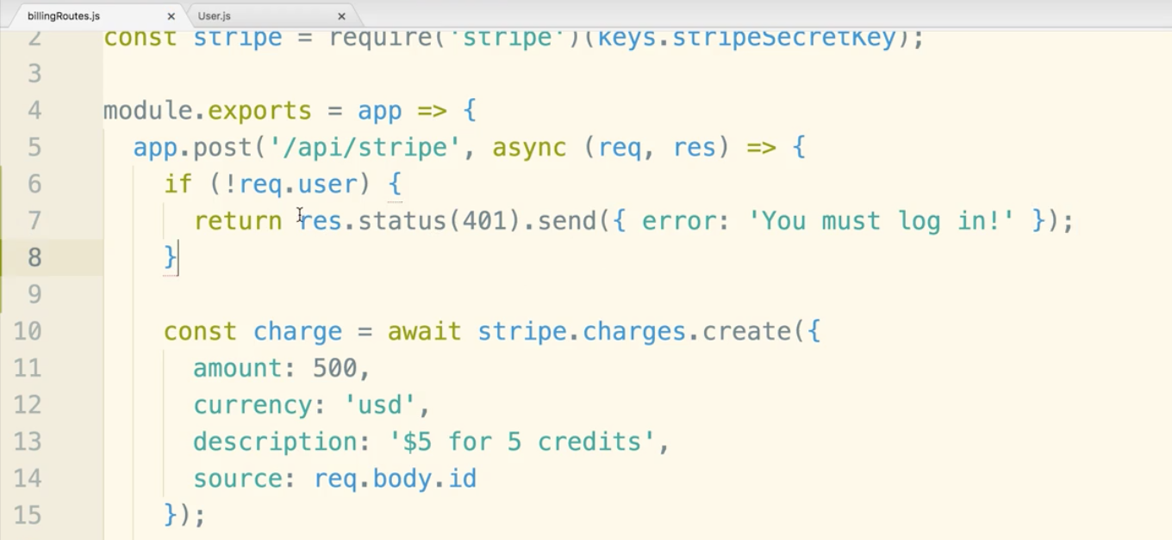

So this definitely works. However, there will be other routes that we want to check with this type of logic. With the current solution, we would have to write this check over and over. We want to DRY it up.

Quick reminder. We can use middleware in our express application. Middlewares expect an incoming request and modify or change it if it so wishes. The request is then taken and then send off to any route handler we might have inside of our app. In our case remember middleware is some function that takes the request and messes around with it and little bit before the request is sent on.

**Route-Specific Middleware**

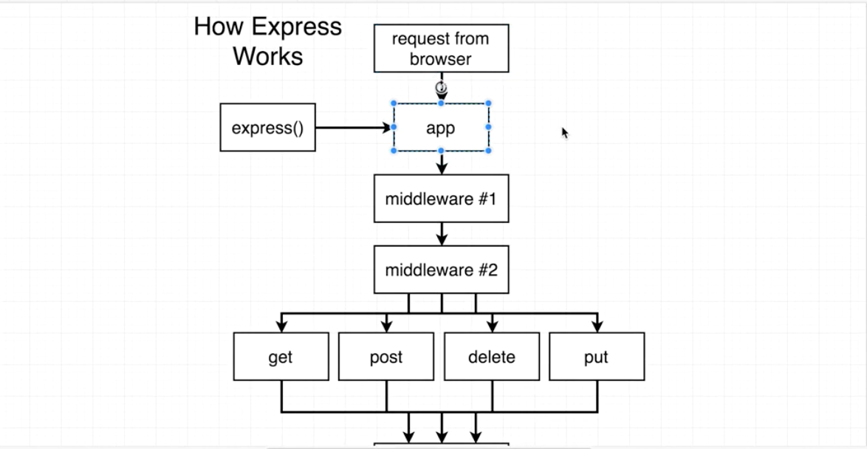

We want to run the ‘are you logged in check’ on very particular route handlers.

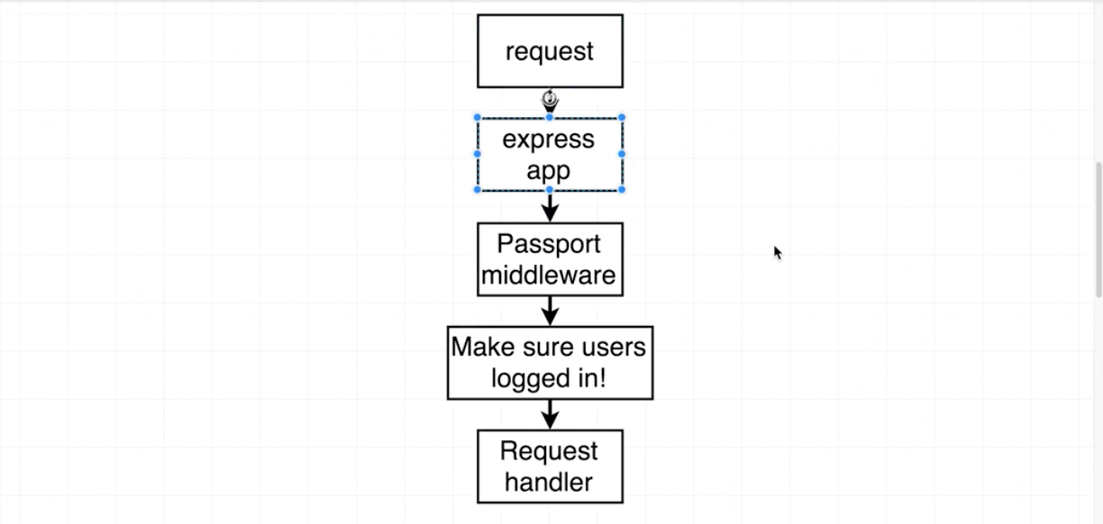

We will create a new middleware that we will use to make sure a user is actually logged in to our app. We will use middleware for very particular route handlers, specifically, the ones we need to make sure the user is logged in for. So far our use of middleware applies to ALL routes (like the bodyParser middleware). We will want middlewares that apply to only some of the routes.

create a middleware folder inside server directory. Create a file name requireLogin.js. Our naming convention here start with a lowercase because we will require in this snippet, but it is not a Component or Model Class that would start with a capital letter.

The middleware we are creating will take in 3 arguments: req, res, and next. next is a function that we call when we are done and want to move on to the next middleware. We don’t have to call next if we don’t want the response to move on. That is the exact case that occurs when we notice that user is not logged in and we need them to be. We can respond with a 401 status and error object instead of calling next and moving the response on. This is what the completed middleware should look like:

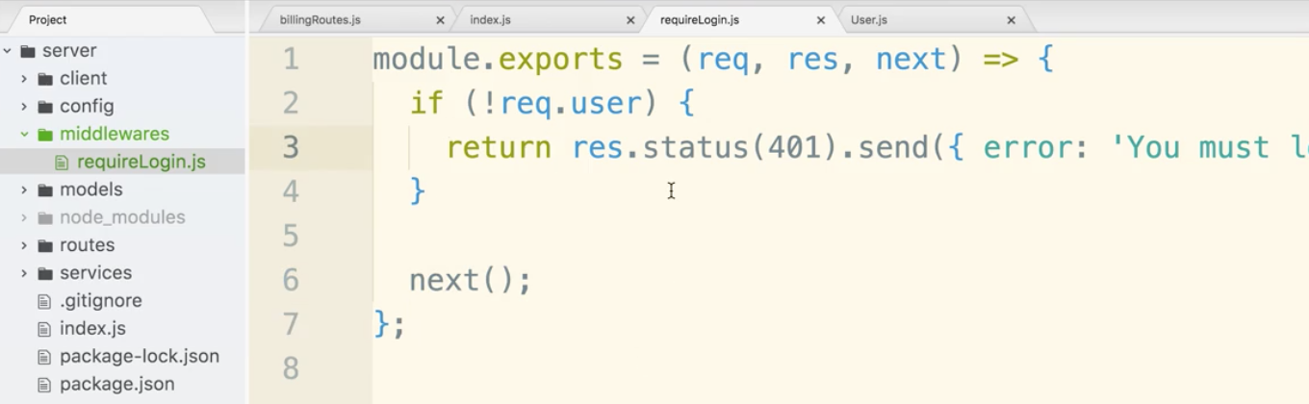

Now we can go over to billingRoutes.js and require the middleware requireLogin. Notice that post can take in as many middleware arguments as it wants. The only requirement is that eventually the the request is handled. Another thing to point out. The argument is written as requireLogin instead of requireLogin(). We do not want the function to run when first loaded in. We only want it to point to a function that will be used when the specific route is accessed.

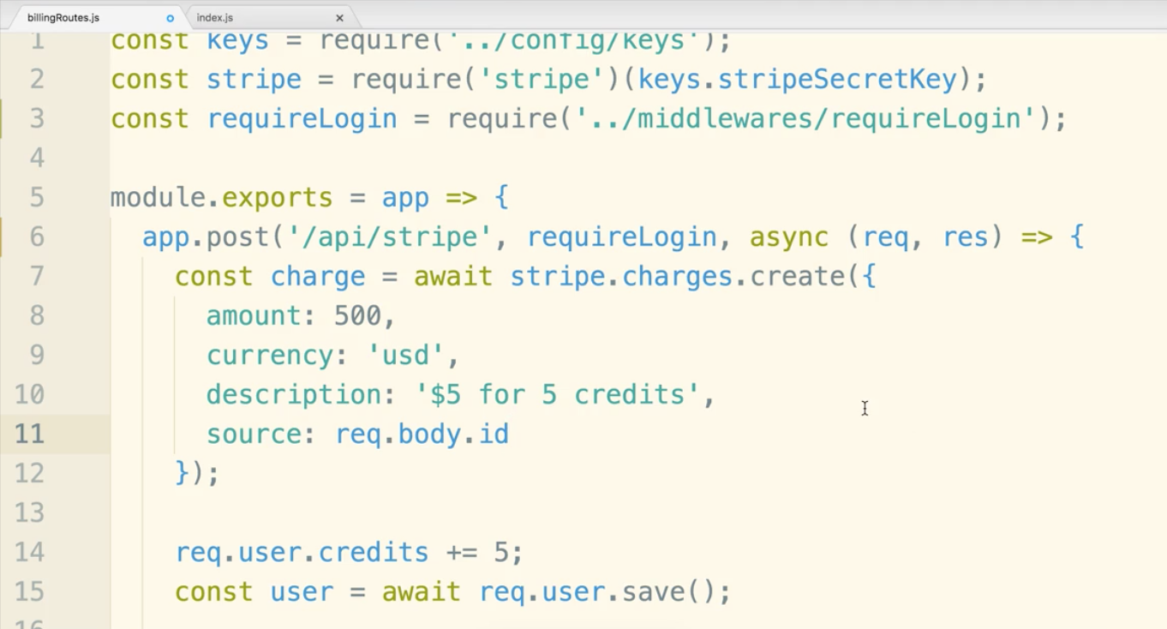

Notice the login if statement was removed. We can now use that middleware anywhere we need to require a login.

Now let’s get the number of credits to appear in the header. Start by opening the client/src/components/Header.js. Currently we have an array of li tags that list out based on whether the user is logged in. (whether property auth is true or false) Now let’s add in another li that has the credits.

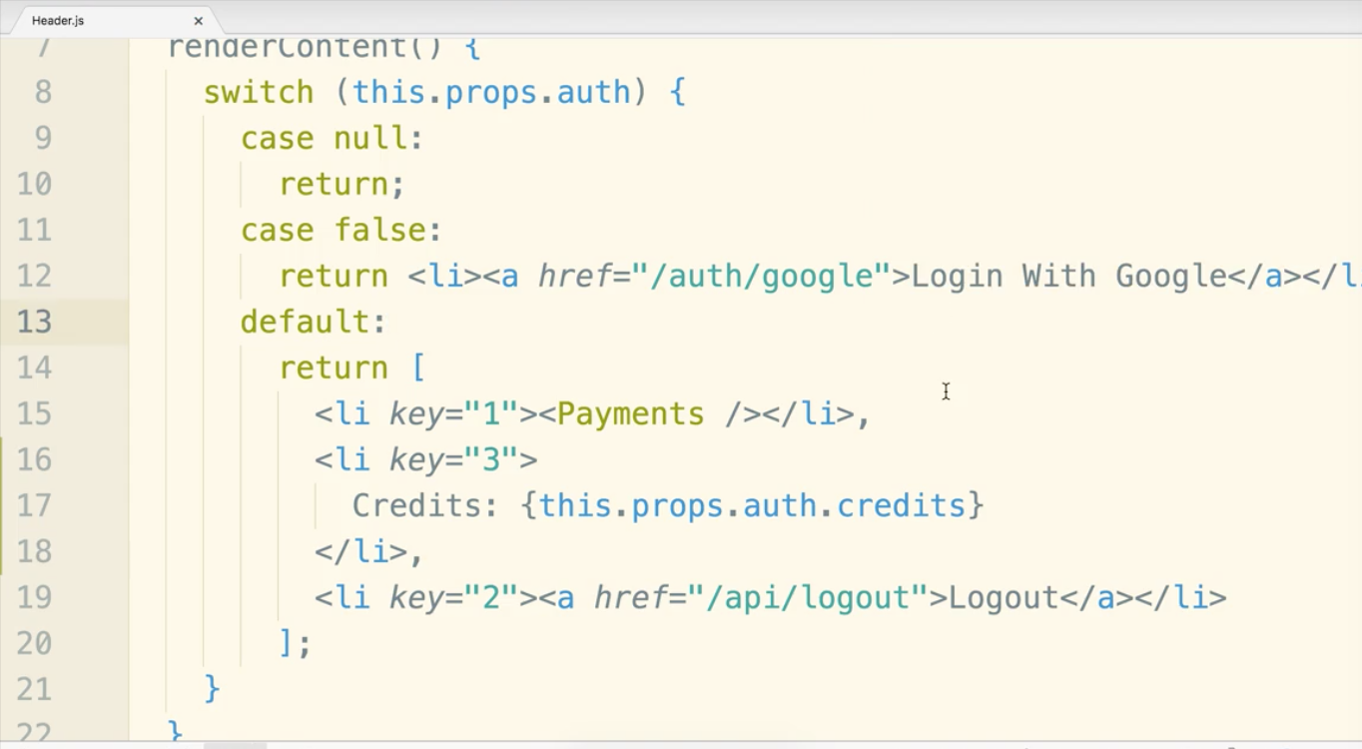

You may notice on the browser that the style of the li needs margins. We can put in a quick inline style to fix it up.

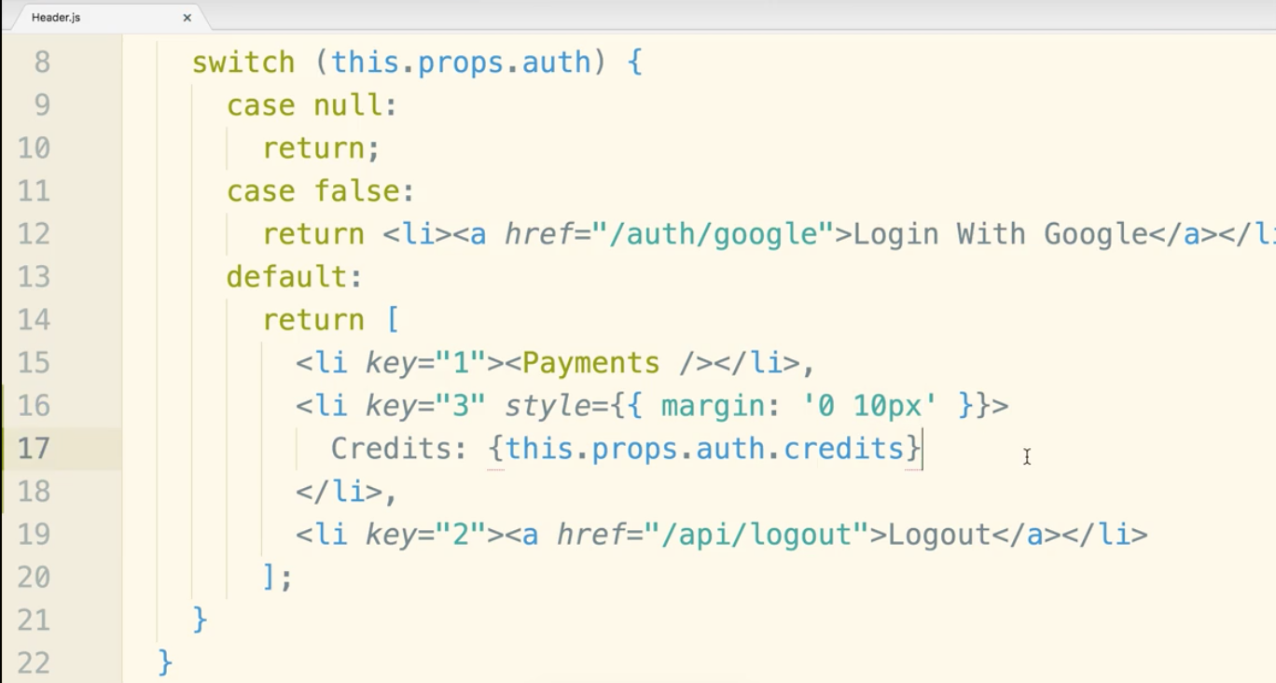

Now there is one small edge case we need to fix up. We also want to make sure the credit amounts are always 100% up to date. This is how things should work:

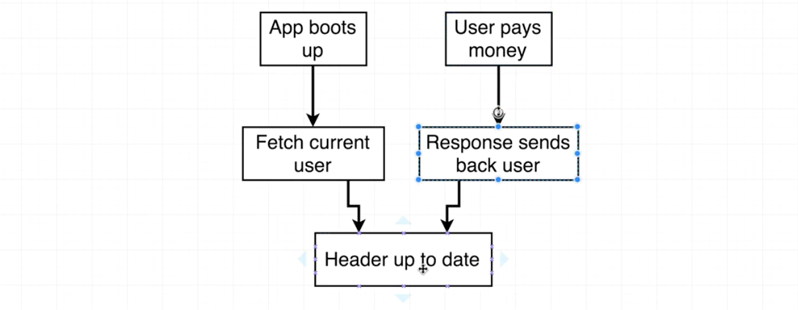

So if you go to the browser and add credits with phoney credit card info, the credits will indeed increment from 5 to 10.

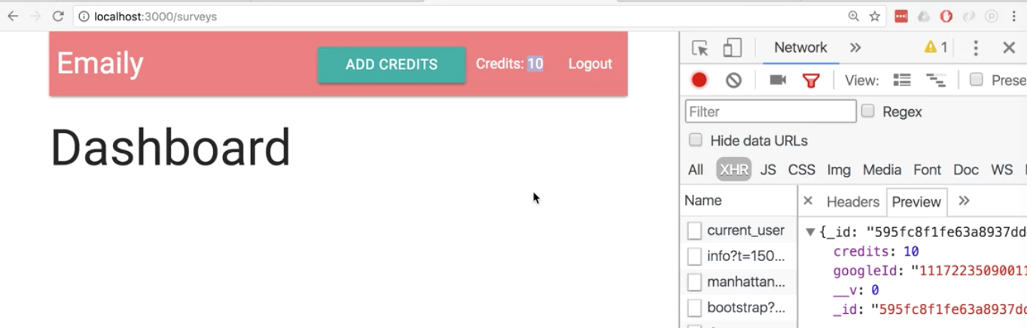

That does it for the billing section.

**Back End to Front End Routing in Production**

We should deploy to heroku again. We have not done this since we added the client side of things! It’s a bit tricky the way things are currently set up, but we will discuss it.

So we need to discuss how our express server works in production vs development.

We will also discuss the build process we use on the client side of our application.

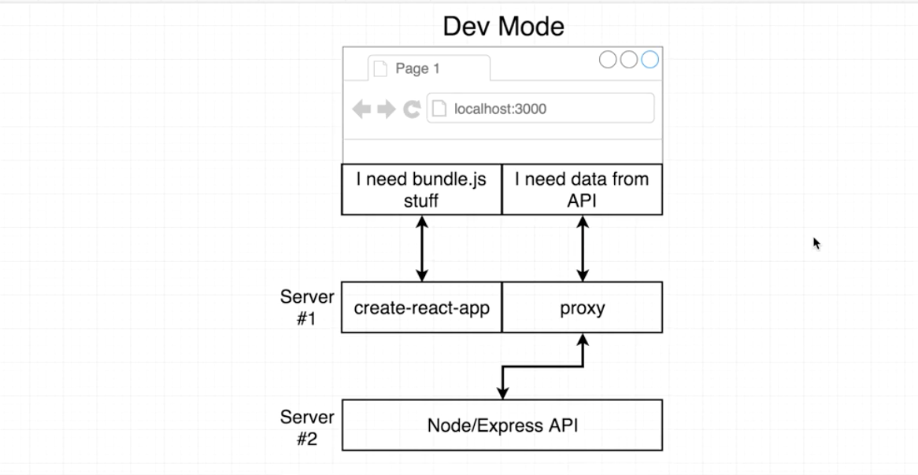

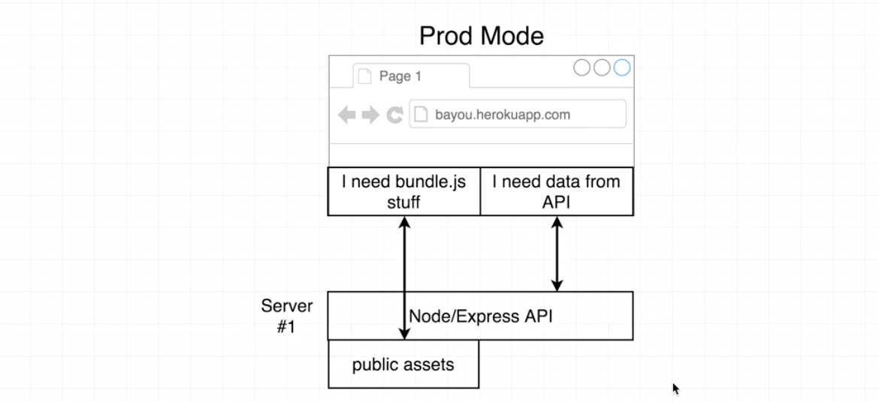When we run npm build in the client directory the js, css, and html file get placed in the client/build/static folder.

Let’s look at why it’s a bit challenging to get the express side of our application to serve up these public assets.

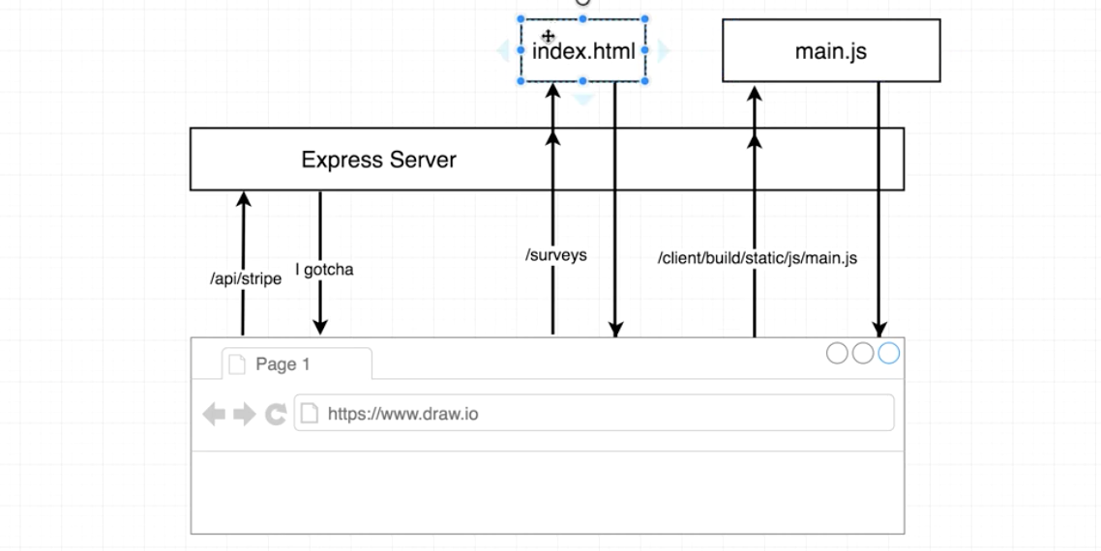

There are some routes being handled by React Router and others being handled by the express server.

There are 3 types of routes.

-One like the /api/stripe that is handled by the backend. Straightforward, the express server has instructions on how to handle it.

-One that needs to redirect the user back to index.html. If the backend doesn’t have instructions for the something like ‘/surveys’ we need the user to be redirected to index.js. Once index.js loads up, the javascript bundle will be loaded in, and the React Router may take over and display the proper view for /surveys.

-And another type of request wants very specific files, like javascript or css, inside our client build directory.

This may seem confusing now, but it should clear up later.

We now need to set up the Express Server to know that there may be routes it does not have and handler for.

Open up index.js in the server directory. Scroll down to where all our other routing logic is. Let’s add in some configuration right below that to make sure express behaves correctly when in the production environment.

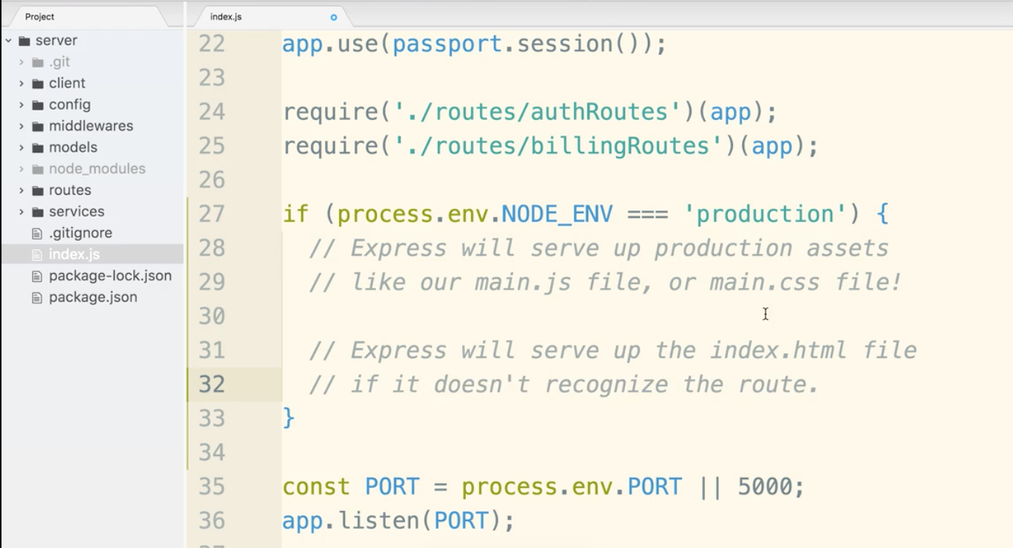

Let’s add in the code.

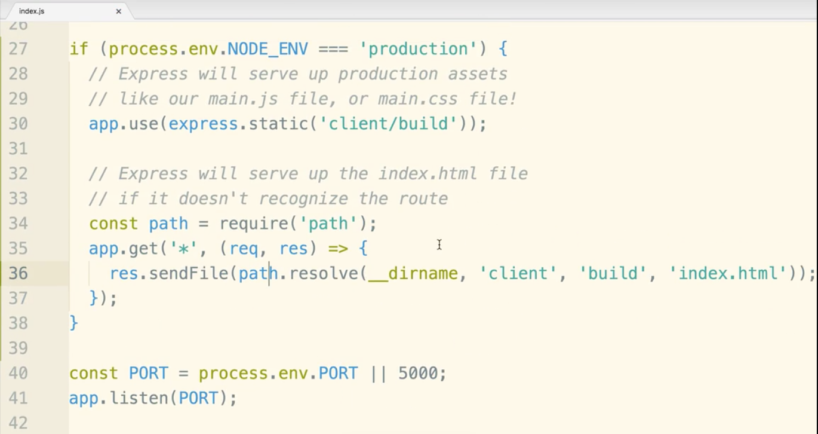

Lines 34-36 is the catch all case. The order in which these things are listed is important. The last thing that should happen if no routes are matched in production, is for the user to be sent back to index.js.

Before deployment, we need to run npm build if we want the latest changes to be in our build folder.

Now Heroku goes by what is deployed to git. By default we do not commit the build folder at all. We need to deal with this in one way or the other. The first option violates convention and source control in general. For Option 2, we need to make sure heroku installs all dependency, like ALL of them. Webpack, babel, you name it. You are installing dependencies that are only needed in development as well. Option 3 is used more in companies. A CI server predominantly exist to test the code, but you can set it up to build and commit if all the tests are passed.

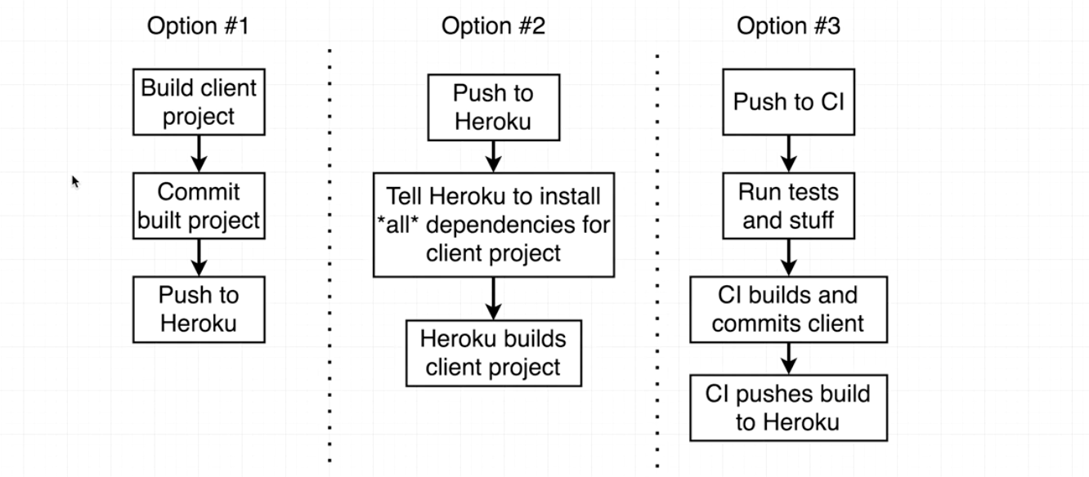

If you wanted to try the CI approach you could try circleci.com and start for free. We will not do that in this course, it’s pretty heavy duty. We are going with Option 2.

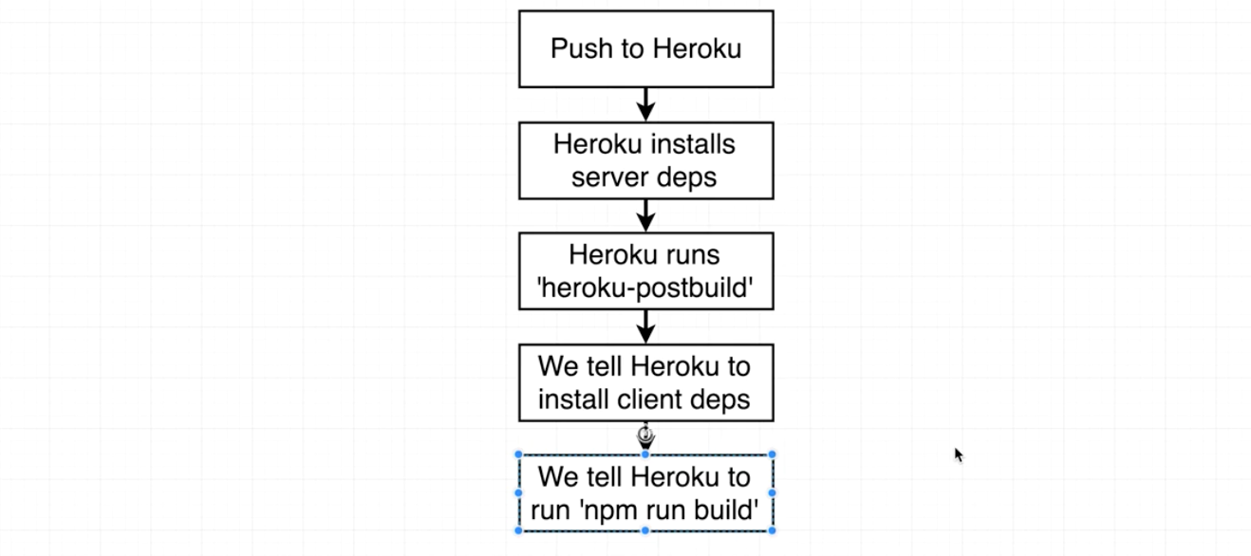

If you want you can go to the heroku article that tell you how to customize node js in heroku.

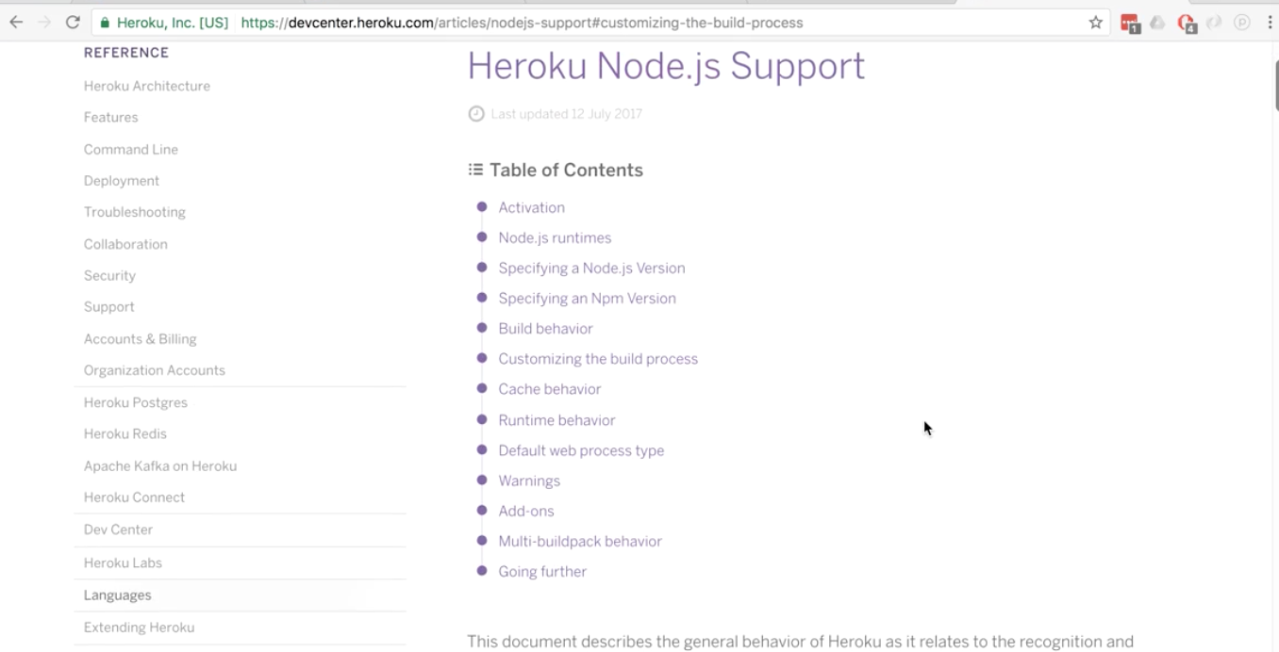

We want to focus on the section “Customizing Build Process”

We can use postinstall to call scripts after loading the server side npm modules.

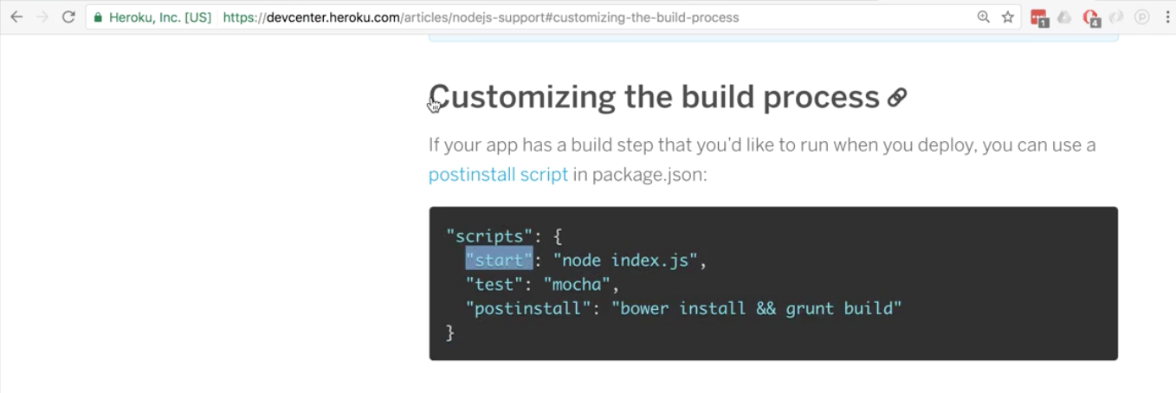

heroku-postbuild insures that we only run a script before a heroku build. This is what we want. This is the part we really want:

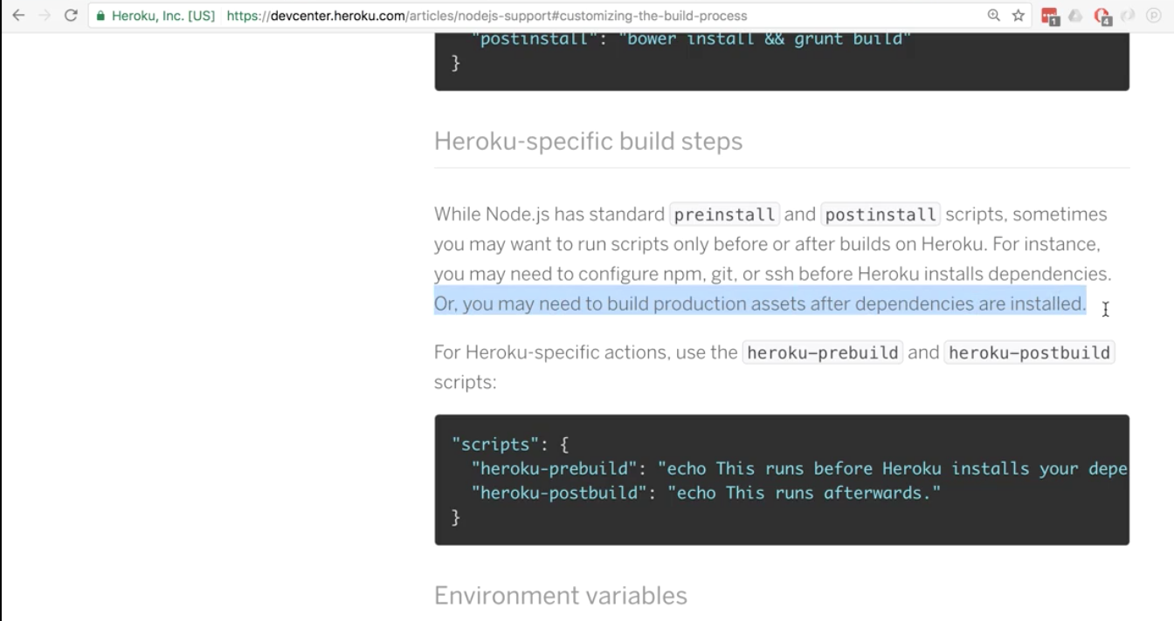

If you want to run just devDependancies. We will do something similar to this:

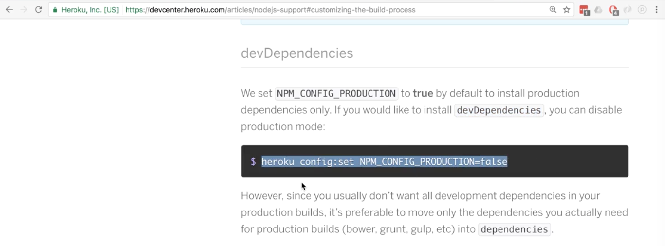

Now let’s jump into the package.json file in the server directory. Remember this is what Heroku cares about, it won’t look at the other package.json file.

In the scripts section create a property name of heroku-postbuild.

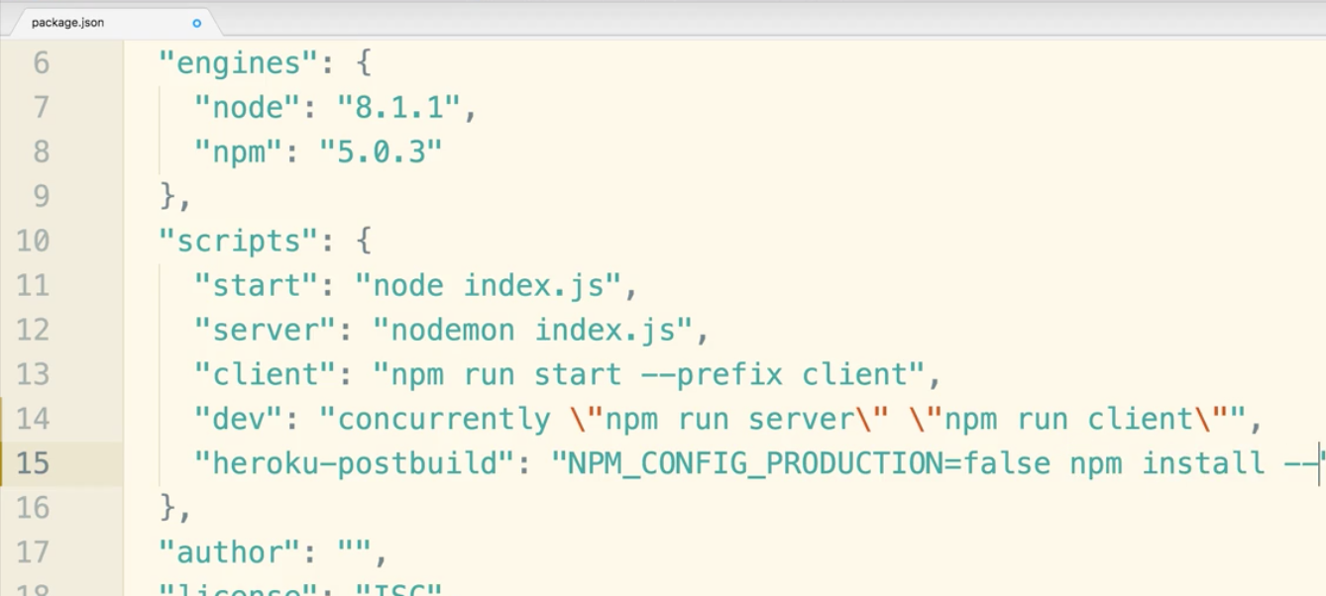

The line after postbuild will be super long so we’ll show it in a separate document broken up just so you can see it. Just to be clear though, the line in the scripts section SHOULD be just one long line. Don’t break it up.

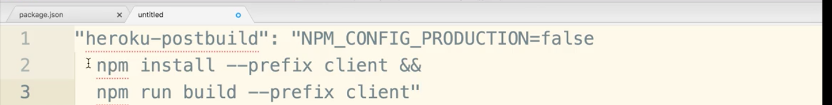

The prefix tell heroku to go into the client directory and install all of those dependences and then again run the build from inside the client directory.

Go to terminal server directory.

$ git status

$ git add .

$ git commit -m “Added billing and client side app!”

$ git push heroku master

If any errors popped up you can use

$ heroku logs

If there were errors you can read them and find where you made the typo.

$ heroku open

If you got any errors you can use heroku logs again.